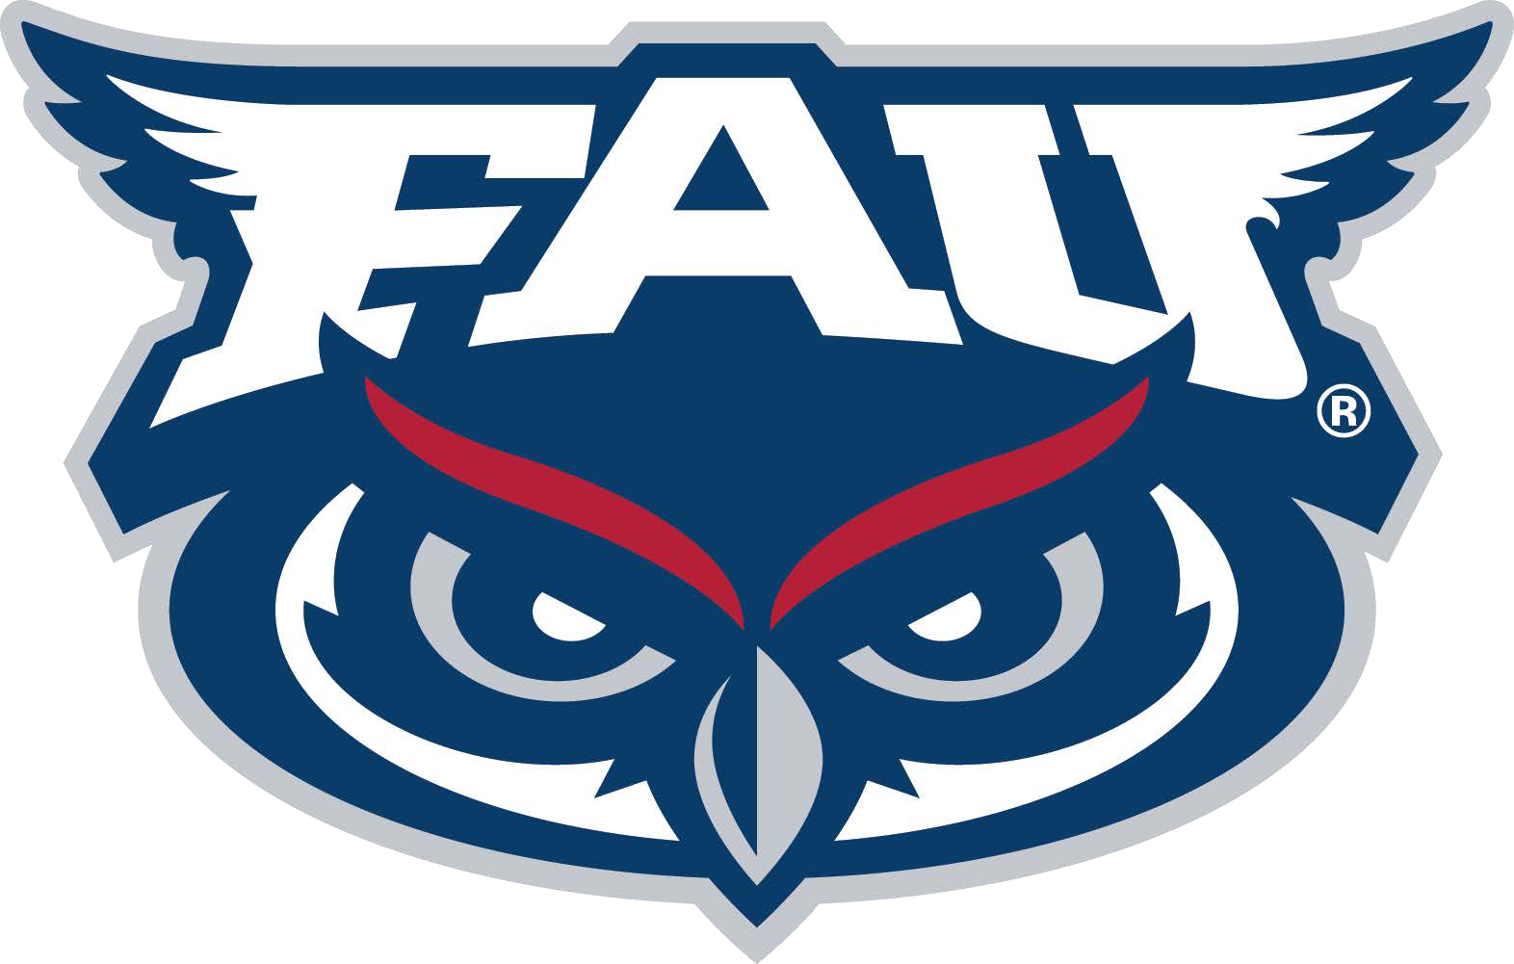
Compliance

Individual Associated with a Prospective Student-Athlete

IAWPSA NON-COACHING STAFF MEMBER HIRE REVIEW FORM

Per NCAA Bylaws 11.4.2, 11.4.3 and 11.4.4, for any athletics department non-coaching staff position or strength and conditioning staff position, an institution may not employ (either on a salaried or volunteer basis) an individual associated with a football or men’s or women’s basketball prospective student-athlete (PSA) – as defined below – during a two-year period before the PSA’s anticipated enrollment or a two- year period after the PSA’s actual enrollment. In order to comply with this legislation, any potential new hire will be vetted by the Compliance Office via questionnaire, internet search, and contact with former employer(s), if applicable.

Potential Hire Name Most Recent Employer

SECTION 1: POTENTIAL NON-COACHING STAFF HIRE INTERVIEW

An IAWPSA is any person who maintains (or directs others to maintain) contact with a PSA, a PSA's relatives or legal guardians, or coaches at any point during a PSA's participation in Football or Basketball, and whose contact is directly or indirectly related to either a PSA’s athletic skills and abilities or a PSA’s recruitment by or enrollment in an NCAA institution. This definition includes, but is not limited to, parents, legal guardians, handlers, personal trainers, mentors and coaches. Coaches or employees at collegiate institutions may also be considered IAWPs for PSAs that they recruit. I am aware that the answers to the below questions are truthful, do not omit information relevant to this issue, and that false or misleading answers could result in termination or disqualification from eligibility for any employment at Florida Atlantic University (FAU):
- Are you an IAWP for any of the student-athletes on your attached list?* Yes No

If YES, please explain:

- Are you an IAWP for any individual FAU may be recruiting in the next two years in the sports of Football or Men's or Women's Basketball?
If YES, please explain:

Yes No

- Were you involved in the recruitment of current FAU Football
or Men's or Women's Basketball players?
Yes No

- Are you a full time undergraduate (12 hours) or graduate (9 hours) student at FAU? Yes No

* Please provide a list of any Football, Men's Basketball, or Women's Basketball student-athletes or prospective student-athletes you interacted with at your prior institution(s) in the past 2 years.

Compliance

Individual Associated with a Prospective Student-Athlete

SECTION 2: HEAD COACH / OVERSIGHT CONFIRMATION

- Will this individual perform traditional managerial duties with
any team (e.g., equipment, laundry, hydration,
practice set up/break down etc.)? Yes No

If Yes, is this student a full time undergraduate
(12 hours) or graduate (9 hours) student at FAU? Yes No

If Yes, Z-Number: ________________________________

By signing below, I affirm that I have exercised due diligence in conducting a thorough background review of the above-named potential hire. I have reviewed the information contained herein and I have notified the Compliance Office of any potential issue(s) related to the above-named potential hire, including any issues that are not outlined herein.

Signature of Head Coach / Supervisor Date

SECTION 3: COMPLIANCE OFFICE CONFIRMATION or VIA EMAIL APPROVAL

Potential hire does trigger NCAA IAWP bylaws for Football.

Potential hire does trigger NCAA IAWP bylaws for Men’s Basketball.

Potential hire does trigger NCAA IAWP bylaws for Women’s Basketball.

Potential hire does not trigger NCAA IAWP bylaws.

Comments:

Compliance

SECTION 4: VOLUNTEER STAFF EDUCATION
- Extra Benefits
  - Student-athletes may not receive any benefit that is (a) not available to the public/student body and/or (b) only being made available to them because of their status as a student-athlete.
  - Volunteer Staff should not provide ANY tangible item or service to a student-athlete or prospective student-athlete without first seeking approval from Compliance.
- Name, Image, Likeness (NIL)
  - An institutional staff member (paid or unpaid) shall not provide professional services related to a student-athletes NIL activities and a student-athlete may not compensate a coach or staff member to be involved in or assist with the activity.
  - Institutional staff members shall not compensate or cause compensation to be directed to a current or prospective student-athlete for their NIL
- Sports Wagering
  - An institutional staff member (paid or unpaid) may not place a sports wager on any sport that the NCAA conducts a championship in (or emerging sports for women) at ANY level.
    - Examples of Sports Wagering include, but are not limited to:
      - Entering an NFL fantasy draft league with an entry fee and prize pool
      - Placing a wager on the outcome of a little league game with a family member
      - Using a bookmaker or parlay card
      - Feeding institutional information to outside entities for the purpose of sports wagering
- Countable Athletically Related Activity (CARA)
  - CARA is required practice, competition, and athletically related meetings
  - Generally, a student-athletes participation in college athletics is limited to the following:
    - In-Season:
      - 4 hours of CARA per day
      - 20 hours of CARA per week
      - 1 required day off per week
    - Out-of-Season
      - 8 hours of CARA per week
      - No more than 4 hours of skill-related instruction (practice) per week
      - 2 required days off per week

By signing below, I acknowledge that I have reviewed all of this information and will abide by FAU Compliance and NCAA rules during my assignment with the Florida Atlantic University Department of Athletics.

Signature Date

