1. Writing Plan Cover Page

☐Subsequent Edition of Writing Plan: This is a revision of the initial plan from May 2015.
Please fill in the gray areas on these forms.

Languages Programs
WEC Unit Name
Languages, Linguistics, and Comparative Literature | Dorothy F. Schmidt College of Arts and Letters
Department | College
Frédéric Conrod | Associate Professor of Comparative Literature
WEC Faculty Liaison (Print Name) | Title
fconrod@fau.edu | 561 297 3313
Email | Phone

Writing Plan Ratified by Faculty
Date: | If Vote:
 |  | # yes | # total

Process by which Writing Plan was ratified within unit (vote, consensus, other- please explain):

2. Unit Profile: _______________________
Number of Tenured and Tenure-Track Faculty:
6 | Professors
8 | Associate Professors
5 | Assistant Professors
7 | Instructors
26 | Total

Major(s) Total # students enrolled in Total # students graduating
Please list each major your Unit offers: major of 2016-2017 with major AY 2017-2018

French Program |  | 30 |  | 3
Italian Program |  | 12 |  | 1
Linguistics Program |  | 98 |  | 10
Spanish Program |  | 44 |  | 6

WEC Implementation Process | Date | Participated / | # invited
Intro Meeting for Faculty | 8/ 28/ 2014 | 24 | 25
Online Faculty Survey | 8/14 – 10/1 /2014 | 17 | 28
Online Student Survey | 8/14 – 10/1 /2014 | 13 | 25
Online Affiliate Survey | 8/14 – 10/1 /2014 | 35 | 180
Meeting 1 | 10/8/2014 | 15 | 25
Meeting 1 (cont) | 10/29/10 | 13 | 25
Meeting 2 | 11/5/2014 | 9 | 25
Meeting 2 (cont) | 12/5/2014 | 13 | 25
Meeting 3 | 2/17/2015 | 6 | 25
Meeting 4 | 3/17/2015 | 6 | 25
Meeting 4 (cont/FRE) | 3/24/2015 | 4 | 5
Meeting 4 (cont/LIN) | 4/15/2015 | 4 | 5
Meeting 4 (cont/SPN) | 4/8/2015 | 10 | 12

WEC Initiative Summary Ay 17-18 | Date | Participated / | # invited
5 Meetings in the Fall about  Implementation of New Writing-Enriched Courses for all Students in LLCL | 8/ 28/ 2016 through  1/27/2017 | 5 | 5
WEC Liaison took WAC Faculty Seminar with Dr. Jeff Gailin | January 2017 | 6 | 6
Department Workshop on “Designing Assignment: Microthemes” | 3/22/2017 | 9 | 45
Initial Meeting with Dpt Chair and WEC Director Jeffrey Gailin | October 2016 | 4 | 4
Best Undergraduate Writing in Lingua Awards (2 competition per AY) | December 2016  May 2017 | 5 | 11
Grant Proposal for New Writing-Enriched Courses Drawn for Submission to Distinction through Discovery QEP Curricular Development Grants. | In-progress | 5 | 5

3. Signature Page
Electronic signatures may be submitted in lieu of this page. If this page is submitted as a hard copy, please include a print out of the electronic signature chain here.

WEC Faculty Liaison
Frédéric Conrod | Associate Professor of Comparative Literature
WEC Faculty Liaison (print name) | Title
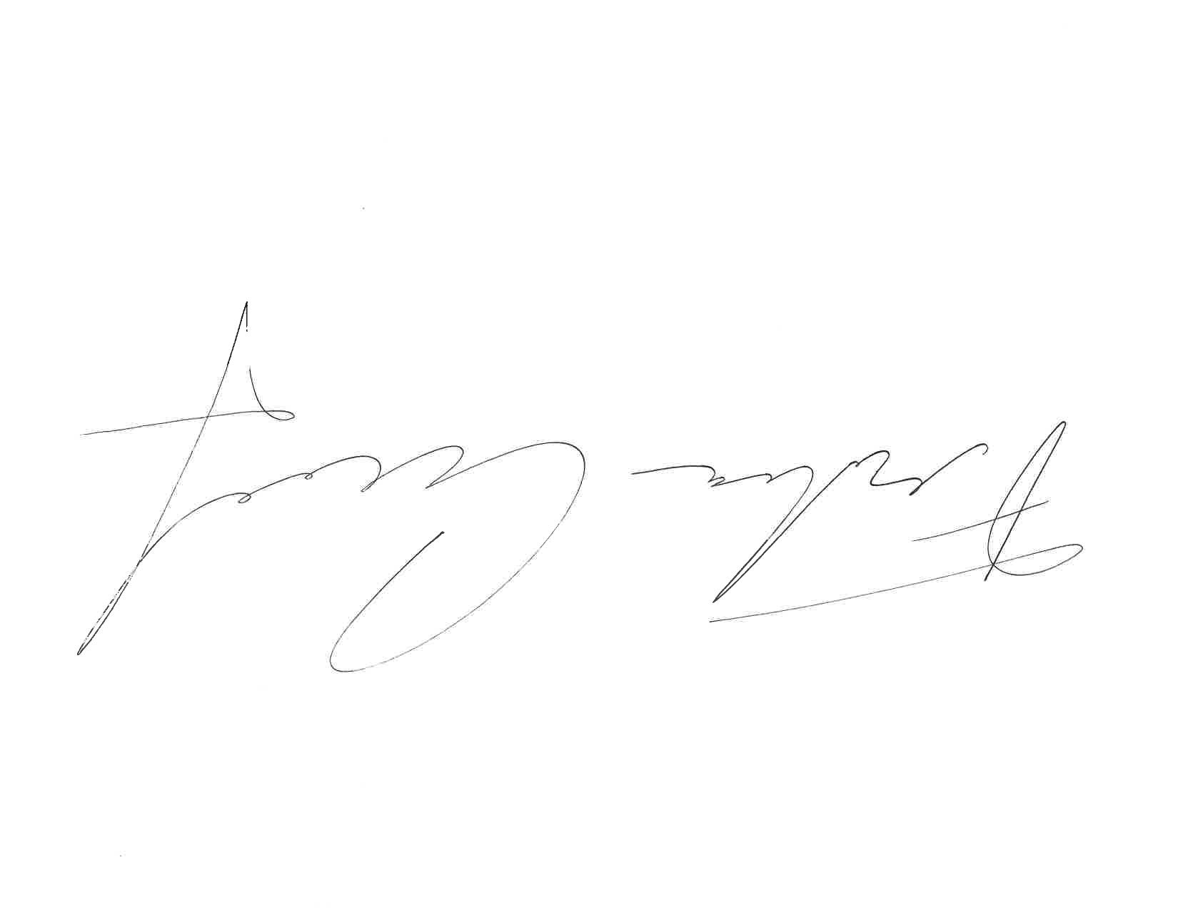 | 4/18/2017
Signature | Date

Department Head/Chair
Marcella Munson | Chair of the Department of Languages, Linguistics, and Comparative Literature  and Associate Professor of French
Print Name | Title
Signature | Date

College Dean
Heather Coltman | Dean of the Dorothy F. Schmidt College of Arts and Letters and Professor of Music
Print Name | Title
Signature | Date

4. WRITING PLAN NARRATIVE

Executive Summary: (1-page) For what reason(s) did this unit (department, school, college) become involved in the WEC project? What key implementation activities are proposed in this edition of its Writing Plan and what, briefly, is the thinking behind these proposed activities?

The Department of Languages, Linguistics, and Comparative Literature (LLCL) offers four mayors: three in Language Programs -including French (FRE), Italian (ITA), and Spanish (SPN)- and one in Linguistics (LIN). The nature of the Language Programs differs from the Program in Linguistics: in the first one, writing is essential at all levels, while in the second one, an intensive level of writing is not required for most courses. Consequently, this specific discipline defers the writing implementation plan until the next proposal edition, in which LIN will have the opportunity to design a new track for the implementation of a writing plan that requires new criteria and the integration of more written assignments in the courses.

LLCL became involved in the Writing Enriched Curriculum (WEC) initiative, due to the general concern among faculty members about students’ writing skills at all levels of English, as well as the writing, reading, and communication competencies at the upper level in lingua. The Department agreed to pilot the WEC initiative in August 2014, since writing is a core competency in our Language Programs. Weak writing and reading skills in upper level courses can hinder the understanding of advanced concepts, resulting in the frustration of students and the disappointment of instructors. The WEC initiative provides us with a valuable tool to address these issues -reflecting together as a faculty upon the challenges found in writing instruction within our discipline- and also acts as a promising platform for improving the writing proficiency among the students in our department. Since the initiative has been implemented, a majority of the LLCL faculty has used the criteria established in the initial version of this report as official departmental criteria for their courses, and have included them in their syllabi. In addition, five faculty members from different sections where writing is in need of drastic improvement (Dr. Calargé, Dr. Conrod, Dr. Horswell, Dr. Godón-Martinez, and Dr. Serra) formed an ad-hoc committee to work on the development of a new writing-enriched course at the entry level (see Appendix 5), to potentially be offered for all LLCL students to take as foundation in preparation for further writing in lingua in upper-division courses. This course would prepare students to the required writing skills for an easier access to the 4000-level courses. Currently, the department sees too many students entering the 4000-level content courses who do not have the necessary training for writing a decently written, organized and formatted paper.

In this first edition of our writing plan, the WEC Team has collected data on current writing expectations from faculty, students, and affiliates, as well as writing instruction from LLCL faculty. We also had a series of meetings where a chart of desired writing abilities and a chart of desired characteristics for LLCL disciplines were proposed. In order to do so, we took into consideration the writing proficiency that is expected to be reached by the majors in our disciplines by the time they graduate. In addition, we have created measures to evaluate the desired writing abilities -identifying levels of student performance necessary to score student work- and have mapped the courses that are using written assignments, in order to see how these courses can most effectively sequence the aforementioned desired writing abilities. The mapping process revealed a lack of coherent implementation of what professors and students have considered to be the most important points in the writing criteria to achieve an appropriate writing competence by the time which students graduate. These results provided us with a starting point to draw our attention to these writing abilities and to work towards improving their implementation across our curricula. In order to continue this effort, the new liaison entering in the AY 2017-2018 has chosen to focus on the writing assignment design, has joined the WAC workshop and has offered a workshop in the Spring 2017 to discuss how the LLCL department faculty designs its writing assignment. Dr. Jeff Galin was invited to speak about some of the techniques that can be envisioned when proposing coherent writing assignment to the students, i.e., micro-themes Although the workshops were announced with plenty of advance and reminders were sent, the faculty attendance was rather poor. Graduate students constituted the great majority of participants, as they strive more training. In order to fix this problem, the Chair and the WEC Liaison are working on a series for the AY 2017-1028 that would involve the faculty of the department, make them the center focus of the workshops, keep the GTAs as the main audience, and therefore raise the interest of tenure-line faculty in participating by sharing their tips and experiences. In creating such a culture, the WEC Liaison will be able to measure the impact on the workshops by surveying both faculty and GTAs about potential topics they would like to see covered during these workshops. Faculty can also suggest names of potential guest speakers that can share their experience.

During the upcoming 2017-2018 AY, the WEC initiative in the LLCL department will continue to include a series of workshops on the importance of good reading and writing skills; acquiring a good communicative competence; implementing reading and writing in our courses; developing teaching materials and effective rubrics, as well as providing feedback to students on written assignments. There has been advice given through the report and the workshops on grading, based on criteria and expectations, all through the support of new writing and reading pedagogy among faculty, while educating students on the value of reading and writing. In addition to these activities of general interest for the whole department, which have helped us to create a common path to their implementation, each language program has proposed different actions based on the gaps and issues in each of the three units. These actions are: an increment implementation in reading materials at the lower division levels; reorganization of courses offered; a creation and reinstallation of writing courses at the upper level; placing a representative at the Writing Center to support students with their written assignments in lingua throughout the drafting, revision and edition stages; and offering “Best Undergraduate Writing in Lingua Awards,” once in the Fall semester, and once in the Spring semester. The recipients of these awards are acknowledged during the LLCL graduation reception in May

Our main priority is the improvement of writing, reading, and communicative skills in lingua among students, while encouraging our faculty to integrate a coherent progression of reading and writing within and across the curriculum, also respecting the diverse nature of pedagogical approaches to writing in the department. Since the implementation of the WEC initiative, a majority of faculty teaching at the upper-division level has been consistent in communicating during sectional assessment meetings about the common path that was originated in the initial version of this document. In terms of actual outcomes, it is important to make sure that faculty keep discussion flowing around the implementation of the criteria, since a majority of faculty in literature are happy with the criteria. The next step, therefore, would be to measure all or most criteria. The department and its liaison will consider adapting a version of the WAC assessment interface for Languages assessment.

Section 1: Discipline-specific Writing Characteristics

What characterizes academic and professional communication in this discipline?

The Department of Languages, Linguistics, and Comparative Literature provides students a broad liberal arts background, through coursework in linguistics, language, culture, and literature in interdisciplinary and cross-cultural contexts. In a competitive global context, our programs appeal to a wide variety of students, including humanities-oriented individuals, future educators, and those who wish to broaden their global horizons, while pursuing careers in business, law, healthcare, engineering, international relations, and science, among others. Due to the need to communicate effectively and connect strongly with people from other cultures and nationalities in these professions, it is important to establish and maintain personal and professional contacts, where writing and communication competencies in lingua come into play. The following characteristics cover the writing skills that are expected in Language Programs across curricula to accomplish writing and communication competence in our disciplines:

- Original/original thinking: follow guidelines of academic honesty rules.

- Proper use of language: clear, carefully chosen, and precise, with a high degree of accuracy in written conventions (orthography, accents, punctuation, paragraphing), syntax and morphology, lexicon, style, and linguistic registers. Grammar is effective and appropriate to the task.

- Contextualized: sustained on the importance of the cultural contexts in which texts are written and received.

- Informed: evidence of reading based on professional research done on a specific topic.

- Concise: well-crafted writing. Clear articulation and explicit statement of ideas without being repetitive, avoids unnecessary language or information; on target.

- Organized: logical and effective order (introduction/body/conclusion); main points and details connected; not choppy, strong transitions between paragraphs to maintain order of essay.

- Descriptive: demonstrate a basic understanding of the text by summarizing what is being presented.

- Argumentative: persuades readers through a thesis-driven argument.

- Analytical: logical examination through selection of appropriate examples from the chosen work to support the response in a convincing way, how the ideas expressed in the citations are reflected in the text, evidence of good understanding of the text.

- Critical: interpretation and evaluation of the text, synthesizing and explaining information from a range of sources to fully reflect the complexities and different perspectives of issues and events. Discuss text(s) with conviction and authority to form independent literary judgments and to support ideas.

- Accurate and appropriate use of literary and linguistic terminology as well as jargon concerned with a particular subject, culture, or profession.

- Use of sources: using well-chosen sources, correctly and smoothly integrated.

- Proper citation: follow MLA or APA style.

Section 2: Desired Writing abilities*

With which writing abilities should students in this unit’s (department’s) major graduate?

The desired writing abilities within the disciplines of Language programs’ curricula (FRE / ITA/ SPN) are:

- Demonstrate awareness of historical and cultural contexts and knowledge of social and political audiences through the study of works.

- Recognize and communicate with specific audiences taking into account different registers, style, tone, and terminology, using them appropriately for the intended audience.

- Propose informed and persuasive arguments based on relevant professional readings/research and carefully chosen sources.

- Analyze ideas, texts, or events offering substantial information. Major points supported with relevant details/examples from a variety of non-literary and literary texts.

- Use critical thinking to analyze, evaluate, and synthesize ideas, texts, or events in both primary and secondary sources developing the ability to form independent literary judgments and support those ideas.

- Organize a coherent narrative structure to flow logically from one point to the next. A coherent narrative must have an introduction that offers a forecasting statement that leads to an organizational framework; a body to develop the topic with effectively integrated examples/citations from works used; and a conclusion that reviews main points, restates thesis, and offers an effective ending.

- Demonstrate competence in morphology, orthography, and syntax: agreement, gender, number, determinants, pronouns, nouns, adjectives, verbs, adverbs, prepositions, and conjunctions are generally accurate, among other grammar components.

- Show command and awareness of genres to implement them in official and non-official correspondence, diaries, compositions, proposals, abstracts, book reviews, papers, and/or works of creative writing.

- Demonstrate an ability to compile appropriately a bibliography (e.g., peer-reviewed) sources from primary and secondary literature, as well as non-literary works that are useful and contribute in comparison to other sources in the bibliography. Information must come from reliable source.

- Conform to MLA, APA bibliographic standards and conventions.

- Follow academic honor code: recognize and understand plagiarism in various forms and demonstrate knowledge and strategies for avoiding it.

* These writing abilities were proposed as a starting point for the first unit’s draft. Now in its second academic year of implementation, these 11 points have become part of the LLCL assessment routine and now resonate in the language used during session meetings. They will be revised for minor changes during the spring semester of 2018 to better accomplish their implementation in the curricula. The criteria needs to be discussed and potentially revised at the department’s level. Also, the document still needs to figure out a measuring system for criteria #7, #8, #9, #10, #11.

Section 3: Integration of Writing into Undergrad. Curriculum

How is writing instruction currently positioned in this unit’s undergraduate curriculum (or curricula)? What, if any, structural plans does this unit have for changing the way that writing and writing instruction are sequenced across its course offerings? With what rationales are changes proposed and what indicators signify their impact?

The following visual maps indicate the current state of writing and writing instruction among our majors at the department. These charts link desired writing abilities to the current sequence of courses, clustered into several categories, according to analogous expectations towards written competence. Through them, we point out our three current levels of progression in writing competence, not taking into account the course per se, but rather its function within and across the entire curriculum: E, SB, I. “E” should be read as exposition, “SB” as skill building, and “I” as intensive. The purpose is evaluating the consistency at the progressive level of writing within the curriculum, determining where the gaps that put in danger a coherent progression of written development are, in order to solve them and propose a smooth progression of writing skills.

LANGUAGE ROGRAM: VISUAL MAP- FRENCH

CRITERIA | Cluster  #1  FRE 1120  FRE 1121 | Cluster #2  FRE 2220  FRE 2221 | Cluster#3  FRE 3340  FRE 3400  FRE 3401  FRE 3393 | Cluster #4  FRW 3001  FRW 3102  FRW 3122 | Cluster#5  FOL 3880 | Cluster#6  FRW 4930  FRW 4933
1. Demonstrate awareness of historical and cultural contents and knowledge of social and political audiences | E | E | SB | SB>I | I | I
2. Recognize and communicate with specific audiences | E | E | SB>I | SB>I | I | I
3. Propose informed and persuasive arguments |  |  | E>SB | SB>I | I | I
4. Analyze ideas, texts, or events offering substantial information |  |  | SB | I | SB>I | I
5. Use critical thinking to analyze, evaluate, and synthesize |  |  | SB | I | SB>I | I
6. Organize a coherent narrative structure |  |  | SB | SB>I | SB>I | I
7. Demonstrate competence in morphology, orthography, and syntax | E | E | SB | I | SB>I | I
8. Show command and awareness of genres |  |  | E | SB>I | SB> I | I
9. Demonstrate an ability to compile appropriately a bibliography |  |  |  | E>SB | SB> I
10. Conform to MLA, APA |  |  |  | E>SB | SB | SB
11. Follow academic honor code | E> SB> I | I | I | I | I | I

LANGUAGE PROGRAM: VISUAL MAP- ITALIAN

CRITERIA | Cluster#1  ITA 1120  ITA 1121 | Cluster #2  ITA 2220 | Cluster#3  ITA 2221 | Cluster #4  ITA 4930  ITA 3412  ITA 3300  ITA 4730 | Cluster#5  ITA 3420  ITA 3421 | Cluster#6  ITT 3520  ITT 4440  ITT 3522  FOL 3880 | Cluster#7  ITW 3100  ITW 3101
1. Demonstrate awareness of historical and cultural contents and knowledge of social and political audiences | E | SB | SB | SB> I | SB | SB> I | I
2. Recognize and communicate with specific audiences | E | E | E>SB | I | SB>I | I | I
3. Recognize and practice informed and persuasive arguments |  |  | E | E>SB | E | I | I
4. Analyze ideas, texts, or events offering substantial information |  |  | E | SB>I | SB | SB>I | I
5. Use critical thinking to analyze, evaluate, and synthesize |  |  | E | SB>I | E | SB>I | I
6. Organize a coherent narrative structure |  |  | E | SB>I | E>SB | SB>I | SB>I
7. Demonstrate competence in morphology, orthography, and syntax | E | E | E>SB | SB | E>SB | SB>I | I
8. Show command and awareness of genres |  |  |  | SB | E | SB>I | I
9. Demonstrate an ability to compile appropriately a bibliography |  |  |  | E>SB |  | SB>I | SB>I
10. Conform to MLA, APA |  |  |  | E>SB |  | SB | SB
11. Follow academic honor code | E> SB> I | I | I | I | I | I | I

LANGUAGE PROGRAM: VISUAL MAP- SPANISH

CRITERIA | Cluster  #1  SPN 1120  SPN1121  SPN 1340 | Cluster #2  SPN 2220 | Cluster  #3  SPN 2221  SPN2341 | Cluster #4  SPN 3400  SPN 3343 | Cluster #5  SPN 3500  SPN 3501  SPT 4130  SPT 4800 | Cluster#6  FOL 3880 | Cluster #7  SPW 3012  SPW 3020 | Cluster#8  SPW 4930  SPW4583
1. Demonstrate awareness of historical and cultural contents and knowledge of social and political audiences | E | E | SB | SB | SB> I | I | I | I
2. Recognize and communicate with specific audiences | E | E | E>SB | I | I | I | I | I
3. Recognize and practice informed and persuasive arguments |  |  |  | E | SB | I | I | I
4. Analyze ideas, texts, or events offering substantial information |  |  | E | E | SB | SB>I | I | I
5. Use critical thinking to analyze, evaluate, and synthesize |  |  | E | E | SB | SB>I | SB>I | I
6. Organize a coherent narrative structure |  |  | E | SB | I | SB>I | I | I
8. Demonstrate competence in morphology, orthography, and syntax | E | E | E | SB | I | SB>I | I | I
9. Show command and awareness of genres |  |  | E | E | E | SB>I | SB | I
10. Demonstrate an ability to compile appropriately a bibliography |  |  |  | E | SB |  | SB | I
11. Conform to MLA, APA |  |  |  | E | SB | SB | SB | SB
12. Follow academic honor code | E> SB> I | I | I | I | I | I | I | I

LINGUISTICS PROGRAM: VISUAL MAP- LINGUISTICS

CRITERIA | Cluster#1  LING 2607 | Cluster #2  LING 3100 | Cluster#3  LING 3003 | Cluster #4  LING 4600  TSL 4251
1. Demonstrate awareness of historical and cultural contents and knowledge of social and political audiences | SB |  | E
2. Recognize and communicate with specific audiences | E | E>SB | SB | SB
3. Propose informed and persuasive arguments | E |  | SB | SB
4. Analyze ideas, texts, or events offering substantial information | SB |  | SB | SB
5. Use critical thinking to analyze, evaluate, and synthesize | SB |  | SB | SB
6. Organize a coherent narrative structure | E | SB | SB | SB
7. Demonstrate competence in morphology, orthography, and syntax | E | SB | SB | SB
8. Show command and awareness of genres |  |  |  | E
9. Demonstrate an ability to compile appropriately a bibliography | E |  | SB | SB
10. Conform to MLA, APA | E |  |  | SB
11. Follow academic honor code | E> SB> I | I | I | I

CHANGES AND IMPACTS ON THE PROGRAM : For the coming year or so this set of charts should be revisited to determine how WEC had begun to change the culture of writing in the department. Perhaps include a survey to determine which assignments across majors have changed in specific courses so that the department can represent how WEC is impacting courses, which courses, and how it helps to see changes in the charts above.

After examining and discussing the visual maps within all the programs, a general consensus has been reached on the need to emphasize the importance of not only writing itself, but also on how to impart a smooth and well organized progression in this learning process. It is with this purpose that the Department of Languages, Linguistics, and Comparative Literature considered the offering of workshops on the importance of reading and writing to be very beneficial in support of changes in the curricula. For this reason, the Department of Languages, Linguistics, and Comparative Literature has invited a diverse group of people, including faculty members, specialists in the implementation of reading and writing in curricula, along with other professionals from diverse pedagogic backgrounds, to give two series of workshops.

The first series of workshops consisted of a presentation series and is aimed towards students and professors. The people invited will come from different backgrounds and professions to share their input on how writing is essential on a daily basis for maintaining a successful professional life. On the one hand, the importance of reading and writing in English and in lingua for the achievement of a good communicative competence, was presented. On the other hand, the benefits which reading and writing provide in the academic and professional contexts throughout a globalized world, where contact and mutual understanding with other cultures is vital, was emphasized.

The second series of workshops was aimed towards faculty, including Graduate Teaching Assistants, especially those interested in pursuing a profession in teaching or education that involves the development of courses and creation and/or implementation of new material, were encouraged to attend. Here, the main focus was a reflection about the very first step of the writing process, which is the assignment designed by the instructor. Throughout the Department of Languages, Linguistics and Comparative Literature, the WEC Liaison noted a very drastic difference in assignment design. Although this is completely normal given the variety of teaching style and academic freedom to choose between many different formats, students commented during several meetings (both groups and individuals) about the discrepancy between the assignments given to them in the department. The focus of the WEC Liaison during the AY 2017-2018 was thereforeto listen and engage in conversation with students in order to bring new elements to discussins with faculty members teaching the courses in which extensive writing skills are developing about how they design their assignment. With somewhat of a common faculty philosophy around the generation of topics, length, questions, and critical-thinking in the department, it will easier for students to navigate from one course to the next and find themselves already familiar with the criteria.

Visual maps have also revealed a consensus on the nature and value of writing in Language Programs, which differ from those in the Linguistics program. This was reflected in the amount of courses in which writing is a key component.

Linguistic Program

The Linguistic Program has four courses in which writing is a relevant component. The small number of courses where the desired writing abilities are found indicates that writing is not offered as a fundamental component in the curriculum. Under the current writing criteria, the emphasis on these courses lies within the Skill Building level, with few Exposure and no Intensive levels. The reason is likely that the departmental criteria are based upon writing a research paper as an end product. However, this assignment is not the main objective in this discipline, where writing is a minor component that provides a summary of a study, a phenomenon or a linguistic relation. Therefore, it has been decided in this program to wait until the second edition of the writing plan, while considering other criteria that better align their writing assignments.

French Program

The French visual map shows writing as a major component in most courses across the curriculum. However, this map also revealed a lack of Exposure levels in relevant points 3, 4, 5, and 6 of the writing desired abilities, showing a non-uniform integration of criteria across the curriculum, which affects the development of the literacy competence process. In order to obtain a better flow from one level to the other in these important points, the following recommendation was proposed and succeeded after two years:

- A revision of the syllabi at the intermediate level, FRE 2220 and FRE 2221, (Cluster 2) to include more readings. These courses should increase the amount of reading through the incorporation of a list of literary and non-literary references with appropriate levels of difficulty (low/intermediate). Also, before-reading/during-reading/after-reading written assignments, based on these references were implemented and taken into consideration to evaluate the progression of the students’ writing skill. Faculty teaching French at this level reports that the increase of the amount of reading did have a clear and positive repercussion on the quality of students’ writings. In the future, the French Section plans to establish a system to
- The transition from BlackBoard to Canvas at the university level turns out to show early results of improvement in writing assignments at the 3000-level, since the new system is a lot more user-friendly when it comes to submitting, sharing, editing and revising a text than BlackBoard was. A few faculty members have noticed a significant improvement in students’ dedication to turn in a better paper that corresponds to the rubrics and criteria available to them on Canvas.
- See Appendix 4 for assessment of FRW 4933 (Senior Seminar).

Italian Program

The Italian visual map shows writing as a major component in most courses across the curriculum. However, this visual map also revealed a weak integration of Exposure and Intensive levels in lingua across the curriculum. On the one hand, Exposure level in relevant points 3, 4, 5, and 6 of the desired abilities only occurs in one course, ITA 2221. On the other hand, an Intensive level in lingua only occurs in two courses at the 3000 level: ITW 3100 & ITW 3101. This affects the development of the literary competence process and requires a reinforcement of both levels. Also, an inconsistency in the sequence across course offerings was revealed, since courses in Cluster # 4 entail a stronger level of writing competence than courses in Cluster # 5.

To improve writing effectiveness in the learning process, the following recommendations were proposed and succeeded after two years:

- The revision of the syllabi at the first intermediate level, ITA 2220, to include more readings. This course should increase the number of pages read through the incorporation of a list of literary and non-literary references with an appropriate level of difficulty (low/intermediate). Also, pre-reading/whilst-reading/post-reading written assignments, based on these references was implemented and taken into consideration to evaluate the progression of the students’ writing skill. Faculty teaching Italian at this level reports that this increase in the amount of reading did have a clear and positive repercussion on the quality of students’ writings.
- The creation of a course in ITW at the 4000 level or the combination of some ITT and ITW hybrid model (e.g. at the graduate level) with a fourth hour of language discussion led by a Teaching Assistant.
- Making changes in the order of sequences in clusters 4 & 5 to facilitate students taking a course in Cluster # 5 before Cluster # 4.

Spanish Program

The Spanish visual map shows writing as a major component in most courses across the curriculum. However, the visual map also reveals a weak and late integration of Skill Building level in lingua over general criteria, which affects the development of a literary competence process and requires reinforcement and an earlier integration of Skill Building level. The implementation of reading material, which took place in SPN 2221 two years ago, enables a progression in the analysis of texts in SPN 3400, and its equivalent track for Heritage Learners SPN 3343. This progression may be reinforced through the reinstatement of the SPN 3401 elective course. In this manner, a balance between the number of courses and the time dedicated towards the levels of Skill Building and Intensive will be facilitated. In the same way, it is worth considering the inclusion of criterion #3 through the use of texts which have already been implemented in SPN 2221.

To improve writing effectiveness in the learning process, the following recommendations were proposed:

- The reinstatement of SPN3401.
- Assigning a Spanish Program representative at the Writing Center to support Spanish students in upper levels with their written assignments in lingua, throughout drafting, revision and edition stages.
- The Spanish section is currently focusing its attention in textbook evaluations for the 1000 and 2000 levels. There will be limited pilot runs of new textbooks during the AY 2017-2018. The section wants to focus on textbooks that have a writing enrichment component. This adoption is important because the Basic Language Program has used the same standard text for the past seven years and this shift will be a significant departure involving Spanish faculty debate.

The impact that these measures will have on the students’ learning process will be assessed at the end of 2017, by reviewing and comparing the progress among students who have received the enhanced writing from course to course, and those who have not. This comparative analysis will take writing samples -previously considered by the WEC Team during Fall 2014 to address the desired writing competences- as starting point to observe student’s progression. Also, a survey on the implementation of these measures will be sent to students, Teaching Assistants, and faculty to get data that helps in considering the level of effectiveness of this plan’s implementation.

Section 4: Assessment of Student Writing

How does this unit currently communicate writing expectations (see section 1 &2) to undergraduate students? How satisfied is the unit faculty that students are adequately familiar with these expectations? How satisfied is the unit faculty that student writers are successfully meeting the identified expectations by the time they graduate? Why? If less than satisfied, what plans does the unit propose for closing the gap?

The diagrams in Appendix 1 show significant results about writing characteristics and ability expectations expressed by LLCL faculty in Fall 2014. They also show how faculty communicate these criteria to students. When describing writing, faculty and students consider that the most important characteristics and abilities are: critical, analytical, thesis-driven, and argumentative. This remarkable consensus implies a good communication between faculty and students regarding these criteria. Although, argumentative writing seems to show an incongruence when the evaluation takes into consideration writing characteristics vs. writing abilities. In other words, faculty and students agree on persuasively arguing a position regarding writing abilities, while differing in the value of argumentative writing when focusing in characteristics, the latter being one of the most important aspects for faculty rather than students. Surprisingly, within a context of writing abilities, students show a high interest in persuasively arguing a position, which ultimately marks a joint interest through the importance of argumentation. More importantly, what faculty and students consider to be the most valuable writing characteristics are reinforced by the fact that both, faculty and students, give them in the writing abilities diagram (see number 3, 6, 9, and 13), hence demonstrating that students are adequately familiar with these expectations.

Nevertheless, considering that students are acquainted with these expectations, the unit faculty is not satisfied with the level that students achieve by the time they graduate, in regards to writing. Taking a look into the issues highlighted by all LLCL visual maps, we find out that LLCL curricula have gaps precisely in these specific points of criteria, coinciding with what faculty and students consider the most important aspect- to achieve an appropriate writing competence by the time of their graduation:

- Propose informed and persuasive arguments based on relevant professional readings/research and carefully chosen sources.

- Analyze ideas, texts, or events offering substantial information. Major points supported with relevant details/examples from a variety of non-literary and literary texts.

- Use critical thinking to analyze, evaluate, and synthesize ideas, texts, or events in both primary and secondary sources developing the ability to form independent literary judgments and support those ideas.

- Organize a coherent narrative structure to flow logically from one point to the next. A coherent narrative must have an introduction that offers a forecasting statement that leads to an organizational framework; a body to develop the topic with effectively integrated examples/citations from works used; and a conclusion that reviews main points, restates thesis, and offers an effective ending.

To close this gap, the need has been expressed in Language Programs for ensuring that relevant writing abilities are adequately and logically infused into the curricula. In order to do so, the following actions were proposed:

- To increment readings at 2000 level courses, in order to develop higher levels earlier, through writing these particular criteria.
- To take into consideration the earlier integration of the Exposure level in the curriculum, thus integrating an earlier Skill Building to balance the learning process while offering a more gradual transition from one level to the next.
- To reconsider and change order sequences in course offerings when necessary.
- To create new courses.
- To reinstate old courses.
- To have a representative to work in lingua at the Writing Center
- To offer “Best Undergraduate Writing in Lingua Awards”

In addition, the following rubric addressing measures were utilized to evaluate the desired writing abilities: An identification of levels in student performance, necessary to score student work, was created (see Appendix 2) and an ongoing revision with the help of de Director of Undergraduate Assessment has already started (see Appendix 3)

Section 5: Summary of Implementation Plans and Requested Support

Based on above discussions, what does the unit plan to implement during the period covered by this plan? What forms of instructional support does this unit request to help implement proposed changes? What are the expected outcomes of named support? What kinds of assessment support does this unit request to help assess the efficacy of this Writing Plan? What are the expected outcomes of this support?

Initial two-year implementation plan submitted in June 2015:

Semester | Activities:  Instructional and Assessment Support | Personal & Material | Requested Support*
Fall 2015 | 1.Writing and Reading  Workshop for students and faculty  2.Writing and Reading  Assessment Workshop for faculty  3.Selection of readings for  intermediate level courses  4.Creation of FRE Library  5. Revision of rubrics: Ongoing revision of measures to evaluate desired writing abilities  6. Re-approaching LIN writing expectations, assignments, and courses to create new criteria in this discipline | -WEC Subcommittee  - WEC Research Fellowship for a graduate student (or WEC Research Assistant)  -Reading material: book series (low/intermediate levels) | - Guest Speakers: $2000. Two workshops given: one on WEC structure and implementation; one on SLA (Second Language Acquisition) best practices and the infusion of writing in lingua in the lower division.  - WEC RF – position held by LLCL French MA student (to help with activities 1, 2,4):  $1000. Specific responsibilities for this term : reviews of potential leveled readers  - FRE Library – acquisition of targeted collections of leveled readers for the intermediate lower-division sequence classes (FRE 2220/2221):  $2000
Spring 2016 | 1.Writing and Reading  Workshop for students and faculty  2.Writing and Reading  Assessment Workshop for faculty  3. Implementation of readings at Intermediate level in FRE and ITA and  implementation of criteria #3, 4, 5, 6 at Exposure level.  5. Reinforcement of level  E>SB in criteria #3, 4, 5, 6 6. Writing Center Spanish Program representative  7.Writing Best Undergraduate Paper Award | -WEC Subcommittee  -Research Fellowship  -Writing Center Spanish Program representative | - Guest Speakers for workshops centering on writing in lingua for our disciplines: $2000. One workshop focused on creative writing specifically; another focused on the assessment of writing, with our faculty and Ph.D. GTAs specifically encouraged to attend.  - WEC RF:  $1000 (to help with #1, 2,7). Position held by LLCL French MA student. Specific responsibilities for this term: assistance in selection of leveled readers ; creation of cultural activities and reading question HW sets based on leveled readers.  - Writing Center Spanish Program Representative: $2250. Comp Studies Spanish/Italian Ph.D. student assigned to provide in lingua writing support through the Writing Center. Individual upper-division Spanish courses send their students to the Writing Center for structured in lingua writing support.  - Best Undergraduate Writing in Lingua Awards ($200/each Language Program):  $600
Fall 2016 | 1. New course ITW 4000  2. Reinstatement of SPN3401 with emphasis on criteria #3, 4, 5, 6.  3.Survey in specific courses where Writing Enhance was implemented.  4. “Best Undergraduate Writing in Lingua Awards” | -WEC Subcommittee  -TA support for ITW4000  -Research Fellowship  -Writing Center Spanish Program representative | - WEC RF(to help with # 3 and 4):  $1000. Position held by LLCL French MA student. Specific responsibilities for this term: assistance in tracking library materials as they are loaned out to French courses on a rotating basis; assistance in developing additional reading comprehension/writing activities in lingua based on leveled readers.  - ITW Teaching Assistant Support: $1000. Comp Studies: Italian Ph.D. student assigned to help create writing-infused activities in part of the Italian lower-division sequence (ITA 1120, 1121, 2220); assisted in creating cultural activities and guided reading question HW sets.  - Writing Center Spanish Program Representative:  $2250. Comp Studies Spanish/Italian Ph.D. student assigned to provide in lingua writing support through the Writing Center. Individual upper-division Spanish courses send their students to the Writing Center for structured in lingua writing support.  - “Best Undergraduate Writing in Lingua Awards” ($200/each Language Program):  $600
Spring 2017 | 1.Collecting data from faculty and Teaching Assistants on WEC implementation plan and student progression  2.Curriculum mapping & analysis of writing assignments and rubric, synthesis of data and presentation of data  3. “Best Undergraduate Writing in Lingua Awards” | -Research Fellowship  -Writing Center Spanish Program representative | - WEC RF (to help with #1, 2, and 3)  $1000. Position held by LLCL French MA student. Specific responsibilities for this term: assistance in reassessing the cultural activities and guided reading question HW sets; assistance in selecting additional leveled readers for expansion of the “French Library” concept (infusion of in lingua reading/ writing activities) at the first-year level (FRE 1120/1121) as well.  -A Writing Center Spanish Program Representative: $2250. Comp Studies Spanish/Italian Ph.D. student assigned to provide in lingua writing support through the Writing Center. Individual upper-division Spanish courses send their students to the Writing Center for structured in lingua writing support.  - Best Undergraduate Writing in Lingua Awards ($200/each Language Program):  $600
Two-year plan (Fall 2015- Spring 2017) |  | REQUEST SUPPORT/ TOTAL: $19,550.00
*Request support cannot include faculty salary support

Revised Plan for AY 2017-2018

Semester | Activities:  Instructional and Assessment Support | Personal & Material | Requested Support*
Fall 2017 | 1.Writing and Reading  Workshop for students and faculty  2.Writing and Reading  Assessment Workshop for faculty  3. Revision of rubrics: Ongoing revision of measures to evaluate desired writing abilities  4. Re-approaching LIN writing expectations, assignments, and courses to create new criteria in this discipline | -WEC Subcommittee  - WEC Research Fellowship for a graduate student (or WEC Research Assistant)  -Reading material: book series (low/intermediate levels) | - WEC RF(to help with activities 1, 2,4):  $1000.  - Writing Center Spanish Program Representative: $2250
Spring 2018 | 1.Writing and Reading  Workshop for students and faculty  2.Writing and Reading  Assessment Workshop for GTASs  3. Implementation of readings at Intermediate level in FRE and ITA and implementation of criteria #3, 4, 5, 6 at Exposure level.  5. Reinforcement of level  E>SB in criteria #3, 4, 5, 6 6. Writing Center Spanish Program representative  - Writing Best Undergraduate Paper Award  - Series of workshops focusing on the LLCL GTA population featuring faculty from the department.  - LIT 2100 Ph.D. GTA workshop at the beginning of the semester. | -WEC Subcommittee  -Research Fellowship  -Writing Center Spanish Program representative | - Guest Speakers: $4000  - WEC RF:  $1000 (to help with #1, 2,7)  - Writing Center Spanish Program Representative: $2250  - Best Undergraduate Writing in Lingua Awards ($200/each Language Program):  $600

Workshops will provide guidance in: acquiring a good communicative competence; implementing reading and writing in our courses, developing teaching materials and effective rubrics for grading based on criteria and expectations, while educating students on the value of reading and writing. Therefore, workshops will facilitate different ways to implement a coherent progression of the desired writing abilities, resulting in better writing assignments. The AY 2017-2018 will be dedicated to the training of our GTA population, both at the MA and the PhD levels, as previously stated on page 5 of this report.

A faculty and students survey will provide a better understanding of the importance of the writing plan’s implementation, offering suggestions on how to include and/or reinforce what LLCL faculty and students consider the most important desired abilities, allowing students to achieve a better writing competence by the time they graduate.

Curriculum mapping through the revision of writing samples will provide the necessary data to identify the skill progression obtained through the incorporation and/or reinforcement of the desired writing abilities. These results will be compared to those offered by the writing samples collected and selected by the WEC Team at the beginning of Fall 2014. The revised rubrics, which were developed during the workshops, will be used in the analysis of both sets of samples, in order to evaluate the efficiency of the WEC initiative. It is through this method that we are trying to establish written evaluation standards, based upon the balance of a logical learning progression.

A Best Undergraduate Writing in Lingua Awards has increased motivation among students to develop the desired writing abilities. Its culture is still fairly new and developing, and not widely known, but faculty members who promote it have reported an increase in students’ motivation to write their assignment with the LLCL criteria in mind.

In sum, through this implementation plan, the Language Programs will contribute to the early involvement in research activities by Florida's college and university students, improving their writing quality and offering undergraduate students the tools to also become involved in some of the other research opportunities available to them, such as the Annual Undergraduate Research Symposium or the Florida Undergraduate Research Conference, forthcoming in 2017.

Section 6: Process used to create this Writing Plan
How, and to what degree, were stakeholders in this unit (faculty members, instructors, affiliates, teaching assistants, undergraduates, others) engaged in providing, revising, and approving the content of this Writing Plan?

WEC liaison, Frédéric Conrod, has continued to review data from other institutions, maintained closed correspondence with colleagues in the LLCL department about the enforcement of the adopted criteria, course profiles, and rubrics. He has encouraged faculty members, instructors, affiliates, teaching assistants and undergraduate students to participate in the WEC initiative, while maintaining a continuous contact with LLCL faculty members through multiple personal and group interviews. The WEC liaison always encouraged the LLCL faculty to provide, revise and approve the content of the different parts which have been compiled by previous liaison, Nuria Godón, and revised by current liaison, Frédéric Conrod, in the Writing Plan Narrative. The WEC initiative requires a high degree of support and involvement among unit members. Despite the already numerous responsibilities and tasks of the faculty, the WEC liaison obtained a moderate participation from most department members, while the required assiduous involvement was received from a not so large percentage of individuals. This increase in effort should be considered as service to the department due to the additional time and work invested by these members.

Section 7: Student Learning Outcomes

Briefly, please describe the ways that the ideas contained in the Undergraduate Writing Plan address the University’s student learning outcomes.

The WEC implementation plan in Language Programs at the Department of Languages, Linguistics, and Comparative Literature addresses several of the University’s student learning outcomes highlighted in the FAU 2012-2017 Strategic Plan, from which the support of the development of writing skills in students will be referred -providing academic support services and opportunities for students to promote writing success in lingua, taking also into account our growing multicultural student body population,- to others which focus on enriching the educational experience, offering high quality academic programs that develop critical thinking skills. Moreover, this implementation plan will help ensure progress in research, stimulating students to participate in scholarly activities through the opportunities of winning writing Awards. The WEC implementation plan in the Language program will provide a pool of funds that will also support undergraduate scholarships through writing.

In addition to support these important objectives from the FAU Strategic Plan, the WEC implementation plan of the LLCL department also concurs in several relevant points with the Student Learning Outcome Assessment Plan: Continuous Quality Improvement. Among these, it is worth mentioning: the revision of the departmental program, drawing attention on outcomes such as the curricula for improvement and contributions to institutional effectiveness; the revision of academic standards to facilitate improvement of the academic programs; involving representatives from across educational community: students, faculty members, experts and affiliates; and presenting explicit stated proposes. In this sense, the Language Program implementation plan pursues the improvement of effectiveness in teaching learning process as well as the preparation of graduates to face professional world and a life with success.

APPENDIX 1

Faculty: In your opinion, which three characteristics are the most important in describing writing in this major?

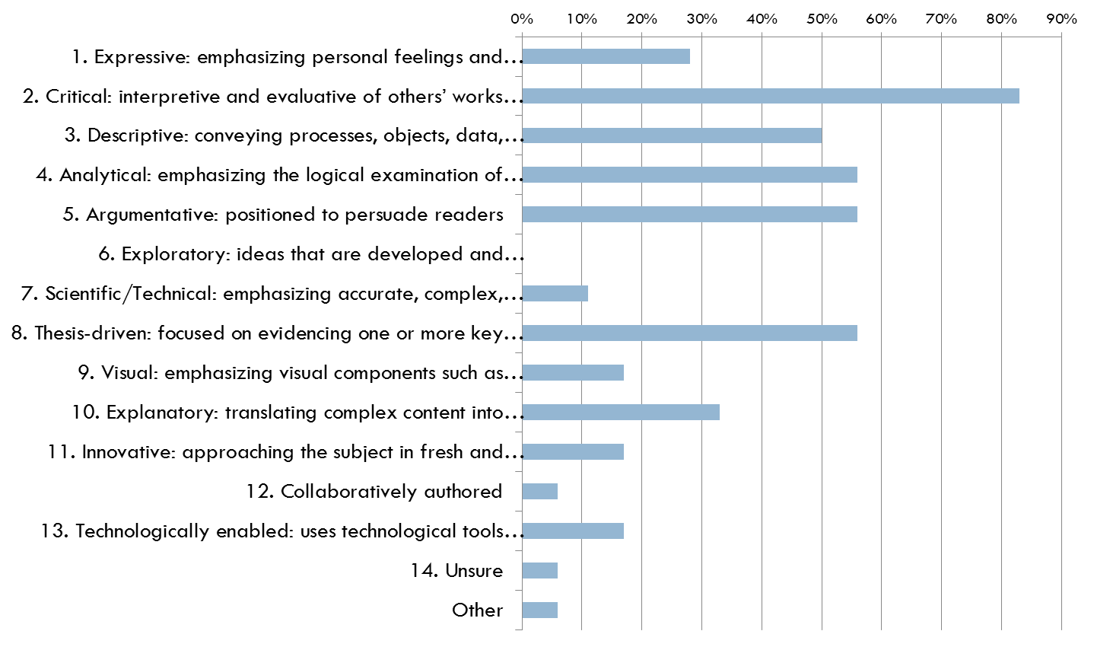

Students: In your opinion, of the characteristics you selected, which three characteristics (listed below) are most important in describing writing in this major?
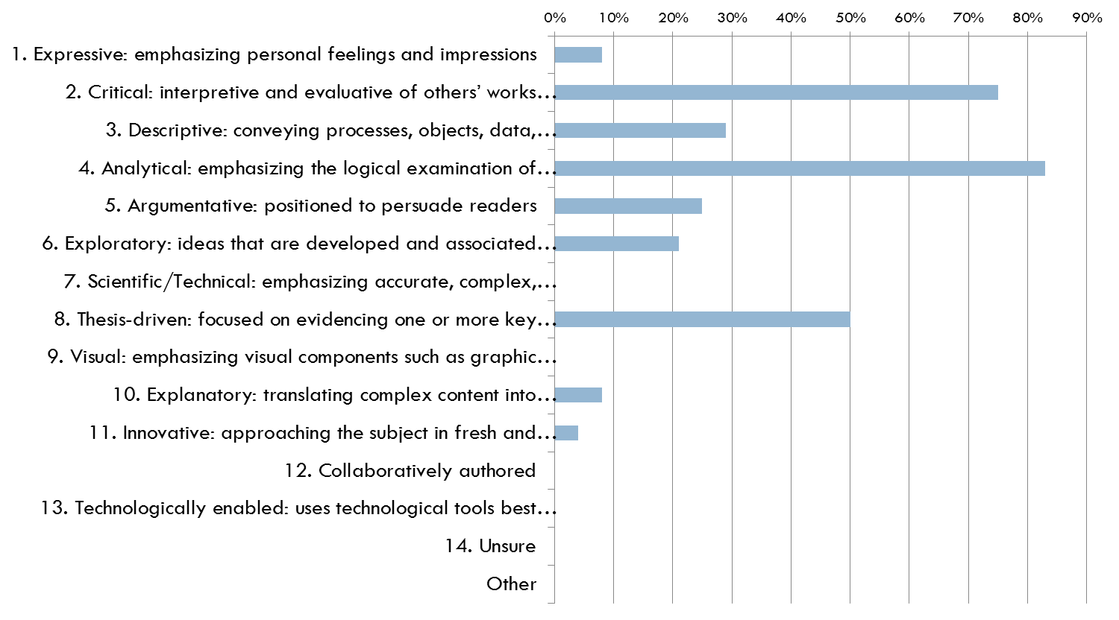

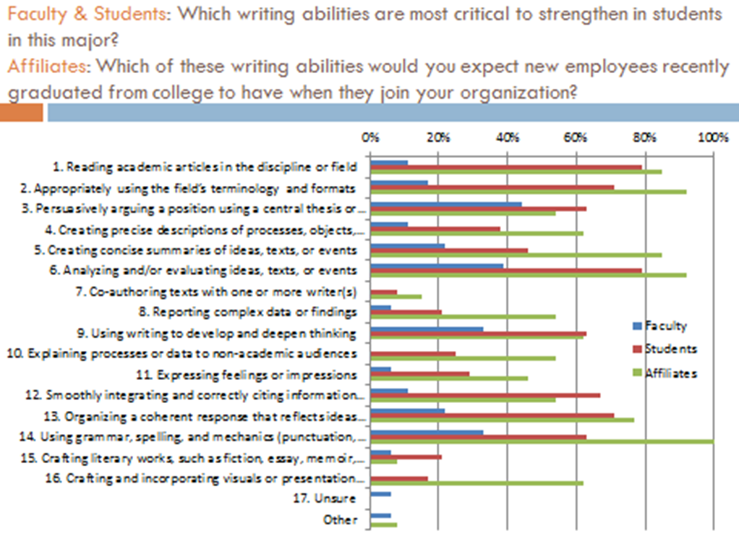

APPENDIX 2

Creating Measures to Evaluate Desired Writing Abilities:
Identifying Levels of Student Performance Necessary to Score Student Work

Desired Abilities | Action/Behavior/Criteria (ABCs) | Levels of Performance |  | Measures
 |  | High Performer | Low Performer (not acceptable)
1. Demonstrate awareness of historical and cultural contexts and knowledge of social and political audiences through the study of works. | Action (Bloom’s): Comprehension  Measurable Behavior: Awareness (through a study of works).  Possible Evaluation Criteria: 1) Historical/cultural contexts, 2) Knowledge of social/political audiences, 3) Through a study of works. | -Show awareness of correct dates, sequence of events and historical consequences.  -Demonstrate awareness of  different perceptions, believes, and literary vs. historical versions on socio-political and cultural events and principles within the same period.  -Ability to provide cultural comparison and contrasts with other historical/cultural/national contexts. | -Show lagoons in dates, sequence of events and confusion about what actually happened historically as distinct from fictionalized events or characters in a literary text. | -Essays, reaction or research papers.  -Sections on exam on cultural viewings.  -Discussion boards online or in class discussion.  -Oral presentations  -Wikis
2. Recognize and communicate with specific audiences taking into account different registers, style, tone, and terminology, vocabulary, using them appropriately for the intended audience. | Action (Bloom’s): Knowledge and Application  Measurable Behavior: 1) Ability to recognize, 2) Communication.  Possible Evaluation Criteria: 1) [Recognizing need for] different registers, style, tone and terminology, 2) [Communicating] them appropriately for the intended audience. | -Show original and personal (writing) style:  * Writing tailored to fit the topic and /or the audience (appropriate choice of words; show command of specialized jargon), sentence clarity, fluency or sophistication, formal vs. informal register, academic tone. | - Very weak style, poor choice of words, improper registers, colloquialisms, inquired use of specialize jargon and sentences are unclear | -In class debates or discussions  - Reaction papers  -Short essays  -Long essays  -Oral presentations  -Wikis
3.Recognize and practice informed and persuasive arguments, based on relevant, professional readings/research, and carefully chosen sources. | Action (Bloom’s): Synthesis  Measurable Behavior: Arguments (informed and persuasive)  Possible Evaluation Criteria: Based on relevant, professional readings/research, and carefully chosen sources. | -State argument clearly  -Expand argument in a cogent way, (additional premises)  -Substantiate argument with evidence in text/film  -Show pertinent knowledge of secondary literature (citation) | - No or inappropriate citation,  - Muddled argument  - Points presented out of order (or random order)  - No or inappropriate reference to the text. | -In class discussion  -Essays
4. Analyze ideas, texts, or events offering substantial information. Major points supported with relevant details/examples from a variety of fiction and non-fiction. | Action (Bloom’s): Analysis  Measurable Behavior: [Constructing] major points.  Possible Evaluation Criteria: 1) Supported with relevant details/examples, 3) From a variety of non-literary and literary texts. | -Show command of close reading of a text:  a) Identify and extract major ideas from a text  b) Support identified ideas through textual evidence | - Misidentify or fail to identify all major ideas  - No or inappropriate reference to the text | -Textual analysis  -Essays /papers
5. Use critical thinking: evaluate and synthesize ideas, texts, or events in both primary and secondary sources developing the ability to form independent literary judgments and support those ideas. | Action (Bloom’s): Analysis, Synthesis, Evaluation  Measurable Behavior: 1) Ability to form independent literary judgments, 2) Supporting those ideas.  Possible Evaluation Criteria: 1) Forming independent literary judgments 2) Supporting those judgments. | -Engage critically with primary or secondary sources: agree or disagree with idea/discuss limits etc.  -Place competing interpretations and dialog and when appropriate choose between them. | - Unaware of competing interpretations.  - Not engage. | -Textual analysis  -Essays/ papers
6. Organize a coherent narrative structure to flow logically from one point to the next. A coherent narrative must have an introduction that offers a forecasting statement that leads to an organizational framework; a body to develop the topic with effectively integrated examples/citations from works used; and a conclusion | Action (Bloom’s): Analysis  Measureable Behavior: A narrative structure  Possible Evaluation Criteria: 1) Flows logically from one point to the next, 2) Has intro that offers a forecasting statement leading to an organizational framework, 3) A body to develop the topic, 4) Effectively integrated examples/citations from works used, 5) A conclusion that reviews main points, restates thesis, and offers an effective ending. | -Delineate various parts of text (clear forecasting framework)  -Articulate forecasting statement well in introduction  - Use strong topic sentences that reflect the content and logical order of the thesis.  -See # 3 (Arguments)  -Transitions allow an easy flow between parts of paper  -avoidance of repetition  -Good conclusion that reviews main points, restates thesis, and offers an ending that goes beyond the summery | -Lack of forecasting stamens that does not lead any clear organizational statement (no organizational order) | Textual analysis  Essays/ research papers
7. Demonstrate competence in morphology, orthography, and syntax: |  | Agreement, gender, number, determinants, pronouns, nouns, adjectives, verbs, adverbs, prepositions, and conjunctions are almost always accurate, among other grammar components. | - Agreement, gender, number, determinants, pronouns, nouns, adjectives, verbs, adverbs, prepositions, and conjunctions are rarely accurate, among other grammar components.
8. Show awareness of genres |  | Identifying and referring correctly to official and non-official correspondence, diaries, compositions, proposals, abstracts, book reviews, papers, and/or works of creative writing. | -Inability to identifying and referring correctly to official and non-official correspondence, diaries, compositions, proposals, abstracts, book reviews, papers, and/or works of creative writing.
9. Demonstrate an ability to compile appropriately a bibliography (e.g., peer-reviewed) appropriate sources from primary and secondary literature, as well as non-literary works that are useful and contribute in comparison to other sources in the bibliography. |  | -Choose academic sources that illuminate an argument made in the assignment | -Lack of sources or use of inaccurate sources
10.Conform to MLA, APA bibliographic standards and conventions. |  | -Follow MLA APA guidelines | -Not Follow MLA APA guidelines
11. Follow academic honor code. |  | -Recognize and understand plagiarism in various forms and demonstrate knowledge and strategies for avoiding it. | -Not Recognize and understand plagiarism in various forms
* If you want to measure for command of genre in #8, an assessment needs to take place in an earlier level, for ex. FRE 3401.

During the AY 17-18, this rubric will be completed for Criteria 7 through 11, in terms of ABCs and Measures.
APPENDIX 3

Creating Measures to Evaluate Desired Writing Abilities:
Identifying Levels of Student Performance Necessary to Score Student Work

 | High Performer | Average Performer | Low Performer
Cultural Awareness: Demonstrates critical awareness of historical and cultural contexts and knowledge of social, political audiences by synthesizing and evaluating ideas, texts, and events. | - Student establishes awareness of contextual components (e.g., congruent historical, political contexts, correct dates, sequential events, accurate historical references) by explaining interconnections among them.  - Student draws insightful conclusions by. | - Student establishes awareness of contextual components (e.g., congruent historical, political contexts, correct dates, sequential events, accurate historical references), but makes limited or superficial connections among them.  - Student conclusions lack full development. | - Student show gaps in contextual components (e.g., incongruent historical, political contexts, incorrect dates, non-sequential events, mistakes in historical references) and make no connections among them and do not recognize competing interpretations.

Audience is word choice, context, drawing from the text in a way that others can follow without reading the text. It is vocabulary. It is to make yourself understood. It is all register. It is not the simple restating of the assignment question which reveals that the student is just trying to perform a task instead of thinking how an audience shapes their writing.

APPENDIX 4
ASSESSMENT OF WEC CRITERIA IMPLEMENTATION IN LLCL UPPER-DIVISION (4000-LEVEL) FRENCH/SPANISH COURSES.
Given the strong commonalities in curricular structure among all the modern language BA tracks, as relates to this particular learning outcome, and given that all FOL 3880 papers are written in English and not in lingua, we have chosen to assemble a data set that is comparable in size to the one for the Linguistics BA Outcome #3, and in which all three modern language tracks (French, Italian, Spanish) are represented.

AY 2015-2016:

Analysis of General Disciplinary Research Skills Across Language Programs (French, Spanish, Italian): For the 2015-2016 academic year, 15 representative final papers from FOL 3880 were analyzed. All 15 papers were written by students with a declared modern language (i.e. French, Italian, Spanish) major, and written on a topic relating to one of these literary and/or cultural arenas. These papers were discipline-specific research. Of these 15 final papers: 2 (or about 13%) were given a score of “Excellent/Clearly Exceeds Expectations,” with these papers clearly demonstrating accurate use and citation of relevant sources, and with all of the sources supporting the main thesis; 2 (or about 13%) were given a score of “Mostly Exceeds Expectations,” with most sources going to directly support the paper’s thesis, 5 (or about 33%) were given a score of “Meets Basic Expectations,” with a basically tenable thesis statement supported at a basic level by a less-varied range of resources; 4 (or about 27%) were given a score of “Below Expectations,” with these papers featuring a lack of sufficient and appropriate academic sources; and 2 (about 13%) were given a score of “Does not meet expectations” based on clear-cut plagiarism and/or errors in bibliographic reference and in-text source citation which made it impossible to assess the status or in-paper use of the source.

Analysis of Performance Targets for General Disciplinary Research Skills Across Language Programs (French, Spanish, Italian): As stated in our WEC proposal plan, we are committed as a department to make concrete steps towards helping our students demonstrate fundamental competency in writing – including the writing of a detailed, style-sheet-specific research paper in discipline. We feel strongly that this is a very challenging learning outcome. We also know, after thorough curricular analysis of our BA programs through the WEC assessment process, that our modern language majors do not have any practice writing full-length term papers before they reach FOL 3880, and we also know that true mastery of any type of writing, including research-focused writing, takes a good deal of time and practice. This has major programmatic implications, discussed in greater depth in the section below.

Analysis of Higher-Level Disciplinary Research Skills (Spanish): A representative sample of 15 papers, written for a 4000-level major course in Spanish were assessed for the breadth, appropriateness, accuracy, and detail of their discipline-specific research. Each paper received an overall assessment score: 2 papers (about 13%) was scored “Excellent,” 2 papers (about 13%) were scored “Mostly Exceeds Expectations,” 7 (about 46%) were scored “Meets Basic Expectations,” and 4 (about 27%) were scored “Below Expectations.” The department faculty agrees that they would like to see all student work meeting basic expectations, at a minimum.

Analysis of Higher-Level Disciplinary Research Skills (French): A representative sample of 10 papers, written for the French major capstone course (FRW 4933 “Object Culturel: la Cathédrale”) were assessed in the breadth, appropriateness, accuracy, and detail for their discipline-specific research. Each paper received an overall assessment score: 1 paper (10%) was scored “Excellent,” 2 papers (20%) were scored “Mostly Exceeds Expectations,” 4 (40%) were scored “Meets Basic Expectations,” and 3 (30%) were scored “Below Expectations.” The department faculty agrees that they would like to see all student work meeting basic expectations, at a minimum.

In order to derive more useful data for further analysis as we continue implementing our WEC curricular plan, two individual WEC writing criteria were explicitly referenced in this assessment process, as follows:

- Desired Ability #4: Analyze ideas, texts, or events offering substantial information drawn from relevant examples chosen by the student from the primary source under study. High performance on this trait is characterized by the ability to show command of the overall argument presented about a literary topic via close and persuasive reading of both the text under analysis and of other texts (either fiction or non-fiction) placed in dialogue with the text under analysis. Note: This work is performed in lingua (French, Spanish) on primary sources written in these languages.

- Desired Ability #5: Use critical thinking in order to evaluate and synthesize ideas, text, or events in both primary and secondary sources in service of forming well-grounded and independent literary judgments. High performance on this trait is characterized by the ability to engage critically with primary and secondary sources in order to be able to discern among them, choose which ones best support the argument being made, place them in meaningful dialogue with each other, and determine the relative benefits, drawbacks, limits (or etc.) of them. Note: This worked is performed in lingua (French, Spanish) on primary and secondary sources written in these languages.

ASSESSED COURSE: FRW 4933 (“L’Object Culturel: La Cathédrale): Each of the 10 papers written for this course were assessed on these traits.

- For Ability #4, 1 paper was scored “Excellent,” 3 papers were scored “Mostly Exceeds Expectations,” 5 papers were scored “Meets Basic Expectations,” and 1 paper was scored “Below Expectations.” The course professor explicitly implemented these WEC writing criteria from the beginning of the Spring 2016 term, and that this clear focus on the criteria seems to have led to much stronger student writing results when it comes to primary sources use and citation.
- For Ability #5, 1 paper was scored “Excellent,” 2 papers were scored “Mostly Exceeds Expectations,” 4 papers were scored “Below Expectations.” This particular writing trait is much harder for students to master, as it asks them to be able to interpret and evaluate sources of varying types and functions (primary/secondary, fiction/non-fiction, etc.) This is the type of writing trait which we need to provide strong scaffolding for all the way through the curriculum – beginning in an initial research course such as FOL 3880, and continuing on all the way up through the curriculum.

ASSESSED COURSE: SPW 4930 (“Don Quixote in Pop Culture”): Each of the 15 papers written for this course were assessed on these traits.

- For Ability #4, 2 paper was scored “Excellent,” 2 papers were scored “Mostly Exceeds Expectations,” 8 papers were scored “Meets Basic Expectations,” and 3 paper was scored “Below Expectations.” The course professor explicitly implemented these WEC writing criteria from the beginning of the Spring 2016 term, and that this clear focus on the criteria seems to have led to much stronger student writing results when it comes to primary sources use and citation.

- For Ability #5, 1 paper was scored “Excellent,” 2 papers were scored “Mostly Exceeds Expectations,” 4 papers were scored “Meets Basic Expectations,” and 3 papers were scored “Below Expectations.” This particular writing trait is much harder for students to master, as it asks them to be able to interpret and evaluate sources of varying types and functions (primary/secondary, fiction/non-fiction, etc.) This is the type of writing trait which we need to provide strong scaffolding for all the way through the curriculum – beginning in an initial research course such as FOL 3880, and continuing on all the way up through the curriculum. The implementation of a clearer sequence for our students is therefore necessary. A few additional writing-focused courses at the upper-division are being considered.

AY 2016-2017:
Since it appeared very clearly in the assessment from AY 2015-2016 that the explicit implementation of the WEC writing criteria resulted in much stronger student performance and writing results, the professors continue to dedicate more time explaining the importance of all this criteria to students at the beginning of the term and pursued the development of a departmental culture around them.

In order to compare with the AY 2015-2016 data more effectively, the course chosen for this assessment were the same, FRW 4933 and SPW 4930, both offered in the Spring term of 2017.

As a result, the criteria were used directly as a grading rubric for the students to follow and receive as part of their evaluation. Criteria #10 and #11 (from Appendix 2) were merged into one single number (#10) in order to simply the calculus and grant 10 points to the 10 criteria, as in the following example (student’s name has been changed):

FRW 4933 – SENIOR SEMINAR – FINAL PAPER ASSESSMENT (WEC CRITERIA)

STUDENT’S NAME: ______Larimer, Joseph_____________ GRADE: _94__/100

1. Demonstrate awareness of historical and cultural contexts and knowledge of social and political audiences through the study of works.
__10_/10

2. Recognize and communicate with specific audiences taking into account different registers, style, tone, and terminology, vocabulary, using them appropriately for the intended audience.
_10__/10

3. Recognize and practice informed and persuasive arguments, based on relevant, professional readings/research, and carefully chosen sources. One source quotation did not seem to add much to the existing argument of the author and sounded more like a summary of the plot.
__9___/10

4. Analyze ideas, texts, or events offering substantial information. Major points supported with relevant details/examples from a variety of fiction and non-fiction.
__10__/10

5. Use critical thinking: evaluate and synthesize ideas, texts, or events in both primary and secondary sources developing the ability to form independent literary judgments and support those ideas. You seem to stick to the pre-existing critical thinking and should be more daring in generating your own.
__8__/10

6. Organize a coherent narrative structure to flow logically from one point to the next. A coherent narrative must have an introduction that offers a forecasting statement that leads to an organizational framework; a body to develop the topic with effectively integrated examples/citations from works used; and a conclusion.
___10_/10

7. Demonstrate competence in morphology, orthography, and syntax: Some problems with expressions that could be improved. You need to pay attention to the punctuation particularly. Avoid the somewhat colloquial formulas and the use of the “nous” form to convene your argument.
___7__/10

8. Show awareness of genres
_10___/10

9. Demonstrate an ability to compile appropriately a bibliography (e.g., peer-reviewed) appropriate sources from primary and secondary literature, as well as non-literary works that are useful and contribute in comparison to other sources in the bibliography.
__10__/10

10. Respect MLA Style and follows Academic Honor Code.

__10__/10
As this system was used early on in the semester, the culture of the WEC criteria in these two courses was diffused very rapidly.

ASSESSED COURSE: FRW 4933 (“L’Objet Culturel: La Carte de Paris”): Since the professor was a participant in the WAC Faculty Seminar at the beginning of the Spring 2017 term, he was able to assess the 10 students’ performance on assignments particularly designed for an evaluation according to the WEC/LLCL criteria.

- On Criteria #1, all assessed papers received a score of “Excellent” (9-10).
- On Criteria #2, all assessed papers received a score of “Excellent” (9-10).
- On Criteria #3, all assessed papers received a score of “Excellent” (9-10).
- On Criteria #4, 80% of the papers received a score of “Excellent” (9-10), and 20% received a score of “Satisfactory” (7-8).
- On Criteria #5, 50% of the papers received a score of “Excellent” (9-10), and 50% received a score of “Satisfactory” (7-8).
- On Criteria #6, 40% of the papers received a score of “Excellent” (9-10), 40% received a score of “Satisfactory” (7-8), and 20% received a score of “Acceptable” (5-6).
- On Criteria #7, 60% of the papers received a score of “Excellent” (9-10), 40% received a score of “Satisfactory” (7-8).
- On Criteria #8, all assessed papers received a score of “Excellent” (9-10).
- On Criteria #9, 80% of the papers received a score of “Excellent” (9-10), 20% received a score of “Satisfactory” (7-8).
- On Criteria #10, 20% of the papers received a score of “Excellent” (9-10), 40% received a score of “Satisfactory” (7-8), and 40% received a score of “Acceptable” (5-6).

Data Interpretation:
These results reflect a highly effective implementation of the WEC criteria. However, it also shows that students have focused their excellence primarily on criteria #1, #2, #3. We observe a greater division in the students’ performance in Criteria #5, when there is a clear division between students who understand that critical thinking should come from them instead of a quoted source, and those who find refuge behind pre-existing critical thinking that they adopt and somewhat reinforce in their arguments. Criteria #10 reflect the lack of respect of MLA Convention Style. 2 students came to this class without having taken FOL 3880: one did not perform well in this pre-requisite, the other was an international student.

ASSESSED COURSE: SPW 493) (“Almodóvar”): Since the professor was a participant in the WAC Faculty Seminar at the beginning of the Spring 2017 term, he was able to assess the 10 students’ performance on in-class assignments particularly designed for an evaluation according to the WEC/LLCL criteria. Since this course was a film class and the assignments (sequence analysis and micro-themes) were consequently shorter and more numerous, the criteria were reduced to a list of 6 that synthesized. Criteria #1 was Cultural and Critical Awareness and worth 20% of the grade. Criteria #2 was Vocabulary and Expression and worth 10% of the grade. Criteria #3 was Analysis and Persuasiveness and worth 20% of the grade. Criteria #4 was Narrative Coherence and worth 20% of the grade. Criteria #5 was Form and Style and worth 10% of the grade. Criteria #6 was MLA Style Convention and Ethics and worth 20% of the grade.

- On Criteria #1, 80% of the papers received a score of “Excellent” (9-10), and 20% received a score of “Satisfactory” (7-8).
- On Criteria #2, 40% of the papers received a score of “Excellent” (9-10), 40% received a score of “Satisfactory” (7-8), and 20% received a score of “Acceptable” (5-6).
- On Criteria #3, 50% of the papers received a score of “Excellent” (9-10), and 50% received a score of “Satisfactory” (7-8).
- On Criteria #4, 20% of the papers received a score of “Excellent” (9-10), 40% received a score of “Satisfactory” (7-8), and 40% received a score of “Acceptable” (5-6).
- On Criteria #5, 50% of the papers received a score of “Excellent” (9-10), 30% received a score of “Satisfactory” (7-8), and 20% received a score of “Acceptable” (5-6).
- On Criteria #6, 20% of the papers received a score of “Excellent” (9-10), 40% received a score of “Satisfactory” (7-8), and 40% received a score of “Acceptable” (5-6).
This assessment reflects a much weaker respect for Narrative Coherence and MLA Style Convention/Ethics. Again these papers were written under the pressure of time as take-home essays. Although unrelated conceptually, it underlines students’ primary focus on Cultural and Critical Awareness at the detriment of other parameters.

ASSESSMENT SUMMARY: The implementation of the WEC Criteria has most definitely contributed to the improvement of students’ writing at the upper level in French and Spanish courses. In order to strengthen the sequence of courses that lead them to these upper-division classes, faculty in LLCL is coming up with a few strategies to transform our current FOL 3880 into a more literature-oriented course. The discussion is currently ongoing in the department and proposals will be reviewed during Ay 2017-2018. In any case, FOL 3880 would no longer be the primary focus of the WEC program because a single course in the curriculum for writing can become a bottleneck and a difficult one to staff over time.

BENCHMARKS: Future assessment will need to show what numbers have changed from previous to current ratings. Benchmarks could be very helpful because the department can set goals based on previous year’s performance and changes made in the curriculum.
The LLCL faculty will discuss setting goals for these outcomes. Some of the questions that needs to be asked are: what percentage for each level would we like to see next year for each level of each criterion assessed? After AY 17-18, we will be able to determine if the department met or exceeded those goals. And if not, we will interpret the assessment consequently and take the necessary measures we judge adequate as a faculty. This process can lead to more explicit change.

APPENDIX 5: RE-THINKING FOL 3880 AND PROPOSING A WRITING-ENRICHED LLCL INTRODUCTORY COURSE FOR UPPER-LEVEL.

Stories you know (or not?)
Thinking Critically about Literary and Cultural Production

Description of course
This course is designed to offer students the basic tools that are needed for them to be(come) critical readers of cultural and literary production. It aims to teach them strategies and inquiry postures necessary to approach, analyze and decode a text: oral and written texts, films, postcards, paintings, songs, and comics will be analyzed in order to decipher their (hidden) meanings and messages. Because the course will not be limited to “high art” productions, it will invite students to reflect on the distinctions usually drawn between “high and low culture,” in order to ultimately subvert them. It will also invite students to examine ideologies at work in cultural production as it looks at social, economic, historical, and/or political conditions in which works are produced, to which they respond, and with which they dialogue.
Because of the broadness of the field of cultural and literary criticism, this course will analyze works mainly drawn from the Western cultural tradition. It will be structured around sections: each section will explore an issue related to (the construction of) cultural identity—such as gender, social class, sexuality, nationality, race etc. Readings and in-class discussions will explore various interpretations of the same text in order to explain how and why (groups of) readers with different value systems might receive, understand, or evaluate the same text in various ways.
Finally, this course is designed to help students acquire the basic tools for research and bibliographic methods as each module will focus on one skill that is necessary to writing a good research essay. Course taught in English.

Objectives of course
This course is designed to meet the following objectives:
- Introduce students to the basic tools and methods to critically read cultural and literary production.
- Introduce students to various the basic theories of cultural and literary criticism.
- Introduce students to a variety of European cultural products from various centuries.
- Help students build and improve their critical thinking skills.
- Help students build and improve their research and writing skills.

Module 1. Good and evil in literature. Building a bibliography.
Session 1 | Homework due for this session
Iznogoud is up to nothing good: Axiology and the (hidden) architecture of a literary work’s value system. Looking at the imagery of good and bad characters. Narrative and point of view etc. | Read: Iznogoud. I want to be Caliph Instead of the Caliph by René Goscinny and Tabari
Session 2
Discussion of the film and the reading.  Analysis of the various characters in light of previous discussion  Finding Critical Essays: searching the library catalogue and databases | Watch: Disney’s Aladin  Read: Felperin, Leslie “The Thief of Buena Vista: Disney's Aladdin and Orientalism” in A Reader in Animation Studies.Pilling, Jayne (ed. and introd.) Sydney, Australia: Libbey; 1997 p. 137-142.
Session 3
Class meets at the library  Creating a bibliography, finding books and articles. Identifying relevant articles for research. | Read The Arabian Nights (1/2 of excerpts)
Session 4
Discussion of Readings. Storytelling and Power, the Power of Storytelling.  Creating an annotated bibliography: summarizing and citing reference | Finish reading excerpts of The Arabian Nights  Iznogoud and the Thousand and One Nights  By: Marzolph, Ulrich; Francofonia: Studi e Ricerche Sulle Letterature di Lingua Francese, 2015 Autumn; 35 (69): 261-285
Session 5
Finish discussion of Readings: storytelling and subversion  Protocole of citation: MLA | Assignment: Create and submit a short annotated bibliography on a topic indicated by your instructor. Your bibliography must include a book chapter and at least one article.

Module 2. A puppet is not only a puppet. Writing an introduction.
Session 1 | Homework for next session
Introduction to the module: What lays beyond one of the most beloved icons of popular culture?  The historical origins of the wooden puppet.  Pinocchio and New-Born Italy | Watch: Walt Disney’s Pinocchio (1940)  Read: Amy Boylan, “Carving a national identity: Collodi, Pinocchio, and post-unification Italy”  Pinocchio, Chapters 1-4 (creation)  (http://www.gutenberg.org/files/500/500-h/500-h.htm or Rebecca West’s “The Persistent Puppet” web-site.
Session 2
The hidden Pinocchio: Pinocchio and archetypes  Writing skill: introductory paragraph and thesis statement.  Individuate the thesis statement of the articles you read. | Read: Rebecca West, “The Persistent Puppet: Pinocchio's Heirs in Contemporary Fiction and Film”. Website (http://fathom.lib.uchicago.edu/2/72810000/)  Rossana Dedola, “Pinocchio between symbols and archetypes” (Pinocchio and Its Adaptations, pp.16-20)  David Del Principe, “Pinocchio and the gothic” (Pinocchio and Its Adaptations, pp. 21-27  Pinocchio, Chapters 14-17 (hanging)
Session 3
The hidden Pinocchio: Pinocchio and Psychoanalysis  Individuate the thesis statement of the articles you read. Class discussion on what makes a good introduction and thesis statement. | Mark West, “Pinocchio’s Journey from the Pleasure Principle to the Reality Principle”, Psychoanalytic Responses to Children Literature. Lucy Rollin, Mark West. London: McFarland, 1999. 65-70  Pinocchio, Chapters 21-22 (Melampo)
Session 4
The hidden Pinocchio: women and blue fairies  Individuate the thesis statement of the articles you read. | Read: Cristina Mazzoni, “The Short-Legged Fairy: reading and Teaching Pinocchio as a Feminist” (“Pinocchio and Its Adaptations, pp. 80-86).  Pinocchio, Chapters 35-36 (ending)
Session 5
The hidden Pinocchio: Aesopian animals | Read: Nancy Canepa, “Talking with Animals: Pinocchio and Dialogicity” (Pinocchio and Its Adaptations, 87-94)  Final assignment for this module: On the topic: “What Pinocchio does not say” write an opening paragraph with thesis statement of a possible essay, where you highlight the surprising aspects of a seemingly innocuous popular culture icon.

Module 3. The Beautiful and the Monstrous: Organizing your ideas in a coherent outline.
Session 1 | Homework for next session
Introduction to the module: The arbitrariness of Beauty, the need for Monstrosity.  Building a detailed outline of one of the arguments of a thesis statement related to primary material and provided by instructor. | Watch: Disney’s Beauty and the Beast (1991)  Read: Notre Dame de Paris, Victor Hugo (Selected passages)  Search 5 contemporary comparables of the archetypal stories listed above.

Session 2
Marginality and Deconstruction: the Monstrous Figure marks “our” Limit.  Theories of Otherness, an Introduction.  Students will 1)look at an argument developed in secondary literature and define its structure and 2) examine the structure of the argument in order to identify its various components (ideas, theory, supporting evidence in the text) | Watch: Disney’s Hunchback of Notre Dame (1996)  Read: Notre Dame de Paris, Victor Hugo (Selected passages, first part)  Read article: Jeffrey Spires’ ‘Victor Hugo's Notre-Dame de Paris: The Politics and Poetics of Transition’ (2002).

Session 3
The dissection of speech: Ideologies and Discourses  Students will identify the outline of an article assigned for reading by professor. In turn, they will identify ideas related to an argument provided by the instructor. | Watch: Cyrano de Bergerac (1990)  Read: Notre Dame de Paris, Victor Hugo (Selected passages, second part)

Session 4
Recycling the Beautiful and the Monstrous in Post-Modern Literature and Film  After organizing their ideas in a coherent progression, student will build an outline for a body paragraph that includes detailed evidential support (organizational structure provided by professor) | Read: Notre Dame de Paris, Victor Hugo (Selected passages, third part)  Consult Canvas for Narrative Structure guidelines.

Session 5
Final Conclusions  Student’s short presentations of their outline | Watch: Maleficient (2014)  Final Assignment: Organize a coherent narrative structure to flow logically from one point to the next. A coherent structure must comprise several ideas developing the main argument and supported by evidence drawn from the primary reading.

