Dr. Kevin Lanning
Dr. Kanybek Nur-tegin
Fall 2015
EXP 4631 – Honors Thinking and Decision Making/
ECO 4932 – Honors Behavioral Economics
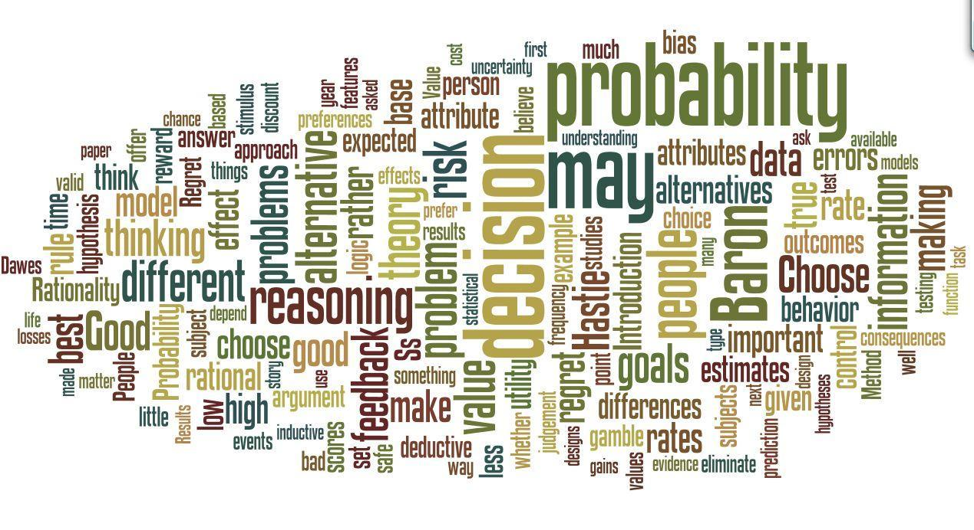
Introduction
The study of thinking and decision making is central in the liberal arts, for it lies at the nexus of the two major approaches to understanding the world, reason and empiricism. Within economics, the topic has recently been articulated as the subdiscipline of Behavioral Economics. The sources we will consider this term derive from both psychology and economics and have relevance to public policy as well. The leading figures in the field include Daniel Kahneman, a psychologist, who was awarded the Nobel Prize in Economics in 2002.
In this course, we will consider both normative models of how we should reason and empirical studies of how we in fact think and decide. Much of the research has been on seeming discrepancies between normative models and empirical data. These discrepancies call into question a central premise in both psychology (that behavior is largely functional) and economics (that people are rational decision makers).
The study of thinking and decision making has practical as well as academic significance. In this course, by understanding normative models and human shortfalls, you are likely to learn to reason better, and to make better decisions in your own personal life and career (Lilienfeld, Ammirati, & Landfield, 2009; Nisbett, Fong, Lehman, & Cheng, 1987). This is not a trivial thing.

Prerequisites and meeting time
Ideally, students should have taken one or more courses in psychology, economics, and/or statistics. The course meets MW 12:30-1:50 PM in WB 105 on the Jupiter campus.
Instructor
Dr. Kevin Lanning (lanning@fau.edu). Office is WB 220; hours are M 2-4 and Tues 12-4 & by appointment.
Dr. Kanybek Nur-tegin (knurtegi@fau.edu). Office is HA 123; hours are MW 11-12 pm & 3:30-4:30 pm and by appointment.
Texts
Angner, E. (2012). A course in behavioral economics. Palgrave. (required)
Hastie, R. & Dawes, R. M. (2010). Rational choice in an uncertain world, 2nd Ed. Thousand Oaks: Sage (required)
Baron, J. (2008). Thinking and deciding (4th ed.). NY: Cambridge UP. (recommended; 3rd Ed ok)
Thaler, R. (2015). Misbehaving: The Making of Behavioral Economics. W.W. Norton & Company. (recommended)
In addition, a number of research articles will be assigned and available on MyFAU, and students will be expected to read part or all of one or more trade paperbacks as described in the next section.
Grading & assignments
Grades in this class will be based on exams (20% midterm, 30% final), a term paper and presentation (30%), and class participation (20%). Attendance is a necessary but not sufficient component of class participation; informed questions, comments, and contributions to class discussion are needed as well.
The term paper will be a review of part or all of a recent popular book in behavioral economics and related disciplines. These include Nudge: Improving Decisions About Health, Wealth, and Happiness (Thaler & Sunstein), Thinking Fast and Slow (Kahneman), Scarcity: Why Having Too Little Means So Much (Mullainathan & Shafir), and Predictably Irrational: The Hidden Forces That Shape Our Decisions (Ariely). The presentations will be done in groups, with each of ~7 students contributing one key idea from the book in five to ten minutes. Specifics on the structure of the exams and term paper/project will be given at a later date.
Other
In order to enhance and maintain a productive atmosphere for education, personal communication devices, such as cell phones, are to be disabled in class sessions. Laptops and tablets should be used only for appropriate purposes.
POLICY ON ACCOMMODATIONS: In compliance with the Americans with Disabilities Act (ADA), students who require reasonable accommodations to properly execute coursework must register with Student Accessibility Services (SAS) -- in Boca Raton, SU 131(561-297-3880); in Davie, LA 131 (954-236-1222); in Jupiter and all Northern Campuses, SR 111F (561-799-8585) – and follow all SAS procedures.
Students at Florida Atlantic University are expected to maintain the highest ethical standards. Academic dishonesty is considered a serious breach of these ethical standards, because it interferes with the university mission to provide a high quality education in which no student enjoys an unfair advantage over any other. Academic dishonesty is also destructive of the university community, which is grounded in a system of mutual trust and places high value on personal integrity and individual responsibility. Harsh penalties are associated with academic dishonesty. In enrolling in this course, students agree to abide by the Honor Code of the College, whose full text may be found at http://www.fau.edu/divdept/honcol/academics_honor_code.htm, and by the FAU Code of Academic Integrity, whose full text can be found at http://www.fau.edu/regulations/chapter4/4.001_Code_of_Academic_Integrity.pdf.
All dates are subject to change. It is probable that we'll tinker with specific assignments as we go along.
In enrolling in this course, students agree to abide by the Honor Code of the college, whose full text can be found at http://www.fau.edu/divdept/honcol/academics_honor_code.htm.
Mtg | Date | Topic | Required reading | Additional references
Part I: Introduction
1 | 8/17 | Decision pretest; Introduction and methods |  | (Nisbett, 1987; Thaler 1)
2 | 8/19 | Thinking, deciding, and understanding | Hastie 1.1 - 1.4 | Baron 1
3 | 8/24 | Descriptive, normative, and prescriptive approaches | Angner 1 | Baron 2
4 | 8/26 | Decisions and expected utility | Hastie 2.1 - 2.4  Angner 6
5 | 8/31 | Expected utility and rationality | Hastie 1.5-1.6  Angner 3.1-3.2 | Baron 3
6 | 9/2 | Sunk costs | Hastie 2.5-2.6  Angner 3.3 | Baron 12  (Arkes, 1999)  (Boettcher 2009)

Part II: Two types of reasoning
7 | 9/9 | Deductive logic | Angner 2.1-2.4 | Baron 4
8 | 9/14 | Deduction vs. induction | (Rips, 2001)  (Osherson, 1998)
9 | 9/16 | Probability | Hastie Appendix  Angner 4.1-4.4 | Baron 5
10 | 9/21 | Probability continued / Bayes Theorem | Hastie 8  Angner 4.5-4.7

Part III: Heuristics and biases
11 | 9/23 | Anchoring and adjustment | Hastie 4
12 | 9/28 | Availability and representativeness | Hastie 5  Angner 5  (Tversky, 1974) | Baron 6
13 | 9/30 | Scenario based reasoning, conjunction effect, probability matching and hindsight | Hastie 6  Angner 5 (continued)
14 | 10/5 | Randomness, causation, regression to the mean, & illusory correlation | Hastie 7  (Gilovich, 1985)  (Redelmeier, 1996) | Baron 8
15 | 10/7 | Exam

Part IV: Behavioral economics
16 | 10/12 | Analytical Game Theory | Angner 10
17 | 10/14 | Analytical Game Theory (continued) | Angner 10
18 | 10/19 | Behavioral Game Theory | Angner 11
19 | 10/21 | Behavioral Game Theory (continued) | Angner 11

Part V: Applications
20 | 10/26 | Cooperation and competition | (Dawes, 1988) | Baron 18  (Hardin, 1968)  (Hardin, 1988)
21 | 10/28 | The ultimatum game | (Thaler, 1988)  (Camerer 1995)  (Osumi, 2010) | Baron 17
22 | 11/2 | Additional variants of the ultimatum game | (continued)
23 | 11/4 | Evaluating choices  Happiness, value | Hastie 9
24 | 11/9 | Prospect theory, framing effects | Angner 7  Hastie 12  (Kahneman, 1991) | Thaler 2-4  Baron 11  (Kahneman, 2003)
25 | 11/16 | Temporal aspects (discounting, affective forecasting) | (Loewenstein, 1989) | Angner 8 and 9 Baron 19  (Morewedge, 2005)
26 | 11/18 | Student presentations I
27 | 11/23 | Student presentations II (
28 | 11/25 | Student presentations III (Public policy, Finance)
29 | 11/30 | Choice strategies, review | Hastie 10, 14 | Baron 9
30 | 12/4 | Final exam 10:30 am – 1:00 pm

