Department of Exceptional Student Education
College of Education
Florida Atlantic University

Instructor:
Office:
Phone:
E-mail:
Office Hours:
Class Day/Time:

Insert instructor picture here:

Course Number: SLS 1200

Course Title: Increasing Personal Effectiveness

Catalog Description:

This course reviews key strategies for personal growth, analyzes personal strengths and weaknesses, identifies personal goals and motivates the participant towards those goals.

INSTRUCTOR’s INTRODUCTION TO THE COURSE:

Students will explore their unique abilities and interests. That information will be used to develop life goals regarding community, vocational and personal aspects of life. Students will also learn how to run their upcoming person-centered planning meeting.

PREREQUISITE or CO-REQUISITES:

Co-requisites for this class are: SLS 1304 and SLS 1570
Note: This class may be repeated to ensure mastery of the skills presented in the course objectives. If class is repeated, the co-requisite classes do not need to be repeated.

REQUIRED TEXTS or MATERIALS:

All materials will be provided by instructor in class or on Blackboard. Materials will be provided in multiple formats as appropriate.

TECHNOLOGY:

E-mail: Your FAU email address will be used.

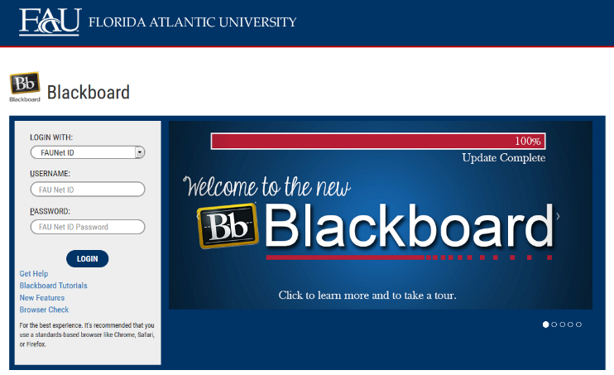
Computer: This course will be web assisted through FAU Blackboard site. Some handouts, forms, handbook and resources may be available on the website. Go to the website: http://blackboard.fau.edu (Do not type www).

COURSE OBJECTIVES:

Upon completion of this course, the successful student will demonstrate:

- An understanding of self-determination.
- The ability to identify personal strengths and weaknesses.
- The ability to determine preferred living options.
- Communicating personal life goals with friends, family, and professionals.

Content Outline:

COURSE REQUIREMENTS:
This course has a MASTERY ASSIGNMENT. You will be required to pass this assignment with 85% score to meet the Mastery Assignment requirement. More information about Mastery Assignments can be found in the Student Handbook.

The Mastery Assignment for this course is:

- Personal Portfolio
Students will demonstrate their ability to develop and create a personal portfolio that describes their individual aspirations in the following areas.

- Dreams
- Strengths
- Housing Preferences
- Career Options
- Leisure Activities
- Community Involvement
- Circle of Support

2) In-class and Homework Assignments
Students are expected to attend and fully participate in class. Each class session will have either an in-class or homework assignment that will allow them to practice the skills presented in class. Students are responsible for completing the assignments within the given time frame stated by the instructor.

3) Life Plan Presentation
Students will practice presenting their life plan to their instructor and classmates. The presentation will run in a similar fashion to the upcoming person-centered planning meeting.

ASSESSMENT PROCEDURES:

Assignment | Possible
In-class and Homework Assignments | 28
Personal Portfolio (Master Assignment) | 42
Life Plan Presentation | 30
TOTAL | 100

GRADING (FAU GRADING SCALE):
Activity scores are cumulative and the grade scale represents percentage of total points earned.
A = 93-100 A- = 90-92 B+= 87-89 B = 83-86
B- = 80-82 C+= 77-79 C = 73-76 C-= 70-72
D+= 67-69 D = 63-66 D-= 60-62 F = Below 60

POLICIES AND PROCEDURES:

ATTENDANCE:
According to University policy, “Students are expected to attend all of their scheduled University Classes and to satisfy all academic objectives as outlined by the instructor.” Attendance includes meaningful, active involvement in all class sessions, class discussions, and class activities as well as professional, ethical, conduct in class. Reasonable accommodations are made for religious observances.

STUDENTS WITH DISABILITIES:
In compliance with the Americans with Disabilities Act (ADA) and FAU policy, students with disabilities who require special accommodations to properly execute course work must register with the Office for Students with Disabilities (OSD) and provide the instructor of this course with a letter from OSD which indicates the reasonable accommodations that would be appropriate for this course. OSD offices are located on Boca, Davie and Jupiter campuses. Information regarding OSD services and locations can be found on the FAU website.

CODE OF INTEGRITY:
Students at Florida Atlantic University are expected to maintain the highest ethical standards. Academic dishonesty, including cheating and plagiarism, is considered a serious breach of these ethical standards, because it interferes with the University mission to provide a high quality education in which no student enjoys an unfair advantage over any other. Academic dishonesty is also destructive of the University community, which is grounded in a system of mutual trust and places high value on personal integrity and individual responsibility. Harsh penalties are associated with academic dishonesty. For more information, see http://www.fau.edu/regulations/chapter4/4.001_Code_of_Academic_Integrity.pdf

BIBLIOGRAPHY

Barkley, J., & Cobb, J. (2001). Full life ahead: A workbook and guide to adult life for students and family of students with disabilities. Montgomery, AL: Auburn University.

Grigal M., & Hart D. (2010). Think College: Postsecondary Education Options for Students with Intellectual Disabilities. Baltimore, MD: Paul H. Brookes Publishing.

Falvey M., Forest M., Pearpoint J., & Rosenberg R. (2000). All My Life’s A Circle Using the Tools: Circles, Maps and Paths. Toronto, Canada: Inclusion Press.

Flexer R., Baer R., Luft P., & Simmons, T. (2013). Transition Planning for Secondary Students with Disabilities, Fourth Edition. Boston, MA: Pearson.

Pearpoint J., Obrien J., & Forest M. (1998). PATH: A Workbook for Planning Positive, Possible Futures. Toronto, Canada: Inclusion Press.

Test D., Aspel N., & Everson J. (2006). Transition Methods for Youth with Disabilities. Columbus, OH: Pearson.

Van Reusen K., Bos C., Schumaker J, & Deshler D. (2007). The Self-Advocacy Strategy for Enhancing Student Motivation and Self-Determination. Lawrence, KS: Edge Enterprises.

Wehmeyer, M. (2007). Promoting Self-Determination in Students with Developmental Disabilities. New York, NY: The Guilford Press.

SLS 1200 Spring, 2016
COURSE SCHEDULE

SESSION | Week of | TOPICS | ASSIGNMENTS
1 | 1/11 | How is college different from high school?  What is self-determination? | Collect class materials and organize them.  Hmwk: read page 59
2 | 1/18 | What are my dreams & nightmares? | Word list of dreams & nightmares
3 | 1/25 | What are my strengths & weaknesses? | Word list of strengths and weaknesses
4 | 2/1 | Where will I live?  Who will live with me? | A list of living options  Hmwk: read page 83
5 | 2/8 | Why do I need money?  How will I make money? | A list of jobs they might like  Hmwk: read page 67
6 | 2/15 | What will I do with my leisure time? | A list of the things they like to do  Hmwk: read page 77
7 | 2/22 | How will I contribute to my community? | A list of ways to volunteer  Hmwk: read page 77
8 | 2/29 | Who will help me?  How will they help me? | List of family and friends
9 | 3/7 | Spring Break – No Classes
10 | 3/14 | What will I be doing in a few years from now?  What are the first steps? | Review your choices for portfolio building  Hmwk: read page 51
11 | 3/21 | Project Week – individual meeting  Students are to meet with peer mentors to work on Personal Portfolios. | Meet with peer mentor for review
12 | 3/28 | Is my plan ready? | Personal Portfolio  Due by 4/1  Hmwk: read page 121
13 | 4/4 | How will MY conference look? | Prepare 1-pager for conference
14 | 4/11 | How I act at my conference | Dress rehearsal for presentation: wear your presentation clothes
15 | 4/18 | Am I ready? | Life Plan Presentations
16 | 4/25 | Am I ready? | Life Plan Presentations

Page references are part of:
Barkley, J., & Cobb, J. (2001). Full life ahead: A workbook and guide to adult life for students and family of students with disabilities. Montgomery, AL: Auburn University.

SLS 1200

SCORING RUBRIC FOR
Personal Portfolio: SLS 1200

Increasing Personal Effectiveness

Name:
Date: Instructor: Carey
Overall Rating / Points Earned: /42

Project Component | Exceeds Expectations | Meets Expectations | Does Not Meet Expectations
Dreams / Nightmares
___ /3
Strengths / Weaknesses
___ /3
Housing Options
___ /3
Career Interests
___ /3
Recreational Time
___ /3
Community Contribution
___ /3
Circle of Support
___ /3

SLS 1200

SCORING RUBRIC FOR
Life Plan Presentation: SLA 1200

Increasing Personal Effectiveness

Name:
Date: Instructor: Carey
Overall Rating / Points Earned: /30

Project Component | Exceeds Expectations | Meets Expectations | Does Not Meet Expectations
Clearly Communicates Ideas

___ /20
Displays Interest &Enthusiasm

___ /10

