Department of Exceptional Student Education
College of Education
Florida Atlantic University
Instructor:
Office:
Phone:
E-mail:
Office Hours:
Class Day/Time:

Insert instructor picture here:

COURSE NUMBER: SLS 1571

2 credits

COURSE TITLE: Learning with Technology 2

CATALOG DESCRIPTION:
Students will continue to develop technology skills that support their academic, social, and employment activities. The central focus of this course is to develop skills using mobile technology, including cellphones and tablets especially on the job.

INSTRUCTOR INTRODUCTION TO THE COURSE:
In the first course called Learning and Technology, students learned the basics for using all types of tech tools that are part of being in college. Students learned how to use Blackboard, and the library. They also learned important compute skills to help them get their classwork done. In this class students will learn more complex skills that will help them take their learning anywhere. Students will learn how to use video to improve their work skills and other mobile technology supports.
PREREQUISITE or COREQUISITE:
No pre- or co-requisite
REQUIRED TEXTS or MATERIALS:
Students will be required to use a “2-in-1” tablet/laptop for this course. Information on 2-in-1 tablet/laptops can be obtained by contacting the instructor. All written materials will be provided by instructor in class or on Blackboard. Materials will be provided in multiple formats as appropriate. Please refer to the course schedule for reading and materials.
TECHNOLOGY:

E-mail: Your FAU email address will be used.

Computer: This course will be web assisted through FAU Blackboard site. Some handouts, forms, handbook and resources may be available on the website. Go to the website: http://blackboard.fau.edu (Do not type www).

VIDEOS: All videos will be available through a web link or Blackboard. The instructor will demonstrate how to find and use these videos in class.

COURSE OBJECTIVES:
At the end of the course, students will be able to:

1. Explain the difference between technology that is used for recreation and technology that is used to help them learn effectively.

2. Demonstrate the ways technology can be used to help them read and write easily and effectively.

3. Demonstrate the use of the specific technology tools that provide them with the appropriate accommodations.

4. Demonstrate the ability to make and use video prompting tools for daily living skills and employment.

CONTENT OUTLINE:

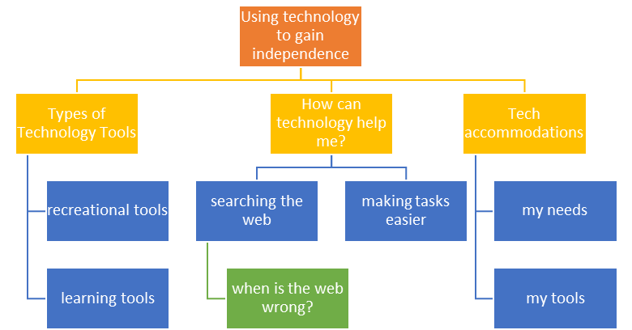
COURSE REQUIREMENTS:

1) In Class Assessments:
In this class there will be several chances for students to demonstrate their skills using technology. Each assessment has separate points that can be earned for a grade.

a) The first is the Technology Skills Assessment: this will review skills from the previous class and must be completed before moving through the class lectures and activities. See the Course Schedule for dates. (10 points)

b) The second is the Technology Preference Sheet: this evaluation will help students identify which types of technology strategies work for them. Students will use the information from this assessment to build a personal technology strategies reference. (10 points)

c) The last assessment is the Final Exam: this evaluation comes at the end of the semester and will review concepts and ideas presented over the course of the semester. This assessment is a demonstration assessment that requires the students to show how they use different types of technology. (40 points)

2) Your Personal Accommodations:
Students will be required to identify and ultimately share their preferred technology accommodations with others. To do this, students will make an Accommodations Movie using PowerPoint © and will share the movie with another person. This could be their family, their friends, or their mentors. To earn full credit, the student must not only make the PPT but also share it. (40 points)

3) Develop a Skill Movie:
Student will develop a Skill Movie (30 points) (to support an employment, independent living, or academic skill. The movie will be reviewed in class and the students will be asked to give feedback to a peer on their movie. The Peer Evaluation is part of this project (10 points).

4) Participation and Homework:
As with most classes in the Academy, attendance and participation is important. Students need to follow the course schedule which includes the reading and video assignments. If a student will ab absent from class, it is their responsibility to get the information they missed and be prepared for the next class session. (10 points)

ASSESSMENT PROCEDURES:

Assignment | Points I Earned | Possible
In Class Assessments  Technology Skills Assessment  Technology Preference Sheet  Final Exam |  | 10  10  40
Personal Accommodations Movie |  | 40
Skill Movie  Movie Maker  Peer Evaluation |  | 30  10
Participation and Homework |  | 10
TOTAL |  | 150

GRADING (FAU GRADING SCALE):
Activity scores are cumulative and the grade scale represents percentage of total points earned.

A = 93-100 A- = 90-92 B+= 87-89 B = 83-86
B- = 80-82 C+= 77-79 C = 73-76 C-= 70-72
D+= 67-69 D = 63-66 D-= 60-62 F = Below 60

POLICIES AND PROCEDURES:

ATTENDANCE:
According to University policy, “Students are expected to attend all of their scheduled University Classes and to satisfy all academic objectives as outlined by the instructor.” Attendance includes meaningful, active involvement in all class sessions, class discussions, and class activities as well as professional, ethical, conduct in class. Reasonable accommodations are made for religious observances.

STUDENTS WITH DISABILITIES:
In compliance with the Americans with Disabilities Act (ADA) and FAU policy, students with disabilities who require special accommodations to properly execute course work must register with FAU Student Accessibility Services (SAS) and provide the instructor of this course with a letter from SAS indicates the reasonable accommodations that would be appropriate for this course. SAS offices are located on Boca, Davie and Jupiter campuses. Information regarding SAS services and locations can be found at: http://www.fau.edu/sas/

CODE OF INTEGRITY:
Students at Florida Atlantic University are expected to maintain the highest ethical standards. Academic dishonesty, including cheating and plagiarism, is considered a serious breach of these ethical standards, because it interferes with the University mission to provide a high quality education in which no student enjoys an unfair advantage over any other. Academic dishonesty is also destructive of the University community, which is grounded in a system of mutual trust and places high value on personal integrity and individual responsibility. Harsh penalties are associated with academic dishonesty. For more information, see https://www.fau.edu/ctl/4.001_Code_of_Academic_Integrity.pdf

BIBLIOGRAPHY

Bowser, G., & Reed, P. (2007). Hey! Can I try that?: A student handbook for choosing and using assistive technology. Retrieved from: http://www.wati.org/?pageLoad=content/supports/free/index.php

Bugai, C.R., & Norton-Darr, S. (2010). The practical and fun guide to assistive technology in public schools. Washington, D.C.: International Society for Technology in Education. books@iste.org

Carpenter, L.B., Johnston, L.B., & Beard, L.A. (2015). Assistive technology: Access for all students. Boston, MA: Pearson.

Edyburn, D.L. (2015). Advances in special education technology (Vol. 1): Efficacy of assistive technology interventions. Bingsley, UK: Emerald Group Publishing Limited.

Gierach, J. (2009). Assessing students’ needs for assistive technology (ASNAT): A resource manual for school district teams (5th Ed.). Milton, WI: Wisconsin Assistive Technology Initiative.

Lanconi, G.E., Sigafoos, J., O’Rilly, M.F., & Singh, N.N. (2013). Assistive technology: interventions for individuals with severe/profound and multiple disabilities.
New York, NY: Springer Science+ Business Media.

Oslund, C. (2013). Succeeding as a student in the STEM fields with an invisible disability: A college handbook for science, technology, engineering, and math students with autism, ADD, affective disorders, or learning difficulties and their families. London, UK: Jessica Kingsley Publishers.

Sigafoos, J., O’Reilly, M., & de la Cruz, B. (2007). How to use video modeling and video prompting. Austin, TX: Pro-Ed.

WEEK/ DATE | TOPICS | ASSIGNMENTS
1 | What do I remember for last semester?  -Reviewing skills from last term  -Assistive technology assessment | Skill review assessment  Hmwk: complete online activity in Blackboard for 2nd class
2 | How can AT help me?  -Your technology supports  -Your accommodations | Hmwk: watch video at:  http://www.going-to-college.org/campuslife/accommodations.html
3 | How do I explain this to my professors? | Hmwk: read Pat’s story from “Hey Can I Try That?”  Answer page 11 questions
4 | How can I use tech for fun?
5 | How can I use tech for learning? | Hmwk: complete technology preference sheets
6 | Can I explain my accommodations using a PowerPoint? | Hmwk: share accommodation plan with someone (parents, family, mentors)
7 | Can you use PPT to make a movie? | Hmwk: make an accommodation movie
8 | How do turn a PPT into a video? | Hmwk: record a “home movie” for class
9 | ---continued  Working with video  http://www.microsoft.com/en-us/DigitalLiteracy/curriculum4.aspx#digitlife | Hmwk: edit your video
10 | ---continued  Peer Review of Videos
11 | ---continued  Peer Review of Videos | Hmwk: complete peer review
12 | What are some safety rules on the internet?  http://www.gcflearnfree.org/internetsafety | Hmwk: review notes from class
13 | ---continued  Internet safety
14 | How do people use cellphones and tablets today?  -Cellphones and Tablets | Hmwk: watch video  https://www.youtube.com/watch?v=0_n541sj9qU
15 | ---continued  Tablet tools | Hmwk: watch video  https://www.youtube.com/watch?v=aAx49Wo_AbU&feature=youtu.be
16 | Final exam

