Department of Exceptional Student Education
College of Education
Florida Atlantic University

Instructor: Office:
Phone: E-mail:
Office Hours: Class Day/Time:

Course Number: Sls 1250

Course Title: Living With Roommates

Catalog Description: This course discusses the differences in living situations and explores how to interpret human behavior and how to adjust, share, and compromise in multiple residential settings.

INSTRUCTOR INTRODUCTION TO THE COURSE: This course is designed for the Florida Atlantic University Academy for Community Inclusion. In this course, students will compare and contrast different living environments such as dorm life, apartments, in a house, and living at home with your parents. Students will learn the issues that arise in residential settings such as adjusting, sharing, compromising, cooperating and the importance of communication with others. Students will then choose a residential setting that they will pursue.

PREREQUISITE or COREQUISITE:
No pre- or co-requisite

REQUIRED TEXTS or MATERIALS:
All materials will be provided by instructor in class or on Blackboard. Materials will be provided in multiple formats as appropriate.
Tablet for video recording purposes

TECHNOLOGY:

E-mail: Your FAU email will be used for this class.

Computer: This course will be web assisted through FAU Blackboard site. Some handouts, forms, handbook and resources may be available on the website. Go to the website: http://blackboard.fau.edu (Do not type www).

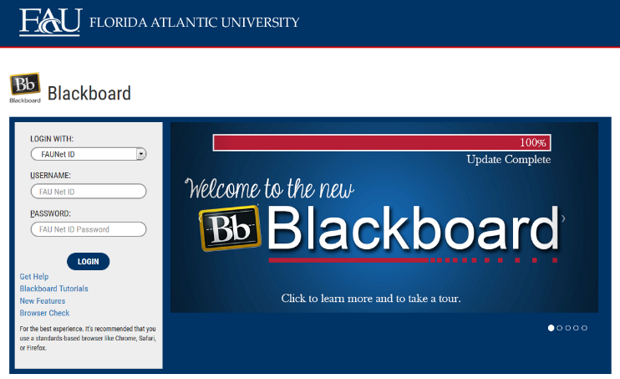

Videos:
- Tips for living with a roommate-https://www.youtube.com/watch?v=s7Ml1vVYkj8
- How to: Live With A Roommate-https://www.youtube.com/watch?v=X7hCDuvufUo
- Living at Home? 6 Simple Ways to Make it Awesome!-https://www.youtube.com/watch?v=tule6A_6YuI

COURSE OBJECTIVES:
Upon completion of this course, the successful student will be able to demonstrate the following:

- Students will identify various types of living options.
- Students will identify the benefits of different living options
- Students will compare and contrast the different types of living options
- Students will demonstrate how to effectively communicate with roommates.
- Students will develop the skills to share with others in a residential environment.
- Students will develop the skills to cooperate and make adjustments in a residential environment.
- Students will define compromise.
- Students will determine which living option they want to pursue.

Content Outline:

COURSE REQUIREMENTS: (See Appendix for assignment rubrics)

- Tour Summary- (20 points)
As part of a class period, students will take a guided tour through some residential options. After the tour, students will write a one-page summary about their thoughts and opinions on the tour. The summary will include where they went on the tour, what they saw and the set-up of each living situation, how they felt about the living situation, and which living situation they liked the best. Students will also include any other detail about the living options that they observed such as proximity to campus, access to community resources and activities, safety, etc. The summary will be a Microsoft Word produced document and submitted via Blackboard on: DUE DATE. Note: Student’s will need to attend class to be able to complete this assignment. If the student is unable to attend for a serious reason, the student must contact the instructor prior to the scheduled tour to make other arrangements.

- Sharing Role Models- (40 points)
Students will work in groups of three to record what to do and what not to do in a given scenario. The scenarios will be assigned in class once the groups are established. They will include issues such as, sharing the TV, cleaning schedules, buying groceries, cooking, having friends over, paying the bills, taking the garbage out, fixing appliances, sharing possessions, etc. The students will record a video as if they were living together in an apartment, apartment style dorm, or a house without parents.

- Housing Plan- (20 points)
In this assignment, the student will create a housing plan for their future housing arrangements. Will they live in a dorm, an apartment, a house without their parents, or a house with their parents? What are the some of the issues that a student may encounter in the situation they want to live in? How could students handle and resolve these issues? First, the students will make a chart stating the pros and cons of the living situation they have chosen. Then the student will make a list of social or communication issues that could arise in that living situation. Then students will write a paragraph about how they would deal with the issues and the appropriate way to communicate with their roommates. The students will present this in a PowerPoint format to the class. The students are encouraged to be creative with their PowerPoint content, using visuals, or videos to show appropriate ways to communicate in a residential setting.

4) In Class Assignments and Homework- (20 points)
Students are expected to attend and fully participate in class. Each class session will have either an in- class or homework assignment that will allow students to practice the skills presented in class. Students are responsible for completing the assignments within the given time frame stated by the instructor.

ASSESSMENT PROCEDURES:

Assignment | Points I Earned | Possible
1: Tour Summary |  | 20
2: Sharing Role Models |  | 40
3: Housing Plan |  | 20
4: In Class Assignments and Homework |  | 20
TOTAL |  | 100

GRADING (FAU GRADING SCALE):
Activity scores are cumulative and the grade scale represents percentage of total points earned.
A = 93-100 A- = 90-92 B+= 87-89 B = 83-86
B- = 80-82 C+= 77-79 C = 73-76 C-= 70-72
D+= 67-69 D = 63-66 D-= 60-62 F = Below 60

POLICIES AND PROCEDURES:

ATTENDANCE:
According to University policy, “Students are expected to attend all of their scheduled University Classes and to satisfy all academic objectives as outlined by the instructor.” Attendance includes meaningful, active involvement in all class sessions, class discussions, and class activities as well as professional, ethical, conduct in class. Reasonable accommodations are made for religious observances.

STUDENTS WITH DISABILITIES:
In compliance with the Americans with Disabilities Act (ADA) and FAU policy, students with disabilities who require special accommodations to properly execute course work must register with FAU Student Accessibility Services (SAS) and provide the instructor of this course with a letter from SAS indicates the reasonable accommodations that would be appropriate for this course. SAS offices are located on Boca, Davie and Jupiter campuses. Information regarding SAS services and locations can be found at: http://www.fau.edu/sas/

CODE OF INTEGRITY:
Students at Florida Atlantic University are expected to maintain the highest ethical standards. Academic dishonesty, including cheating and plagiarism, is considered a serious breach of these ethical standards, because it interferes with the University mission to provide a high quality education in which no student enjoys an unfair advantage over any other. Academic dishonesty is also destructive of the University community, which is grounded in a system of mutual trust and places high value on personal integrity and individual responsibility. Harsh penalties are associated with academic dishonesty. For more information, see https://www.fau.edu/ctl/4.001_Code_of_Academic_Integrity.pdf

BIBLIOGRAPHY

Becoming a comprehensive transition program. (n.d.). Retrieved October 9, 2015, from http://www.thinkcollege.net/topics/becoming-a-comprehensive-transition-program

Gaumer Erickson, A., Clark, G., & Patton, J. (2013). Informal assessments for transition planning (pp. 54-162). Austin, TX: PRO-ED.

Pankaskie, S., & Chandler, S. (2012). Social skills. In P. Wehman & J. Kregel (Eds.), Functional curriculum for elementary and secondary students with special needs (pp. 258-317). Austin, TX: PRO-ED.

Synatschk, K., Clark, G., Patton, J., & Copeland, L. (2007). Informal assessments for transition: Employment and career planning (pp. 17-47). Austin, TX: PRO-ED.

COURSE SCHEDULE FOR SEMESTER

Week | DATE | TOPICS | ASSIGNMENTS
1 |  | Overview of Syllabus  Introduction to Course | Hmwk: collect required materials for class
2 |  | What are the differences between dorms and apartments? | Hmwk: Complete the diagram about the differences between dorms and apartments
3 |  | What are some of the responsibilities of living in a house? | Hmwk: Watch https://www.youtube.com/watch?v=s7Ml1vVYkj8
4 |  | Residential Tour | TOUR DAY
5 |  | Why is it important to communicate with my roommate? | Tour Summary Due
6 |  | How do I share with my roommates? | In-class Activity about sharing
7 |  | Why do I need to make changes when living with others? | Hmwk: watch https://www.youtube.com/watch?v=X7hCDuvufUo
8 |  | What is a compromise? | Hmwk: Make a list of the type of qualities you would like in a roommate. (clean, early riser, etc.).
9 |  | Presentations | Sharing Role Models Due
10 |  | Presentations | Sharing Role Models Due
11 |  | What are the benefits of all the different living options? | Hmwk: Watch https://www.youtube.com/watch?v=tule6A_6YuI
12 |  | What are the challenges of all the different living options? | Hmwk: Talk with your family and friends about which living option is right for you
13 |  | How do I choose my residential plan? | Hmwk: Work on your Presentation
14 |  | What is your residential Plan? Presentations | Housing Plan Due
15 |  | What is your residential plan? Presentations | Housing Plan Due

Appendix A- Assignment Rubrics

Tour Summary | Exceeds Expectations | Meets Expectations | Does Not Meet Expectations
Details

_____/5

Content

_____/5

Accuracy

____/10

Sharing Role Models | Exceeds Expectations | Meets Expectations | Does Not Meet Expectations
Creativeness

_____/10

Presentation

_____/10

Scenario Interactions/ Communication Skills

____/20

Housing Plan | Exceeds Expectations | Meets Expectations | Does Not Meet Expectations
Pros and Con Chart

_____/5

Issues List

_____/5

Solutions paragraph

____/5

Presentation

_____/ 5

