Department of Exceptional Student Education
College of Education
Florida Atlantic University

Instructor: Office:
Phone: E-mail:
Office Hours: Class Day/Time:

Insert instructor picture here:

Course Number: REA 1008

Course Title: Reading for Life

2 CREDITS

Catalog Description:
In this class, students will learn reading strategies to increase comprehension and vocabulary skills. Readings in the course will be based on student’s interests and will foster the idea of reading beyond school.

INSTRUCTOR INTRODUCTION TO THE COURSE:
In this class, the students will read a wide variety of material. Some will be current news and some will be classic stories. Students will also learn how to “read” using different technology supports. The real reason to take this class is to become a better reader and learn how to enjoy reading.

PREREQUISITE or COREQUISITE:
No pre- requisites and no co-requisites

REQUIRED TEXTS or MATERIALS:
Students will use assistive technology in this class to become better readers. The use of laptops will be part of the course materials.

TECHNOLOGY:

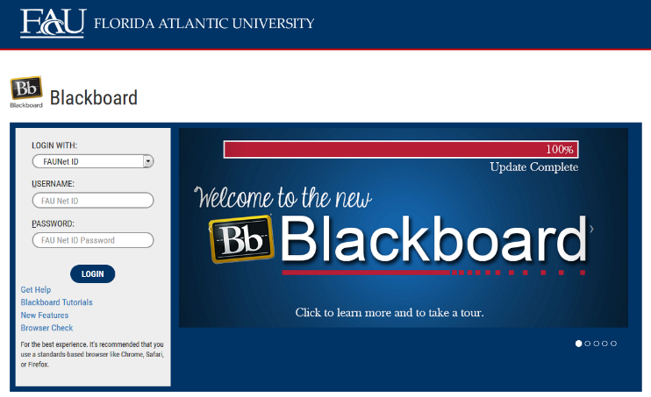
E-mail: Your FAU email address will be used.

Computer: This course will be web assisted through FAU Blackboard site. Some handouts, forms, handbook and resources may be available on the website. Go to the website: http://blackboard.fau.edu (Do not type www).

Videos:
YouTube resources:
- Inferences
https://www.youtube.com/watch?v=1oqdI5JMJnM
- Context Clues
https://www.youtube.com/watch?v=6spWj7Ol3x0
- Main ideas
https://www.youtube.com/watch?v=42SJTk2XSi4
- Themes in stories and fables
https://www.youtube.com/watch?v=AXPbijjMnV8
- Claims and supporting evidence
https://www.youtube.com/watch?v=3571UcZlFyc
- Author’s purpose
https://www.youtube.com/watch?v=2QMs24TTZrA
- Reading videos
http://www.tv411.org/reading

COURSE OBJECTIVES:
At the end of this course the successful student will be able to:

1) Select reading material from a variety of resources, like the library, online, audio books, newspaper, and magazines
2) Use technology to help them read
3) Retell a story to another person, including the main ideas, characters, plot and conclusion.
4) Demonstrate how to read for important ideas and solutions to problems from a variety of sources.

Content Outline:

COURSE REQUIREMENTS:

1) Personal Reading Log:
Students will keep a personal reading log that provides documentation of the time spent out of class reading from a variety of sources. At the beginning of the semester, students will set a personal goal for reading. Students are expected to read in MULTIPLE FORMATS and from MULTIPLE SOURCES. The reading log is found at the end of this syllabus. Students should keep their reading log up to date as it will be checked frequently throughout the semester.

2) Homework and Class Participation:
To become a better reader and learn to enjoy reading, you have to READ. This class has short reading activities that will be part of the class activities. Students are required to keep up with the Homework of assigned readings to be able to participate in class the following session.

3) Reading Strategies that work for you:
Students will practice the memory, comprehension and fluency strategy exercises in class and for homework. Then students will complete the reflection sheets to identify their preferred strategies.

ASSESSMENT PROCEDURES:

Assignment | Points I Earned | Possible
Personal Reading Log |  | 120
Homework |  | 90
Personal Strategy Reflection |  | 30
Book Club Participation |  | 60
TOTAL |  | 300

GRADING (FAU GRADING SCALE):
Activity scores are cumulative and the grade scale represents percentage of total points earned.
A = 93-100 A- = 90-92 B+= 87-89 B = 83-86
B- = 80-82 C+= 77-79 C = 73-76 C-= 70-72
D+= 67-69 D = 63-66 D-= 60-62 F = Below 60

POLICIES AND PROCEDURES:

ATTENDANCE:
According to University policy, “Students are expected to attend all of their scheduled University Classes and to satisfy all academic objectives as outlined by the instructor.” Attendance includes meaningful, active involvement in all class sessions, class discussions, and class activities as well as professional, ethical, conduct in class. Reasonable accommodations are made for religious observances.

STUDENTS WITH DISABILITIES:
In compliance with the Americans with Disabilities Act (ADA) and FAU policy, students with disabilities who require special accommodations to properly execute course work must register with FAU Student Accessibility Services (SAS) and provide the instructor of this course with a letter from SAS indicates the reasonable accommodations that would be appropriate for this course. SAS offices are located on Boca, Davie and Jupiter campuses. Information regarding SAS services and locations can be found at: http://www.fau.edu/sas/

CODE OF INTEGRITY:
Students at Florida Atlantic University are expected to maintain the highest ethical standards. Academic dishonesty, including cheating and plagiarism, is considered a serious breach of these ethical standards, because it interferes with the University mission to provide a high quality education in which no student enjoys an unfair advantage over any other. Academic dishonesty is also destructive of the University community, which is grounded in a system of mutual trust and places high value on personal integrity and individual responsibility. Harsh penalties are associated with academic dishonesty. For more information, see https://www.fau.edu/ctl/4.001_Code_of_Academic_Integrity.pdf

BIBLIOGRAPHY

Engstrom, E. (2005). Using assistive technology to teach students with learning disabilities: A guide for educators. Putney, VT: Landmark College Institute for Research and Training.

Grigal M., & Hart D. (2010). Think College: Postsecondary Education Options for Students with Intellectual Disabilities. Baltimore, MD: Paul H. Brookes Publishing

Minskoff, E. (2005). Teaching reading to struggling readers. Baltimore, MD: Paul H. Brookes Publishing Co.

Internet resources:

1) Goodwill Community Foundation: http://www.gcflearnfree.org/reading/practicereading/play

2) Pro Literacy Education Network:
http://www.proliteracyednet.org/articles.asp?mcid=1&cid=8

3) LINCS Learner Center: https://learner.lincs.ed.gov/

4) Flash Card Maker: http://www.kitzkikz.com/flashcards/

5) Palm Beach County Adult Literacy Project:
http://www.pbclibrary.org/services/adult-literacy-project

Grass Roots Press: Adult Literacy and ESL Resources
6520-82 Avenue, Main Floor Edmonton, AB T6b oE7

Quick Reads: http://www.quickreads.org.uk/

COURSE SCHEDULE FOR SEMESTER

 | DATE | TOPICS | ASSIGNMENTS
1 |  | How do you read?  Basic reading skills & your preferences | -bring laptop to class to set up apps  -complete County library application
2 |  | How do I read online?  Magazines and newspapers  http://www.thetimesinplainenglish.com/wp/ | -Complete Reading Goals;  -Submit for review
3 |  | How do I read online?  E-books
4 |  | How can I get the most from the Public Library?  Palm Beach County Public Libraries | -bring laptop for
5 |  | How much fun can you have in a Book Club?  What do you do at a Book Club? | -begin reading your selected book
6 |  | Book Club Meeting | -bring book club book with you to class
7 |  | What types of technology can help me read better?  Text readers  http://dreamreader.net/
8 |  | What can I do to help me remember information I read?  Memory & comprehension strategies | -watch video and complete activity sheet  https://www.youtube.com/watch?v=XU7UpWXdTqo  https://www.youtube.com/watch?v=ZUDigw4LCYE
9 |  | Memory and Comprehension Strategies  ---continued  https://www.youtube.com/watch?v=HfoNBZJQqjM  https://www.youtube.com/watch?v=zY7Mz7Qi4x0
10 |  | Book Club Meeting | -bring book club book with you to class
11 |  | How can I read faster?  Timed readings  http://marshalladulteducation.org/reading-skills-for-todays-adult | -complete 2 timed readings this week
12 |  | Reading Practice  -strategies  -speed | -keep up with your reading fluency chart
13 |  | Reading Practice  -strategies  -speed
14 |  | Reading Practice  -strategies  -speed
15 |  | Book Club Meeting | -bring book club book with you to class
16 |  | Wrap up semester | Bring in completed:  Personal Reading Log  Strategy Reflection  Reading Fluency Chart

REA 1008: Reading for Life

Personal Reading Log for:

Date and time  (start and finish) | What did I read? | How did I read it?

Note: Students must complete the chart by reading 12 different items. Save the Personal Reading Log to your computer and bring with you to each class session.

Reflection Sheet

List the strategies that you tried and your outcomes.
Then describe which strategies work best for you and why.

Memory Strategies:
Date | Strategy Tried | Outcome

What worked for me? Why?

Reading Comprehension Strategies:
Date | Strategy Tried | Outcome

What worked for me? Why?

Fluency Strategies:
Date | Strategy Tried | Outcome

What worked for me? Why?

SAMPLE Fluency Chart

Students are to add weekly Reading Fluency Scores to the chart above. Use Excel to build your chart.

