AMH 4133-23173

The Revolutionary Age

3 credits
Dr. Adrian Finucane AL 160, 561-297-3951
Department of History, Florida Atlantic University Office Hours: Mondays afinucane@fau.edu 12-3pm & by appointment

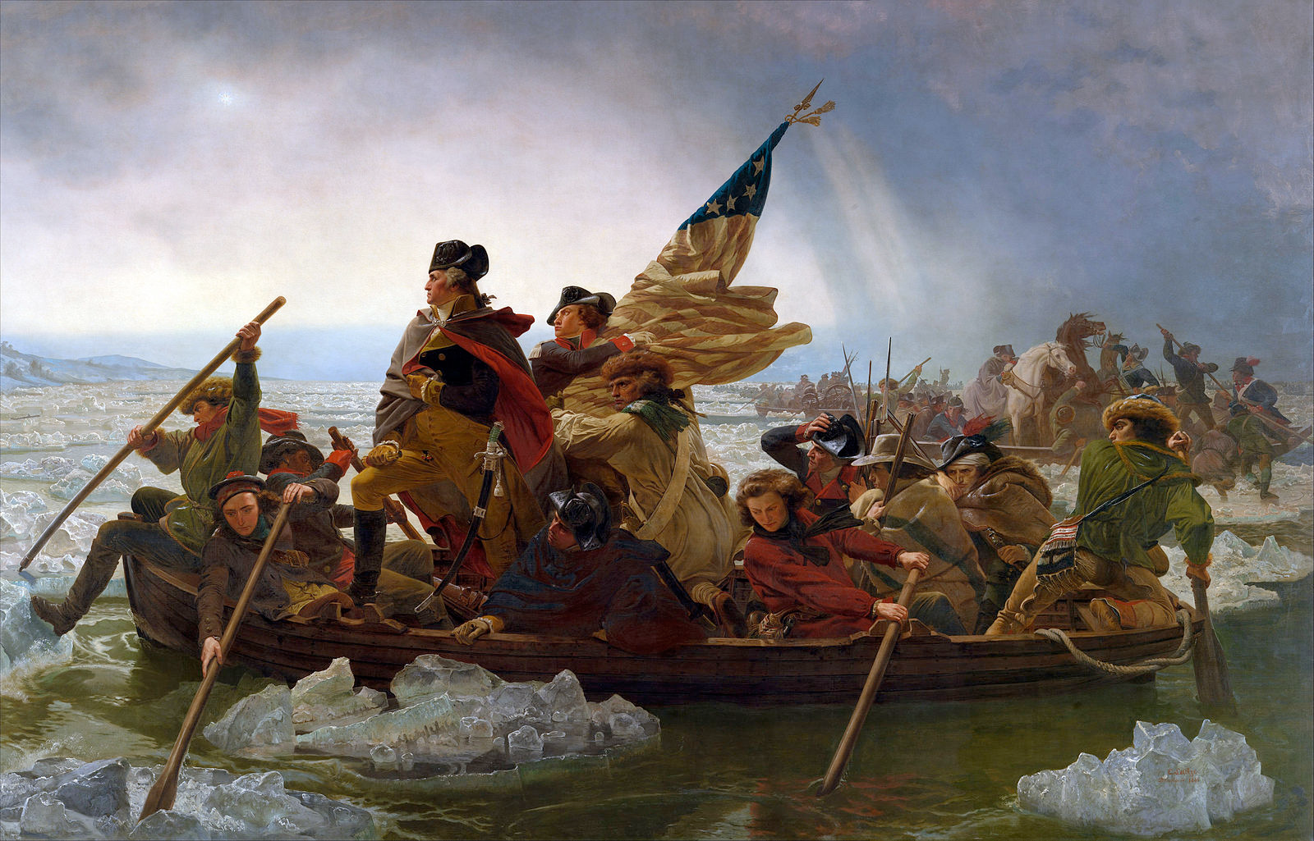
Course Description and Statement of Goals
When the colonists of British North America declared in 1776 that “all men are created equal” and that they were “free and independent states,” they were already deeply engaged in one of the most formidable sets of events in American history: the American Revolution. This course will cover the history of the revolution from the colonial struggles of the Seven Years’ War through the constitutional period and the Federalist era; the Republican ascendancy; the significance of the early republic; and the impact and historiography of the Revolution.
In this course, students will become familiar with the historical outlines of the American Revolution and the diversity of the American colonies and the New United States. This includes not only the acts of the generals and politicians of the era, but the lives and experiences of all members of colonial society, including women, African Americans, Native Americans, loyalists, and soldiers. They will develop the skills to read and analyze some of the most important primary sources in the formation of the American nation, as well as secondary sources that explain and contextualize these sources.

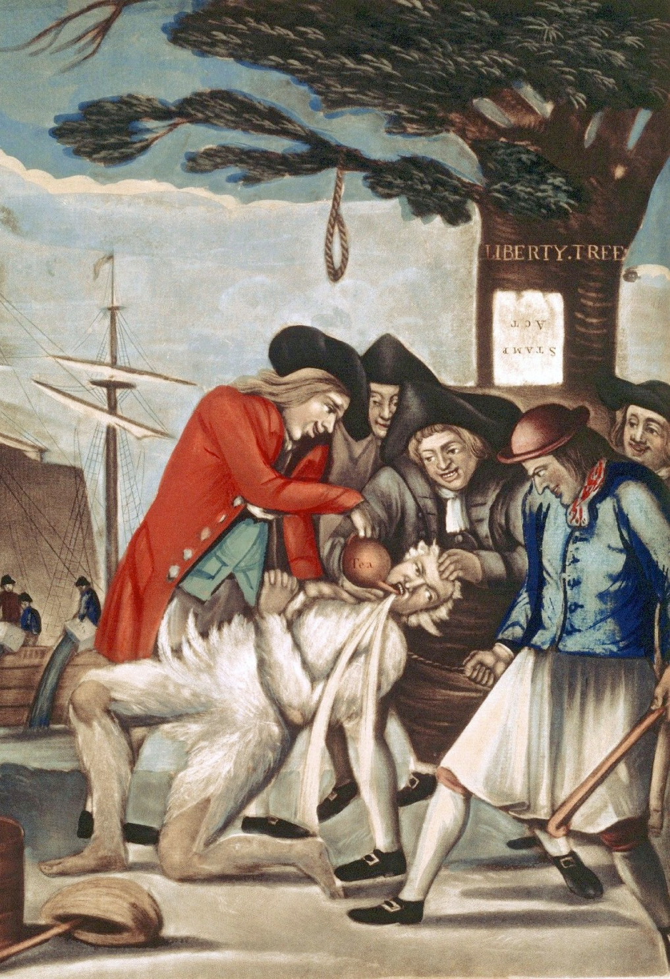
Class Meetings
Wednesdays and Fridays, 11-12:20, AL 342
3 Credit Hours

Policies

Attendance Policy: Students are expected to attend all of their scheduled University classes and to satisfy all academic objectives as outlined by the instructor. The effect of absences upon grades is determined by the instructor, and the University reserves the right to deal at any time with individual cases of non-attendance.
Students are responsible for arranging to make up work missed because of legitimate class absence, such as illness, family emergencies, military obligation, court-imposed legal obligations or participation in University-approved activities. Examples of University-approved reasons for absences include participating on an athletic or scholastic team, musical and theatrical performances and debate activities. It is the student’s responsibility to give the instructor notice prior to any anticipated absences and within a reasonable amount of time after an unanticipated absence, ordinarily by the next scheduled class meeting. Instructors must allow each student who is absent for a University-approved reason the opportunity to make up work missed without any reduction in the student’s final course grade as a direct result of such absence.

Late work and absences: Papers turned in late will be penalized. Students may not be penalized for absences due to participation in University-approved activities, including athletic or scholastics teams, musical and theatrical performances, and debate activities; students may make up missed work without any reduction in the student’s final course grade. Reasonable accommodation will be made for students participating in a religious observance.

Grades of Incomplete (“I”) are reserved for students who are passing a course but have not completed all the required work because of exceptional circumstances (documented illness, death or severe illness in the family, unexpected hospitalization, or severe family crisis).

Students with disabilities: In compliance with the Americans with Disabilities Act (ADA), students who require special accommodation due to a disability to properly execute coursework must register with Student Accessibility Services (SAS) and follow all SAS procedures. SAS has offices across three of FAU’s campuses – Boca Raton, Davie and Jupiter – however disability services are available for students on all campuses.

Academic misconduct, including plagiarism, will be penalized. Class discussion and debate is highly encouraged, but interactions with others must remain respectful.

Code of Academic Integrity policy Students at Florida Atlantic University are expected to maintain the highest ethical standards. Academic dishonesty is considered a serious breach of these ethical standards, because it interferes with the university mission to provide a high quality education in which no student enjoys an unfair advantage over any other. Academic dishonesty is also destructive of the university community, which is grounded in a system of mutual trust and places high value on personal integrity and individual responsibility. Harsh penalties are associated with academic dishonesty. For more information, see University Regulation 4.001.

Students are expected to produce original and individual work on all assignments. Students are expected to understand that the definition of plagiarism
includes:
1. Copying large or smalls sections of a written text without appropriate quotations and citation
2. Paraphrasing written material without citing the source
3. Citing a source other than that from which you obtained your evidence
4. Altering or contriving evidence
Plagiarizing, intentionally or unintentionally, may result in the failure of individual assignments and/or the course as a whole.

Students must complete exams on their own, without referring to any notes or other students during the exam. Papers will be submitted through Turnitin on Canvas and filtered through antiplagiarism software.

Students are required to turn off cell phones and other devices that vibrate or make noise during class meetings. The use of laptops during meetings is permitted but restricted to class-related activity.

Students must check their FAU email and the Canvas website regularly for notice of changes.

The FAU Center for Excellence in Writing has a number of resources designed to help you with your writing, including appointments to address individual assignments both in person and online. Students are encouraged to take advantage of the writing center, which can be accessed at www.fau.edu/ucew.

Should the examination schedule for this course conflict with your mandated religious observance, please contact Dr. Finucane at the beginning of the semester so we can schedule a make-up exam at a mutually acceptable time. In addition, students will not be penalized of absence from regularly scheduled class activities which conflict with mandated religious observances. As stated in FAU’s University Regulation 5.010, “The University is committed to fostering an inclusive, accessible, and diverse intellectual and cultural campus experience.

Students are encouraged to take advantage of office hours in order to ask questions about assignments, seek clarifications, and discuss further any class material they do not fully understand. You can sign up for office hours via Canvas. Email will be answered on weekdays.

Grading
This course will use the following grading system:
A = 940-1000 points A- = 900-939
B+ = 870-899 B = 830-869 B- = 800-829
C+ = 770-799 C = 730-769 C- = 700-729
D+ = 670-699 D = 630-669 D- = 600-629
F = below 599 points
Participation will be graded as follows:
A-level Participation: Attends class consistently and always contributes actively and insightfully to the discussion. Comments are judicious and succinct. Student demonstrates engagement with the reading and the class discussion, and asks questions that advance the conversation.
B-level Participation: Attends consistently, and often contributes substantively to the discussion. Demonstrates a considerable effort to understand the material and advances the class discussion. Student asks good questions.
C-level Participation: Student participates infrequently, in ways that suggest a lack of preparation.
D-level Participation: Student is present but unengaged in the discussion. Contributions are very infrequent or unproductive. Does not advance the class discussion.
F-level Participation: Student is absent.
Students are required to attend all class meetings, do all of the assigned readings by the date they are due, and complete the assignments listed on the following page.

Readings should be completed before the Wednesday class for the week on which they are listed. You should bring copies of the assigned readings to relevant class meetings for reference during discussion. The following books are required for all students, and are available through the campus bookstore or a variety of online retailers.

Colin G. Calloway, The Scratch of a Pen (ISBN: 978-0195331271)
Gordon S. Wood, The American Revolution, a History (ISBN: 978-0812970418)
Thomas Paine, Common Sense (Dover thrift edition) (ISBN: 978-0486296029)

Additional readings will be available on the class Canvas website and are marked with a * on the class calendar.

All written assignments are due at the beginning of the class period on the listed due date. The paper will be due via Canvas, and all other written assignments outside of class will be due electronically at the deadline listed. Midterms will be held for 30 minutes at the beginning of the relevant class period.

Late Work: In only two situations are students permitted to turn in a late paper or to make up a missed quiz or exam without penalty:
    - they have made prior arrangement with the instructor or GTA at least 24 hours in advance
    - they can provide written proof of sickness or a major emergency

In all other circumstances, a student may turn in a late paper with a penalty of 10 percentage points per 24-hour period it is late. This includes turning the paper in late on the day it is due. (For instance, if an assignment is due at 1pm on Monday, turning it in at 6pm on Monday or 11am on Tuesday would be considered 1 day late; turning it in at 2pm on Tuesday would be considered 2 days late.)
Students are responsible for submitting their assignments to Canvas and confirming that they have been successfully uploaded. It is recommended that students download submission receipts from Canvas and save them for their records. If you are ever concerned that a submission has not gone through, you should also email the assignment to the professor.
The components of your grade, their relative weight, and a short description are listed below. More detailed instructions for writing assignments will be distributed in during the semester.

Assignments

Participation (130 points): You are expected to participate fully in all class discussions. To this end, you should come to each class meeting prepared, having completed and taken notes on the readings. Attendance will be taken regularly. Students are permitted 2 free absences without penalty; these are meant to be used for instances of illness, travel, etc. Additional absences for any reason will result in a lowering of the participation grade, except when they relate to a significant medical emergency, official University-sanctioned travel such as for intercollegiate sports, or mandated religious observances. For one of these exceptions to be recognized, official documentation is always required and should be provided well in advance. Students are recommended to save their two free absences for unforeseen events later in the semester.

Reading Responses (20 points each, 220 points total): In weeks without other writing assignments or exams, students will complete a short assignment of 200 words responding to the week’s readings, due by 11am on the relevant Wednesday. These will be due electronically and are described more fully on Canvas.
Weeks 2, 3, 4, 6, 7, 8, 9, 11, 13, 14, 15

2 Midterm Exams (150 points each): These short exams will be based on ID terms discussed in the course readings and in the lectures. Midterms will be given September 22nd and October 27th

3-page Primary Source Paper (150 points): For this assignment, you will conduct a short interpretation of a single document. You may choose to interpret one of the following in the context of class discussions, lecture, and the assigned readings: “Sentiments of an American Woman” or Jefferson on Slavery, from Notes on the State of Virginia. Both readings are posted on Canvas. Due November 8th
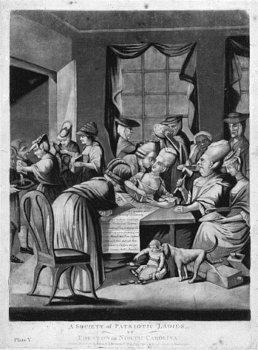
Final Exam (200 points): This final exam will be a combination of an ID section like those on the midterm exams and an essay question: From the perspective of 1800, who can be said to have “won” the American Revolution? How did the lives of the groups that inhabited the American colonies - including the upper classes, the poor, women, enslaved people, free African Americans, Native Americans, loyalists, etc. - change from before the war, and how did these changes measure up to their hopes for Revolution? To answer this question, draw on the class lectures and assigned readings from throughout the semester. You must make significant use of at least three specific readings.
Final Exam December 13th 10:30amAt the discretion of the instructor, there may be changes to this syllabus over the course of the semester.
Image credits: Page 1 Emmanuel Gottlieb Leutze, “Washington Crossing the Delaware,” 1851
Page 2 Philip Dawe, “Bostonians Paying the Excise-Man,” 1774
Page 5 Philip Dawe, “A Society of Patriotic Ladies,” 1775

Class Calendar

Week 1
Read | Wood, The American Revolution, pp. 1-24
Write | No writing assignment this week
Wednesday August 23 | Introduction and the Colonies
Friday August 25 | The Rights of Englishmen: Being British in Early America

Week 2
Read | Franklin, Autobiography, Chapters 2-10*
Write | Reading Response #1 Due (See Canvas for instructions)
Wednesday August 30 | The Archetypal American: Benjamin Franklin
Friday September 1 | Dependence and Independence

Week 3
Read | Calloway, The Scratch of a Pen, pp. 3-111
Write | Reading Response #2 Due
Wednesday September 6 | The French and Indian War
Friday September 8 | The British Empire in 1763

Week 4
Read | Wood, The American Revolution, pp. 27-64  John Dickinson, Letters from a Pennsylvania Farmer, Letter 2*  John Dickinson, Letters from a Pennsylvania Farmer, Letter 4*
Write | Reading Response #3 Due
Wednesday September 13 | The Stamp Act Crisis
Friday September 15 | The Power of the Mob: Boycotts and Riots

Week 5
Read | Accounts of the Boston Massacre*
Wednesday September 20 | Printing in the Revolutionary Era: Visit to Weiner Collection  CLASS WILL MEET ON THE 5th FLOOR OF WIMBERLY LIBRARY
Friday September 22 | The Boston Massacre  MIDTERM EXAM 1 SEPTEMBER 22nd – Bring a blue book

Week 6
Read | Thomas Paine, Common Sense
Write | Reading Response #4 Due
Wednesday September 27 | Tea, Taxation, and Liberty
Friday September 29 | The Empire Strikes Back

Week 7
Read | The Declaration of Independence*  Washington, Letter to Congress on Recruiting and Maintaining an Army*
Write | Reading Response #5 Due
Wednesday October 4 | Thirteen Clocks (the Second Continental Congress)
Friday October 6 | Fighting the American Revolution: The Generals

Week 8
Read | Charles Royster, A Revolutionary People at War, Prologue and Ch.1*  Speech to the Six Confederate Nations, 1775*  Treaty with the Delaware, 1778*
Write | Reading Response #6 Due
Wednesday October 11 | Fighting the American Revolution: The Soldiers
Friday October 13 | War on the American Frontier: Native American Forces

Week 9
Read | Elizabeth Fenn, Pox Americana, selections*  Alfred Young, Masquerade, selections*  Abigail and John Adams, letters*
Write | Reading Response #7 Due
Wednesday October 18 | Smallpox
Friday October 20 | Unlikely Heroes: The Life of Deborah Sampson and Women in the War

Week 10
Read | Dunmore’s Proclamation*  Petition of Slaves to the Massachusetts Legislature*  St. George Tucker, “Journal of the Siege of Yorktown” (1781)*
Wednesday October 25 | The Meanings of Freedom (Slavery and the Revolution)
Friday October 27 | Waging War, North and South  MIDTERM EXAM 2 OCTOBER 27th – Bring a blue book

Week 11
Read | Maya Jasanoff, Liberty’s Exiles, pp. 5-81*  Wood, American Revolution, pp. 65-109
Write | Reading Response # 8 Due
Wednesday November 1 | Loyalists
Friday November 3 | Early Failures: The Articles of Confederation

Week 12
Read | Federalist Papers #10*  Letter from George Washington to James Madison, 31 March 1787*  Letter from George Washington to David Humphreys, 10 October 1787*
Write | PRIMARY SOURCE PAPER DUE NOVEMBER 8th
Wednesday November 8 | The Constitutional Convention
Friday November 10 | NO CLASS – VETERANS DAY

Week 13
Read | Wood, American Revolution, pp. 113-166  The Constitution of the United States and the Bill of Rights*
Write | Reading Response #9 Due
Wednesday November 15 | Pamphlet Wars and the Constitution: Visit to Weiner Collection  CLASS WILL MEET ON THE 5th FLOOR OF WIMBERLY LIBRARY
Friday November 17 | Political Parties

Week 14
Read | Alfred Young, “George Robert Twelves Hewes (1742-1840): A Boston Shoemaker and the Memory of the American Revolution, WMQ 38:4 (October 1981): 561-623.*
Write | Reading Response #10 Due
Wednesday November 22 | Political Life in the Early Republic
Friday November 24 | NO CLASS – THANKSGIVING BREAK

Week 15
Read | Address of the House of Assembly to Lieutenant Governor Sherbrooke Opposing Black Refugee Immigration, 1815*  A British Chaplain’s Account of the Battle of New Orleans*  Laurent Dubois, Slave Revolution in the Caribbean, excerpts*
Write | Reading Response #11 Due
Wednesday November 29 | Remembering the American Revolution
Friday December 1 | The Second American Revolution: The War of 1812

FINAL EXAM: December 13th 10:30am-1pm – Bring blue books

