REOPENING

PLAN

COVID-19



FLORIDA ATLANTIC UNIVERSITY | EMERGENCY MANAGEMENT

Table of Contents

Executive SummaryTable of Contents

Executive Summary & PromulgationtsIntroductionSuConcept of Operationss

Executive Summary & Promulgation 4
Introduction 5
Purpose 5
Scope 5
Planning Picture 5
Relation to Other Plans 5
Planning Assumptions & Direction 6
Pillars 7
Concept of Operations 7
Methodology 7
Benchmarks/Gating Criteria 7
Fall 2020 Semester at a Glance 8
A Healthy Campus Environment 9
Protect Your Owl Family 9
Ask a COVID Team Member 10
Student Affairs 10
Activities 10
On-Campus Housing 10
Employee Affairs 11
Remote Work 11
Families First Coronavirus Response Act (FFCRA) 11
Emergency Paid Sick Leave Act (EPSLA) 12
Vulnerable Employee Population Program 12
Athletic Affairs - Intercollegiate Competition 12
Dining on Campus 13
Community Protective Measures 13
Good Hand Hygiene 13
Physical Distancing 14
Physical Distancing Controls and Barriers 14
Face Coverings 14
Cleaning and Disinfection Practices 15
Area Disinfection and Responsible Party 16
Common Area Disinfection (High Traffic/High Touch Areas) 16
Compliance & Enforcement 17
FAU Students 17
FAU Employees and Faculty 17
A Healthy Community Environment 19
Participation in Community Response 19
Emergency Coordination 19
Shared Facilities 19
Communication 19
COVID-19 Virus Testing 20
Self-Assessment 20
Mobile Application 20
Employee Workday Process 20
Student Testing Program 20
Employee Testing Program 21
Health System Capacity 21
Contact Tracking & Notification 22
Contact Tracking Software 22
Student-Related Cases 22
Employee-Related Cases 23
On-Campus Quarantine & Isolation Plan 23
Academic Program Delivery 24
Academic Instruction & Delivery 24
Classroom Protocols 24
Reducing Classroom Capacities 24
Managing Classroom Flow 24
Lab-Specific 25
Teaching lab protocols 25

It is the policy of Florida Atlantic University (FAU) to protect its human and physical assets and safeguard continued operations during and after all manner of emergencies, such as COVID-19, by implementing appropriate emergency management policies, plans, and procedures designed to ensure the University’s ability to manage and navigate an incident.

Executive Summary & Promulgation

This incident-specific reopening plan applies to all members of the university community, including all faculty, staff, students, volunteers, contractors, and visitors at all FAU campuses, sites, and facilities. While no plan can completely capture the complete ever-changing environment related to COVID-19, good plans carried out by knowledgeable and well-trained people can and will reduce losses and ensure a steadfast pathway to scaled operating levels at the University. This plan establishes the reopening activities for COVID-19 while serving as the governing strategy for the development of supportive policies, directives, and general procedures. Furthermore, this document provides a succinct coordination platform for connecting service elements across the University and builds cascading enabling drivers for our complex environment. Campuses, facilities, and sites co-located with other organizations have special considerations and relationships that may affect plan implementation, and these should be identified in individual unit plans.

Detailed within this incident reopening plan is the framework for coordination and full mobilization of university assets through a multi-phased reopening approach. Specific core areas are derivative of instituting practices of A Healthy Campus Environment, A Healthy Campus Community, Virus Testing, Contact Tracking & Notification, and Academic Program Delivery.

As the University’ embraces the “new normal” resulting from COVID-19, the health and safety of FAU’s students, faculty, staff, and visitors remains the top priority in the University’s planning principles. The following document is governed by the latest health recommendations from the state of Florida and the Centers for Disease Control and Prevention. Denoted within this plan is a firm reliance and adherence to principles grounded in up to date science and data.
This plan is intended to comply with all applicable University, local, state, and federal laws and regulations. In the absence of specific regulatory mandates for situations, best emergency management practices shall be followed.
The Department of Emergency Management is authorized to amend this reopening plan to maintain operational consistency, implement corrective action, and enhance the document or apply other appropriate changes.
This promulgation shall be effective upon signing and remain in force until amended or rescinded by further promulgation.



As the COVID-19 pandemic developed, the university’s Emergency Operations Team (EOT), which consists of FAU employees representing numerous areas of the university, was activated and has since formulated planning foundations regarding a phased approach to reopening our campuses. The EOT has provided recommendations to the Executive Policy Group (EPG) for their consideration and subsequent policy decisions. The EPG is made up of the President and the executive cabinet. EOT representatives are assigned to Emergency Support Functions (ESFs):

Introduction
Emergency Operations Center Director | Emergency Operations Center Coordinator | Procurement  Purchasing
Volunteer Coordination | Donation Management | Food & Water
Claims Management & Assistance | Accounting | Research Operations & Subject Care
Health, Public Health and Medical Triage | Student Affairs | Academic Affairs
Athletic Affairs | Faculty & Staff Affairs | Law Enforcement
Environmental Health & Safety | Facilities & Grounds | Information & Technology
Traffic Management | Campus/Facility Access | Transportation
Emergency Coordination | Planning & Analysis | Situation Status
Compliance | General Counsel | Safety
Communications and Media Relations | University Relations | Campus Representation supports the EOT
Pursuant to the Board of Governor’s Blueprint for Opening the State University System for Fall 2020 Semester, the following plan lays out the University’s plan for reopening its campuses for Fall 2020 Semester.

Purpose
The purpose of this planning document is to define a systematic university-wide strategy for reopening and resuming operations as a result of COVID-19 through defining criterion based on principles substantiated in up-to-date science and what is feasible, practical, and applicable to the needs of the University community.

Scope
This incident-specific plan supports with the University’s pre-established emergency management planning portfolio, policies, and Section C of the Comprehensive Emergency Management Plan (CEMP). This plan supplements the Basic Plan through a concentration on critical operational functions and the courses of actions needed to carry them out respectively to COVID-19.

Planning Picture
The University has instituted a multi-level methodology to the reopening through a planning picture that models and supports federal, state, and local conceptions.
The University strategy is derivative of three dominant layers that grant fundamental enabling delivers and supportive channels to ensure full assimilation of resumption and recovery efforts across the University. The layers consist of the university-level, EOT/EFS level, and unit level.

Relation to Other Plans
This plan is particular to COVID-19 and the University’s operational reopening. It is intended to be used in concurrence with other university-level COVID-19 planning documents, strategies, and unit plans. All relevant plans shall be leveraged. The following are university-wide complementary planning document that have been institutionalized to support this reopening plan.
Health & Safety Plan | On-Campus Quarantine & Isolation Plan
Cleaning & Disinfection Plan | Virus Testing, Contact Tracking & Notification Plan

Planning Assumptions & Direction
- This is a living document that will continue to evolve.
- Studies indicate that the more individuals interact, and the longer the interaction, the higher the risk of COVID-19 spread.
- COVID-19 is primarily spread by respiratory droplets released when people talk, cough, or sneeze. It is thought that the virus may spread to hands from a contaminated surface and then to the nose or mouth, causing infection.
- Personal prevention practices and environmental prevention practices are critical principles.
- Guiding assumptions and other information in this plan are subject to change in relation to local actions and guidance issued by public health and government officials.
- A phased reopening of operations provides the ability to reimplement mitigation measures should case clusters, community transmission, or new waves of the virus occur, whether before, at the beginning, or during the Fall 2020 Semester.
- Prompting actions and associated response actions identified in this plan may not occur sequentially. Not all elements outlined in a phase may be applicable at the time of implementation.
- If mitigation strategies are relaxed too quickly, a resurgence in COVID-19 impacts are likely and risks undoing any progress that was made.
- Safety, security, and well-being of the University community will remain of the utmost importance during this process.
- Decisions about changes to mitigation measures in place must be evidence-based, data-driven, and implemented incrementally.
- Facility occupancy will increase as appropriate and operate under new parameters.
- Minimize potential exposure of returning students and employees to the virus and reduce opportunities for community transmission.
- Physical distancing and limiting the size of mass gatherings remains one of the most effective mitigation strategies currently available. These measures will remain in place but are expected to be loosened based on the reduction in community transmission.

Pillars

Concept of Operations
The following pillars form the University’s reopening focus:

Methodology
The conceptual methodology to the reopening of the University is one that is framed through stages of resumption strategies for increasing activities on campus. These phases, like the State of Florida’s reopening plan, positions the University to implement mitigation strategies in a controlled manner to reduce the opportunity for a resurgence in COVID-19 impacts and the undoing of progress that has been made. The proposed outline is arranged in terms of the academic calendar, specifically the Fall 2020 Semester; however, the identified timeline will be adapted as circumstances change and are subject to change. The concept of operations will be operationalized based on guidance from the Board of Governors (BOG), Board of Trustees (BOT), EPG, the EOT, as well as other factors, including governmental orders and evidence-based advice from health professionals.
The University reserves the discretion to determine when an official transition between operations will occur as well as whether a return to any phase is warranted based on such factors as federal, state, and local orders, and guidance from the CDC, state, local, and University health professionals.

Benchmarks/Gating Criteria
The benchmarks/gating criteria is designed as a framework to evaluate current conditions to identify prospects to expand resumption of activities, or the need to hold or return to tighter social distancing and behavioral restrictions.
Symptoms | Cases | FAU
Syndromic surveillance systems look at individual and population health indicators. The objective of this component is to provide data and analytic tools needed to identify outbreaks or unusual trends more rapidly, leading to timely public health responses. | Case data that is captured provides an opportunity to align objectives of ensuring the service area is effectively managing the spread of COVID-19, and both the broader and internal community is employing effective mitigation measures. | Considerations about the University’s resource mobilization and availability show whether FAU is in a position to respond in the event of an unexpected surge of COVID-19. The ideal situation is for the University to be able to manage all cases without overwhelming systems while having robust capabilities for personal and environmental prevention practices.
Metric  Downward trajectory of Influenza-like illnesses reported within a 14-day period.  AND  AND  Downward trajectory of COVID-19 like cases reported within a 14-day period. | Metric  Downward trajectory of documented cases within a 14-day period  AND  OR  Downward trajectory of positive tests as a percent of total tests within a 14-day period (flat or increasing volume of tests. | Metric  Approval to proceed by BOG.  AND  SHS/HR Preparedness to manage cases  AND  FAU capabilities for personal prevention practices and environmental prevention practices
Data Sources to be Used :
Florida Department of Health, State Joint Information Center, SHS/HR Reports and Systems

Fall 2020 Semester at a Glance
General Guidelines: | Academic Instruction | Hybrid remote
General Guidelines: | Work Arrangements | Hybrid in-person/remote
General Guidelines: | Residence Halls | 96% occupancy
General Guidelines: | K-12, Daycare, Adult Day Center | K-12/Daycare open. Adult Day Center reduced operations or closed.
General Guidelines: | On-Campus Programs | Operate with physical distancing based on the function
General Guidelines: | Large Venues | Operate under strict physical distancing
General Guidelines: | Events | 50 persons or less
General Guidelines: | Vulnerable Population | Accommodations made wherever possible.
General Guidelines: | Face Coverings | Encouraged when physical distancing is possible; otherwise required.
General Guidelines: | Travel | No non-essential travel
Explicit direction is structured regarding mitigation measures that will be employed to limit the spread of COVID-19 in the community as the University transitions into the Fall 2020 Semester. Health experts have recognized these measures as fundamental to reducing the transmission of the virus that causes COVID-19. The approaches to supporting a healthy campus environment is a keystone to the University’s efforts in the Fall 2020 Semester. The following are key concepts positioned within the University’s approach to a healthy campus environment:

A Healthy Campus Environment
- Slow transmission of disease: Primary goals for the deployment of mitigation strategies in the University is to slow the transmission of disease and in particular to protect individuals at increased risk for severe illness, including older adults and persons of any age with underlying health conditions, and the internal and external healthcare and the University’s critical infrastructure workforces.
- Emphasize individual responsibility: The health and safety of the University is a collective responsibility for all. All students, faculty, staff, vendors, volunteers, and visitors are subject to the University policies, procedures, and oversight. The University mitigation strategies are predicated on emphasizing individual responsibility for implementing recommended personal-level actions, empowering units, and community partners to implement recommended actions, particularly in ways that protect persons at increased risk of severe illness, focusing on settings that provide critical infrastructure or services to individuals at increased risk of severe illness, and minimizing disruptions to daily life to the extent possible. The reopening plan is designed to promote a safer and healthier environment for teaching, learning, and working, including the encompassed strategies to protect individuals at higher risk for developing adverse outcomes of COVID-19.
- Tailored strategies to the University community: The University’s mitigation strategies are based on the level of community transmission, characteristics of the University community, and the University’s capacity to implement strategies. Considerations have been given to all aspects of the community that might be impacted. Mitigation strategies can be scaled up or down depending on the evolving local situation.

Protect Your Owl Family
The provision of a safe environment for the pursuit of learning has long stood as a University value. The University intends to employ this safety culture as a critical component of its mitigation strategy. The University will advance the safety culture and campus life to foster support of the public health measures to direct behaviors necessary for advancing a safer community. The University will use a vibrant approach to changing norms associated with community protective measures, physical distancing, face coverings, increased hygiene, and reduction of precarious behaviors.
The University will leverage innovative methods and communication strategies to present a compliment of outreach, engagement, education, and enforcement strategies. Strategies include:
- Integrate the University’s COVID-19 Health & Safety Plan through all operations and functions of the University.
- Deploy designed messaging, training, and engagement initiatives that support the facial covering usage, hand washing and physical distancing.
- Create a shift in campus culture through the application of community skill and support development, an emphasis on personal responsibility, involvement, and peer education.
- Publicize campaign materials that focus on care, compassion, and community responsibility.
- Leverage partnerships with internal and external stakeholders to promote healthy behaviors.
- Employ awareness-level curriculum to the community that trains them in the requirements and expectations for the new health and safety procedures and the consequences for non-compliance with these university policies.

All sections of this strategy seek to embolden positive and healthy behaviors, whether directed at student extracurricular activities, Greek organization operations and functions, student organizations, clubs, intramural sports, social gatherings, research, or employee-oriented operations and activities.
A public awareness campaign and messaging strategy had been prepared and launched for the preparedness and continuance of the Fall 2020 Semester. The campaign underscores that the health and safety of the campus is a shared responsibility among community members. Strategic placement of signage in highly visible locations (e.g., building entrances, restrooms, dining areas) has been introduced to promote awareness to all patrons who visit the University. These resources advocate everyday protective measures and describe how to stop the spread of germs. The following are samples of signage:
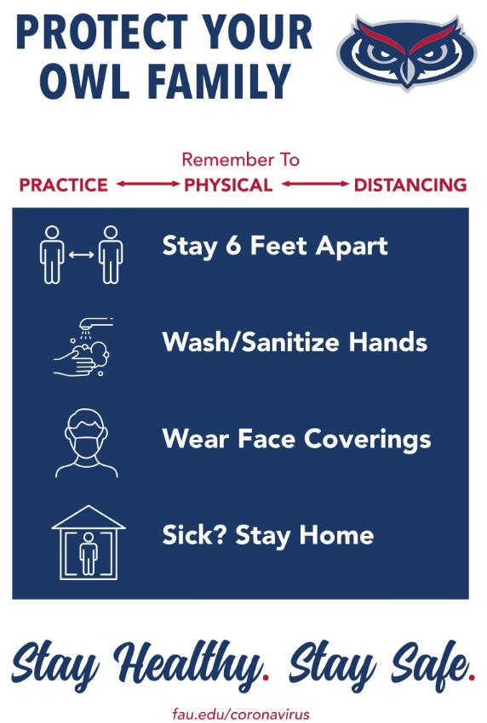 | 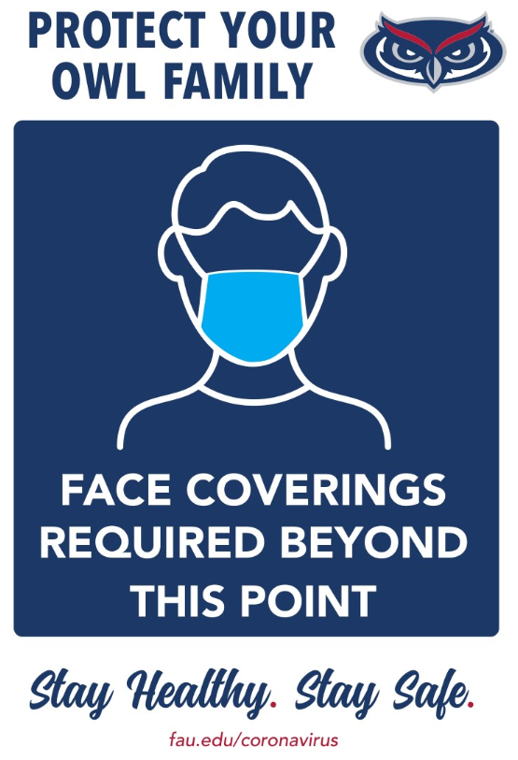 | 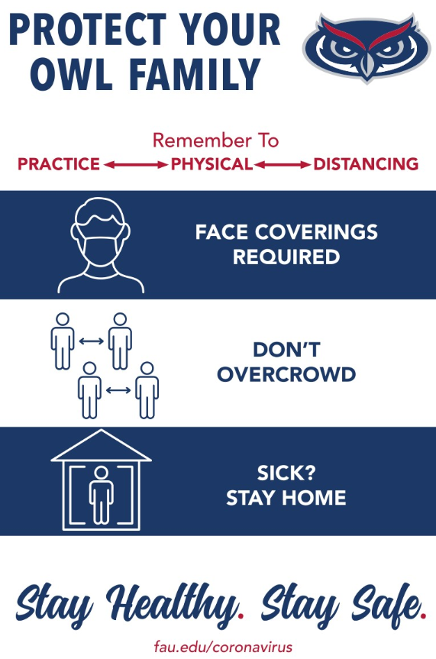
Additional communication platforms (web-based, email, social media accounts, etc.) will be leveraged that center on behaviors that prevent the spread of COVID-19.

Ask a COVID Team Member
A centralized email has been established to provide an avenue for community members to submit questions and provide important information. Students, faculty, staff, parents, and visitors may send questions to directly to COVID19@FAU.EDU.

Student Affairs
The Division of Student Affairs and Enrollment Management has been actively engaged in developing processes and protocols to support a healthy campus environment while permitting programming and functions that equip students with necessary tools to achieve academic, personal, and career success.

Activities
Student activities that wish to reopen in the Fall 2020 Semester are required to work with the Division of Student Affairs and Enrollment Management (with assistance from the Department of Emergency Management and the Department of Environmental Health and Safety) to develop plans than demonstrate a shared sense of ownership in maintaining a campus and community.

On-Campus Housing
The University recognizes that on-campus housing is an important component of the student experience and student success. The University will continue to honor housing contracts for the Fall 2020 Semester. To support this several steps have been identified and are being included to assist in enhancing residents’ health and safety while living on-campus. Included within these steps are:
- Strategic facilitation and coordination of move-in periods to promote physical distancing and limit the density of spaces.
- Marketing campaign targeting residence students and explaining healthy practices and instruction on room cleaning.
- A modified guest and visitation policy to limit guests within residence facilities and reduce overall density of the facilities.
- A continuance on emphasizing cleaning protocols and a focus on high tough surfaces within the facilities.
- Providing training for employees whose function and role are within the residence facilities.
As part of the University efforts of promoting a healthy campus environment, specific protocols have been developed should a student residing in the residence facilities that are symptomatic, presumptive positive, and COVID-19 positive. Should the need arise, students who are required to quarantine or isolate will have resources made available to them to provide care, counseling, food services, and other services to include the ability to continue their studies. The University has identified 112 spaces in Boca, and 12 spaces in Jupiter to isolate resident students if needed.

Employee Affairs
The Department of Human Resources (HR) has taken great care and attention to developing programs, services, and resources to assist managers, supervisors, and employees as the University begins planning for the Fall 2020 Semester. Since the onset of the pandemic, HR has been a strategic partner to the University in addressing the unique challenges COVID-19 has presented. HR partners with Units across the University in navigating impacts associated with COVID-19 and employee affairs. HR has established a dedicated page for employee COVID-19 information. Included on this page is information pertaining to University leave guidance for COVID-19, the University’s Talent Share Program, the University’s COVID-19 Leave Donation Plan, The Families First Coronavirus Response Act and the Emergency Paid Sick Leave Act, and Tips for Employees/Supervisors Working Remotely.

Remote Work
Remote work for employees will remain a fundamental concept as the University transitions into the Fall 2020 Semester. It is encouraged that employees participate in some form of in-person work. This may include a hybrid work schedule model. It is further understood that employees in some positions cannot adequately perform their functions remotely. Each Vice President will work within their Divisions to identify where remote work is viable and applicable. Human Resources has developed a COVID-19 Alternative Work Arrangement Form to be used by employees and supervisors to communicate clearly about expectations and formulating an effective remote work strategy. This form allows the University to garnish metrics on which members of the employee population have been identified to work remotely. All alternative work arrangements must be documented utilizing processes outlined by HR.

Families First Coronavirus Response Act (FFCRA)
Full-time and part-time employees who have been on FAU’s payroll for 30 calendar days are eligible for
the FFCRA. This applies to Faculty, AMP, SP, OPS, Postdoctoral, and student employees. There are some exceptions for health care providers and emergency responders.

Eligible employees are entitled to take up to 12 weeks of FMLA leave when an employee is unable to work (or telework) to care for a minor child if the child’s school or place of childcare has been closed or is unavailable due to a public health emergency.

Please note that the first 10 days are unpaid, but an employee can substitute accrued paid leave, including emergency paid sick leave. The remaining 10 weeks are paid at 2/3 of the full-time employee’s regular rate, or the number of hours the part-time employee would otherwise be scheduled to work (with a maximum payment of $200 per day and $10,000 total).

Emergency Paid Sick Leave Act (EPSLA)
The EPSLA is immediately available to eligible employees. This applies to Faculty, AMP, SP, OPS, Postdoctoral, and student employees. There are some exceptions for health care providers and emergency responders.
Employers are required to provide up to 80 hours of paid sick leave to an employee who is unable to work or telework because the employee:
- is subject to a Federal, State, or local quarantine or isolation order related to COVID-19.
- has been advised by a health care provider to self-quarantine due to concerns related to COVID19.
- is experiencing COVID-19 symptoms and is seeking a medical diagnosis.
- is caring for an individual who is subject to an order as described in (1) or self-quarantine as described in (2).
- is caring for a child whose school or place of care is closed (or childcare provider is unavailable) due to COVID-19 related reasons; or
- is experiencing any other substantially similar condition specified by the U.S. Department of Health and Human Services.
Employees who take leave for reasons (1), (2), or (3) are entitled to full, regular pay for the leave period; however, a cap of $511 per day and $5,110 in total applies (over a 2-week period).
Employees who take leave for reasons (4) or (6) are entitled to 2/3 of their regular pay, subject to a cap of $200 per day and $2,000 in total (over a 2-week period). Employees who take leave for reason (5) are entitled to 2/3 of their regular pay, up to $200 per day and $12,000 in total (over a 12-week period).
- The University has decided to allow employees to use their sick or annual leave to make up any difference in pay while on COVID-19 related leave.
- Emergency Paid Sick Leave can be used intermittently while working remotely; however, eligible employees must work with their supervisor to devise an alternate work schedule.
- Once employees have exhausted the 80 hours of Emergency Paid Sick Leave and cannot work on site or telework remotely, employees should use their accrued leave (annual and sick). If employees have exhausted their accrued leave or do not earn accrued leave, they will be unpaid.

Vulnerable Employee Population Program
Strategies employed to protect the general population are likely not to be sufficient for everyone, especially those at higher risk for developing adverse outcomes associated with COVID-19. HR has developed a vulnerable population program that managers and supervisors may navigate with individuals with disabilities or conditions that are at a high risk of complications from exposure to COVID-19.

Athletic Affairs - Intercollegiate Competition
The University has developed, implemented, and will regularly update specific plans, protections, and protocols for participation in athletic competition by students, staff, and spectators that comply with CDC guidelines and state policies regarding COVID-19. Decisions about intercollegiate competitions will come later and be made in conjunction with national and regional athletic conferences. Once those decisions are communicated, Athletics will update their plan accordingly. Athletics has developed a large-scope planning document which provides for additional supportive planning efforts. The following planning efforts, all of which remain fluid as procedures and protocols are advanced to meet the most up to date information, provide a lens on more area-specific plans and procedures that have been developed:
COVID-19 Screening for All Staff and Incoming Student-Athletes | Special Considerations for Preventing the Spread during Athletic Activities
Restarting Timeline for Sport Programs | Sport-Specific Logistics
Sports Medicine Plan of Action | Strength & Conditioning Plan of Action
Athletic Facilities Plan of Action | Equipment Room Plan of Action

Dining on Campus
The University has worked with its dining partner to promote healthy and safe practices at all food service locations, including our resident dining halls. Concepts which will be deployed within the dining facilities include, but are not limited to:
- Dining Service employees will go through a daily wellness screening program including temperature checks.
- Face coverings will be required for all employees both front and back of house.
- Food production, serving, and cashier areas will incorporate physical distancing.
- Use of disposable service items.
- Tables and chairs reduce with the remaining strategically placed to encourage physical distancing.
- Expanded use of sneeze guards (plexiglass dividers)
- Updated protocols for cashiers conducting transactions.
- Dining Service employees will continuously clean tables, chairs, and all high touch services with Oxivir.
- Added technology to help with advance ordering and pick-up for food,
- Multiple pick-up points for advance ordering to minimize congestion and density.
- Upon closing for the day, the entire facility will be disinfected with Virex II.
- Dining Service employees will continuously clean tables, chairs, and all high touch surfaces with Oxivir.
- All Dining Services employees will take serve safe COVID-19 training provided directly by Chartwells.

Community Protective Measures

Good Hand Hygiene
All members of the University community have equal responsibility to protect themselves and those around them from the spread of COVID-19 while at the University. Good hand hygiene is considered a standard protective measure for all:
- Wash/sanitize hands frequently.
- When available, use soap and water and scrub hands for a minimum of 20 seconds.
- If soap and water are not available, use an alcohol-based hand sanitizer (at least 60% alcohol content) and cover all hand surfaces and rub until dry.
- Regardless of the cleaning practices conducted, all persons should wash or sanitize their hands after each touch of shared equipment, common surfaces, etc., before using the restroom, eating, applying cosmetics or lip balm, and before touching their face.
- Cough/sneeze into a tissue. Dispose of used tissues immediately into a trashcan and then wash hands. If there are no tissues available, cough/sneeze into the crook of your elbow, not your hands
- Avoid touching your face, eyes, nose, and mouth. This can accelerate the spread of infection.

Physical Distancing
To the degree possible and practical, physical distancing will be a fundamental piece in the University’s efforts to combat COVID-19. The following is a prescribed framework for physical distancing and groups for the Fall 2020 Semester:
- Hold all meetings/gatherings, including one-on-one meetings, online, or over the phone whenever possible.
- Avoid close contact with others, maintaining greater than 6 feet of separation whenever possible.
- A limit of 50 people in a group. Events, where physical distancing is not possible, shall not be permitted.

Physical Distancing Controls and Barriers
Administrative and engineering controls are designed for reducing the potential transmission of COVID droplets between people. The following are models being deployed throughout the University however are not exhaustive of all measures.
Reconfiguring Space | Movement of furnishing, changes to traffic flow, blocking off areas, or removing of furnishings to increase physical distancing between people and processes.
Sneeze Guards | The use of sneeze guards (plexiglass barriers) where there is sustained interaction between people.
Barrier Ropes | Placed around areas to limit or reduce accessibility and close contact with others.
Demarcation Tape | Placed on the floor to demarcate the area where someone should not bass further.
Administrative Controls | Used to avoid crowding or excessive proximity. Includes process of meetings, office operations, and other directives.

Face Coverings
Face coverings should be worn during all public activities and when around others. Face coverings are required when in close proximity to others and wherever physical distancing cannot be maintained. All employees and students are required to have a face covering available, and on their person, while traversing the campus.

Situations that call for mandatory face coverings include, but are not be limited to, riding in FAU buses or shuttles, riding in vehicles, golf carts, or utility vehicles with others, riding elevators, using restroom facilities, classrooms, other spaces of instruction, and study rooms.

Care and use of face coverings and the materials required to make a DIY face covering are the responsibility of everyone in the FAU Community. Face coverings must be cleaned routinely and made of a cloth material that can be normally laundered and dried. Ideally, have multiple face coverings made and rotate usage. Refer to the CDC Guidance on Cloth Face Coverings for more information.

Cleaning and Disinfection Practices
Due to the highly contagious nature of COVID-19, the University has prescribed the following systematic approach to the regular cleaning and disinfection of all University facilities, including classrooms, office space, housing and food service facilities, research equipment and laboratories, and public spaces. These measures are consistent with CDC guidance for Institutions of Higher Education. These measures are not a replacement for good hand hygiene.
- When feasible, use an EPA-registered disinfectant that is effective against COVID-19.
- Most disinfectants will not be effective on a soiled surface, if necessary, clean gross debris and dust from the surface first.
- For cleaning surfaces, use wipes moistened with a disinfectant or a spray and paper towels.
Defined Space | Practices
General Office Space | Disinfection of high contact surfaces within general office spaces by individual area users. Utilizing disinfection wipes, gloves and a face covering, units will wipe down commonly touched surfaces several times per day. Wipe down of commonly touched areas may include countertops, doorknobs, sneeze guards, shared equipment, appliances, and the like.
Laboratory Space | The disinfection of laboratories will be conducted by the laboratory. Develop a list of high-touch locations and equipment in the laboratory. Special attention should be given to those areas that will have continued use. These types of areas represent a higher probability of viral loading in the work area and should be disinfected on a routine basis.
Gyms, Computer Labs, Libraries, and Other High Traffic Areas | The disinfection of high contact surfaces and equipment in these spaces will be conducted by individual area users under supervision of area staff. High traffic areas with high touch points must be cleaned more frequently than any other area of the campus.  These areas must require users to wipe down equipment, tables and other individual-use surfaces before each use. Staff within these areas will be required to monitor disinfection practices and disinfect any surfaces that may be missed by individual cleaning processes.  Deep cleaning/disinfection will be done in addition to the user practices outlined.
Classrooms | Classrooms will a require wipe down of high contact surfaces in between classes at a minimum and will be conducted by each class. Students should wipe down their desks upon entry into the room.  Deep cleaning/disinfection will be done in addition to the user practices outlined.
Common Areas | Disinfection of common areas, hallways, large venues, and high touch surfaces outside offices, classrooms, entrances, elevators, stair railings, restrooms, break rooms, and the like will be professionally cleaned by the approved FAU vendor using an approved protocol at least once per day.  Upon confirmation of a positive case of COVID-19 in the FAU community, an approved vendor will conduct a deep-disinfection of the affected areas using an approved protocol

Area Disinfection and Responsible Party
Area | Common Surfaces for Disinfection (Not Exhaustive) | Responsible Party
General Office Space | Individual workspaces. | Employees or area user
In-Suite Common Areas | High Touch Surfaces such as copiers, coffee areas, appliances, tables, scheduling board pens/erasers, door handles and knobs, etc. | Unit managers
Common Building Break Rooms | Campus Custodial | Campus Custodial  FAU community will request additional cleaning through FAMIS if deficiencies are noted.
Classrooms | Tables, desks, podiums, pens/erasers for white boards, remote controls, high touch room electronics | Students/Professors wipe down individual work areas before/after each use.
Conference Rooms | Tables, desks, podiums, pens/erasers for white boards, remote controls, high touch room electronics | Meeting host and participants wipe down individual work areas before/after each use.
Gyms, Computer Labs, Libraries | Equipment, computer equipment, tables, desks, and other high touch points | Area users wipe down individual spaces before/after each use; monitored by area staff for additional cleaning needed following use.
Common Areas Across Campus | Hallways, Common Break Rooms, Building Entrance Doors, Elevator buttons/doors, stairwell railings, Common Area Tables/Chairs, restrooms, and other high touch points in common areas like tables, doorknobs, light switches, countertops, handles, phones, keyboards, toilets, faucets, sinks, ATM machines, etc. | Campus Custodial  FAU community will request additional cleaning through FAMIS if deficiencies are noted.

Common Area Disinfection (High Traffic/High Touch Areas)
Campus common area disinfection necessitates a collaborative and succinct approach by all units who oversee, administer, and manage custodial functions for the University. These combined units oversee custodial operations utilizing a hybrid-model of in-house and outsourced resources, including contracted service providers. Therefore, deployment of effective strategies requires ongoing coordination of unit efforts with stakeholders and outsourced resource providers to ensure the alignment of strategies and plans, adoption of a common operating picture, and oversight and monitoring of operationalized strategies and planning elements.
A full Facilities Management – Physical Plant COVID-19 Cleaning and Disinfecting Plan has been developed to provide a systematic approach to mitigating public health risks through cleaning and disinfecting practices. Included within this document are protocols for securing an inventory of appropriate supplies and equipment.

Compliance & Enforcement
The University’s eventual return to operations is dependent on all of us doing our part to follow the University’s health and safety plan and notifying appropriate University officials when concerns arise.
The University Policies and Procedures manual (UPPM) serves as a repository of University policies and procedures. These tools provide for reference materials regarding compliance, enforcement, and consequences associated with health and safety practices.
Consistent with Board of Governors Regulation 3.001, and pursuant to University Policy 4.1.2, Environmental Health & Safety (EH&S) is responsible for the development and operation of Public Health programs such as infection control, medical monitoring programs, wildlife management on FAU campuses and any other programs as appropriate. Consistent with these responsibilities, EH&S is authorized to develop program documentation, educational materials, training requirements, guidance documents and standard operating procedures to ensure compliance with relevant environmental health and safety requirements, laws and regulations. Policy 4.1.2 specifically provides that “compliance with EH&S program procedures and guidelines and applicable laws and regulations is a shared responsibility of all members of the University,” and “all members of the University are responsible for compliance with applicable environmental health and safety laws, regulations and codes as well as applicable policies and procedures of the University.”
Florida Atlantic University’s Department of Emergency Management, through its Emergency Operations Team (EOT), and in collaboration with EH&S, has developed a health and safety plan in preparation for returning to campus through a phased re-entry process when the public health situation allows. As the University begins the implementation of this plan, questions are anticipated regarding enforcement of certain safety precautions including social distancing, handwashing, disinfecting workspaces and the individual use of face coverings.
Compliance with FAU’s health and safety plan will be a binding responsibility of all students, faculty and staff, and compliance will be enforced consistent with existing FAU Regulations and Policies and the Collective Bargaining Agreement, including but not limited to, the following:

FAU Students
- Regulation 4.007, the Student Code of Conduct, identifies several violations that may be applicable when a student fails or refuses to comply with mandatory provisions of the health and safety plan. Potential sanctions could range from a conduct warning up to suspension or expulsion from the University.
- If faculty or staff encounter a situation where a student refuses to comply with a mandatory provision of the University Safety Plan, the incident should be reported to the Dean of Students Office or by filing a report at FAU INCIDENT REPORTING. If the student’s refusal occurs in the classroom environment, faculty should ask the student to exit the classroom until they are willing and able to comply with mandatory safety requirements.
- As always, if any student’s conduct constitutes an emergency, an imminent threat, or a substantial disruption to university operations, contact University Police by calling 911.

FAU Employees and Faculty
- Regulation 5.012, Employee Standards and Disciplinary Procedures identifies the standards of conduct and disciplinary actions.
- The UFF-FAU Collective Bargaining Agreement includes the following provisions relevant to in-unit faculty:
  - Article 5 - Faculty shall contribute to the orderly and effective functioning of the academic unit and the University;
  - Article 16 - Faculty may be disciplined for misconduct;
  - Article 17.11 - Employees who pose a health risk to the University may be placed on compulsory leave and required to undergo an assessment to determine whether they are able to work, unable to work or able to work with restrictions such as behavioral adjustments that enable the employee to perform their duties effectively and contribute to the safe, orderly and effective function of the University;
  - Article 21.3 - Employees should report conditions which the employee feels may violate a safety or health rule or regulation or which is an unreasonable hazard to persons or property, and those concerns shall be promptly investigated.
- Incidents involving an employee should be addressed directly with the employee’s supervisor. All supervisors are responsible for promptly addressing safety plan compliance issues within their areas of operations. As always, if any employee’s conduct constitutes and emergency, an imminent threat, or a substantial disruption to university operations, contact University Police by calling 911.
The following provides for a snapshot of compliance and enforcement actions:
Compliance Areas | Enforcement Action
Workspace sanitation | Department Heads and Supervisors will notify employees to wipe down commonly touched surfaces every two hours.
Common area sanitation | Students, Faculty, and Staff can place a work order for service of an area.
Employee sick at work | Department Heads and HR will require sick employee to return home if sick.
Student sick in class | Professors and SHS will require students to return home or to their residence hall if sick.
Maintaining physical distancing | Students, Faculty, and Staff will always remain 6 feet from others or all persons in close proximity must wear face coverings. Each member of the FAU community will need to assist in enforcement.
Failure to wear face coverings | Supervisors are responsible for enforcing the use of face coverings among employees.  Faculty and FAU Employees operating in areas of the campus will be responsible for enforcing the use of face coverings among students.
Not wearing face coverings to ride on FAU transportation | Bus Drivers will deny entry to any FAU transportation if the rider does not have a face covering in place.

The University has a close working relationship within our host communities and as such, believes that its public health mission must also extend outwards. The University remains committed to the broader community and recognizes the value that comes from these partnerships. The University intends to leverage these relationships as it navigates the road to recovery acknowledging that our FAU stakeholders are part of the broader community.

A Healthy Community Environment

The University is mindful of its role within the community and recognizes that the safe and successful commencement of the Fall 2020 Semester is contingent upon acknowledging the symbiotic relationship of one another.

Participation in Community Response
Different units within the institution have setup frequently occurring meetings with external agencies to preserve a collective and shared understanding of the mutual responsibility to promote the health of the campus and the broader community. The collaboration includes efforts with the local and regional public, private, and non-profit sectors which center around a commitment and dedication to service to one another.

Emergency Coordination
The University’s Department of Emergency Management has been directly involved with state and local coordination groups to foster broader community synchronization efforts, the sharing of information and resources, and the exploration of opportunities for joint-response and coordination efforts. Coordination platforms includes but is not limited to those with the State Division of Emergency Management, State University System Emergency Managers, Broward County Division of Emergency Management, Palm Beach County Division of Emergency Management, St. Lucie County Division of Emergency Management, and several other public and private organizations.

Shared Facilities
The University has several facilities and locations that are shared use. Designated points of contact have and will continue to be identified to facilitate cohesive relationships and corresponding planning efforts. These efforts have been long withstanding since the onset of the pandemic and the University recognizes the importance of the continuation of these as we navigate the repopulation of our joint use locations. All individuals operating on University property share and follow similar considerations.

Communication
The University will communicate the protocols, policies, and procedures as it pertains to promoting a safe and healthy environment to campus vendors, contractors, and businesses that employ our students.
University officials who oversee contacts and the facilitation of services both internal and external to the community, to include all on campus partners, vendors, and those that work occasionally on campus, will provide direct communications towards this. Examples of this include:
- Career Services working with community businesses that employ and offer internships to students.
- Procurement communicating with all university vendors as to campus protocols and the expectation and requirement that they all abide by those.
- Administrative Affairs (Business Services), Student Affairs, and other applicable University units will serve as contacts with on-campus partners to ensure that they are well informed of reopening plans and requirements and understand their need to comply.

The University has established a detailed virus testing program to promote a healthy and safe working and learning environment as the institution reopens. The program for testing is supported through Student Health Services (SHS), HR, and external testing sites.

COVID-19 Virus Testing
The University will continue to work with the local and state health departments to coordinate testing or work with commercial or clinical laboratories using diagnostic tests authorized.

Self-Assessment

Mobile Application
The Department of Emergency Management has developed and deployed a voluntary self-assessment module within the University’s official mobile safety application Owl Ready. This optional self-assessment methodology is derivative of a logical decision tree which guided end-users through a series of questions that are designed around CDC guidance and University nuances. Based on an individuals’ response, different recommendations are made to the end-user, such as reporting to work /school/premises or to stay home. When an end-user completes their self-assessment, they are provided an on-screen confirmation and sent an email confirmation. The University is also provided with a confirmation email that provides the University with actionable information. The University will be working with areas that have high contact with the University community to determine how the mobile application may serve as a requirement to better protect the safety and welfare of the campus community.

Employee Workday Process
As part of HR’s return to work plan, they have developed a process in Workday and all employees will complete a self-screening and attestation form in Workday prior to returning to the workplace.

Student Testing Program
SHS has been conducting COVID-19 testing since the onset of the pandemic and has been instrumental in developing a clinical program capable of supporting the Fall 2020 Semester. SHS provides a virus testing program to support the determination of students in the University community that should be tested. This program is designed to help university-wide efforts to increase testing, improving communication, and the implementation of isolation and quarantine.
SHS has activated a Respiratory Illness Clinic as a foundation for their virus testing program. SHS utilizes the Box It In methodology.
SHS will use their judgment to determine if a patient has signs and symptoms compatible with COVID-19 and whether the patient should be tested. Other considerations that may guide testing are epidemiologic factors such as known exposure to an individual who has tested positive, and the occurrent of local community transmission or transmission within a specific setting or facility.
SHS has implemented infection prevention and control practices to include the use of recommended personal protective equipment in their operations to reduce the opportunity for virus spread. SHS testing structure is a clinical framework formulated around principles that are used to identify and priority who warrants testing:

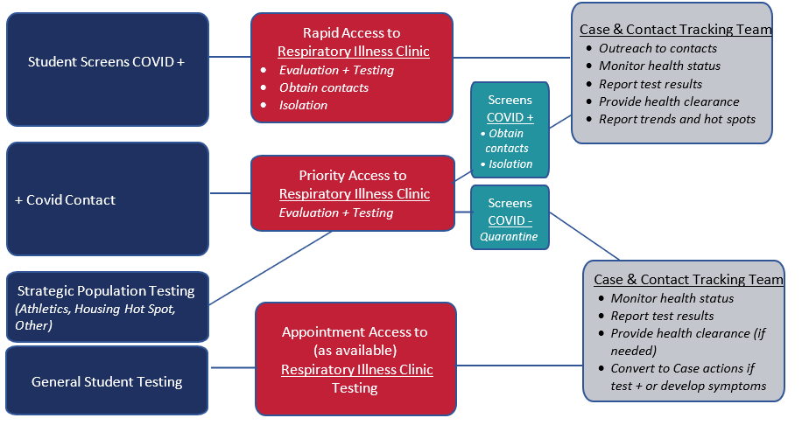

Employee Testing Program
Employees who are experiencing flu-like symptoms (fever, cough, shortness of breath) are recommended to see their health care provider immediately. Employees may access testing in the community, and information is made available on testing sites through the University’s official COVID-19 page and from HR. HR is developing a collaboration with SHS to provide COVID-19 testing in SHS campus clinics to employees.

Health System Capacity
As part of the University strategy, SHS has established protocols to actively monitor the capacity of the local health care system as the University increases operations. Daily data and reports on hospital capacities provide metrics concerning the healthcare systems capabilities and available resources in the University’s immediate service area. As students and employees return in a more significant number, these metrics, along with internal systems, will be monitored closely to ensure the health care capacity is sufficient to handle increased caseloads.

Contact tracing is under the authority of the Florida Department of Health (FDOH). The University has cultivated a collaborative relationship with FDOH and local count health departments to establish processes for how the University may function and assist in contact tracking & notification relative to community members. Therefore, this section has been respectively identified as contact tracking & notification to emphasize the role in which the University shall be situated.

Contact Tracking & Notification
A concept through which contact tracking & notification will be effective is framed through a dual partnership between SHS and HR. The ongoing coordination of these units’ efforts with stakeholders and the broader health community is crucial to ensure the alignment of strategies to regularly monitor the status of the health environment of the campus.
SHS oversees contact tracking & notification for student-related cases, whereas HR oversees contact tracking & notification for employee-related cases.

Contact Tracking Software
To effect contact tracking & notification practices properly, SHS, HR, and the Office of Information Technology (OIT) have procured a web-based application to enhance the University’s capability to track, monitor, isolate and test symptomatic contacts. This technology provides robust case management and permits increase capability to:
- Contain the spread of the disease through effective monitoring and rapid response.
- Isolate positive cases or quarantine of close contacts, which can slow and stop the transmission.
- Force multiplier to allow resources to be directed where most needed.
Student-Related Cases
SHS has established a Case & Contact Tracking Team with a priority of administering and managing all facets of the unit’s function for contact tracking & notification. Included as the administrative and operational responsibilities of the Case Contact Tracking Team is to:
- Communicate with newly diagnosed patients and their contacts in a professional and empathetic manner.
- Collect and record information on symptoms.
- Update systems of quarantine/isolation statuses and other health status changes.
- Escalate clinical concerns to clinical personnel for further action, as indicated in the protocol.
- Provide patients and contacts with approved information about SHS quarantine/isolation procedures.
- Refer and schedule contacts to COVID-19 testing according to protocol.
- Verify the testing status of patients and contacts.
- Ensure that the testing results have been received and communicated to patients.
- Conduct virtual health visits for health clearances.
- If necessary, work with FAU Dean of Students Office (DOS) to obtain class rosters to disseminate scripted notification about possible exposure and issue symptom monitoring information.
- If appropriate, liaison with FAU Housing and Residential Education about quarantine/isolation needs.
- If appropriate, refer to FAU DOS for social resources, notify FAU HR about employee contacts.
- If appropriate, work with FAU Environmental Health & Safety for facility, classroom, building concerns.

Employee-Related Cases
HR’s Employee Relations team is the unit responsible for contact tracking and notification for FAU employee-related cases. The HR team has established generalized procedures to assist in the identification, communication, and case management for employees:
- Employee or supervisor notifies HR of a positive case. HR collects and receives pertinent information regarding the employee and who they had been in close contact with.
- If a student has been identified to have been a close contact, that information will be immediately turned over to SHS.
- HR contacts the impacted employee to make sure they are following protocols to monitor their fever and to remain isolated for 14 days.
- HR gathers information released about whom the impacted employee had been in contact with and reaches out to those identified employees to advise them to self-quarantine. The time frame is contingent upon the last time of contact with the impacted employee and may extend to up to 14 days.
- HR will conduct frequent check-ins with employees who are in isolation and quarantine.
- All positive employee cases shall have a medical release to return to work and be fever-free for at least three days before to their clearance to return to duty.
- Employees who have been identified to having close contact with the impacted employee are able to return to work after their self-quarantine and have been symptom-free.
- Work-related cases are required to contact workers compensation (W/C) to file in which case W/C will take over and monitor. W/C shall keep HR informed along the way up to providing the University with the release to return to work.
- HR maintains a log of all cases (to include both isolation and quarantine) and follow-ups with all individuals when their 14-day mark is approaching to make sure they can return to work.

On-Campus Quarantine & Isolation Plan
The University has leveraged and evolved its COVID-19 On-Campus Quarantine Isolation Plan in support of the Fall 2020 Semester. The strategy is a guiding protocol should the need arise for an on-campus resident student to be quarantined or isolated on-site. Students who are required to quarantine or isolate will have resources made available to them to provide care, counseling, food services, and other services to include the ability to continue their studies. The University has the capability to isolate individuals into 112 spaces in Boca, and 12 spaces in Jupiter.

- Medium Risk: Student who has possible exposure based on travel or close contact with a positive or presumed positive case of COVID-19 and exhibits no active symptoms. SHS will establish travel risk based on the most current guidance from the CDC, the State Department, and the State of Florida. Current CDC Guidance for exposures. Recommendation for 14 days of quarantine, no roommates, symptom monitoring, and restrict travel outside of residence.

- High Risk: Students who are symptomatic and testing is warranted are diagnosed with COVID-19, OR they are given a diagnosis of presumptive positive. Current CDC Guidance for COVID-19 cases. Recommendation for full isolation in a suite with no roommates or suitemates, symptom management while ill, and maintain isolation until medical clearance is granted by a medical provider. Complete restriction of travel outside of residence.

After unprecedented disruption of the Spring 2020 semester due to the global COVID-19 pandemic, the faculty, and staff of Florida Atlantic University (FAU) have taken appropriate steps to transition to remote delivery for all instruction and most business operations. The health and safety of students and employees has been of paramount concern for the university. While eager to provide students once again with on-campus instruction and enriching experiences, the university is committed to doing so in a safe and carefully planned fashion.

Academic Program Delivery

Academic Program Delivery

Academic Instruction & Delivery
The University has engaged various areas of the Division of Academic Affairs to explore new and creative ways to leverage technology to deliver classes in a variety of modes. The goal for the Fall 2020 Semester is to prioritize courses (including labs) that critically need the in-person experiences.
Colleges and Departments have planned for a number of course sections to occur in a fully-remote format, prioritizing University classrooms for courses that require on-campus engagement.
Reasonable alternatives have been made for faculty and students who are unable to participate in available class delivery formats such as, for any on-campus sections, to the extent possible, lectures also being made available online (synchronously or asynchronously) for students who are unable to attend the lecture that day for whatever reason.
High-enrollment sections (more than 50 students) will remain fully-remote for the Fall 2020 Semester or shall rely on a hybrid approach that limits on-campus seats to no more than 50 per section, with the rest attending remotely. This is to promote a healthy and safe environment.
All graduate courses are planned to occur in a fully-remote format, unless specific courses critically need the in-person experiences, and an approval process has been built to support adequate review and consideration.
The Division of Academic Affairs has developed a robust training and outreach program to provide training and professional development to Faculty in continuance of opportunities to provide enhanced training and support for new online technologies and non-traditional modes of delivery.

Classroom Protocols

Reducing Classroom Capacities
At the federal level, there is a shortage of clear, specific guidelines for establishing classroom occupancy. Therefore, the University has established a conservative approach that will only be relaxed if specific guidance from the appropriate health and safety agencies become readily. To proceed as cautiously as possible, the following standards have been set for classroom occupancy in Fall 2020 Semester.
- Reduced class sizes of 25% regular capacity for rooms with moveable student seating, including teaching labs, to provide for a minimum of 80 square feet per person.
- Reduced class size of 20% of regular capacity for rooms with fixed student seating to provide for a minimum of 100 square feet per person.

Managing Classroom Flow
For all classrooms, additional social distancing measures have been structured to ensure minimal contact, especially if desks cannot be located six feet apart from other desks. The CDC currently recommends institutions of higher education consider modifying classroom layouts by actively spacing desks apart or blocking off seats and rows so that six-foot distancing is mandatory. Furthermore, the Occupational Safety and Health Administration (OSHA) guidelines also encourage all workplaces to provide physical barriers, such as plastic or glass screens, or physical guides in areas where queueing or other congregating occurs. Numerous measures and concepts have been considered by the University for the Fall 2020 Semester and include but are not limited to staggering schedules to limit density in areas, developing mechanisms for students to rotate attendance between on-campus and remote learning to comply with reduced room capacities, as well as establishing other classroom-specific protocols.

Lab-Specific
Teaching labs are important opportunities to engage students. The institution will strive to provide access to such hands-on activities only if social distancing and personal protective equipment (PPE) are strictly mandated.
Rotated, staggered lab sessions over multiple periods may be required. For instance, one 3-hour lab session may be replicated up to 4 times to cycle every student through.
Academic units will consider mitigating the loss of lab time by using recorded demonstrations, virtual simulations, at home kits, etc. without reducing the content or student outcomes. For example, some engineering fluids lab experiments or some basic chemistry lab experiences can be done at home with common household/kitchen items. Faculty should investigate if curricula of lab classes, particularly introductory lab classes, can be broadened to allow for qualitative assignments or experiences that are related more to concepts than specific techniques or instruments. Specifically, ACS.org, labster.com, and others have virtual chemistry, anatomy/physiology, biology, engineering, physics, and medicine desktop simulations for experiments such as pipetting, titrating, materials testing, PCR, spectroscopic techniques, and more, so that students can have a meaningful lab experience without physically using the instrument.
Students may analyze data and prepare the lab reports in groups, but they do not have to be in the lab together at the same time. Lastly, academic programs might consider assessing student learning outcomes related to prerequisite skills needed for subsequent coursework and adjust accordingly.

Teaching lab protocols
Faculty will clearly articulate the check-in and checkout/exit procedures. With respect to personnel movement, whenever possible, there should be a one-way traffic pattern. For check-in, the procedure should consider how students satisfy the entry protocol (e.g. symptom checks, PPE checks, hand sanitizing checks, etc.). There should be 6-foot markings at the entrance to allow for queuing safely. Door handles should be wiped with disinfectant in between each use, or else hands-free, motorized doorways should be explored. Once students have satisfied the entry protocol, students can file into the lab room with the first student assigned to the farthest station and proceeding to the nearest station to the door. Each student entering should be assigned a number to a lab station with all items pre-placed on the workspace.
During the lab, the traffic pattern should be clearly marked so that each student can move safely in between stations. If fume hoods are going to be used, they should be limited to one person at a time. Finally, an exit pattern should be established to allow for the first student who completes the lab work to be the first one out, and so forth, or another option could be for the student nearest to the door to be the first one out, such as with airplane disembarking. After each lab session, students should use wipes to disinfect their workspaces and then place the equipment and materials in the pre-lab position to prepare the experimental set up for the next group of students. The instructor or teaching assistants should verify that this is completed before initiating any student exit procedure.
Sufficient time should be allotted in between sessions to allow for disinfection of stations, high-touch areas, and shared workspaces.

