1. The UFS meeting was called to order by William McDaniel, President, at 2:00 p.m. in Engineering East 106 on the Boca Raton Campus and videoconference at the Davie Campus, the SeaTech Campus, the Fort Lauderdale Campus, the Harbor Branch Campus, and the Jupiter Campus.

Members present: see appendix for spreadsheet.

Guests present: Janet Cramer, Ed Pratt, James Burnham, Diane Alperin [Associate Provost], Robert Trammell, Barry Rosson [Graduate College Dean] and others who did not sign in

2. Without one addition and no objection, the Senate accepted the November 2, 2012 UFS minutes

3. The President’s report: a.Steering has charged the Assessment Committee to again consider online SPOTs; b. Steering advised that Senate participation in any tenure review proposal must wait until the UFF and the administration have agreed to some form of tenure review; c. A/V Serve has suggested that a room in the College of Nursing building might be more suitable for Senate meetings. This suggestion is under consideration. d. The President had prepared a roughly 7-minute commentary on UFS-Administration negotiations to set a maximum of $12,500 per summer course [affecting faculty with 9-month salaries exceeding $100,000]. As he began, Associate Provost Alperin stated that this proposal is no longer under consideration. However, at the request of several senators, the President stated four brief points from his remarks: i. $100,000 is an arbitrary number, ii. some administrators and athletic department persons make in excess of $100,000, so faculty skills are also conceptually worthy of this rate as well, iii.the targeted faculty have either been highly productive for many years or in high demand in the job markets, and thus are not logical subjects for a remuneration cut, and iv.the cuts run counter to FAU goals and strategic plans for high quality instruction, improved faculty remuneration, improved undergraduate graduation rate, improved graduate student graduation rates, the need for more PhD graduates as part of achieving an R1 research status. The recommendation is for UFF and the administration to be creative in achieving a raise package for all faculty. The notes for the full, but undelivered comments, are available from the President upon request.

4. UPC Consent Agenda [see appendices]: Accepted without objection

5. UPC Action Items [see appendices for details]:
a.New Certificate Program in Geomatics Engineering. Explanatory comments were by Don Leone. Approved by majority vote
b.New Minor in Geomatics Engineering. Explanatory comments and answers to questions by Don Leone.Approved by majority vote
c.Certificate Revisions to GIS Certificate and termination of the Advanced GIS. Approved by majority vote

6. UGC Consent Agenda [see appendices]:Accepted without objection

7. UGC Action Items [see appendices]:
a.Medicine: Thesis-track Requirement. Senator Levitt explained the need for this change. Approved by majority vote
b. Tuition benefits policy changes for graduate students. Via constitutional quirks, this item still needs approval by the UGC, but the Senate’s function is to advise on this item. Pursuant to this duty, many senators gave suggestions and criticisms to the Graduate Dean Rosson. Specifically, Dean Rosson outlined that, under the current policy, it is possible that students are receiving superfluous benefits, due to ambiguity in continued summer semester registration and benefit caps. Tim Lenz expressed concerns with the flexibility to offer less-than-half time appointments, which is sometimes necessary in particular departments. Not being able to offer these flexible appointments may impact the ability of departments to provide adequate graduate instructors for undergraduate courses. Dean Rosson responded that the policy will only be impacting new students and the College may add full tuition benefits to department budgets. Javad Hashemi, chair of Ocean and Mechanical Engineering in the College of Engineering and Computer Science asked if this would ultimately create a reduction in revenues due to having fewer PhD students to teach undergraduate courses. Dean Rosson responded again that Colleges have the discretion to allocate more funds to full-benefit appointments, which would subsequently increase the number of undergraduate course sections. Chris Beetle added to Dean Rosson’s response that Colleges should have discretion over their own budgets. Deborah Floyd suggested that there be more details regarding the criteria to receive benefits, including a definition of “non-academic” graduate assistant appointments. Dean Rosson responded that Student Government, Athletics, and “non-academic” appointments will be approved by the appropriate vice president or the Provost. Chris Beetle returned to the topic of flexibility in 20 hour appointments, suggesting that pro-rating be available. Rosson responded that pro-rating could be an option. Deans and Departments will have the authority to create positions under the revised policy.

8. Business item: Report on activities of the Academic Planning and Budget Committee. President-Elect and APBC chair, Ron Nyhan gave three areas of current work. [i] Specifically, the committee had the opportunity to work with the Provost on developing a legislative funding proposal for a bonus performance-based budget. The proposal included increased metrics for strategic goals that would be enhanced by additional funding. [ii] The committee will also be working with Dennis Crudele and the Provost to craft a plan for the allocation of funding if the state legislature restores last year’s budgetary levels. [iii] Lastly, the committee provided feedback to the Provost and President regarding a state initiative for online education. The Parthenon Group, a third party consulting firm, provided four options for the future of online education in the state of Florida, including (a) encouraging individual universities to develop their own plans for online growth, (b) choosing regional “champion” institutions to lead online education, (c) choosing a single state “champion” institution to lead online education, and (d) establishing a new virtual university. The committee concluded that the first option is the best and the last option is the worst.

9. Comments by President Saunders: The President commented on a number of items, including graduate tuition benefits. She asked that all faculty members and administrators return to the question of what is best for the student when crafting policies. She thanked the Senate for the hard work and thanked the faculty for success in research and publications, including the discovery of a new monkey species and the perfect score of the College of Nursing on a recent National Institutes of Health grant. She noted that FAU’s aging-related projects have had profound impacts on the community. She praised the student diplomacy awards, the student Fulbright awards and all of the work accomplished in the reaccreditation process. She also highlighted the recent announcement that FAU would be joining Conference USA, which would be helpful to produce higher revenues with a wider television audience. She stated that our student athletes lost no scholarships last year, which is a great sign for the academic standards of our student athletes. The President also invited all faculty members to the Baldwin House holiday party and the December 17 Board of Governors strategic planning committee meeting, which is to be hosted at FAU in Davie. She noted the options on the table regarding the state online education plan, which will be discussed by the Governors in Davie. Regarding the Board of Trustees, the President noted that Trustee Plymale will be rotating off the Board. At commencement ceremonies, FAU will be honoring Jay Salkini and the Chordokoffs. Senator Harris asked for the President’s thoughts on the Parthenon Group report. The President responded that we must retain the right to our own online courses but that, considering the trend towards performance-based funding, a new online university might help save us from the negative impact of lower quality students.

10. Open Forum with the Provost: The Provost was unable to attend.

10. Good of the Senate: Senator Harris noted that funding has historically been politically allocated rather than rationally allocated. He also questioned if the savings in tuition benefits comes at the costs of student success initiatives. Dean Rosson responded that the University, specifically the Division of Financial Affairs, will need to fund tuition benefits because the number of teaching assistants has risen drastically while the cost of those benefits also rose.

11. Adjournment was at 4:00 p.m. with good holiday wishes to all from the UFS President

Appendices

Item 1: Attendance Spreadsheet
College - # of Seats | First Name | Last Name | Nov 30
Engineering - 3 | Jonathon | Bagby
 | Evangelos | Kaisar
 | Hari | Kalva | x
DSI - 3 | Philippe | D'Anjou | x
 | Michele | Hawkins
 | Bruce | Arneklev
Honors - 2 | Kanybek | Nurtegin | x
 | Jon | Moore
Business - 5 | John | Valentine | x
 | Jim | Han
 | Eric | Shaw
 | Stuart | Galup | x
 | Bill | Bosshardt | x
Education - 4 | Deborah | Floyd | x
 | Joseph | Furner | x
 | David | Kumar
 | Meredith | Mountford
A&L - 9 | MaryAnn | Branaman
 | Brian | McConnell | x
 | Mike | Harris | x
 | Douglas | McGetchin | x
 | Tim | Lenz | x
 | Max | Kirsch
 | Fred | Fejes
 | Yolanda | Gamboa | x
 | Jennifer | Low | x
Science - 6 | Chris | Beetle | x
 | Stephen | Locke | x
 | James | Kumi-Diaka
 | Markus | Schmidmeier | x
 | Fred | Hoffman
 | Tom | Monson | x
Medicine - 2 | Morton | Levitt | x
 | Kathleen | Guthrie | x
Nursing - 1 | Susan | Dyess | x
Library - 2 | Lauri | Rebar | x
 | Teresa | Van Dyke | x
Senator | First Name | Last Name | Dec
Presidential Rotation:
Senate President | William | McDaniel | x
Past president or president elect | Ronald | Nyhan | x
Faculty Assembly Heads:
EO Medicine | Rainald | Schmidt-Kastner | x
EO Science | Jerry | Haky | x
EO Engineering | Khaled | Sobhan
EO DSI | Rosalind | Carter
EO Honors | Warren | McGovern
EO Education | Philomena | Marinaccio-Eckel | x
EO A&L | Marshall | DeRosa
EO Business | John | Bernandin | x
EO Library | Kristy | Padron
EO Nursing | Bernadette | Lange | x
Committee Chairs:
Academic Freedom and Due Process Committee
Admission and Retention Committee
Assessment Committee | Nancey | France
Athletics Committee | Eric | Shaw | x
Distance Education Committee
Graduate Council | Deborah | Floyd | x
Honors and Awards Committee | Michelle | LaRocque
Library Advisory Committee
Promotion and Tenure Committee
Research Committee | Arlene | Fradkin
Undergraduate Programs Committee | Jerry | Haky | x
Graduate Programs Committee | Nancy | Poulson
Committee on Committees | Valerie | Bryan | x
Nonvoting Members:
President | Mary Jane | Saunders | x
Provost | Brenda | Claiborne
**************************************************************************

Item 4.
 | Consent Agenda Items
 | UUPC Meeting of November 2, 2012 |  |  | 30-Nov
 |  |  |  | Senate
 |  |  |  | Approval?
1. New courses and course changes from the Dorothy F. Schmidt College of Arts and Letters:
AMH 4201 | The U.S. in the Era of World War I and World War II | 3 | New | yes
AMH 4342 | History of African American Women | 3 | New | yes
DIG 3207 | Digital Video Editing change prerequisites | 4 | Change prerequisites | yes
DIG 3253C | Digital Audio Recording and Editing | 4 | Change prerequisites | yes
DIG 4412 | Narrative Video production | 4 | Change prerequisites | yes
ENC 4354 | Writing For Nonprofits | 3 | Add WAC | yes
EUH 4538 | History of Modern Ireland | 3 | New | yes
EUH 4676 | History of European Sexuality | 3 | New | yes
FRE 2220 | Intermediate French Language and Culture 1 | 4 | Change grading | yes
GER 2220 | Intermediate German: Culture and Society | 4 | Change grading | yes
HBR 1121 | Beginning Hebrew Language and Culture 2 | 4 | Change grading | yes
HBR 2220 | Intermediate Hebrew Language and Culture 1 | 4 | Change grading | yes
ITA 2220 | Intermediate Italian Language and Culture 1 | 4 | Change grading | yes
ITA 2221 | Intermediate Italian Language and Culture 2 | 4 | Change grading | yes
ITA 2952 | Italian Language and Culture Study Abroad | 4-Jan | Change grading | yes
RTV 3229 | Experimental Video Production | 4 | Change prerequisites | yes
RTV 3332C | Documentary Video Production | 4 | Change prerequisites | yes
SPN 2220 | Intermediate Spanish Language and Culture 1 | 4 | Change grading | yes
2. New course from the College of Business:
BUL 4641 | Administrative Law | 3 | New | yes
3. New courses and course change from the College of Engineering and Computer Science:
CGN 4803C | Civil Engineering Design 1 | 3 | Add WAC | yes
CGN 4910 | Undergraduate Research in Civil Engineering | 1 | New | yes
EGN 4620 | Dynamic Systems | 3 | New | yes
SUR 4210 | Hydrographic Surveying | 2 | New | yes
SUR 4210L | Hydrographic Surveying Lab | 1 | New | yes
4. Course change from the Charles E. Schmidt College of Science:
IDS 3940 | Medical Shadowing Externship | 1 | Change title and prereqs. | yes
IDS 3940 | (New title: Medical Shadowing Internship) | 1 | Change title and prereqs.
***************************************************************************
Item 5.

University Undergraduate Programs Committee (UUPC) Report of Action Items

Approved at the Meeting of November 2, 2012

- New Certificate Program in Geomatics Engineering Senate approved, November 30
The Geomatics Engineering program is proposing a 13-credit undergraduate Certificate in Geomatics Engineering. The proposed certificate is intended to be available to all students, full or part time, enrolled in a major or not, including the general public who may not be enrolled at any post-secondary institution, as detailed in the memo below. The UUPC approved the proposal.
Certificate Program in Geomatics Engineering
Students are entitled to the Geomatics Engineering Certificate by completing a minimum of 13 credits of coursework with a grade of “C” or better. Selected courses must be checked for the proper prerequisites.

Required Courses (to be taken first) — 7 credits:
Introduction to Geomatics Engineering¹ (3 credits, existing course) SUR 2034
Plane Surveying²with Lab (3-credit lecture, 1-credit lab, existing courses) SUR 2101, SUR 2101L

With an additional 6 or more credits from the list below:
Photogrammetry with Lab³(2-credit lecture, 1-credit lab, existing courses) SUR 3331, SUR 3331L
Automated Surveying and Mapping with Lab³(3-credit lecture, 1-credit lab, existing courses) SUR 3141, SUR 3141L
Land Subdivision and Platting with Lab³(2-credit lecture, 1-credit lab, existing courses) SUR 3463, SUR 3463L
Legal Aspects of Surveying³(3 credits, existing course) SUR 4403

¹ SUR 2104C, Fundamentals of Surveying, may be substituted
² Requires MAC 2311, Calculus with Analytic Geometry 1, as a prerequisite
³ Prerequisite: SUR 2101/SUR 2101L, Plane Surveying with Lab

The certificate program in Geomatics Engineering is intended to be available to all students, full time or part time, enrolled in a major or not, and result in a Certificate of Geomatics Engineering. This includes the general public, who may not be enrolled at any post-secondary institution. The only requirement is the calculus course that is the prerequisite for Plane Surveying. The Certificate is expected to be a credential that may be valuable to those working in occupations related to Geomatics Engineering, or who work with information provided by surveyors and mappers.

- New Minor in Geomatics Engineering Senate approved, November 30
The Geomatics Engineering program is proposing a 19-credit Minor in Geomatics Engineering. The proposed minor is intended to be available to all full-time students of FAU pursuing a declared major, provided all prerequisites are met, as detailed in the memo below. The UUPC approved the proposal.

Minor in Geomatics Engineering
Students minoring in Geomatics Engineering will complete a minimum of 19 credits with a grade of “C” or better in each course. Of the 19 credits, a minimum of 15 must be earned at FAU. Selected courses must be checked for the proper prerequisites.

Required courses (to be taken first) — 7 credits:
Introduction to Geomatics Engineering¹ (3 credits, existing course) SUR 2034
Plane Surveying²with Lab (3-credit lecture, 1-credit lab, existing courses) SUR 2101, SUR 2101L

With an additional 12 or more credits from the list below:
Photogrammetry with Lab³ (2-credit lecture, 1-credit lab, existing courses) SUR 3331, SUR3331L
Surveying Data Analysis⁴(3 credits, existing course) SUR 3643
Automated Surveying and Mapping with Lab³ (3-credit lecture, 1-credit lab, existing courses) SUR 3141, SUR 3141L
Land Subdivision and Platting with Lab³ (2-credit lecture, 1-credit lab, existing courses) SUR 3463, SUR 3463L
Engineering and Construction Surveying with Lab⁵(3-credit lecture, 1-credit lab, existing courses) SUR 3205, SUR 3205L
Introduction to Geodesy⁵(3 credits, existing course) SUR 3530
Positioning with GPS with Lab^{5,6} (2-credit lecture, 1-credit lab, existing courses) SUR 4531, SUR 4531L
Legal Aspects of Surveying³ (3 credits, existing course) SUR 4403

¹ SUR 2104C, Fundamentals of Surveying, may be substituted
² Requires MAC 2311, Calculus with Analytical Geometry 1, as a prerequisite
³ Requires SUR 2101/SUR 2101L, Plane Surveying with Lab, as a prerequisite
⁴ Requires SUR 2101/SUR 2101L, Plane Surveying with Lab, and MAP 3305, Engineering Mathematics 1, as prerequisites, and STA 4032, Probability and Statistics for Engineers, as a corequisite
⁵ Requires SUR 3643, Surveying Data Analysis, as a prerequisite
⁶ Requires SUR 3530, Introduction to Geodesy, as a prerequisite

The Minor in Geomatics Engineering is intended to be available to all full-time students of Florida Atlantic University pursuing a declared major, provided all prerequisites are met. This minor provides graduates of a bachelor’s degree program with an additional credential to their list of knowledge and skills. It is anticipated that this minor, plus an additional 6 credits of surveying and mapping-related coursework, will meet the post-secondary educational requirements for admission to the licensing examination for Professional Surveyor and Mapper in the State of Florida. This minor is expected to be attractive to students with majors such as Civil Engineering and in the Geosciences.

- Terminate B.S.N./M.S. Combined Degree Program withdrawn by College of Nursing before November 30 meeting

The College of Nursing is proposing terminating its B.S.N./M.S. dual-degree program, as curricular changes related to accreditation have reduced the need for the program, an external reviewer has recommended the College reduce programs and there have been administrative difficulties tracking and placing current students. The College is proposing suspending admission beginning in spring 2013 and ending the program upon current students’ graduation. The UUPC approved the proposal.

- Revisions to GIS Certificate and termination of the Advanced GIS Certificate Senate approved, November 30
The Department of Geosciences is proposing removing the elective element of its GIS Certificate and delineating all required courses, as well as eliminating its Advanced GIS Certificate with the intent of proposing a graduate-level certificate, all detailed in the memo below. The UUPC approved the change and termination.

FROM: Russ Ivy, Chair, Geosciences
RE: GIS Certificate and Advanced GIS Certificate

The Department of Geosciences faculty has voted to:
1) Make changes to the GIS Certificate requirements. The certificate program currently has three courses that are required with a fourth course coming from a menu of four courses. We have found that students who do not choose GIS 4037C as their fourth course are sometimes disadvantaged in developing rudimentary skills in GIScience. Therefore, we are streamlining the program to make the fourth course required (GIS 4037C) instead of from a menu. This will not create bottlenecks in finishing the certificate program, as GIS 4037C is offered every semester.

2) Drop the current Advanced GIS Certificate in lieu of the development of a graduate-level GIS certificate (under development).
*****************************************************************************
Item 6.

 | University Graduate Council: Consent Agenda 11/07/2012 |  |  |  | senate
 | Senate Version |  |  | 30-Nov | approved?
ENC 6258 | Scientific Communication | Science | 2 | Change | yes
GIS 6125 | Spatial Data | Science | 3 | New | yes
CHM 5716 | Materials Chemistry | Science | 3 | New | yes
GLY 6456 | Envirnomentsal Geophysics | Science | 3 | New | yes
ISC 5453 | Nonlinear Dynamics in Complex Systems | Science | 3 | New | yes
EDA 6946 | Spring School Leaders Intership | Education | N/A | Change | yes
EDA 6945 | Fall School Leaders Internship | Education | N/A | Change | yes
EDA 6947 | Summer School Leaders Internship | Education | N/A | Change | yes
 |  |  |  |  | yes
SOW 6979 | Thesis Research | CDSI | N/A | Change | yes
SOW 6971 | Thesis Proposal | CDSI | N/A | Change
 |  |  |  |  | yes
ACG 7886 | Scientific Method in Business | Business | 3 | New | yes
 |  |  |  |  | yes
BUL 6644 | Advanced Administrative Law | Business | 3 | New | yes
MAN 7886 | Scientific Method in Business | Business | 3 | New | yes
ACG 5205 | Advanced Accounting 1 | Business | N/A | Change | yes
ACG 5215 | Advanced Accounting 2 | Business | N/A | Change | yes
ACG 6941 | Internship | Business | 3 | Change | yes
ECP 6705 | Advanced Mangerial Economics | Business | 3 | Change | yes
TAX 6835 | Deferred Compensation Taxation | Business | 3 | Change | yes
TAX 6875 | Contemporary Tax Topics | Business | 3 | Change | yes
TAX 6877 | IRS Practice & Procedures | Business | 3 | Change | yes
Memo | Change Track Name- Admistrative& Financial Leadership in Nursing and Healthcare | Nursing | N/A | N/A | yes
Memo | Change Program Name- Master of Science (MS) Major in Nursing | Nursing | N/A | N/A | yes
Proposal | Program Revision- Mental Health Counseling Program | Education | N/A | N/A | yes
*****************************************************************************

Item 7.a. Medicene: Thesis track requirement

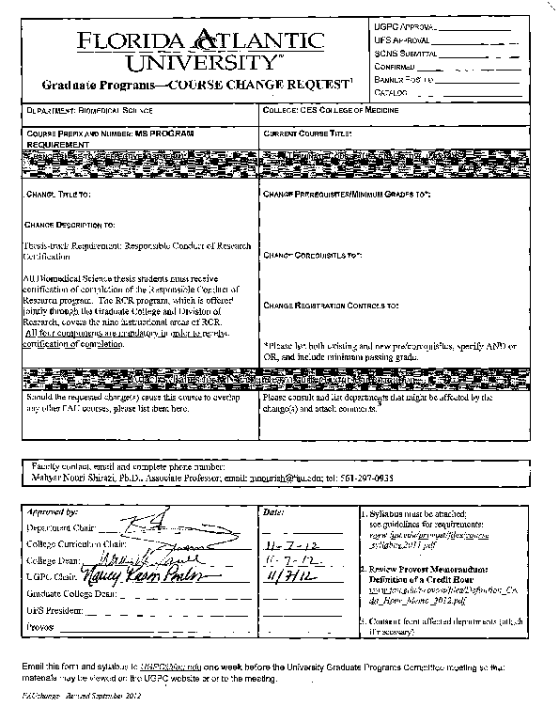

Item 7.b.
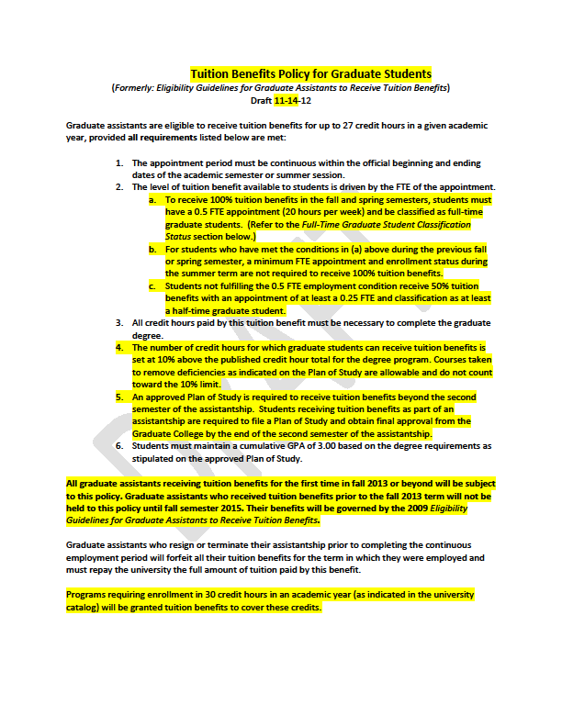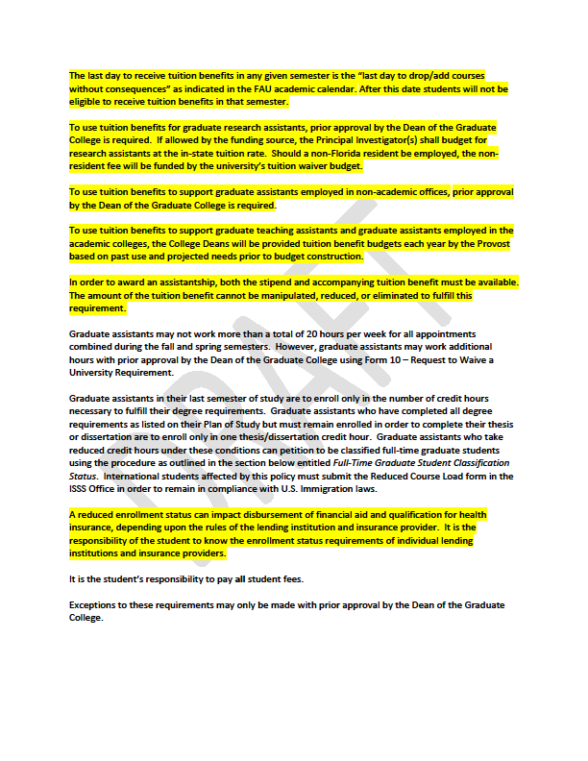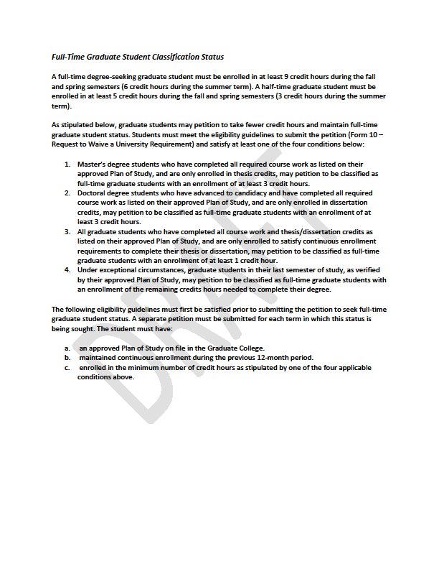
*******
Memo from Dean Rosson
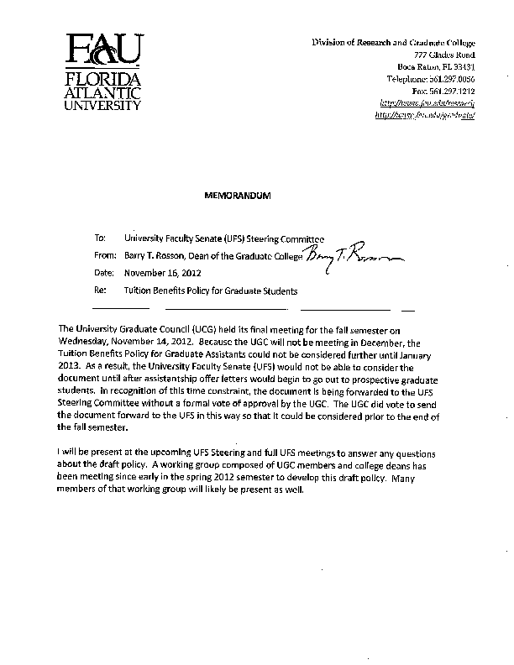
******************
Memorandum from Professor William Rhodes
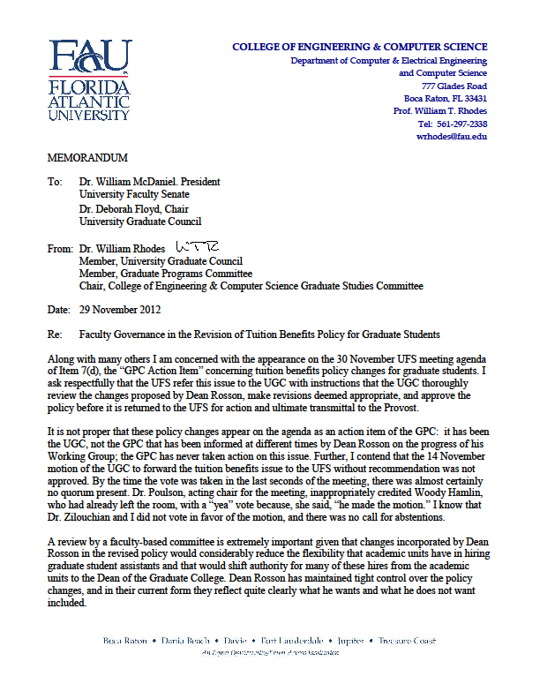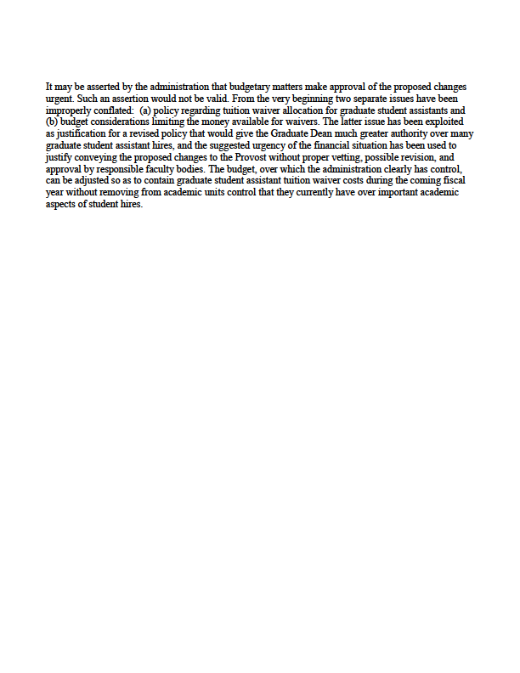

**********************************************
E-mail from UGC Chair Floyd on 11-30-2012

Bill and colleagues:
In preparation for our meeting this afternoon (and in light of the concerns expressed about governance and processes), I am offering these excerpts from two documents approved by graduate faculty regarding graduate governance matters.
First, is the Graduate Governance Document (adopted 2009). You will see the yellow highlight regarding the authority and responsibility of the Graduate Faculty (with the academic authority vested in the University Graduate Council).The authority and responsibilities... "shall include adoption of Graduate College policies and procedures".
Second, the Graduate Programs Committee Governing Procedures (approved by the Graduate Council in 2011) defines responsibilities that are focused on courses, admissions and programs with their recommendations going forward to Graduate Council. The the GPC's policy focus is limited to" policies and procedures regarding graduate student admission and degree completion requirements."
Nancy and I talked this morning and agreed that a case could be made that if the graduate tuition policy is a "Graduate College policy" then the Graduate Council should be charged with voting this up or down. Nancy said that the GC voted to move this forward to the University Steering level, although efforts to obtain evidence from the tape recording of the meeting have not been successful.
I hope this is helpful. See you in a few hours.
All the best,
deb

Professor Floyd pointed out that the GPC passes all items through the UGC. Therefore, Steering and Senate documents should refer to the UGC for consent and action agenda items.

