1. The UFS meeting was called to order by William McDaniel, President, at 2:00 p.m. in Nursing 201 on the Boca Raton Campus and videoconference at the Davie Campus, the SeaTech Campus, the Fort Lauderdale Campus, the Harbor Branch Campus, and the Jupiter Campus.

Members present: see appendix for spreadsheet.

Guests present: Janet Cramer, Ed Pratt [Undergraduate Dean], Diane Alperin [Associate Provost], Robert Trammell, Thomas Fernandez, Brett Laursen, Jayhun Goo and Chris Robe`.

2. Without one addition and no objection, the Senate accepted the November 30, 2012 UFS minutes

3. The President’s report: a. The Assessment Committee is meeting to formulate online SPOT recommendations; b. The Library Advisory Committee is convening; c. President Saunders will host a Q&A coffee, February 15, 9-11 at the Stadium Recruiting Room; d. Year-over-year Spring enrollment increased 2.2% in both headcount and credit-hours. Doctoral enrollment increases 2.9%. Underclassmen increased up toward about 4%; e. The Senate’s own Professor Morton Levitt made an extraordinary contribution to the FAU Foundation to support medical student scholarships; f. Trustee Dr. Jeffrey Feingold made a $250,000 contribution toward the renovation of the BOT room for expansion, technology and remodeling. Perhaps this Fall, the Senate can return to its traditional home meeting room.
4. UPC Consent Agenda [see appendices]: Accepted without objection

5. UPC Action Item [see appendices for details]:
a. ITOM in conjunction with the Marketing Department proposed a new minor in Digital Marketing. Explanatory comments were by Jayhun Goo. Approved by majority vote

6. UGC Consent Agenda: none

7. UGC Action Items [see appendices]:
a. College of Science: changes to the MA in Psychology. Brett Laursen explained that the changes were long overdue housekeeping and updating. Approved by majority vote
b. College of Science: changes to the PhD in Psychology. Brett Laursen explained that the changes were long overdue housekeeping and updating. Approved by majority vote

8. Business items: None

9. Speaker: Vice President Gitanjali Kaul briefed the Senate on the February site visit by the SACS and fielded questions and comments.

10. Open Forum with the Provost: The Provost was unable to attend.

10. Good of the Senate: Senator Bosshardt shared observations about some classroom configurations he had observed in other states. He suggested that before any new classroom space is constructed at FAU, we should examine the success [or lack thereof] of innovative configurations used by others. Senator Harris proffered that the acronym “QEP” is not informative. He opines “Undergraduate Research Program” is more descriptive and would attract more participation. Vice Provost Alperin replied to an inquiry about UFF and FAU negotiations, saying that they continue.

11. Adjournment was at 2:45 p.m.

Appendices

Item 1: Attendance Spreadsheet
College - # of Seats | First Name | Last Name | Jan
Engineering - 3 | Jonathon | Bagby
 | Evangelos | Kaisar
 | Hari | Kalva
DSI - 3 | Philippe | D'Anjou | x
 | Michele | Hawkins
 | Bruce | Arneklev | x
Honors - 2 | Kanybek | Nurtegin | x
 | Jon | Moore
Business - 5 | John | Valentine
 | Jim | Han
 | Eric | Shaw | x
 | Stuart | Galup | x
 | Bill | Bosshardt | x
Education - 4 | Deborah | Floyd | x
 | Joseph | Furner | x
 | David | Kumar
 | Meredith | Mountford
A&L - 9 | MaryAnn | Branaman
 | Brian | McConnell | x
 | Mike | Harris | x
 | Douglas | McGetchin | x
 | Tim | Lenz | x
 | Max | Kirsch
 | Fred | Fejes
 | Yolanda | Gamboa | x
 | Jennifer | Low
Science - 6 | Chris | Beetle | x
 | Stephen | Locke | x
 | James | Kumi-Diaka | x
 | Markus | Schmidmeier | x
 | Fred | Hof fman
 | Tom | Monson | x
Medicine - 2 | Morton | Levitt | x
 | Kathleen | Guthrie | x
Nursing - 1 | Susan | Dyess | x
Library - 2 | Lauri | Rebar | x
 | Teresa | Van Dyke | x
Senator | First Name | Last Name | Jan
Presidential Rotation:
Senate President | William | McDaniel | x
Past president or president elect | Ronald | Nyhan | x
Faculty Assembly Heads:
EO Medicine | Rainald | Schmidt-Kastner | x
EO Science | Jerry | Haky | x
EO Engineering | Khaled | Sobhan
EO DSI | Rosalind | Carter
EO Honors | Warren | McGovern
EO Education | Philomena | Marinaccio-Eckel | x
EO A&L | Marshall | DeRosa
EO Business | John | Bernandin | x
EO Library | Kristy | Padron
EO Nursing | Bernadette | Lange
Committee Chairs:
Academic Freedom and Due Process Committee
Admission and Retention Committee
Assessment Committee | Nancey | France
Athletics Committee | Eric | Shaw | x
Distance Education Committee
Graduate Council | Deborah | Floyd | x
Honors and Awards Committee | Michelle | LaRocque
Library Advisory Committee
Promotion and Tenure Committee
Research Committee | Arlene | Fradkin
Undergraduate Programs Committee | Jerry | Haky | x
Graduate Programs Committee | Nancy | Poulson | x
Committee on Committees | Valerie | Bryan | x
Nonvoting Members:
President | Mary Jane | Saunders
Provost | Brenda | Claiborne

**************************************************************************

Item 4.

 | Consent Agenda Items
 | UUPC Meeting of November 30, 2012
1. New course from the College for Design and Social Inquiry: |  |  |  | Senate Approved?
URP 4851 | Urban Design: Theories and Methods | 3 | New | yes
2. New courses and course changes from the Harriet L. Wilkes Honors College:
ANT 2410 | Honors Culture and Society | 3 | Remove WAC | yes
ANT 4241 | Honors Ritual and Symbolism | 3 | Add WAC | yes
ART 2663C | Honors Multimedia Narrative Expressions in the Arts | 3 | New | yes
MAA 4202 | Honors Modern Analysis 2 | 3 | New | yes

***************************************************************************
Item 5.

University Undergraduate Programs Committee (UUPC) Action Item

- New ITOM Minor in Digital Marketing Senate approved, January 18

Proposal to create a Minor in Digital Marketing, jointly offered by ITOM and Department of Marketing

Jobs in Digital Marketing
Information Systems and Web and Social media connectivity have become a key consideration for Marketing and Sales professionals and executives today.

The need for highly trained professionals who understand both information system and digital media and marketing to strategize, implement, and take full advantage of the digital media to accomplish the marketing goals of a company or institution is growing. Robert Hall Technology Survey, 2011, and Manpower group talent shortage survey, 2012, project 80% growth of jobs in digital marketing and web and social media analysts for the next 7 years. According to McKinsey Global Survey, November 2011, “Digital media and online tools remain a largely untapped resource for companies. Most marketing executives agree that their online presence is important and that digital tools provide their companies with a major opportunity, but few are familiar with the structural steps required to benefit from selling online or engaging consumers through new technologies such as social media.” The proposed minor addresses exactly these needs.

Skills needed
The skills needed for Digital Marketing are inherently interdisciplinary comprising both of knowledge in Marketing and Information Technologies. These two disciplines are taught in business schools, but unless a cross disciplinary minor is created to encourage specialization in this field, students rarely take courses across the two disciplines to acquire the necessary knowledge. This minor will provide the opportunity to the students.

Among the most important competency skills acquired in this minor are: 1) Information Systems and Web and Social media vocabularies and terminologies used in the organization’s digital marketing strategies, 2) Use of specialized technologies to meet specific organization needs such as marketing research, web analytics, data mining, and search engine optimization (SEO), 3) Use of technology, including hardware and software, to ensure data collection, storage, analysis and reporting of information, 4) Use specialized software in the completion of Digital Product processes such as record tracking, release of information, coding, grouping, registries, billing, quality improvement, and imaging, 5) Apply policies and procedures to the use of networks, including intranet and Internet applications to facilitate the electronic records 6) Apply knowledge of data base architecture and design (such as data dictionary, data modeling, data warehousing), 6) Query and generate reports to facilitate information retrieval, 7) Design and generate reports using appropriate software, 8) Protect data integrity and validity using software or hardware technology,
The objectives of this minor relate specifically to the above listed skills.

The proposal:
The Minor in Digital Marketing is a 12 credit program offered jointly by the Department of Marketing and the Department of Information technology and Operations Management (ITOM). The Minor is available to all FAU degree seeking students and enhances the qualifications of students pursuing careers in fields related to business, marketing, and information technologies. Students will acquire knowledge and skills in online and digital business and digital product delivery as well as in developing, analyzing, and enhancing a company’s presence on the web and the Social Networking space. Professions and majors that will benefit from the minor include Marketing, Business Development, Business Strategy, Information Technology, Management Information Systems, and others.
The Minor requires successful completion of the courses below with minimum grades of “C". At least 9 of the 12 credits must be earned from FAU. For non-Business majors, waiver of prerequisites will be made on a case-by-case basis.

ITOM will be the primary department responsible for advising the students about the Digital Marketing Minor. A maximum of 3 credits used for the minor may count toward other Business major requirements. A minimum of two courses (6 credits) must be exclusive to the minor. For exceptions, a petition should be submitted to the ITOM Department Chair or the Department of Marketing Chair.
ITOM – 6 credits.
Choose two courses from the following 4:
1. ISM 4420 Social Media and Web Analytics
2. ISM 4041 Social, Legal, and Ethical Issues of Digital Data
3. ISM 3007 Social Media Innovation
4. ISM 4054 Social Media and Web technologies

Department of Marketing – 6 credits:

- MAR 4613 Marketing Research
- MAR 4721 Marketing on the Internet

Both Marketing Department and ITOM have voted unanimously for the minor.

*****************************************************************************
Item 6. UGC has not met after November 30 Senate meeting

*****************************************************************************
Items for 7: UGC and Steering forwarded these for the November 30 meeting. The College of Science requested a delay until the January Senate meeting. At the January 18 meeting, the Senate approved the changes to both the MA and the PhD in Psychology.


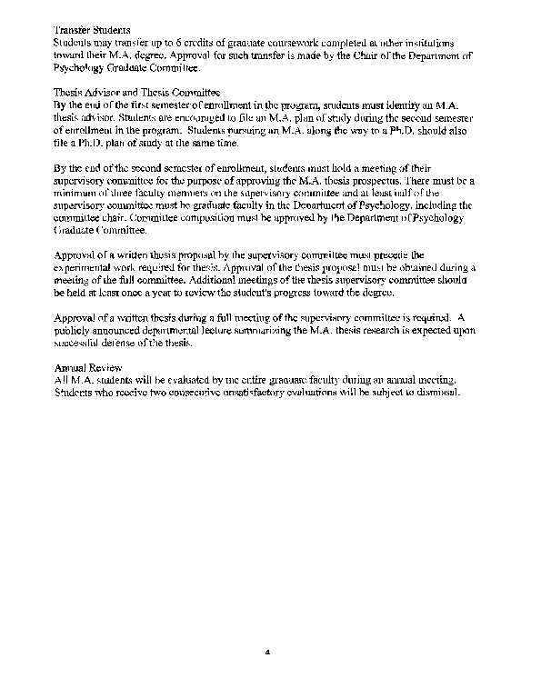

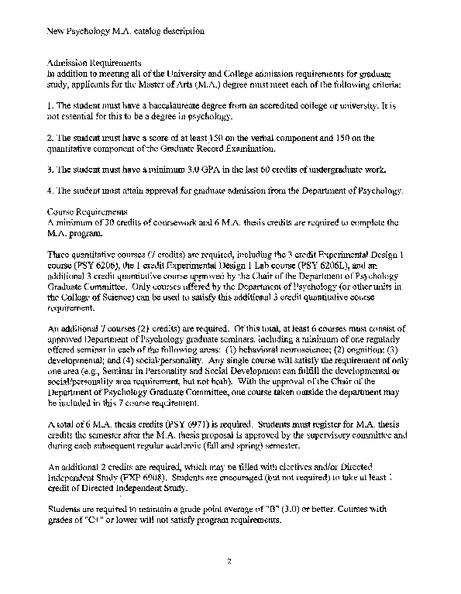

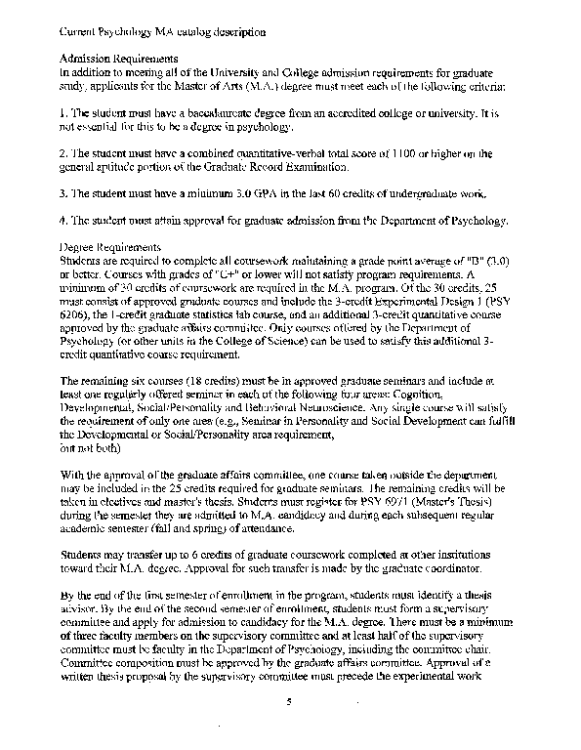

*************************************************************************

Executive Summary of Experimental Psychology Ph.D. Degree Changes
The Experimental Psychology Ph.D. degree now requires a minimum of 80 credits with no fixed number of M.A. thesis or Ph.D. dissertation credits. Changes were made to the Ph.D. degree requirements to (a) reflect the reality that no students ever completed the program with only 80 credits, (b) specify the minimum number of thesis and dissertation credits required for graduation, and (c) increase the number of elective courses (from 2 to 3) required for graduation. The new requirements are designed so that students can complete the degree in 4 years by taking a full time (9 credits per semester) load for 4 academic (spring and fall semesters) years, plus a full time (6 credit) load for 3 summers. The typical student in the program now takes 5 years to complete the degree; most do not take a full time load during the summer because no graduate seminars are of fered during the summer.

New Experimental Psychology Ph.D. catalog description
The Department of Psychology offers graduate study leading to a Doctor of Philosophy in Experimental Psychology. Students may select major and minor areas of study from five areas of psychology: behavioral neuroscience, cognition, developmental psychology, evolutionary psychology and social/personality.
Admission to Doctoral Study In addition to meeting all of the University and College admission requirements for graduate study, applicants for the Doctor of Philosophy (Ph.D.) degree must meet each of the following criteria:
- The student must have a baccalaureate degree from an accredited college or university. It is not essential for this to be a degree in psychology.
- The student must have a score of at least 153 on the verbal component and 152 on the quantitative component of the Graduate Record Examination.
- The student must have a minimum 3.0 GPA in the last 60 credits of undergraduate work.
- The student must attain approval for graduate admission from the Department of Psychology.

An admitted applicant will usually have a strong record of achievement that is higher than the minimum requirements. In considering applications for admission to the Ph.D. program, the
decision of the graduate admissions committee will be based on an evaluation of a student's
record and the likelihood of success in the program. The committee will consider a number of
factors that include, but are not limited to:
- The applicant's record of achievement based on GP A, GRE scores and letters of recommendation;
- The applicant's promise for research productivity while in graduate school; and
- The availability and willingness of a faculty member to serve as a mentor for the student.

Students admitted to the Ph.D. program will be assigned an advisor by the Department of
Psychology Graduate Committee who will supervise their research and chair their M.A. thesis
and Ph.D. dissertation committees. Considerable effort is devoted to matching students with
advisors. As a consequence, few students change advisors. Changing advisors is not generally
recommended because it slows progress toward graduation. The best time to change advisors is
after completion of the M.A. degree but before admission to doctoral status. Students who
change advisors must do so in consultation with the Chair of the Department of Psychology
Graduate Committee. Students without an advisor cannot continue in the program.
Course Requirements
Ph.D. students will complete the M.A. degree requirements as described above.
A total of 90 credits is required to complete the Ph.D. program. Up to 36 hours of credits (30 credits of coursework + 6 thesis credits) that were used to satisfy the M.A. degree requirements
are typically counted toward the Ph.D. degree requirements. No more than 6 M.A. thesis credits may be transferred to satisfy the doctoral degree requirements.
A total of 4 quantitative courses (10 credits) is required. All doctoral students must take the 3 credit Experimental Design I course (PSY 6206) or the 3 credit Experimental Design 2 course (pSY 6207), but they need not take both. The 1 credit Experimental Design 1 Lab course (PSY 6206L) is required, but this requirement may be waived with the written approval of the advisor. All quantitative courses outside of the Experimental Design sequence must be approved by the Chair of the Department of Psychology Graduate Committee. For students who take both Experimental Design I and Experimental Design 2, the third 3 credit quantitative course must be a course offered by the Department of Psychology (or another unit in the College of Science).
Students must take 5 courses (15 credits) in their major area.
An additional 6 courses (18 credits) are required. Of this total, students must take at least one regularly offered Department of Psychology seminar in each the following areas of concentration (excluding the student's major area): (1) behavioral neuroscience; (2) cognition; (3) developmental; and (4) social/personality. Any single course will satisfy the requirement of only one area (e.g., Seminar in Personality and Social Development can fulfill the developmental or social/personality area requirement, but not both). Courses taken outside of the Department of Psychology must be approved by the student's advisor and the Chair of the Department of Psychology Graduate Committee.
A minimum of 9 Ph.D. dissertation credits (PSY 7980) are required. Students must register for dissertation credits starting the semester after they are admitted to candidacy and during each subsequent regular academic (fall and spring) semester.
An additional 32 credits are required, which may be filled with electives, dissertation credits, Advanced Research in Psychology (pSY7978), and Directed Independent Study (EXP 6908).
Taken together, doctoral students must complete a minimum of 10 graduate courses (30 credits) in the Department of Psychology (excluding thesis and dissertation credits, advanced research in psychology, and directed independent study).
Students are required to maintain a grade point average of "B" (3.0) or better. Courses with grades of "C+" or lower will not satisfy program requirements.
Transfer Students
Students admitted to the Ph.D. program may transfer up to 30 graduate credits taken at other
institutions. Transfer courses must be relevant to the student's program of study and must be
approved by the student's advisor and the Department of Psychology Director of Graduate
Studies. Requests to transfer credits into the student's area of concentration are not typically approved.
Doctoral students who have completed an M.A. thesis at another university or in another
department at FA U may substitute this thesis for the M.A. thesis as part of the requirement for
admission to doctoral candidacy if it is approved by the student's advisor and the Chair of the
Department of Psychology Graduate Committee.
Admission to Doctoral Status

Admission to doctoral status requires successful completion of Ph.D. coursework, successful completion and approval of a written M.A. thesis, the formation of a doctoral dissertation supervisory committee, and approval of a written dissertation proposal by the doctoral dissertation committee.
In addition, comprehensive exams must be completed before a doctoral student is admitted to candidacy. Comprehensive exams are designed to demonstrate a breadth of knowledge in the student's area. A student's comprehensive exam committee must include at least three members of the graduate faculty in the FAD Department of Psychology. The comprehensive exam committee is chaired by the student's advisor. The minimum comprehensive exam includes an eight-hour, closed-book essay exam, which may be spread across two separate days. The student must complete at least two written essays for each member of the committee. Additional evaluation material (e.g., more essays, short answer questions, oral questions) may be requested by the comprehensive exam committee. Exams are graded as follows: pass, fail or conditional pass (a pass grade contingent on successful demonstration of competence not evident in the initial exam). A unanimous pass vote from the committee is required to complete the comprehensive exam degree requirement.
Dissertation Advisor and Dissertation Committee The doctoral dissertation supervisory committee must consist of at least five members. At least half of the committee must be graduate faculty in the Department of Psychology, including the committee chair. At least one member of the doctoral committee must be a faculty member from outside of the Department of Psychology. Committee composition must be approved by the Chair of the Department of Psychology Graduate Committee.
A central requirement for the Ph.D. degree is submission and defense of a dissertation based on original work in an area of specialization acceptable to the student's doctoral dissertation supervisory committee. The dissertation must be approved by the doctoral dissertation supervisory committee, the department chair and the Graduate College.
Doctoral dissertation supervisory committee approval of a written dissertation proposal must precede the experimental work required for the dissertation. Approval of the dissertation proposal must be obtained during a meeting of the full doctoral dissertation supervisory committee. Additional meetings of the doctoral dissertation supervisory committee should be held at least once a year to review the student's progress toward the degree.
Approval of a written dissertation during a full meeting of the doctoral dissertation supervisory committee is required. A publicly announced departmental lecture summarizing the Ph.D. dissertation research is expected upon successful defense of the dissertation.
Annual Review All Ph.D. students will be evaluated by the entire graduate faculty during an annual meeting.
Students who receive two consecutive unsatisfactory evaluations will be subject to dismissal
Current Experimental Psychology Ph.D. catalog description
The Department of Psychology offers graduate study leading to a Doctor of Philosophy in Experimental Psychology. Students may select major and minor areas of study from five areas of psychology: behavioral neuroscience, cognition, developmental psychology, evolutionary psychology and social/personality.
Admission to Doctoral Study Minimum requirements for admission to the Ph.D. program are the same as for the M.A. program. However, an admitted applicant will usually have a strong record of achievement that is higher than the minimum requirements. In considering applications for admission to the Ph.D. program, the decision of the graduate admissions committee will be based on an evaluation of a student's record and the likelihood of success in the program. The committee will consider a number of factors that include, but are not limited to:
- The applicant's record of achievement based on OPA, ORE scores and letters of recommendation;
- The applicant's promise for research productivity while in graduate school; and
- The availability and willingness of a faculty member to serve as a mentor for the student.

Students admitted to the Ph.D. program will be assigned an advisor by the graduate affairs committee who will supervise their research and chair their M.A. thesis and Ph.D. dissertation committees. Considerable effort is devoted to matching students with advisors. As a consequence, few students change advisors. Changing advisors is not generally recommended because it slows progress toward graduation. The best time to change advisors is after completion of the M.A. degree but before admission to doctoral status. Students who change advisors must do so in consultation with the graduate coordinator. Students without an advisor cannot continue in the program.
Admission to Doctoral Status Admission to doctoral status requires successful completion of Ph.D. coursework, successful completion of a comprehensive exam, successful completion and approval of an M.A. thesis, the formation of a doctoral dissertation committee and approval of a written dissertation proposal by the doctoral dissertation committee.
Comprehensive exams must be completed before a doctoral student is admitted to candidacy. Comprehensive exams are designed to demonstrate a breadth of knowledge in the student's area. A student's comprehensive exam committee must include at least three members of the graduate faculty in the F AU Department of Psychology. The comprehensive exam committee is chaired by the student's advisor. The minimum comprehensive exam includes an eight-hour, closed-book essay exam, which may be spread across two separate days. The student must complete at least two written essays for each member of the committee. Additional evaluation material (e.g., more essays, short answer questions, oral questions) may be requested by the comprehensive exam committee. Exams are graded as follows: pass, fail or conditional pass (a pass grade contingent on successful demonstration of competence not evident in the initial exam). A unanimous pass vote from the committee is required to complete the comprehensive exam degree requirement.
The doctoral dissertation committee must consist of at least five members. At least half of the committee must be faculty in the Department of Psychology, including the committee chair. At
least one member of the doctoral committee must be a faculty member from outside of the Department of Psychology. Committee composition must be approved by the graduate affairs committee.
Course Requirements Ph.D. students must satisfactorily complete a minimum of 80 credits. Students must complete a minimum of 10, 3-credit graduate courses in psychology, maintaining a GPA of "B" (3.0) or better. Courses with grades of "C+" or lower will not satisfy program requirements. Students must complete three quantitative courses plus a statistics lab. The statistics lab may be waived with the written approval of the advisor. All doctoral students must take Experimental Design I or Experimental Design 2, but they need not take both. All quantitative courses outside of the Experimental Design sequence must be approved by the graduate affairs committee. Students who take both Experimental Design 1 and Experimental Design 2 must take their third 3-credit quantitative course from the Department of Psychology (or other units in the College of Science). Students must also complete five courses in their major area (i.e., behavioral neuroscience, cognition, developmental psychology, evolutionary psychology or social/personality) and one course in each of the other areas of concentration, excluding evolutionary psychology. The remaining credits may be obtained through dissertation credits, master's thesis credits, directed independent study in psychology and elective courses, which may include non-psychology courses approved by the student's advisor and the graduate affairs committee. Students must register for PSY 7980 (Dissertation) during the semester they are admitted to doctoral candidacy and during each subsequent regular academic semester (fall and spring) of attendance.
Students admitted to the Ph.D. program may transfer up to 30 graduate credits taken at other institutions. Transfer courses must be relevant to the student's program of study and must be approved by the student's advisor and the graduate coordinator. Requests to transfer credits in the student's area of concentration are not typically approved.
Doctoral students who have completed an M.A. thesis at another university or in another department at FAU may substitute this thesis for the M.A. thesis required for admission to candidacy ifit is approved by the student's advisor and the graduate coordinator.
Dissertation Requirements A central requirement for the Ph.D. degree is submission and defense of a dissertation based on original work in an area of specialization acceptable to the student's doctoral committee. The dissertation must be approved by the doctoral committee, the department chair and the Graduate College.
Supervisory committee approval of a written dissertation proposal must precede the experimental work required for the dissertation. Approval of the dissertation proposal must be obtained during a meeting of the full doctoral dissertation committee. Additional meetings of the doctoral dissertation committees should be held at least once a year to review the student's progress toward the degree.
A publicly announced departmental lecture summarizing the Ph.D. dissertation research is required.
All Ph.D. students will be evaluated by the entire graduate faculty during an annual meeting. Students who receive two consecutive unsatisfactory evaluations will be automatically discontinued from the program.

