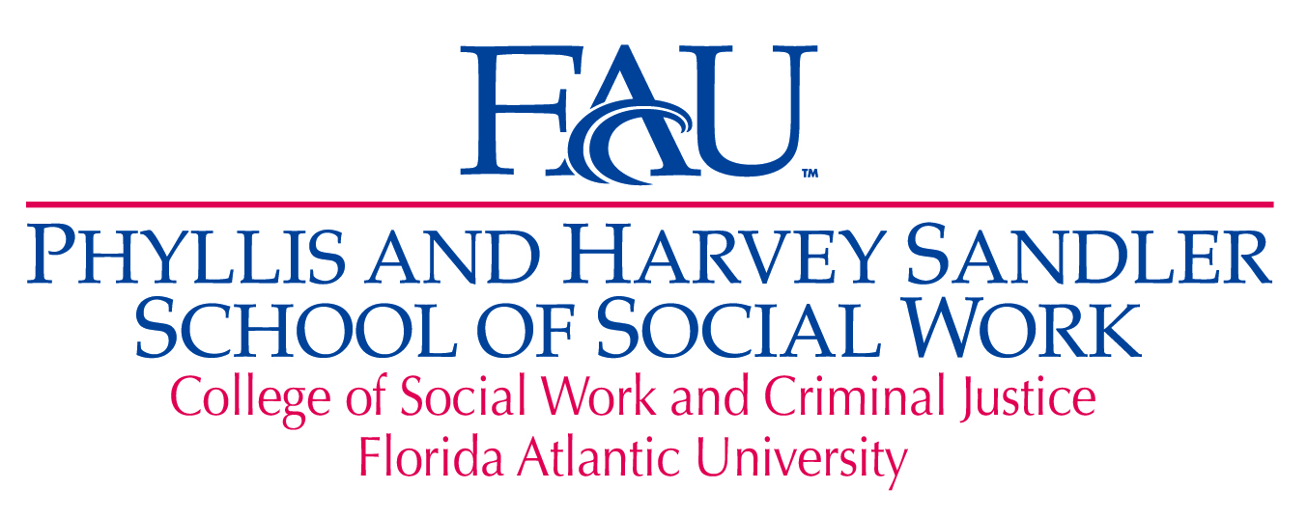

LENDING LIBRARY PROGRAM APPLICATION
1. Complete the entire application. Incomplete forms will not be processed.
2. Email completed application to Program Assistant Valerie Ricciardi at vricciardi@fau.edu.
3. Please submit only one application. To make changes to your application, contact Valerie Ricciardi at vricciardi@fau.edu.
4. You will be notified by email or phone if your books are available for pickup. Please note that books will not be available until the first week of classes.
5. You will be required to sign for your book when you pick up your order.

Personal Information
First Name:
Last Name:
Student Z Number:
Contact Phone Number:
FAU Email Address:
Phone Number: | ( ) -

I am currently receiving FAU Financial Aid: ☐ Yes | ☐ No
INSTRUCTIONS FOR COMPLETING THE TABLE BELOW.
YOU MUST PROVIDE ALL THE INFORMATION REQUESTED FOR EACH BOOK
Enter the information for the book you want most and continue with the books you want least.
Enter the course number associated with the book you are requesting (example: SOW4700)
Enter the official course name as shown on your registration form or in catalog (example: Social Work Practice 1)
Enter the exact name of the textbook you are requesting. Do not use abbreviations.
Enter the name of the textbook author(s). For multiple authors enter in as many names as the text area allows,
Enter the publisher’s edition number if applicable. (example: 3rd Edition)

BOOK #1 – (1st preference)
Course Number:
Course Name:
Textbook Name:
Textbook Author:
Textbook Edition:

BOOK #2 – (2nd preference)
Course Number:
Course Name:
Textbook Name:
Textbook Author:
Textbook Edition:
Please explain why you are
requesting a book loan:

I understand I will need to attach by email to tmarsha5@fau.edu the following documents following submission of this application:
- Your Student Detail Schedule as shown in MyFAU.
- A document showing your Financial Aid Award Summary from MyFAU or
received from the FAU Financial Aid office - (This is only needed if you are a Financial Aid recipient.)
I understand I may only receive two books, and I may not write, underline, highlight or remove any pages from the book.
I understand, if I am tardy in returning my book on two or more occasions, I will be ineligible to participate in the book loan program.
I agree to pay new book replacement costs if it is defaced, lost, stolen or damaged.
Each book option I have requested is a required/core course for social work courses.
For notification purposes, the telephone number I have entered is a working number and has voicemail capabilities.
If I acquire one of these books from another source, I will notify the Sandler School of Social Work to remove that book from my application.
If I buy my book from the bookstore, I know to return it with my receipt to get a full refund within the bookstore’s grace period.
I understand that my application will not be considered if it is INCOMPLETE.
☐ CLICK TO INDICATE YOU HAVE READ AND UNDERSTOOD ALL STATEMENTS ABOVE.
Student Signature:
Today’s Date:

