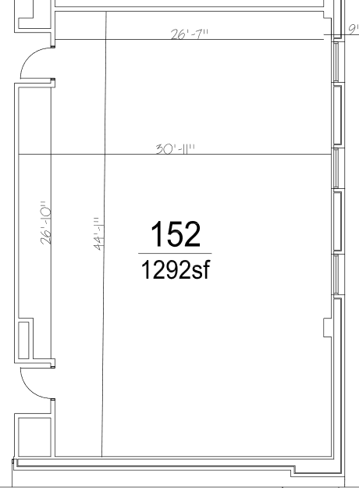
Room to be Used for WiFi Event (PS 152)
2023 Southeast Regional Science Olympiad at FAU
Feb 25, 2023

