  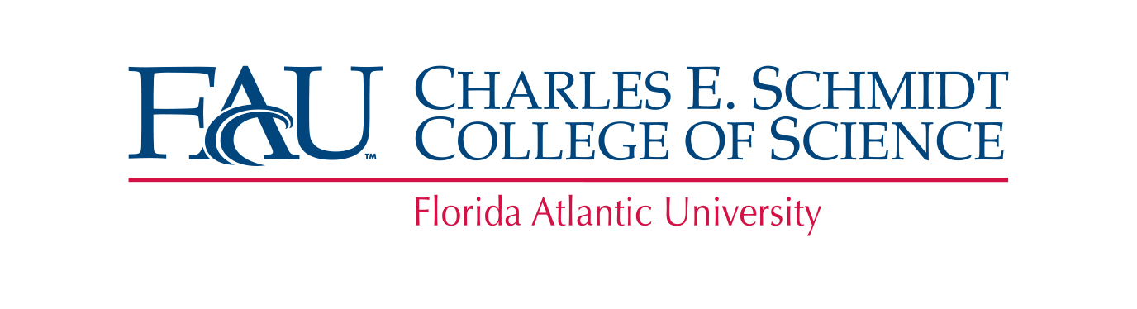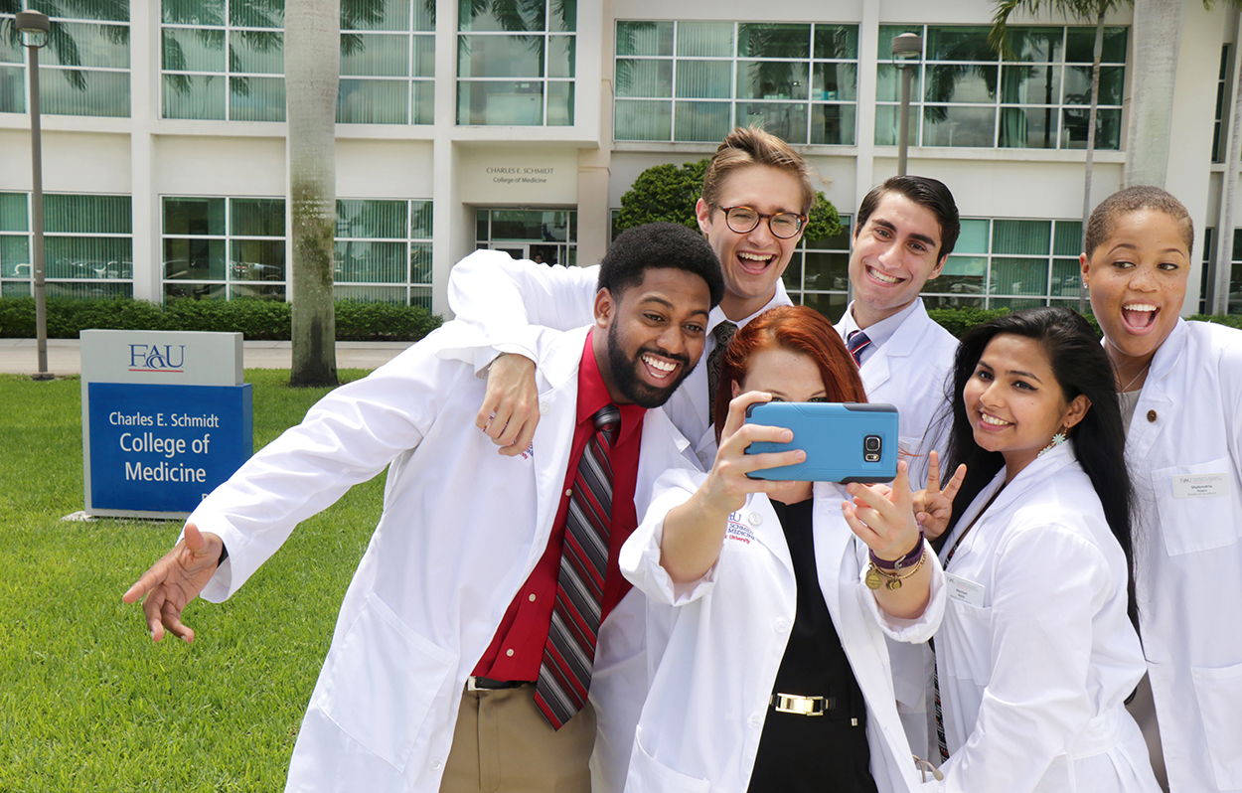
    - Join us for a Virtual
    - STUDENT PANEL Workshop
    - on Webex
    - Ask questions to current Pre-Health Professions students who applied and got accepted in the 2020 cycle. The student panel will provide insight and perspective for the application and interview process.
  The Pre-Health Professions advisors will offer you advice while the student panel gives you an overview of their experience.
  INFORMATION
  June 22, 2020
  https://fau.webex.com/fau/onstage/g.php?MTID=e03873a54981701d4affcda70e8809ebc
  @ 11:30-1:00 AM
  June 24,2020
  https://fau.webex.com/fau/onstage/g.php?MTID=e96eeb48338f77822ab672671584f565b
  @ 9:30-11:30 AM
  eNGage & Interact Virtually with other Pre-HEalth Students
  Q & A Session
  interaction with current medical students and faculty
  eNGage & Interact Virtually with other Pre-HEalth Students

