in the News

updates from the Charles E. Schmidt College of Science
January 6, 2017

FAU ranked #3 as "most affordable" Florida Universities

College Choice Releases 2017 Ranking of the Most Affordable Colleges in Florida. FAU is ranked number three in the state. Read full article here.

traffic noise reduces birds’ response
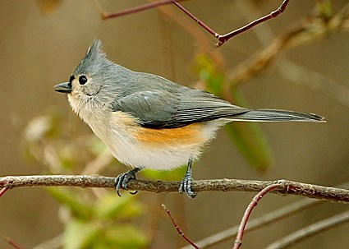
A new study from The Condor: Ornithological Applications shows that traffic noise makes birds less responsive to alarm calls that would otherwise alert them to dangers such as predators. "Gall and Damsky's experiment helps us understand how human-caused noise can interfere with the transfer of information among animals in social groups," according Florida Atlantic University's Rindy Anderson, an expert in vocal communication in birds who was not involved with the study. "It's interesting that the birds' foraging behavior was not affected under any of the playback conditions, which suggests that the behavioral effects were due to the call playbacks being masked by noise, rather than the noise being simply aversive."
Read the full story here. Learn more about Dr. Anderson’s work here.

Bonding with baby even with postpartum
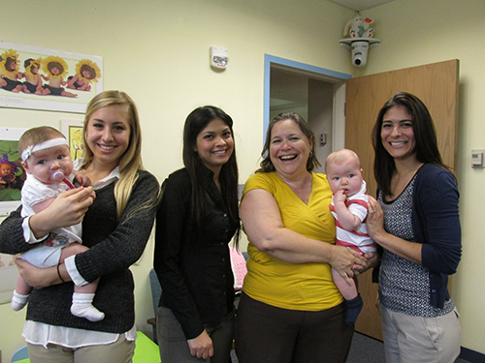
Nancy Aaron Jones, Ph.D., a child psychologist at Florida Atlantic University’s Department of Psychology and Behavioral Neuroscience in Fort Lauderdale, Florida, wanted to know how a baby’s physiology, behavior and interactions with their mother change depending on whether the mother is depressed.

But how can you measure a baby’s mood?

Aaron Jones said, “They call oxytocin the love hormone. We know that in mothers it’s elevated but what we are specifically looking at in this study is how that changes with the mother’s feeding and touch pattern but also the baby’s
Read the full article here.

student working to improve inclusion
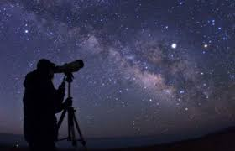
Although nearly 30 percent of U.S. citizens are African-American, Hispanic, Pacific Islander or Native American, these groups make up only 4 percent of the astronomical community. This gap represents major lost opportunity, both for thousands of individual people and for astronomy as a science. A new program aims to change remedy this loss.
Olivia Weaver, a first-generation college student from Florida Atlantic University, is also applying graduate programs in astronomy this year and credits the program in solidifying her decision to switch from a theater career to pursue astrophysics.
Continue reading here.

in the news is published by the Charles E. Schmidt College of Science

