1. Writing Plan Cover Page

☒First Edition of Writing Plan:
☐Subsequent Edition of Writing Plan: (Please Explain)
Please fill in the gray areas on these forms.

Languages Programs
WEC Unit Name
Languages, Linguistics, and Comparative Literature | Dorothy F. Schmidt College of Arts and Letters
Department | College
Nuria Godón | Assistant Professor of Spanish
WEC Faculty Liaison (Print Name) | Title
ngodon@fau.edu | 561 297 0260
Email | Phone

Writing Plan Ratified by Faculty
Date: | If Vote:
 |  | # yes | # total

Process by which Writing Plan was ratified within unit (vote, consensus, other- please explain):

2. Unit Profile: _______________________
Number of Tenured and Tenure-Track Faculty:
5 | Professors
9 | Associate Professors
5 | Assistant Professors
6 | Instructors
25 | Total

Major(s) Total # students enrolled in Total # students graduating
Please list each major your Unit offers: major of _____________ with major AY ___________

French Program |  | 33 |  | 8
Italian Program |  | 13 |  | 3
Linguistics Program |  | 113 |  | 22
Spanish Program |  | 53 |  | 10

WEC Process | Date | Participated / | # invited
Intro Meeting for Faculty | 8/ 28/ 2014 | 24 | 25
Online Faculty Survey | 8/14 – 10/1 /2014 | 17 | 28
Online Student Survey | 8/14 – 10/1 /2014 | 13 | 25
Online Affiliate Survey | 8/14 – 10/1 /2014 | 35 | 180
Meeting 1 | 10/8/2014 | 15 | 25
Meeting 1 (cont) | 10/29/10 | 13 | 25
Meeting 2 | 11/5/2014 | 9 | 25
Meeting 2 (cont) | 12/5/2014 | 13 | 25
Meeting 3 | 2/17/2015 | 6 | 25
Meeting 4 | 3/17/2015 | 6 | 25
Meeting 4 (cont/FRE) | 3/24/2015 | 4 | 5
Meeting 4 (cont/LIN) | 4/15/2015 | 4 | 5
Meeting 4 (cont/SPN) | 4/8/2015 | 10 | 12

3. Signature Page
Electronic signatures may be submitted in lieu of this page. If this page is submitted as a hard copy, please include a print out of the electronic signature chain here.

WEC Faculty Liaison
Nuria Godón | Assistant Professor of Spanish
WEC Faculty Liaison (print name) | Title
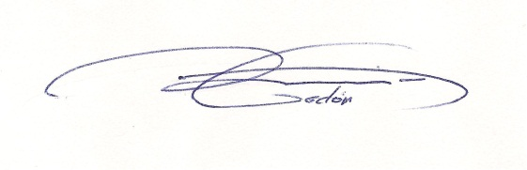 | 5/29/2015
Signature | Date

Department Head/Chair
Marcella Munson | Chair of the Department of Languages, Linguistics, and Comparative Literature  and Associate Professor of French
Print Name | Title
Signature | Date

College Dean
Heather Coltman | Dean of the Dorothy F. Schmidt College of Arts and Letters and Professor of Music
Print Name | Title
Signature | Date

4. WRITING PLAN NARRATIVE

Executive Summary: (1-page) For what reason(s) did this unit (department, school, college) become involved in the WEC project? What key implementation activities are proposed in this edition of its Writing Plan and what, briefly, is the thinking behind these proposed activities?

The Department of Languages, Linguistics, and Comparative Literature (LLCL) offers four mayors: three in Language Programs -including French (FRE), Italian (ITA), and Spanish (SPN)- and one in Linguistics (LIN). The nature of the Language Programs differs from the Program in Linguistics: in the first one, writing is essential at all levels, while in the second one, an intensive level of writing is not required for most courses. Consequently, this specific discipline defers the writing implementation plan until the next proposal edition, in which LIN will have the opportunity to design a new track for the implementation of a writing plan that requires new criteria and the integration of more written assignments in the courses.

LLCL became involved in the Writing Enriched Curriculum (WEC) initiative, due to the general concern among faculty members about students’ writing skills at all levels of English, as well as the writing, reading, and communication competencies at the upper level in lingua. The Department agreed to pilot the WEC initiative in August 2014, since writing is a core competency in our Language Programs. Weak writing and reading skills in upper level courses can hinder the understanding of advanced concepts, resulting in the frustration of students and the disappointment of instructors. The WEC initiative provides us with a valuable tool to address these issues -reflecting together as a faculty upon the challenges found in writing instruction within our discipline- and also acts as a promising platform for improving the writing proficiency among the students in our department.

In this first edition of our writing plan, the WEC Team has collected data on current writing expectations from faculty, students, and affiliates, as well as writing instruction from LLCL faculty. We also had a series of meetings where a chart of desired writing abilities and a chart of desired characteristics for LLCL disciplines were proposed. In order to do so, we took into consideration the writing proficiency that is expected to be reached by the majors in our disciplines by the time they graduate. In addition, we have created measures to evaluate the desired writing abilities -identifying levels of student performance necessary to score student work- and have mapped the courses that are using written assignments, in order to see how these courses can most effectively sequence the aforementioned desired writing abilities. The mapping process revealed a lack of coherent implementation of what professors and students have considered to be the most important points in the writing criteria to achieve an appropriate writing competence by the time which students graduate. These results provided us with a starting point to draw our attention to these writing abilities and to work towards improving their implementation across our curricula.

After discussions on instructional support needed for this first edition of our writing plan, we have considered the key activities to be implemented for this first stage of the writing plan from the Fall of 2015 to the Spring of 2017. These should include a series of workshops on the importance of good reading and writing skills; acquiring a good communicative competence; implementing reading and writing in our courses; developing teaching materials and effective rubrics, as well as providing feedback to students on written assignments. There should also be advice on grading, based on criteria and expectations, all through the support of new
writing and reading pedagogy among faculty, while educating students on the value of reading and writing. In addition to these activities of general interest for the whole department, which would help us to create a common path to their implementation, each language program has proposed different actions based on the gaps and issues in each of the three units. These actions are: an increment implementation in reading materials at the lower division levels; reorganization of courses offered; a creation and reinstallation of writing courses at the upper level; placing a representative at the Writing Center to support students with their written assignments in lingua throughout the drafting, revision and edition stages; and offering “Best Undergraduate Writing in Lingua Awards.” Our main priority is the improvement of writing, reading, and communicative skills in lingua among students, while encouraging our faculty to integrate a coherent progression of reading and writing within and across the curriculum, also respecting the diverse nature of pedagogical approaches to writing in the department.

Section 1: Discipline-specific Writing Characteristics

What characterizes academic and professional communication in this discipline?

The Department of Languages, Linguistics, and Comparative Literature provides students a broad liberal arts background, through coursework in linguistics, language, culture, and literature in interdisciplinary and cross-cultural contexts. In a competitive global context, our programs appeal to a wide variety of students, including humanities-oriented individuals, future educators, and those who wish to broaden their global horizons, while pursuing careers in business, law, healthcare, engineering, international relations, and science, among others. Due to the need to communicate effectively and connect strongly with people from other cultures and nationalities in these professions, it is important to establish and maintain personal and professional contacts, where writing and communication competencies in lingua come into play. The following characteristics cover the writing skills that are expected in Language Programs across curricula to accomplish writing and communication competence in our disciplines:

- Original/original thinking: follow guidelines of academic honesty rules.

- Proper use of language: clear, carefully chosen, and precise, with a high degree of accuracy in written conventions (orthography, accents, punctuation, paragraphing), syntax and morphology, lexicon, style, and linguistic registers. Grammar is effective and appropriate to the task.

- Contextualized: sustained on the importance of the cultural contexts in which texts are written and received.

- Informed: evidence of reading based on professional research done on a specific topic.

- Concise: well-crafted writing. Clear articulation and explicit statement of ideas without being repetitive, avoids unnecessary language or information; on target.

- Organized: logical and effective order (introduction/body/conclusion); main points and details connected; not choppy, strong transitions between paragraphs to maintain order of essay.
- Descriptive: demonstrate a basic understanding of the text by summarizing what is being presented.

- Argumentative: persuades readers through a thesis-driven argument.

- Analytical: logical examination through selection of appropriate examples from the chosen work to support the response in a convincing way, how the ideas expressed in the citations are reflected in the text, evidence of good understanding of the text.

- Critical: interpretation and evaluation of the text, synthesizing and explaining information from a range of sources to fully reflect the complexities and different perspectives of issues and events. Discuss text(s) with conviction and authority to form independent literary judgments and to support ideas.

- Accurate and appropriate use of literary and linguistic terminology as well as jargon concerned with a particular subject, culture, or profession.

- Use of sources: using well-chosen sources, correctly and smoothly integrated.

- Proper citation: follow MLA or APA style.

Section 2: Desired Writing abilities*

With which writing abilities should students in this unit’s (department’s) major graduate?

The desired writing abilities within the disciplines of Language programs’ curricula (FRE / ITA/ SPN) are:

- Demonstrate awareness of historical and cultural contexts and knowledge of social and political audiences through the study of works.

- Recognize and communicate with specific audiences taking into account different registers, style, tone, and terminology, using them appropriately for the intended audience.

- Propose informed and persuasive arguments based on relevant professional readings/research and carefully chosen sources.

- Analyze ideas, texts, or events offering substantial information. Major points supported with relevant details/examples from a variety of non-literary and literary texts.

- Use critical thinking to analyze, evaluate, and synthesize ideas, texts, or events in both primary and secondary sources developing the ability to form independent literary judgments and support those ideas.

- Organize a coherent narrative structure to flow logically from one point to the next. A coherent narrative must have an introduction that offers a forecasting statement that leads to an organizational framework; a body to develop the topic with effectively integrated examples/citations from works used; and a conclusion that reviews main points, restates thesis, and offers an effective ending.

- Demonstrate competence in morphology, orthography, and syntax: agreement, gender, number, determinants, pronouns, nouns, adjectives, verbs, adverbs, prepositions, and conjunctions are generally accurate, among other grammar components.

- Show command and awareness of genres to implement them in official and non-official correspondence, diaries, compositions, proposals, abstracts, book reviews, papers, and/or works of creative writing.

- Demonstrate an ability to compile appropriately a bibliography (e.g., peer-reviewed) sources from primary and secondary literature, as well as non-literary works that are useful and contribute in comparison to other sources in the bibliography. Information must come from reliable source.

- Conform to MLA, APA bibliographic standards and conventions.

- Follow academic honor code: recognize and understand plagiarism in various forms and demonstrate knowledge and strategies for avoiding it.

* These writing abilities were proposed as a starting point for the first unit’s draft. They will be susceptible to minor changes to better accomplish their implementation in the curricula within the development of this implementation plan.

Section 3: Integration of Writing into Undergrad. Curriculum

How is writing instruction currently positioned in this unit’s undergraduate curriculum (or curricula)? What, if any, structural plans does this unit have for changing the way that writing and writing instruction are sequenced across its course offerings? With what rationales are changes proposed and what indicators signify their impact?

The following visual maps indicate the current state of writing and writing instruction among our majors at the department. These charts link desired writing abilities to the current sequence of courses, clustered into several categories, according to analogous expectations towards written competence. Through them, we point out our three current levels of progression in writing competence, not taking into account the course per se, but rather its function within and across the entire curriculum: E, SB, I. “E” should be read as exposition, “SB” as skill building, and “I” as intensive. The purpose is evaluating the consistency at the progressive level of writing within the curriculum, determining where the gaps that put in danger a coherent progression of written development are, in order to solve them and propose a smooth progression of writing skills.

LANGUAGE PROGRAM: VISUAL MAP- FRENCH

CRITERIA | Cluster  #1  FRE 1120  FRE 1121 | Cluster #2  FRE 2220  FRE 2221 | Cluster#3  FRE 3340  FRE 3400  FRE 3401  FRE 3393 | Cluster #4  FRW 3001  FRW 3102  FRW 3122 | Cluster#5  FOL 3880 | Cluster#6  FRW 4930  FRW 4933
1. Demonstrate awareness of historical and cultural contents and knowledge of social and political audiences | E | E | SB | SB>I | I | I
2. Recognize and communicate with specific audiences | E | E | SB>I | SB>I | I | I
3. Propose informed and persuasive arguments |  |  | E>SB | SB>I | I | I
4. Analyze ideas, texts, or events offering substantial information |  |  | SB | I | SB>I | I
5. Use critical thinking to analyze, evaluate, and synthesize |  |  | SB | I | SB>I | I
6. Organize a coherent narrative structure |  |  | SB | SB>I | SB>I | I
7. Demonstrate competence in morphology, orthography, and syntax | E | E | SB | I | SB>I | I
8. Show command and awareness of genres |  |  | E | SB>I | SB> I | I
9. Demonstrate an ability to compile appropriately a bibliography |  |  |  | E>SB | SB> I
10. Conform to MLA, APA |  |  |  | E>SB | SB | SB
11. Follow academic honor code | E> SB> I | I | I | I | I | I

LANGUAGE PROGRAM: VISUAL MAP- ITALIAN

CRITERIA | Cluster#1  ITA 1120  ITA 1121 | Cluster #2  ITA 2220 | Cluster#3  ITA 2221 | Cluster #4  ITA 4930  ITA 3412  ITA 3300  ITA 4730 | Cluster#5  ITA 3420  ITA 3421 | Cluster#6  ITT 3520  ITT 4440  ITT 3522  FOL 3880 | Cluster#7  ITW 3100  ITW 3101
1. Demonstrate awareness of historical and cultural contents and knowledge of social and political audiences | E | SB | SB | SB> I | SB | SB> I | I
2. Recognize and communicate with specific audiences | E | E | E>SB | I | SB>I | I | I
3. Recognize and practice informed and persuasive arguments |  |  | E | E>SB | E | I | I
4. Analyze ideas, texts, or events offering substantial information |  |  | E | SB>I | SB | SB>I | I
5. Use critical thinking to analyze, evaluate, and synthesize |  |  | E | SB>I | E | SB>I | I
6. Organize a coherent narrative structure |  |  | E | SB>I | E>SB | SB>I | SB>I
7. Demonstrate competence in morphology, orthography, and syntax | E | E | E>SB | SB | E>SB | SB>I | I
8. Show command and awareness of genres |  |  |  | SB | E | SB>I | I
9. Demonstrate an ability to compile appropriately a bibliography |  |  |  | E>SB |  | SB>I | SB>I
10. Conform to MLA, APA |  |  |  | E>SB |  | SB | SB
11. Follow academic honor code | E> SB> I | I | I | I | I | I | I

LANGUAGE PROGRAM: VISUAL MAP- SPANISH

CRITERIA | Cluster  #1  SPN 1120  SPN1121  SPN 1340 | Cluster #2  SPN 2220 | Cluster  #3  SPN 2221  SPN2341 | Cluster #4  SPN 3400  SPN 3343 | Cluster #5  SPN 3500  SPN 3501  SPT 4130  SPT 4800 | Cluster#6  FOL 3880 | Cluster #7  SPW 3012  SPW 3020 | Cluster#8  SPW 4930  SPW4583
1. Demonstrate awareness of historical and cultural contents and knowledge of social and political audiences | E | E | SB | SB | SB> I | I | I | I
2. Recognize and communicate with specific audiences | E | E | E>SB | I | I | I | I | I
3. Recognize and practice informed and persuasive arguments |  |  |  | E | SB | I | I | I
4. Analyze ideas, texts, or events offering substantial information |  |  | E | E | SB | SB>I | I | I
5. Use critical thinking to analyze, evaluate, and synthesize |  |  | E | E | SB | SB>I | SB>I | I
6. Organize a coherent narrative structure |  |  | E | SB | I | SB>I | I | I
8. Demonstrate competence in morphology, orthography, and syntax | E | E | E | SB | I | SB>I | I | I
9. Show command and awareness of genres |  |  | E | E | E | SB>I | SB | I
10. Demonstrate an ability to compile appropriately a bibliography |  |  |  | E | SB |  | SB | I
11. Conform to MLA, APA |  |  |  | E | SB | SB | SB | SB
12. Follow academic honor code | E> SB> I | I | I | I | I | I | I | I

LINGUISTICS PROGRAM: VISUAL MAP- LINGUISTICS

CRITERIA | Cluster#1  LING 2607 | Cluster #2  LING 3100 | Cluster#3  LING 3003 | Cluster #4  LING 4600  TSL 4251
1. Demonstrate awareness of historical and cultural contents and knowledge of social and political audiences | SB |  | E
2. Recognize and communicate with specific audiences | E | E>SB | SB | SB
3. Propose informed and persuasive arguments | E |  | SB | SB
4. Analyze ideas, texts, or events offering substantial information | SB |  | SB | SB
5. Use critical thinking to analyze, evaluate, and synthesize | SB |  | SB | SB
6. Organize a coherent narrative structure | E | SB | SB | SB
7. Demonstrate competence in morphology, orthography, and syntax | E | SB | SB | SB
8. Show command and awareness of genres |  |  |  | E
9. Demonstrate an ability to compile appropriately a bibliography | E |  | SB | SB
10. Conform to MLA, APA | E |  |  | SB
11. Follow academic honor code | E> SB> I | I | I | I

After examining and discussing the visual maps within all the programs, a general consensus has been reached on the need to emphasize the importance of not only writing itself, but also on how to impart a smooth and well organized progression in this learning process. It is with this purpose that the Department of Languages, Linguistics, and Comparative Literature considers the offering of workshops on the importance of reading and writing to be very beneficial in support of changes in the curricula. For this reason, the Department of Languages, Linguistics, and Comparative Literature proposes to invite a diverse group of people, including faculty members, specialists in the implementation of reading and writing in curricula, along with other professionals from diverse pedagogic backgrounds, to give two series of workshops.

The first series of workshops consists of a presentation series and is aimed towards students and professors. The people invited will come from different backgrounds and professions to share their input on how writing is essential on a daily basis for maintaining a successful professional life. On the one hand, the importance of reading and writing in English and in lingua for the achievement of a good communicative competence, will be presented. On the other hand, the benefits which reading and writing provide in the academic and professional contexts throughout a globalized world, where contact and mutual understanding with other cultures is vital, will be emphasized.

The second series of workshops will be aimed towards faculty, although Teaching Assistants, especially those interested in pursuing a profession in teaching or education that involves the development of courses and creation and/or implementation of new material, will be encouraged to attend. Here, the main focus will be the implementation of reading and writing in our courses, as well as the expansion of teaching materials and effective rubrics to develop this implementation plan -taking into account what were considered the four most important writing criteria points by students and professors-, along with the provision of feedback to students on written assignments. There should also be advice on grading, based on criteria and expectations; this will be accomplished through the support of new writing and reading pedagogy among the faculty, while educating students on the value of reading and writing.

Visual maps have also revealed a consensus on the nature and value of writing in Language Programs, which differ from those in the Linguistics program. This was reflected in the amount of courses in which writing is a key component.

Linguistic Program

The Linguistic Program has four courses in which writing is a relevant component. The small number of courses where the desired writing abilities are found indicates that writing is not offered as a fundamental component in the curriculum. Under the current writing criteria, the emphasis on these courses lies within the Skill Building level, with few Exposure and no Intensive levels. The reason is likely that the departmental criteria are based upon writing a research paper as an end product. However, this assignment is not the main objective in this discipline, where writing is a minor component that provides a summary of a study, a phenomenon or a linguistic relation. Therefore, it has been decided in this program to wait until the second edition of the writing plan, while considering other criteria that better align their writing assignments.

French Program

The French visual map shows writing as a major component in most courses across the curriculum. However, this map also revealed a lack of Exposure levels in relevant points 3, 4, 5, and 6 of the writing desired abilities, showing a non-uniform integration of criteria across the curriculum, which affects the development of the literacy competence process. In order to obtain a better flow from one level to the other in these important points, the following recommendation was proposed:

- A revision of the syllabi at the intermediate level, FRE 2220 and FRE 2221, (Cluster 2) to include more readings. These courses should increase the amount of reading through the incorporation of a list of literary and non-literary references with appropriate levels of difficulty (low/intermediate). Also, before-reading/during-reading/after-reading written assignments, based on these references should be implemented and taken into consideration to evaluate the progression of the students’ writing skill.

Italian Program

The Italian visual map shows writing as a major component in most courses across the curriculum. However, this visual map also reveals a weak integration of Exposure and Intensive levels in lingua across the curriculum. On the one hand, Exposure level in relevant points 3, 4, 5, and 6 of the desired abilities only occurs in one course, ITA 2221. On the other hand, an Intensive level in lingua only occurs in two courses at the 3000 level: ITW 3100 & ITW 3101. This affects the development of the literary competence process and requires a reinforcement of both levels. Also, an inconsistency in the sequence across course offerings was revealed, since courses in Cluster # 4 entail a stronger level of writing competence than courses in Cluster # 5.

To improve writing effectiveness in the learning process, the following recommendations were proposed:

- The revision of the syllabi at the first intermediate level, ITA 2220, to include more readings. This course should increase the number of pages read through the incorporation of a list of literary and non-literary references with an appropriate level of difficulty (low/intermediate). Also, pre-reading/whilst-reading/post-reading written assignments, based on these references should be implemented and taken into consideration to evaluate the progression of the students’ writing skill.
- The creation of a course in ITW at the 4000 level or the combination of some ITT and ITW hybrid model (e.g. at the graduate level) with a fourth hour of language discussion led by a Teaching Assistant.
- Making changes in the order of sequences in clusters 4 & 5 to facilitate students taking a course in Cluster # 5 before Cluster # 4.

Spanish Program

The Spanish visual map shows writing as a major component in most courses across the curriculum. However, the visual map also reveals a weak and late integration of Skill Building level in lingua over general criteria, which affects the development of a literary competence process and requires reinforcement and an earlier integration of Skill Building level. The implementation of reading material, which took place in SPN 2221 two years ago, enables a progression in the analysis of texts in SPN 3400, and its equivalent track for Heritage Learners SPN 3343. This progression may be reinforced through the reinstatement of the SPN 3401 elective course. In this manner, a balance between the number of courses and the time dedicated towards the levels of Skill Building and Intensive will be facilitated. In the same way, it is worth considering the inclusion of criterion #3 through the use of texts which have already been implemented in SPN 2221.

To improve writing effectiveness in the learning process, the following recommendations were proposed:

- The reinstatement of SPN3401.
- Assigning a Spanish Program representative at the Writing Center to support Spanish students in upper levels with their written assignments in lingua, throughout drafting, revision and edition stages.

The impact that these measures will have on the students’ learning process will be assessed at the end of 2017, by reviewing and comparing the progress among students who have received the enhanced writing from course to course, and those who have not. This comparative analysis will take writing samples -previously considered by the WEC Team during Fall 2014 to address the desired writing competences- as starting point to observe student’s progression. Also, a survey on the implementation of these measures will be sent to students, Teaching Assistants, and faculty to get data that helps in considering the level of effectiveness of this plan’s implementation.

Section 4: Assessment of Student Writing

How does this unit currently communicate writing expectations (see section 1 &2) to undergraduate students? How satisfied is the unit faculty that students are adequately familiar with these expectations? How satisfied is the unit faculty that student writers are successfully meeting the identified expectations by the time they graduate? Why? If less than satisfied, what plans does the unit propose for closing the gap?

The diagrams in Appendix 1 show significant results about writing characteristics and ability expectations expressed by LLCL faculty in Fall 2014. They also show how faculty communicate these criteria to students. When describing writing, faculty and students consider that the most important characteristics and abilities are: critical, analytical, thesis-driven, and argumentative. This remarkable consensus implies a good communication between faculty and students regarding these criteria. Although, argumentative writing seems to show an incongruence when the evaluation takes into consideration writing characteristics vs. writing abilities. In other words, faculty and students agree on persuasively arguing a position regarding writing abilities, while differing in the value of argumentative writing when focusing in characteristics, the latter being one of the most important aspects for faculty rather than students. Surprisingly, within a context of writing abilities, students show a high interest in persuasively arguing a position, which ultimately marks a joint interest through the importance of argumentation. More importantly, what faculty and students consider to be the most valuable writing characteristics are reinforced by the fact that both, faculty and students, give them in the writing abilities diagram (see number 3, 6, 9, and 13), hence demonstrating that students are adequately familiar with these expectations.

Nevertheless, considering that students are acquainted with these expectations, the unit faculty is not satisfied with the level that students achieve by the time they graduate, in regards to writing. Taking a look into the issues highlighted by all LLCL visual maps, we find out that LLCL curricula have gaps precisely in these specific points of criteria, coinciding with what faculty and students consider the most important aspect- to achieve an appropriate writing competence by the time of their graduation:

- Propose informed and persuasive arguments based on relevant professional readings/research and carefully chosen sources.

- Analyze ideas, texts, or events offering substantial information. Major points supported with relevant details/examples from a variety of non-literary and literary texts.

- Use critical thinking to analyze, evaluate, and synthesize ideas, texts, or events in both primary and secondary sources developing the ability to form independent literary judgments and support those ideas.

- Organize a coherent narrative structure to flow logically from one point to the next. A coherent narrative must have an introduction that offers a forecasting statement that leads to an organizational framework; a body to develop the topic with effectively integrated examples/citations from works used; and a conclusion that reviews main points, restates thesis, and offers an effective ending.

To close this gap, the need has been expressed in Language Programs for ensuring that relevant writing abilities are adequately and logically infused into the curricula. In order to do so, the following actions were proposed:

- To increment readings at 2000 level courses, in order to develop higher levels earlier, through writing these particular criteria.
- To take into consideration the earlier integration of the Exposure level in the curriculum, thus integrating an earlier Skill Building to balance the learning process while offering a more gradual transition from one level to the next.
- To reconsider and change order sequences in course offerings when necessary.
- To create new courses.
- To reinstate old courses.
- To have a representative to work in lingua at the Writing Center
- To offer “Best Undergraduate Writing in Lingua Awards”

In addition, the following rubric addressing measures were utilized to evaluate the desired writing abilities: An identification of levels in student performance, necessary to score student work, was created (see Appendix 2) and an ongoing revision with the help of de Director of Undergraduate Assessment has already started (see Appendix 3)

Section 5: Summary of Implementation Plans and Requested Support

Based on above discussions, what does the unit plan to implement during the period covered by this plan? What forms of instructional support does this unit request to help implement proposed changes? What are the expected outcomes of named support? What kinds of assessment support does this unit request to help assess the efficacy of this Writing Plan? What are the expected outcomes of this support?

Tentative two-year implementation plan:

Semester | Activities:  Instructional and Assessment Support | Personal & Material | Requested Support*
Fall 2015 | 1.Writing and Reading  Workshop for students and faculty  2.Writing and Reading  Assessment Workshop for faculty  3.Selection of readings for  intermediate level courses  4.Creation of FRE Library  5. Revision of rubrics: Ongoing revision of measures to evaluate desired writing abilities  6. Re-approaching LIN writing expectations, assignments, and courses to create new criteria in this discipline | -WEC Subcommittee  - WEC Research Fellowship for a graduate student (or WEC Research Assistant)  -Reading material: book series (low/intermediate levels) | - Guest Speakers: $2000  - WEC RF(to help with activities 1, 2,4):  $1000  - FRE Library:  $2000
Spring 2016 | 1.Writing and Reading  Workshop for students and faculty  2.Writing and Reading  Assessment Workshop for faculty  3. Implementation of readings at Intermediate level in FRE and ITA and  implementation of criteria #3, 4, 5, 6 at Exposure level.  5. Reinforcement of level  E>SB in criteria #3, 4, 5, 6 6. Writing Center Spanish Program representative  7.Writing Best Undergraduate Paper Award | -WEC Subcommittee  -Research Fellowship  -Writing Center Spanish Program representative | - Guest Speakers: $2000  - WEC RF:  $1000 (to help with #1, 2,7)  - Writing Center Spanish Program Representative: $2250  - Best Undergraduate Writing in Lingua Awards ($200/each Language Program):  $600
Fall 2016 | 1. New course ITW 4000  2. Reinstatement of SPN3401 with emphasis on criteria #3, 4, 5, 6.  3.Survey in specific courses where Writing Enhance was implemented.  4. “Best Undergraduate Writing in Lingua Awards” | -WEC Subcommittee  -TA support for ITW4000  -Research Fellowship  -Writing Center Spanish Program representative | - WEC RF(to help with # 3 and 4):  $1000  - ITW Teaching Assistant Support: $1000  - Writing Center Spanish Program Representative:  $2250  - “Best Undergraduate Writing in Lingua Awards” ($200/each Language Program):  $600
Spring 2017 | 1.Collecting data from faculty and Teaching Assistants on WEC implementation plan and student progression  2.Curriculum mapping & analysis of writing assignments and rubric, synthesis of data and presentation of data  3. “Best Undergraduate Writing in Lingua Awards” | -Research Fellowship  -Writing Center Spanish Program representative | - WEC RF (to help with #1, 2, and 3)  $1000  -A Writing Center Spanish Program Representative: $2250  - Best Undergraduate Writing in Lingua Awards ($200/each Language Program):  $600
Two-year plan (Fall 2015- Spring 2017) |  | REQUEST SUPPORT/ TOTAL: $19,550.00
*Request support cannot include faculty salary support

Workshops will provide guidance in: acquiring a good communicative competence; implementing reading and writing in our courses, developing teaching materials and effective rubrics for grading based on criteria and expectations, while educating students on the value of reading and writing. Therefore, workshops will facilitate different ways to implement a coherent progression of the desired writing abilities, resulting in better writing assignments.

A faculty and students survey will provide a better understanding of the importance of the writing plan’s implementation, offering suggestions on how to include and/or reinforce what LLCL faculty and students consider the most important desired abilities, allowing students to achieve a better writing competence by the time they graduate.

Curriculum mapping through the revision of writing samples will provide the necessary data to identify the skill progression obtained through the incorporation and/or reinforcement of the desired writing abilities. These results will be compared to those offered by the writing samples collected and selected by the WEC Team at the beginning of Fall 2014. The revised rubrics, which were developed during the workshops, will be used in the analysis of both sets of samples, in order to evaluate the efficiency of the WEC initiative. It is through this method that we are trying to establish written evaluation standards, based upon the balance of a logical learning progression.
A Best Undergraduate Writing in Lingua Awards will increase motivation among students to develop the desired writing abilities.

In sum, through this implementation plan, the Language Programs will contribute to the early involvement in research activities by Florida's college and university students, improving their writing quality and offering undergraduate students the tools to also become involved in some of the other research opportunities available to them, such as the Annual Undergraduate Research Symposium or the Florida Undergraduate Research Conference, forthcoming in 2017.

Section 6: Process used to create this Writing Plan
How, and to what degree, were stakeholders in this unit (faculty members, instructors, affiliates, teaching assistants, undergraduates, others) engaged in providing, revising, and approving the content of this Writing Plan?

WEC liaison, Nuria Godón, has reviewed data from an on-line survey, 23 syllabi, course profiles, rubrics, and 16 approved WEC plans from other institutions. She has encouraged faculty members, instructors, affiliates, teaching assistants and undergraduate students to participate in the WEC initiative, while maintaining a continuous contact with LLCL faculty members through multiple personal and group interviews. The WEC liaison always encouraged the LLCL faculty to provide, revise and approve the content of the different parts which are now compiled in Writing Plan Narrative. The WEC initiative requires a high degree of support and involvement among unit members. The general support offered in August of 2014 to begin this initiative was ratified through a majority vote which took place during February of 2015. Despite the already numerous responsibilities and tasks of the faculty, the WEC liaison obtained a moderate participation from most department members, while the required assiduous involvement was received from a not so large percentage of individuals. This increase in effort should be considered as service to the department due to the additional time and work invested by these members.

Section 7: Student Learning Outcomes

Briefly, please describe the ways that the ideas contained in the Undergraduate Writing Plan address the University’s student learning outcomes.

The WEC implementation plan in Language Programs at the Department of Languages, Linguistics, and Comparative Literature addresses several of the University’s student learning outcomes highlighted in the FAU 2012-2017 Strategic Plan, from which the support of the development of writing skills in students will be referred -providing academic support services and opportunities for students to promote writing success in lingua, taking also into account our growing multicultural student body population,- to others which focus on enriching the educational experience, offering high quality academic programs that develop critical thinking skills. Moreover, this implementation plan will help ensure progress in research, stimulating students to participate in scholarly activities through the opportunities of winning writing Awards. The WEC implementation plan in the Language program will provide a pool of funds that will also support undergraduate scholarships through writing.

In addition to support these important objectives from the FAU Strategic Plan, the WEC implementation plan of the LLCL department also concurs in several relevant points with the Student Learning Outcome Assessment Plan: Continuous Quality Improvement. Among these, it is worth mentioning: the revision of the departmental program, drawing attention on outcomes such as the curricula for improvement and contributions to institutional effectiveness; the revision of academic standards to facilitate improvement of the academic programs; involving representatives from across educational community: students, faculty members, experts and affiliates; and presenting explicit stated proposes. In this sense, the Language Program implementation plan pursues the improvement of effectiveness in teaching learning process as well as the preparation of graduates to face professional world and a life with success.

APPENDIX 1

Faculty: In your opinion, which three characteristics are the most important in describing writing in this major?

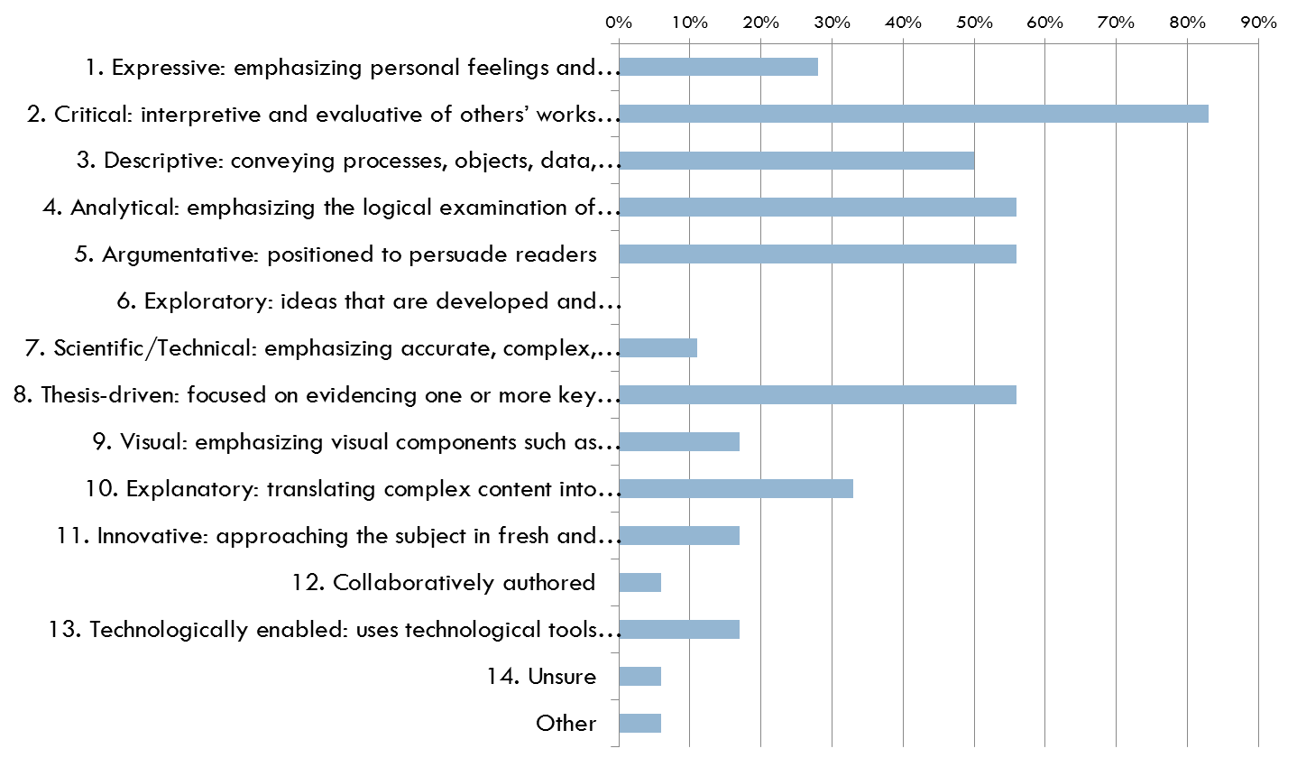

Students: In your opinion, of the characteristics you selected, which three characteristics (listed below) are most important in describing writing in this major?
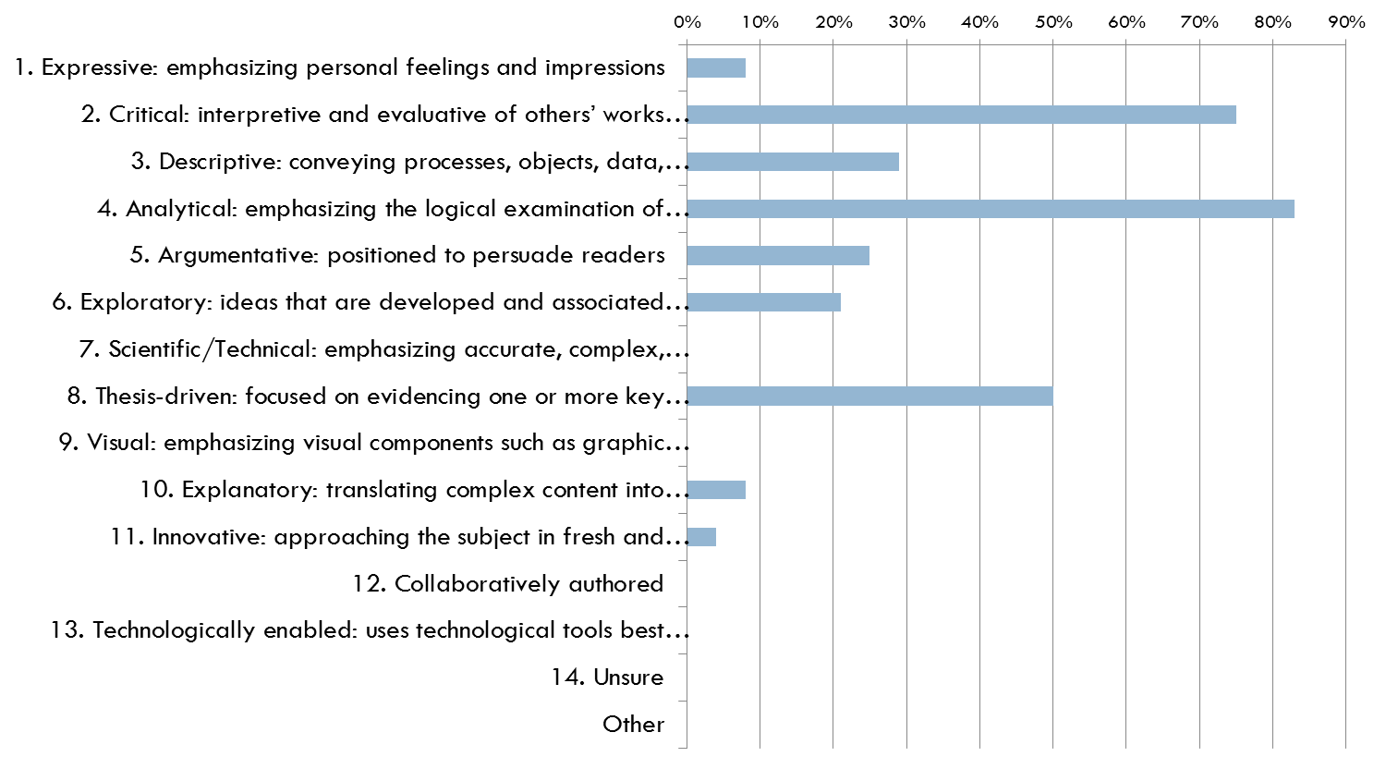

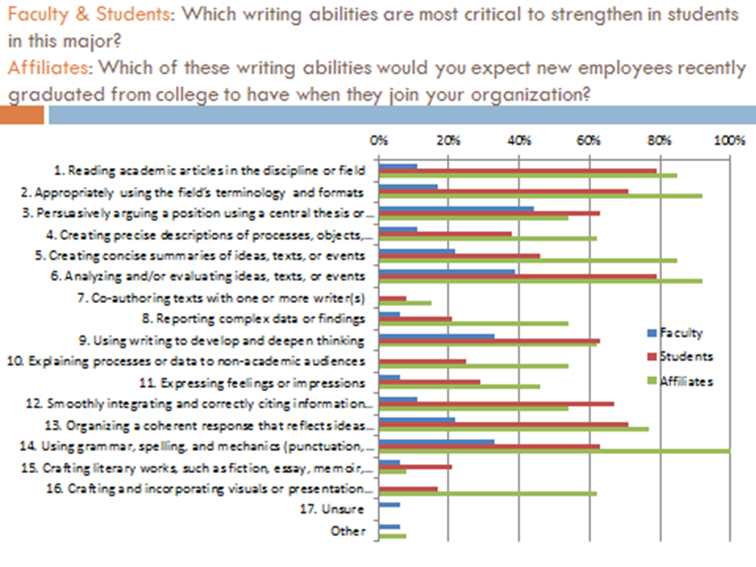

APPENDIX 2

Creating Measures to Evaluate Desired Writing Abilities:
Identifying Levels of Student Performance Necessary to Score Student Work

Desired Abilities | Action/Behavior/Criteria (ABCs) | Levels of Performance |  | Measures
Desired Abilities | Action/Behavior/Criteria (ABCs) | High Performer | Low Performer (not acceptable) | Measures
1. Demonstrate awareness of historical and cultural contexts and knowledge of social and political audiences through the study of works. | Action (Bloom’s): Comprehension  Measurable Behavior: Awareness (through a study of works).  Possible Evaluation Criteria: 1) Historical/cultural contexts, 2) Knowledge of social/political audiences, 3) Through a study of works. | -Show awareness of correct dates, sequence of events and historical consequences.  -Demonstrate awareness of  different perceptions, believes, and literary vs. historical versions on socio-political and cultural events and principles within the same period.  -Ability to provide cultural comparison and contrasts with other historical/cultural/national contexts. | -Show lagoons in dates, sequence of events and confusion about what actually happened historically as distinct from fictionalized events or characters in a literary text. | -Essays, reaction or research papers.  -Sections on exam on cultural viewings.  -Discussion boards online or in class discussion.  -Oral presentations  -Wikis
2. Recognize and communicate with specific audiences taking into account different registers, style, tone, and terminology, vocabulary, using them appropriately for the intended audience. | Action (Bloom’s): Knowledge and Application  Measurable Behavior: 1) Ability to recognize, 2) Communication.  Possible Evaluation Criteria: 1) [Recognizing need for] different registers, style, tone and terminology, 2) [Communicating] them appropriately for the intended audience. | -Show original and personal (writing) style:  * Writing tailored to fit the topic and /or the audience (appropriate choice of words; show command of specialized jargon), sentence clarity, fluency or sophistication, formal vs. informal register, academic tone. | - Very weak style, poor choice of words, improper registers, colloquialisms, inquired use of specialize jargon and sentences are unclear | -In class debates or discussions  - Reaction papers  -Short essays  -Long essays  -Oral presentations  -Wikis
3.Recognize and practice informed and persuasive arguments, based on relevant, professional readings/research, and carefully chosen sources. | Action (Bloom’s): Synthesis  Measurable Behavior: Arguments (informed and persuasive)  Possible Evaluation Criteria: Based on relevant, professional readings/research, and carefully chosen sources. | -State argument clearly  -Expand argument in a cogent way, (additional premises)  -Substantiate argument with evidence in text/film  -Show pertinent knowledge of secondary literature (citation) | - No or inappropriate citation,  - Muddled argument  - Points presented out of order (or random order)  - No or inappropriate reference to the text. | -In class discussion  -Essays
4. Analyze ideas, texts, or events offering substantial information. Major points supported with relevant details/examples from a variety of fiction and non-fiction. | Action (Bloom’s): Analysis  Measurable Behavior: [Constructing] major points.  Possible Evaluation Criteria: 1) Supported with relevant details/examples, 3) From a variety of non-literary and literary texts. | -Show command of close reading of a text:  a) Identify and extract major ideas from a text  b) Support identified ideas through textual evidence | - Misidentify or fail to identify all major ideas  - No or inappropriate reference to the text | -Textual analysis  -Essays /papers
5. Use critical thinking: evaluate and synthesize ideas, texts, or events in both primary and secondary sources developing the ability to form independent literary judgments and support those ideas. | Action (Bloom’s): Analysis, Synthesis, Evaluation  Measurable Behavior: 1) Ability to form independent literary judgments, 2) Supporting those ideas.  Possible Evaluation Criteria: 1) Forming independent literary judgments 2) Supporting those judgments. | -Engage critically with primary or secondary sources: agree or disagree with idea/discuss limits etc.  -Place competing interpretations and dialog and when appropriate choose between them. | - Unaware of competing interpretations.  - Not engage. | -Textual analysis  -Essays/ papers
6. Organize a coherent narrative structure to flow logically from one point to the next. A coherent narrative must have an introduction that offers a forecasting statement that leads to an organizational framework; a body to develop the topic with effectively integrated examples/citations from works used; and a conclusion | Action (Bloom’s): Analysis  Measureable Behavior: A narrative structure  Possible Evaluation Criteria: 1) Flows logically from one point to the next, 2) Has intro that offers a forecasting statement leading to an organizational framework, 3) A body to develop the topic, 4) Effectively integrated examples/citations from works used, 5) A conclusion that reviews main points, restates thesis, and offers an effective ending. | -Delineate various parts of text (clear forecasting framework)  -Articulate forecasting statement well in introduction  - Use strong topic sentences that reflect the content and logical order of the thesis.  -See # 3 (Arguments)  -Transitions allow an easy flow between parts of paper  -avoidance of repetition  -Good conclusion that reviews main points, restates thesis, and offers an ending that goes beyond the summery | -Lack of forecasting stamens that does not lead any clear organizational statement (no organizational order) | Textual analysis  Essays/ research papers
7. Demonstrate competence in morphology, orthography, and syntax: |  | Agreement, gender, number, determinants, pronouns, nouns, adjectives, verbs, adverbs, prepositions, and conjunctions are almost always accurate, among other grammar components. | - Agreement, gender, number, determinants, pronouns, nouns, adjectives, verbs, adverbs, prepositions, and conjunctions are rarely accurate, among other grammar components.
8. Show awareness of genres |  | Identifying and referring correctly to official and non-official correspondence, diaries, compositions, proposals, abstracts, book reviews, papers, and/or works of creative writing. | -Inability to identifying and referring correctly to official and non-official correspondence, diaries, compositions, proposals, abstracts, book reviews, papers, and/or works of creative writing.
9. Demonstrate an ability to compile appropriately a bibliography (e.g., peer-reviewed) appropriate sources from primary and secondary literature, as well as non-literary works that are useful and contribute in comparison to other sources in the bibliography. |  | -Choose academic sources that illuminate an argument made in the assignment | -Lack of sources or use of inaccurate sources
10.Conform to MLA, APA bibliographic standards and conventions. |  | -Follow MLA APA guidelines | -Not Follow MLA APA guidelines
11. Follow academic honor code. |  | -Recognize and understand plagiarism in various forms and demonstrate knowledge and strategies for avoiding it. | -Not Recognize and understand plagiarism in various forms
* If you want to measure for command of genre in #8, an assessment needs to take place in an earlier level, for ex. FRE 3401.

APPENDIX 3

Creating Measures to Evaluate Desired Writing Abilities:
Identifying Levels of Student Performance Necessary to Score Student Work

 | High Performer | Average Performer | Low Performer
Cultural Awareness: Demonstrates critical awareness of historical and cultural contexts and knowledge of social, political audiences by synthesizing and evaluating ideas, texts, and events. | - Student establishes awareness of contextual components (e.g., congruent historical, political contexts, correct dates, sequential events, accurate historical references) by explaining interconnections among them.  - Student draws insightful conclusions by. | - Student establishes awareness of contextual components (e.g., congruent historical, political contexts, correct dates, sequential events, accurate historical references), but makes limited or superficial connections among them.  - Student conclusions lack full development. | - Student show gaps in contextual components (e.g., incongruent historical, political contexts, incorrect dates, non-sequential events, mistakes in historical references) and make no connections among them and do not recognize competing interpretations.

Audience is word choice, context, drawing from the text in a way that others can follow without reading the text. It is vocabulary. It is to make yourself understood. It is all register. It is not the simple restating of the assignment question which reveals that the student is just trying to perform a task instead of thinking how an audience shapes their writing.

