2022 Undergraduate Research Symposium:

People's Choice Award

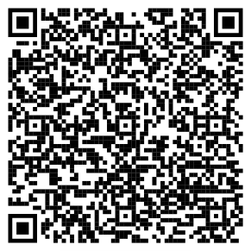

- Please scan the QR code above to access the People’s Choice Award Response (must be signed into FAU google account).
- Next, fill out the required boxes. The information you will need is the poster #, the presenter’s research category, and the lead presenter’s full name.
- When finished, please submit your response.

A winner will be picked next week once all the responses are tabulated.

Thank you for participating in the People’s Choice Award Response!

