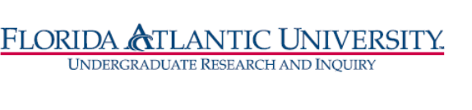
Florida Atlantic University
Undergraduate Research Curriculum Committee
Thursday, November 18, 2021
WebEx meeting from 12:30 to 1:30 pm
MITSOVA, Hindle, Cheryl, D. Meeroff, Williams, bennett, Park, DeDonno
- Approve October 28, meeting minutes – Dan and
- RI Certificate updates
- Substitution and Waivers form updated on CANVAS
- Website updated
- Existing waivers and substitution requests process
  - Fall students – Lopez, Kevin, Jarron, Michelle and Sara Hollenbeck
  - Spring eligibility student list
Kevin – approved Eva, Dan,
Maria Garcia – asked the faculty to indicate the Research nature of HSA4905, and the student needs a product (PENDING)
Sara Hollenbeck – Ethlyn and JuYoung approved
Michelle Jaron approved

- Next steps after URCC approval
  - Letter from OURI to advisor/registrars notifying of URCC approval for waiver/substitution.
D. Meeroff- DARS updated including substitution
Add college next to applicant name
Please review Research Certificate applications by college add language to the email invitation to the meeting
- Discussion of advertising the certificate for Spring. Next meeting, DCW will email flyer. Donna will send an email with things we can do

Evan and DCW met with the advisor in A&L, D. Meeroff with meet with advisors on Tuesday
Microsoft forms find a way to copy college URCC member and advisors or Patricia forward application to URCC members
Meeting Adjourned: 1:33

