GALLERY OF EVOCATEURS

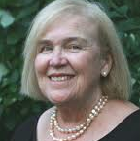 | Charlotte D. Barry, PhD, RN, NCSN, FAAN  Professor Emerita  Christine E. Lynn College of Nursing  Florida Atlantic University  Boca Raton, FL, USA | 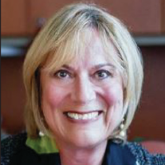 | Marlaine C. Smith, RN, PhD, AHN-BC, HWNC-BC, FAAN  Professor Emerita  Director, Anne Boykin Institute for the Advancement of Caring in Nursing  Christine E. Lynn College of Nursing  Florida Atlantic University  Boca Raton, FL, USA
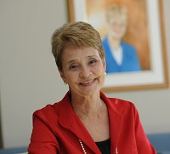 | Anne Boykin, PhD, RN  Professor and Dean Emeritus  Founding Director, Anne Boykin Institute for the Advancement of Caring in Nursing  Christine E. Lynn College of Nursing  Florida Atlantic University  Boca Raton, FL, USA | 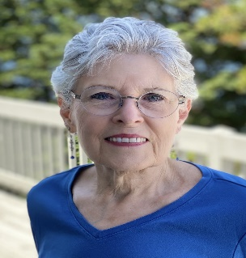 | Zane Robinson Wolf, PhD, RN, FAAN  Dean Emerita and Professor  La Salle University  School of Nursing and Health Sciences  Philadelphia, Pennsylvania, USA
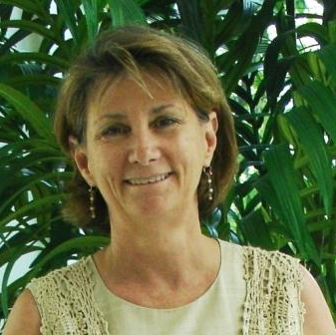 | Shirley Gordon, PhD, RN, NCSN, AHN-BC, HWNC-BC  Professor Emerita  Christine E. Lynn College of Nursing  Florida Atlantic University  Boca Raton, FL, USA | 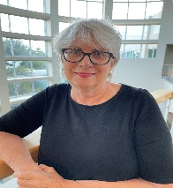 | Beth King, PhD, APRN, PMHNP-BC, FAAN  Associate Professor  Christine E. Lynn College of Nursing  Florida Atlantic University  Boca Raton, FL, USA
 | Katherine Heinz, PhD, RN  Assistant Professor  Christine E. Lynn College of Nursing  Florida Atlantic University  Boca Raton, FL, USA |  | Joy Longo, PhD, RNC-NIC, CNE  Associate Professor  Associate Dean Academic Programs  Christine E. Lynn College of Nursing  Florida Atlantic University  Boca Raton, FL, USA
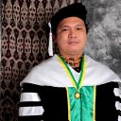 | Rudolf Cymorr Kirby P. Martinez, PhD, MA, RN, LMT, CAA, CSTP, CGNC, SGAHN, FFNRRCSI  Professor  San Beda University  College of Nursing  Philippines | 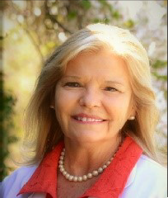 | Mary Ellen Wright, PhD, FAAN  Associate Professor  Clemson University School of Nursing  Fairview, North Carolina, USA
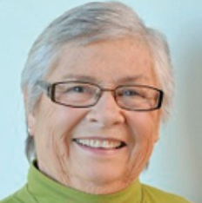 | Savina Schoenhofer, PhD, RN  Founding Board Member of the Anne Boykin Institute for the Advancement of Caring in Nursing | 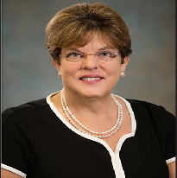 | Kathleen Valentine, PhD, MS, RN  Professor  Clemson University  College of Behavioral, Social, and Health Sciences  Clemson, South Carolina, USA

Co-Chairs
 | Charlotte D. Barry, PhD, RN, NCSN, FAAN  Professor Emerita  Christine E. Lynn College of Nursing  Florida Atlantic University  Boca Raton, FL, USA |  | Joy Longo, PhD, RNC-NIC, CNE  Associate Professor  Associate Dean Academic Programs  Christine E. Lynn College of Nursing  Florida Atlantic University  Boca Raton, FL, USA

Artist in Residence
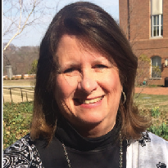 | Mary T. Packard, PhD, RN  Associate Professor  School of Nursing  Notre Dame of Maryland University  Baltimore, Maryland, USA

