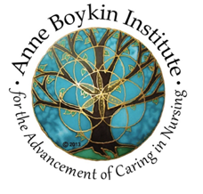

Please join us for the Anne Boykin Institute’s 2025 Summer Academy as we engage in creative dialogue focused on the central place of caring within the professional discipline of nursing. This year’s Summer Academy theme, Caring: Essential Knowledge for Nursing Practice, will inspire our reflections on the critical importance of developing knowledge in caring science that informs and guides nursing practice in all areas. Participants will have the opportunity to imagine plans to transform possibilities to realities through concrete actions. As this important work of caring science emerges, knowledge of the discipline of nursing advances. The Artist-in-residence, Mary Packard, will share her poetry throughout the Academy to create space for reflective thought and deeper understanding of the myriad manifestations of caring in nursing practice.

