PAGE

2 TIME ENTRY – SP

5 TIME ENTRY – OPS

9 TIME OFF

16 LET’S GET STARTED

23 CORRECT APPROVED TIME OFF ENTRY IN CURRENT OR PRIOR PAY PERIOD

30 ENTER TIME OFF FOR A PRIOR PAY PERIOD

35 LEAVE OF ABSENCE

38 ADJUSTMENTS FOR HOLIDAY: REGULAR WORK DAY SCHEDULE MORE THAN 8 HOURS

44 CHANGING EXTRA HOURS TO SPECIAL COMP

53 SPECIAL COMP/HOLIDAY COMP ACCRUAL: SP EMPLOYEE WORKED ON HOLIDAY

60 CHANGING OVERTIME TO OVERTIME COMP

70 HOLIDAY COMP ACCRUAL: EXEMPT EMPLOYEE WORKED ON HOLIDAY

71 ON CALL PAY

75 KEEP TESTING! PRACTICE SITUATIONS

TIME ENTRY: SP EMPLOYEE

- CLICK ON TIME WORKLET



- CHOOSE THE WORK WEEK ( IN MOST CASES THIS WILL BE “THIS WEEK”)

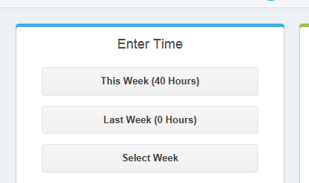

- THERE ARE TWO WAYS TO ENTER TIME:

- OPTION ONE: CLICK ON THE SCREEN FOR THE APPLICABLE DAY. ENTER THE TIME IN AND THE TIME OUT, AND THE “OUT” REASON. DO THIS FOR BOTH MORNING AND AFTERNOON IF APPLICABLE. THIS IS A QUICK AND EASY WAY TO ENTER TIME EACH DAY

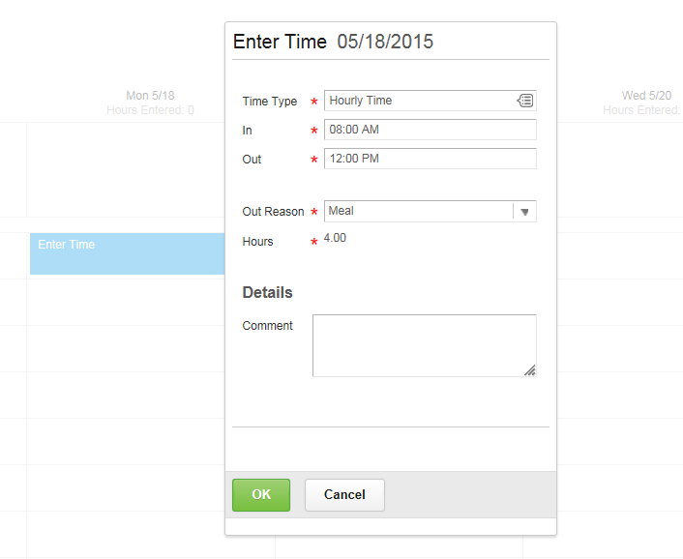

- OPTION TWO: CLICK ON “ENTER TIME” AT THE BOTTOM LEFT OF SCREEN. THE ENTIRE WEEK WILL APPEAR. CLICK ON THE DAY AND THEN ENTER TIME IN AND TIME OUT FOR EACH DAY. YOU MUST CHOOSE AN “OUT” REASON, AND YOU MUST INDICATE “HOURLY TIME” BY CLICKING THE DROP DOWN AND CHOOSING HOURLY TIME

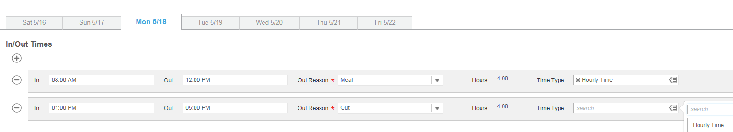

- ALWAYS CHECK THAT AM AND PM ARE CORRECT FOR YOUR ENTRIES

- YOU MUST SUBMIT YOUR TIME. TIME CAN BE SUBMITTED EACH DAY OR AT THE END OF THE WEEK

- THIS IS THE COMPLETED TIME RECORD. SUPERVISOR MUST NOW APPROVE

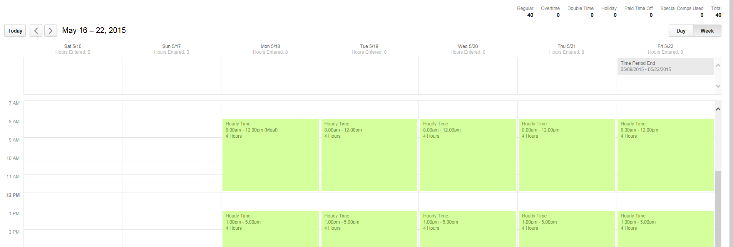

- TO CORRECT A TIME ENTRY, JUST CLICK ON THE TIME AND MAKE THE CHANGE. ALL CHANGES MUST BE APPROVED BY THE SUPERVISOR

TIME ENTRY: OPS EMPLOYEE

- CLICK ON TIME WORKLET

- “TIME CLOCK” IS ON THE BOTTOM OF SCREEN. THERE ARE TWO OPTIONS: “CHECK IN” AND “CHECK OUT”

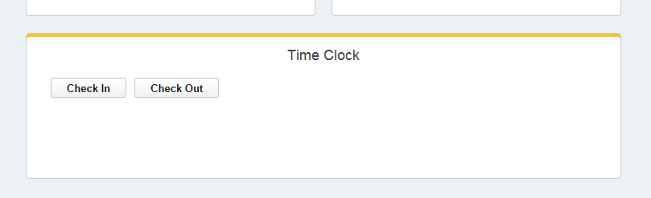

- CLICK “CHECK IN” AS SOON AS YOU ARRIVE TO WORK. THIS WILL BE THE START OF YOUR WORK DAY. THE “TIME TYPE” IS “HOURLY TIME”

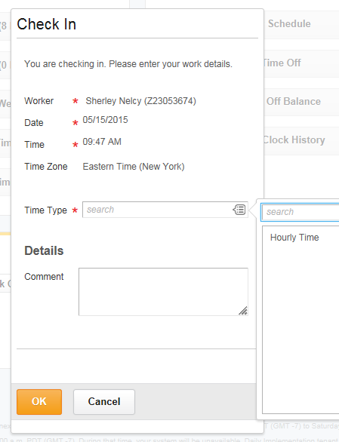

- IF YOU HAVE MORE THAN ONE ASSIGNMENT, CLICK ON THE DROP DOWN MENU AND SELECT THE CORRECT ASSIGNMENT

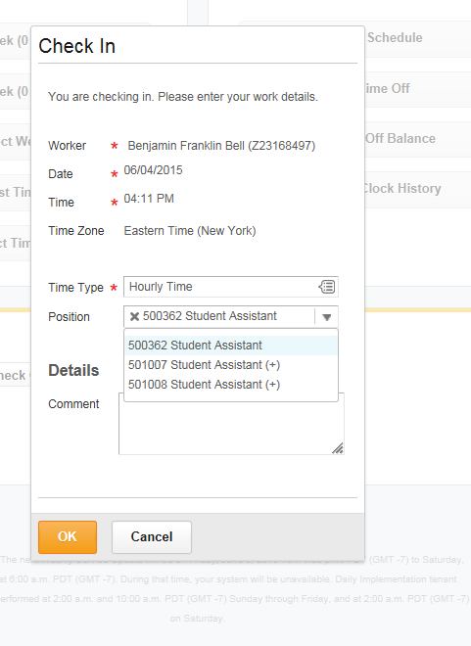

- CLICK “CHECK OUT” AT THE TIME THAT YOU ARE LEAVING FOR A MEAL, OR LEAVING WORK. IF YOU ARE LEAVING FOR A MEAL, YOU WILL HAVE TO “CHECK IN” WHEN YOU RETURN. IF YOU ARE LEAVING WORK FOR THE DAY, THIS IS THE END OF YOUR WORK DAY.

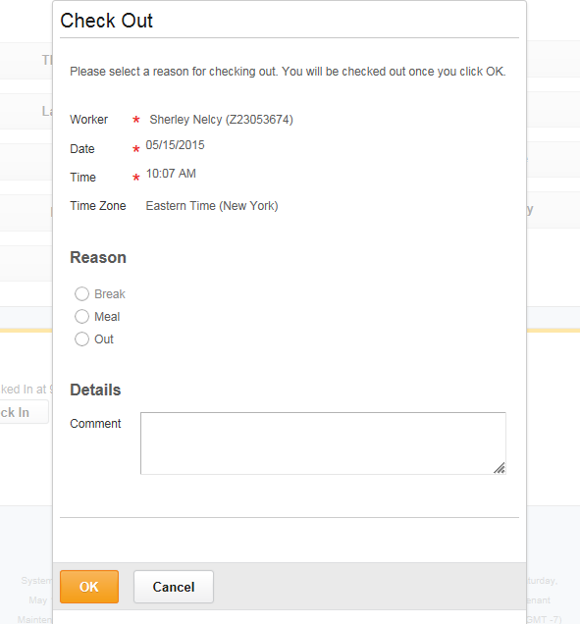

- IF YOU FORGET TO CHECK IN/CHECK OUT, OR ENTER A TIME IN ERROR, YOUR TIMEKEEPER CAN CORRECT THE TIME ENTRY WITH YOUR SUPERVISOR’S APPROVAL.
- YOU MUST SUBMIT YOUR TIME. TIME CAN BE SUBMITTED EACH DAY OR AT THE END OF THE WEEK

TIME OFF REQUEST

- CLICK ON TIME WORKLET

- YOUR LEAVE BALANCE APPEARS AT THE BOTTOM OF THE PAGE OR CLICK ON VIEW YOUR TIME OFF BALANCE FOR MORE DETAILS

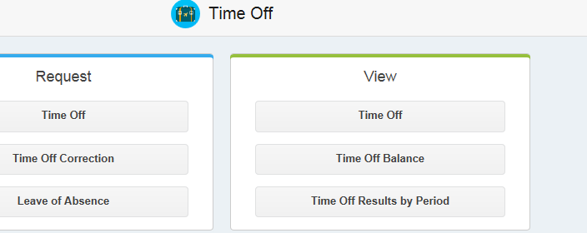

- YOU CAN VIEW YOUR BALANCE FOR A PAST DATE, A FUTURE DATE, OR THE CURRENT DATE

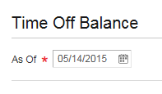

- YOU WILL SEE A DETAILED ACCOUNT OF YOUR LEAVE BALANCES

- CLICK THE HOME KEY TO SEE YOUR WORKLETS, AND CLICK ON TIME OFF TO REQUEST TIME OFF

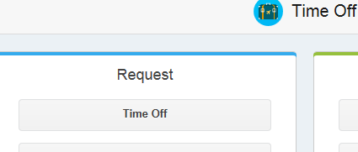

- SCROLL THROUGH THE CALENDAR TO FIND THE DATE(S) YOU ARE REQUESTING AS TIME OFF. NOTE THAT THE LEAVE BALANCES APPEAR ALONG THE LEFT OF THIS SCREEN. IF YOU ARE REQUESTING TIME OFF FOR A FUTURE DATE, YOU CAN ADJUST THE “BALANCE AS OF” DATE TO MATCH

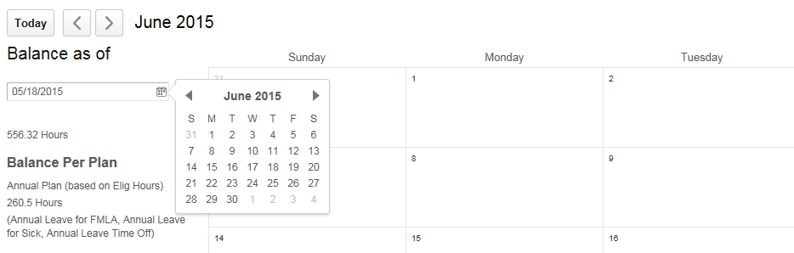

- CLICK ON THE DAY OF LEAVE AND THEN CLICK ON REQUEST TIME OFF. YOU WILL BE ASKED TO CHOOSE THE TYPE OF TIME OFF AND THE NUMBER OF HOURS OF LEAVE EACH DAY. IF NECESSARY, YOU CAN ATTACH A FILE

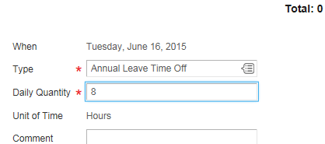

- CLICK ON SUBMIT

- AFTER THE LEAVE IS APPROVED, IT WILL APPEAR ON THE TIME ENTRY CALENDAR FOR THAT DAY

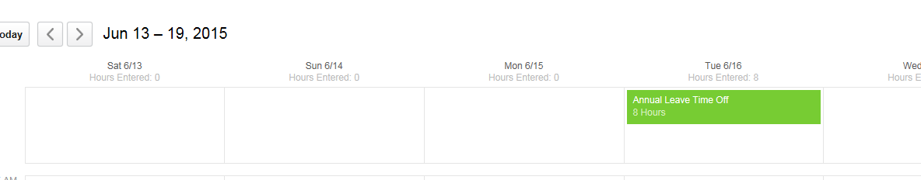

- TO CORRECT A LEAVE ENTRY BEFORE THE SUPERVISOR APPROVED IT:

- GO TO YOUR HOME PAGE AND CLICK ON YOUR INBOX. THE INBOX IS FOUND ON THE DROP DOWN MENU BELOW YOUR PICTURE ON TOP RIGHT OF SCREEN



- CLICK ON “ARCHIVE” TO VIEW THE TIME OFF REQUEST. IF THERE ARE SEVERAL ITEMS IN THE INBOX, CLICK ON THE SPECIFIC TIME OFF REQUEST TO VIEW. THEN CLICK ON CANCEL. THE TIME OFF REQUEST HAS BEEN REMOVED. YOU CAN NOW REDO THE ENTRY.

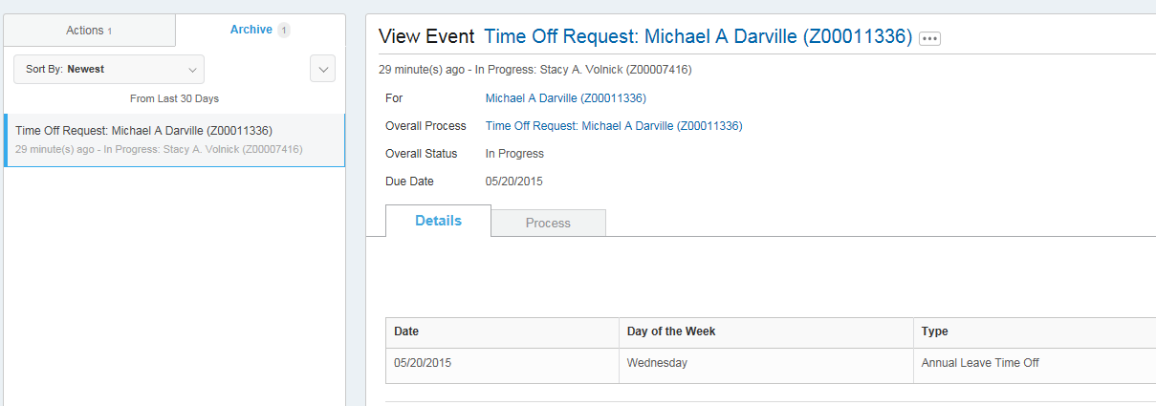

- TO CORRECT OR CANCEL A TIME OFF REQUEST AFTER THE SUPERVISOR HAS APPROVED:

- CLICK ON TIME OFF WORKLET AND THEN ON “TIME OFF CORRECTION”

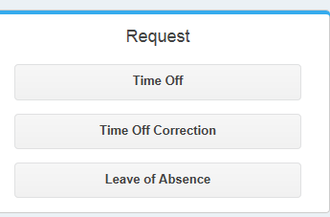

- SCROLL TO THE MONTHLY CALENDAR PAGE THAT HAS THE REQUESTED TIME OFF AND CLICK ON THE REQUEST. YOU CAN THEN CHOOSE TO DELETE THE ENTRY, OR YOU CAN CHANGE THE TYPE OF TIME OFF OR THE NUMBER OF DAILY HOURS (SEE EXAMPLE BELOW)

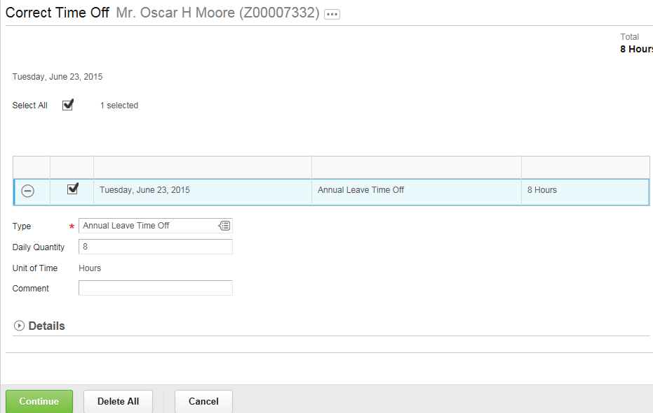

LET’S GET STARTED

- GO TO AN EMPLOYEE’S SCREEN:

- TYPE THE EMPLOYEE’S NAME IN THE SEARCH BOX

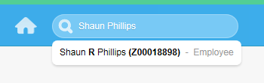

- ENTER TIME FOR AN EMPLOYEE:

- CLICK ON THE ORANGE SYMBOL TO THE RIGHT OF THE EMPLOYEE’S NAME. THIS IS THE RELATED ACTIONS SYMBOL. SCROLL DOWN AND CLICK ON TIME AND LEAVE

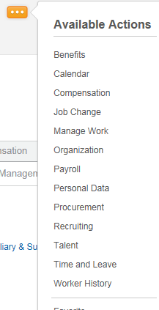

- CLICK ON ENTER TIME

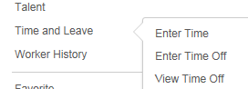

- CHOOSE THE WORK WEEK

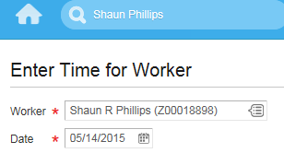

- CLICK ON ENTER TIME AND THEN ENTER TIME FOR ONE OR MORE DAYS. NOTE THAT EVERY TIME ENTRY REQUIRES YOU TO IDENTIFY “HOURLY TIME”

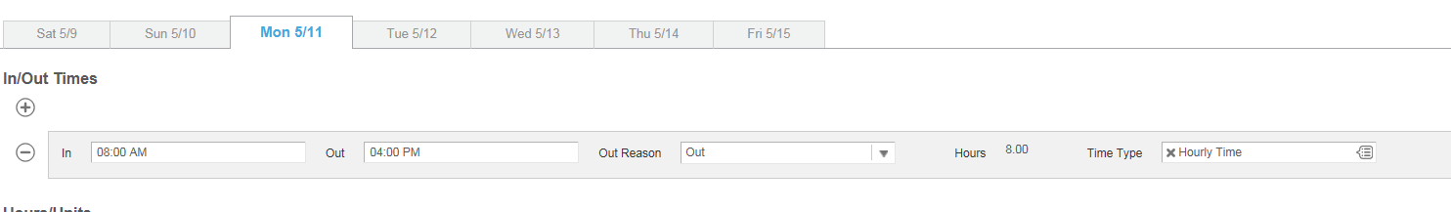
- ALWAYS CHECK THE AM AND PM DESIGNATION TO BE SURE IT IS CORRECT!!

- TO CORRECT A TIME ENTRY, JUST CLICK ON THE TIME AND MAKE THE CHANGE. ALL CHANGES MUST BE APPROVED BY THE SUPERVISOR

- THIS IS HOW THE COMPLETED TIME RECORD APPEARS. NOTE THAT THE TOP RIGHT OF THE SCREEN WILL RECORD THE HOURS

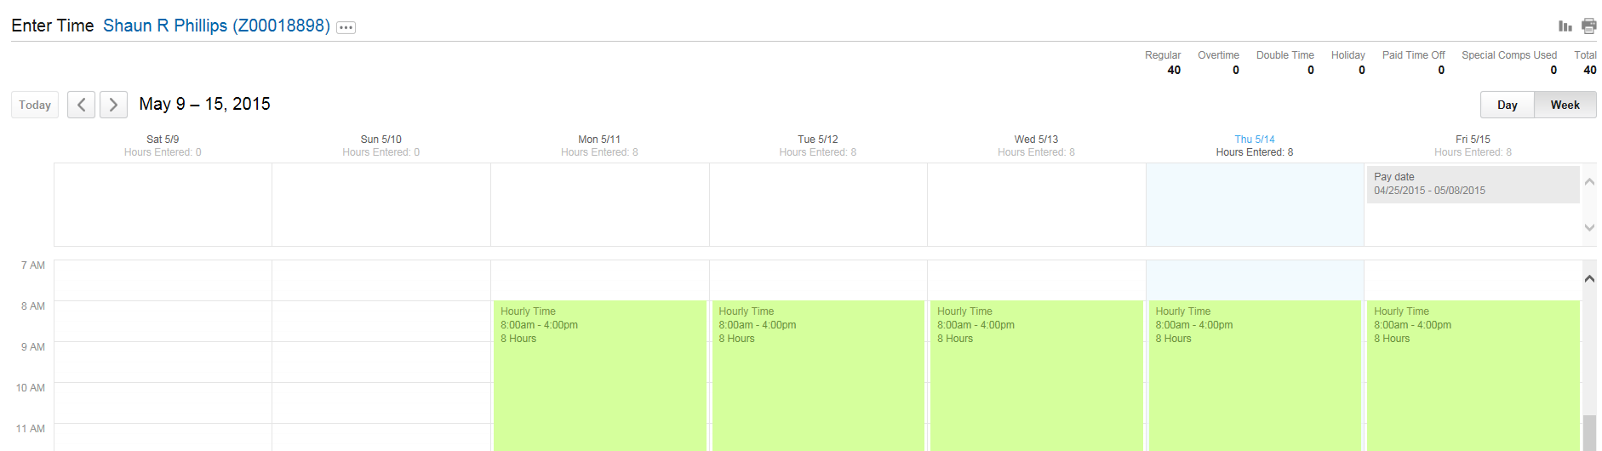

- ENTER TIME OFF FOR AN EMPLOYEE:

- CLICK ON THE RELATED ACTIONS SYMBOL AND THEN ON TIME AND LEAVE (AS DESCRIBED ABOVE)

- CLICK ON ENTER TIME OFF

- SCROLL THROUGH THE CALENDAR TO FIND THE DATE(S) THE EMPLOYEE HAS REQUESTED. NOTE THAT THE LEAVE BALANCES APPEAR ALONG THE LEFT OF THIS SCREEN

- NOTE THAT THE “BALANCE AS OF” DATE COMPUTES WHAT THE LEAVE WILL BE, OR WHAT THE LEAVE WAS, ON THE DATE YOU CHOOSE. IF THE EMPLOYEE HAS REQUESTED TIME OFF FOR A FUTURE DATE, YOU SHOULD CHOOSE THAT DATE UNDER “BALANCE AS OF” TO DETERMINE IF THE EMPLOYEE WILL HAVE A SUFFICIENT BALANCE ON THAT DATE

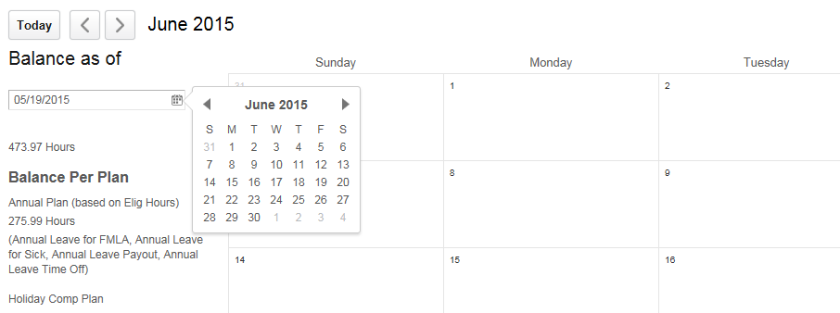

- CLICK ON THE DAY OF LEAVE AND THEN CLICK ON REQUEST TIME OFF. YOU WILL BE ASKED TO CHOOSE THE TYPE OF TIME OFF AND THE NUMBER OF HOURS OF LEAVE EACH DAY

- AFTER THE LEAVE IS APPROVED, IT WILL APPEAR ON THE TIME ENTRY CALENDAR FOR THAT DAY FOR AN SP EMPLOYEE

- IF THE LEAVE BALANCE IS NOT SUFFICIENT FOR THE REQUESTED TIME OFF, YOU WILL SEE AN ALERT

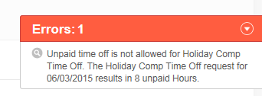
- ADD A LINE:

- MANY SCREENS GIVE THE OPTION, OR REQUIRE YOU, TO ADD A LINE OF INFORMATION. JUST CLICK ON THE + SIGN TO ADD A LINE AND THE – SIGN TO ELIMINATE A LINE

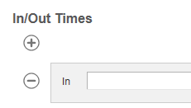

- TIP: IF YOU NEED TO ENTER BOTH TIME AND TIME OFF FOR AN EMPLOYEE, YOU CAN USE THE “ENTER TIME” SCREEN FOR EITHER.

- CHOOSE “ENTER TIME OFF” FROM THE ENTER TIME MENU

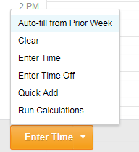

- OR CHOOSE “ENTER TIME ” FROM THE ENTER TIME MENU

CORRECT APPROVED TIME OFF ENTRY IN CURRENT OR PRIOR PAY PERIOD

- EMPLOYEE REQUESTS TIME OFF AND SUPERVISOR APPROVES REQUEST. IN THIS CASE, 8 HOURS OF ANNUAL LEAVE WAS APPROVED FOR JULY 6. (NOTE: IF THE EMPLOYEE REALIZES MISTAKE BEFORE THE SUPERVISOR APPROVES THE REQUEST, THE EMPLOYEE CAN DELETE THE ENTRY BY GOING TO INBOX, TO ARCHIVES, AND CANCELING THE REQUEST)

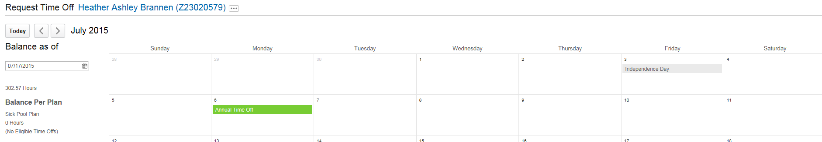

- THERE ARE TWO OPTIONS TO CORRECT OR DELETE LEAVE:

- OPTION 1: THE EMPLOYEE CAN GO TO HOME SCREEN AND CHOOSE TIME OFF, AND THEN TIME OFF CORRECTION

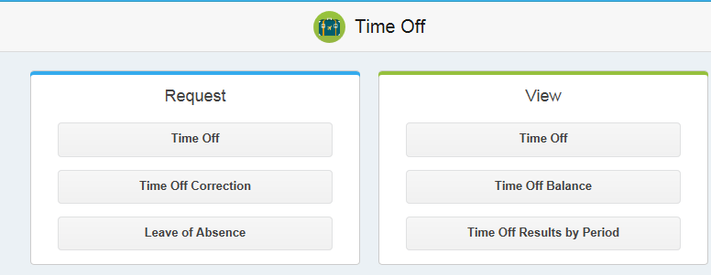

THE EMPLOYEE CHOOSES THE CORRECT MONTH WHICH WILL SHOW THE APPROVED LEAVE TO BE CORRECTED (IN THIS CASE DELETING LEAVE), CLICKS ON THE TIME OFF DESIGNATION (ANNUAL LEAVE), WHICH BRINGS UP THE CORRECTION SCREEN

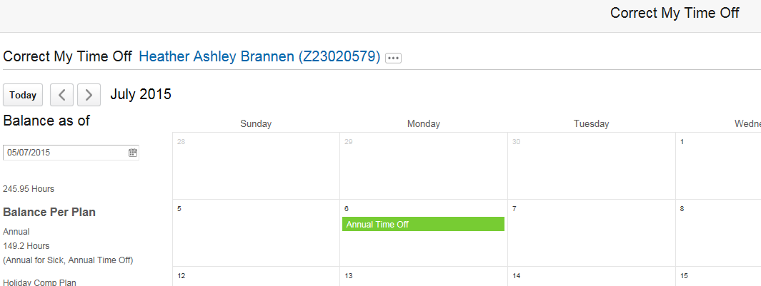

CLICK ON “DELETE ALL” TO DELETE. IF THE EMPLOYEE CHOOSES TO CORRECT THE TIME OFF, THE TYPE OF TIME OFF CAN BE CHANGED, AND THE NUMBER OF DAILY HOURS CAN BE CHANGED
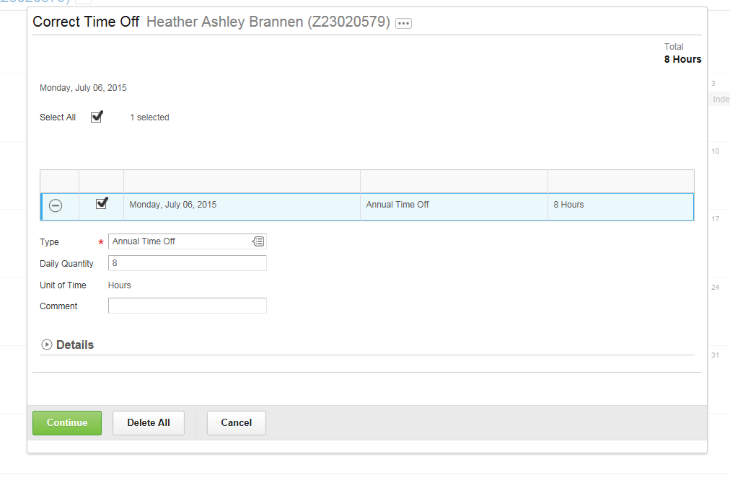
THE SUPERVISOR MUST APPROVE THE CORRECTION OR DELETION

NOTE: IF LEAVE IS DELETED FROM A PRIOR PAY PERIOD FOR AN SP EMPLOYEE, AND IS NOT REPLACED WITH A DIFFERENT TYPE OF LEAVE, AN EQUIVALENT NUMBER OF HOURS OF WORK TIME (HOURLY TIME) MUST BE ENTERED FOR THE SAME DAY(S)

- OPTION TWO: THE TIMEKEEPER CAN TYPE THE EMPLOYEE’S NAME IN THE SEARCH BOX AND BRING UP THE EMPLOYEE’S SCREEN. CLICK ON RELATED ACTIONS TO SEE “TIME AND LEAVE” AND “CORRECT TIME OFF”

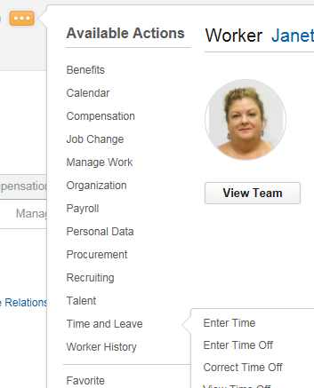

CHOOSE THE MONTH THAT HAS THE REQUESTED LEAVE

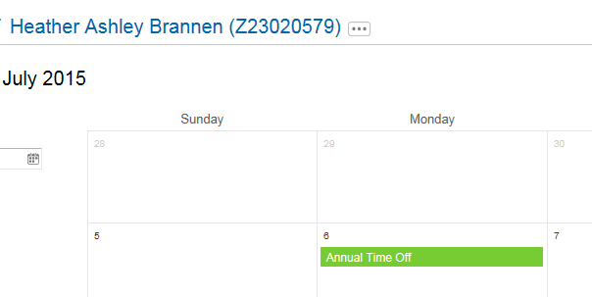

CLICK ON THE LEAVE AND FOLLOW ALL OF THE REMAINING STEPS AS DETAILED ABOVE TO DELETE

IF THE TYPE OF LEAVE IS TO BE CHANGED, CHOOSE THE PREFERRED LEAVE TYPE AND THEN CLICK “CONTINUE”. IN THIS CASE, SICK LEAVE WAS CHOSEN. THE NUMBER OF HOURS CAN ALSO BE CHANGED. THIS CAN BE COMPLETED BY EITHER THE EMPLOYEE OR TIMEKEEPER.

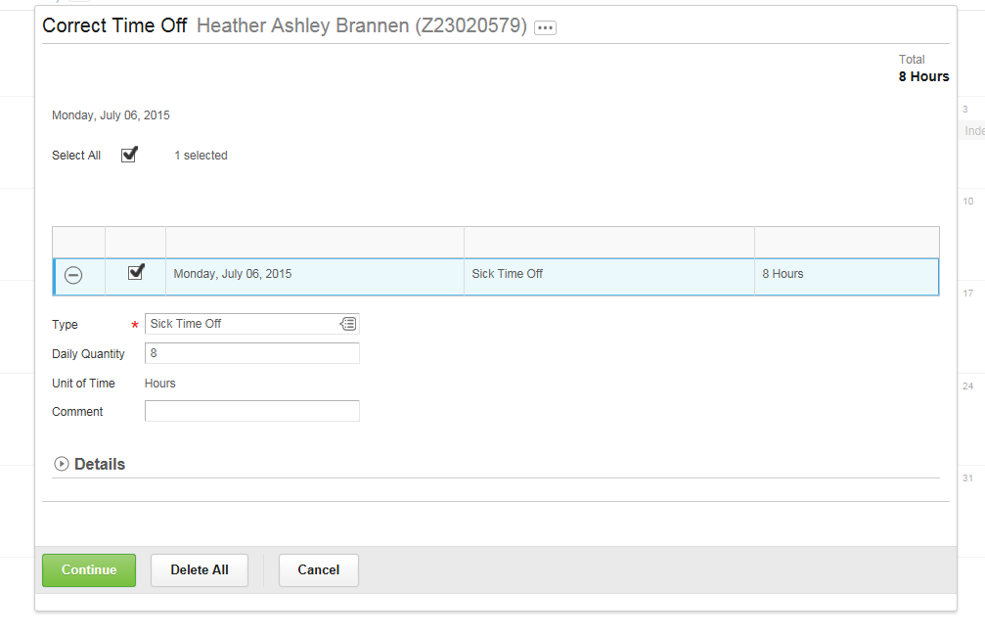
THE TIME OFF REQUEST SCREEN NOW SHOWS SICK LEAVE INSTEAD OF ANNUAL LEAVE

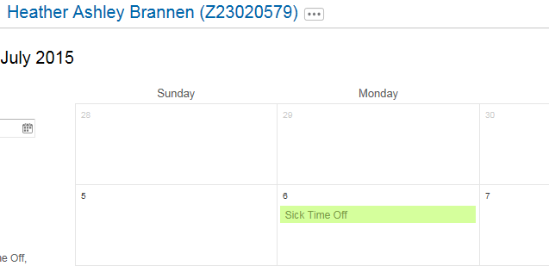

CLICK SUBMIT. YOU WILL SEE A REVIEW OF THE REQUEST WHICH NEEDS TO BE CAREFULLY REVIEWED AND SUBMITTED, AND THEN APPROVED BY THE SUPERVISOR

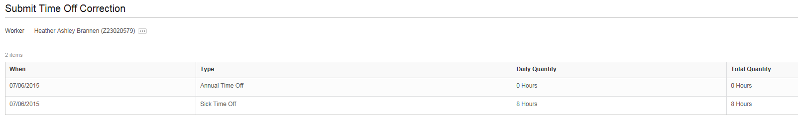

NOTE: IF LEAVE IS DELETED FROM A PRIOR PAY PERIOD FOR AN SP EMPLOYEE, AND IS NOT REPLACED WITH A DIFFERENT TYPE OF LEAVE, AN EQUIVALENT NUMBER OF HOURS OF WORK TIME (HOURLY TIME) MUST BE ENTERED FOR THE SAME DAY(S).

ENTER TIME OFF FOR A PRIOR PAY PERIOD

- IF AN EMPLOYEE TOOK TIME OFF IN A PRIOR PAY PERIOD BUT DID NOT REQUEST IT PRIOR TO THE CLOSE OF THAT PAY PERIOD, THE TIME OFF MUST NOW BE REQUESTED SO THAT IT IS PART OF THE RECORD AND THE LEAVE BALANCE IS REDUCED.

- EXEMPT EMPLOYEES (AMP, FACULTY AND EXECUTIVE SERVICE) SHOULD FOLLOW THE REGULAR PROCEDURES FOR REQUESTING LEAVE, CHOOSING THE APPLICABLE DATE(S) IN THE PRIOR PAY PERIOD. THE SUPERVISOR WILL APPROVE. NOTHING FURTHER IS REQUIRED AND THE LEAVE BALANCE WILL BE REDUCED AND THE PAY IS NOT AFFECTED. THE TIMEKEEPER WILL SEE THE ENTRY IN THE REPORT SHOWING ENTRIES FOR A PRIOR PAY PERIOD, BUT NO ACTION IS REQUIRED.

- SP EMPLOYEES WILL SELECT THE APPLICABLE DATE(S) IN THE PRIOR PAY PERIOD AND REQUEST THE TIME OFF. THE SUPERVISOR MUST APPROVE THE REQUEST. IN THIS EXAMPLE THE EMPLOYEE HAS SUBMITTED THE TIME OFF REQUEST FOR THE LEAVE THAT WAS ACTUALLY TAKEN ON TUESDAY, JULY 14 (A PRIOR PAY PERIOD).

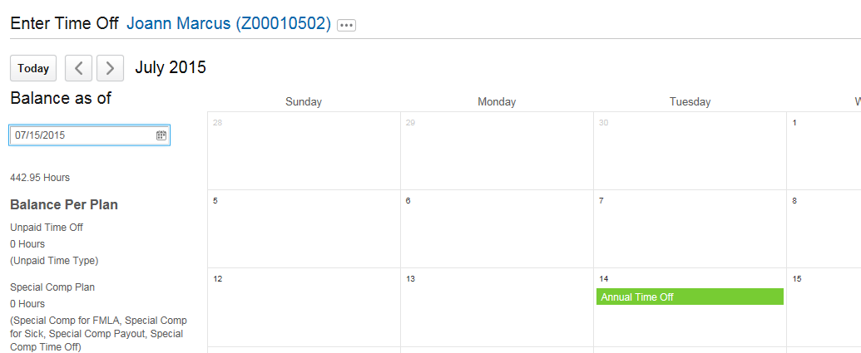

TIMEKEEPER:

- TYPE THE EMPLOYEE’S NAME IN THE SEARCH BOX AND BRING UP EMPLOYEE’S SCREEN. CLICK ON RELATED ACTIONS SYMBOL, THEN ON TIME AND LEAVE AND THEN ON “ADJUST CALCULATED TIME”.

- THE TIMEKEEPER MUST REDUCE THE WORK HOURS FOR THAT WEEK. IF THE EMPLOYEE IS ADDING 8 HOURS OF TIME OFF (IN THIS CASE ANNUAL LEAVE), THEN 8 HOURS OF WORK TIME MUST BE SUBTRACTED. IF THIS STEP IS SKIPPED, THE EMPLOYEE WILL RECEIVE AN ADDITIONAL 8 HOURS OF PAY (IN THE CURRENT PAY PERIOD) FOR THE PAID LEAVE THAT WAS ADDED TO THIS PRIOR PAY PERIOD.

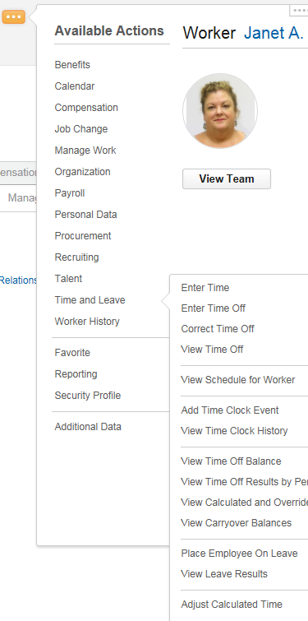

- CHOOSE THE CORRECT DATE FOR THE CORRECTION

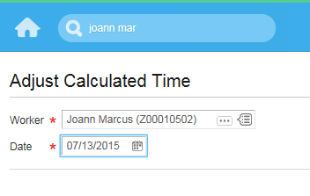
- THE SCREEN WILL SHOW THE EMPLOYEE’S TIME ENTRIES FOR THAT WEEK

- THE SCREEN IS DIVIDED INTO SECTIONS WITH REPORTED TIME ON THE LEFT, AND CALCULATED TIME ON THE RIGHT.

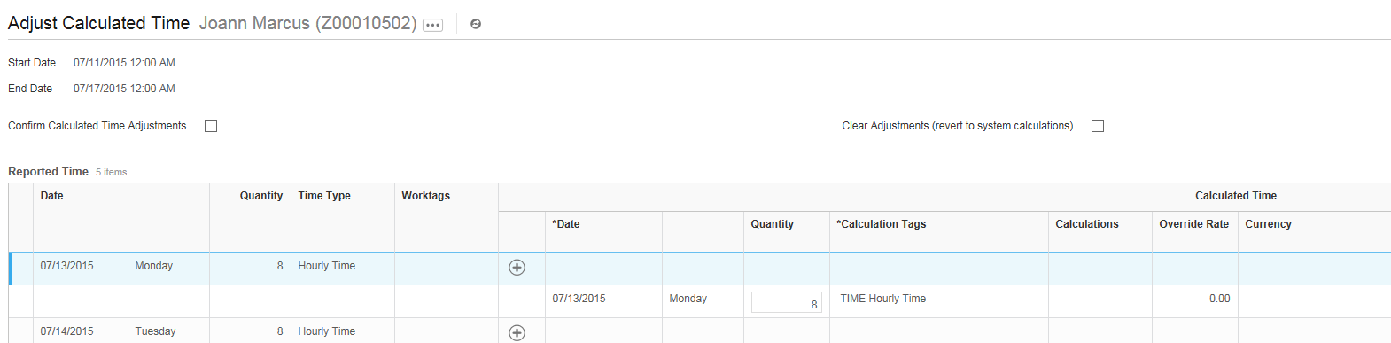

- FIND THE ENTRY FOR THE DATE THAT THE EMPLOYEE ENTERED TIME OFF. IN THIS CASE, TUESDAY, MAY 14. CHANGE THE 8 HOURS OF HOURLY TIME TO “ZERO”, ON THE RIGHT SIDE OF SCREEN, UNDER CALCULATED TIME

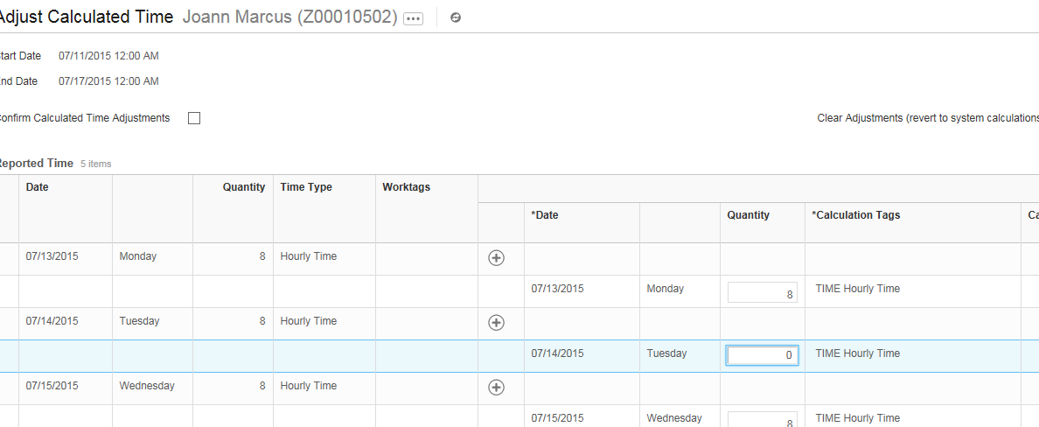

- SCROLL UP AND CHECK THE BOX: “CONFIRM CALCULATED TIME ADJUSTMENTS”. THEN SUBMIT

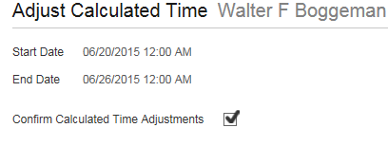

LEAVE OF ABSENCE

- AN EMPLOYEE WHO WILL BE ON LEAVE FOR AN EXTENDED PERIOD OF TIME CAN BE PLACED ON A LEAVE OF ABSENCE.

- HUMAN RESOURCES CAN PLACE AN EMPLOYEE ON A LEAVE OF ABSENCE FOR FMLA OR EXTENDED MEDICAL LEAVE OR FOR MILITARY LEAVE

- A MEDICAL LEAVE OF ABSENCE IS UNPAID, BUT THE EMPLOYEE CAN CHOOSE TO USE PAID TIME OFF DURING SOME OR ALL OF THE PERIOD OF LEAVE

- TO REVIEW OR TRACK THE LEAVE OF ABSENCE GO TO THE EMPLOYEE’S SCREEN, CLICK ON THE RELATED ACTIONS SYMBOL AND ON TIME AND LEAVE. THEN SELECT “VIEW LEAVE RESULTS”

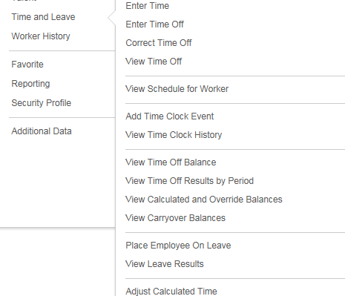

- YOU CAN TRACK THE SPECIFIC LEAVE OF ABSENCE FOR THAT EMPLOYEE. FOR MEDICAL LEAVES, WORKDAY WILL TRACK THE HOURS, FROM A MAXIMUM BALANCE OF 480 HOURS FOR FMLA. IN THIS EXAMPLE, 88 HOURS HAVE BEEN USED, AND A BALANCE OF 392 REMAINS.

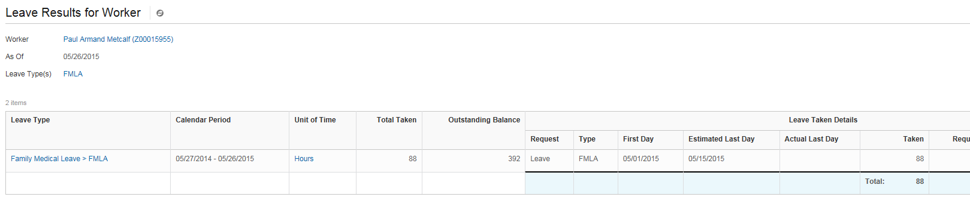

- IF THE EMPLOYEE USES THE FULL 480 HOURS UNDER FMLA, THE LEAVE WILL CONTINUE AS FAU EXTENDED LEAVE.

- IF THE EMPLOYEE CHOOSES TO USE PAID LEAVE WHILE ON FMLA OR MEDICAL LEAVE OF ABSENCE, PAID TIME OFF CAN BE SELECTED FROM THE “REQUEST TIME OFF” DROP DOWN MENU:

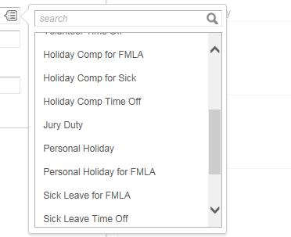

- WHILE THE EMPLOYEE IS ON LEAVE THAT WILL BE NOTED EACH TIME YOU SEE THE EMPLOYEE’S NAME

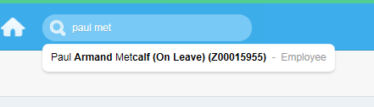

- WHEN THE EMPLOYEE IS READY TO RETURN TO WORK, HUMAN RESOURCES MUST REMOVE THE EMPLOYEE FROM THE LEAVE OF ABSENCE STATUS.

ADJUSTMENTS FOR HOLIDAY:
REGULAR WORK DAY SCHEDULE MORE THAN 8 HOURS

- EMPLOYEES WILL BE GIVEN 8 HOURS FOR HOLIDAYS, INCLUDING THE PERSONAL HOLIDAY. HOWEVER, ALL HOLIDAYS ARE PAID BASED ON THE HOURS REGULARLY WORKED ON THAT DAY. THEREFORE, IF THE EMPLOYEE REGULARLY WORKS MORE THAN 8 HOURS IN A DAY, WE HAVE TO MAKE UP THAT ADDITIONAL TIME SO THAT THE EMPLOYEE IS PAID IN FULL FOR THE DAY

- EXEMPT EMPLOYEES (AMP, FACULTY AND EXECUTIVE SERVICE) WILL AUTOMATICALLY DEFAULT TO 40 HOURS, SO NO FURTHER ACTION IS REQUIRED

- SP EMPLOYEES DO NOT HAVE DEFAULT PAY, SO THE TIMEKEEPER WILL NEED TO MAKE AN ADJUSTMENT

TIMEKEEPER:

- EXAMPLE: EMPLOYEE WORKS FOUR “10 HOUR” DAYS. IN THIS CASE, THE EMPLOYEE’S SCHEDULE IS MONDAY THROUGH THURSDAY. THE TIME RECORD SHOWS 38 HOURS, BECAUSE ONLY 8 HOURS WAS PAID FOR THE HOLIDAY

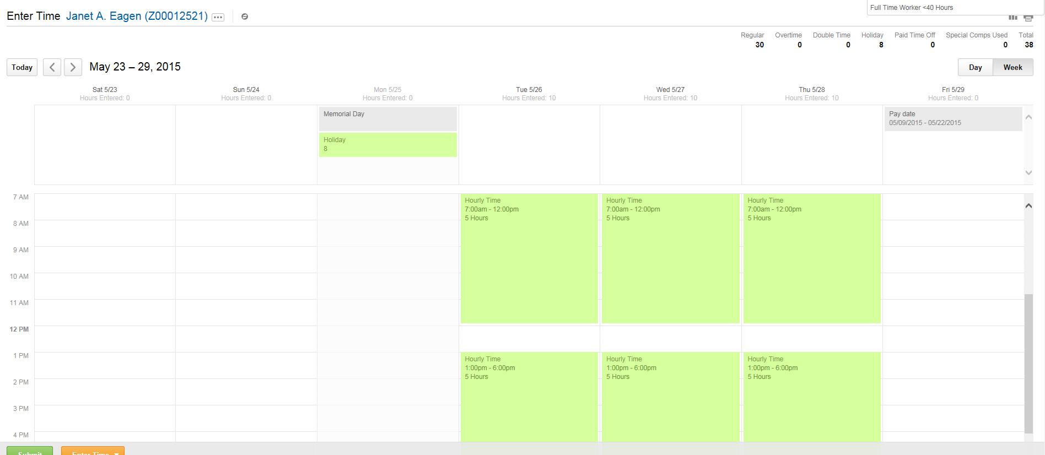

- THE TIMEKEEPER WILL RUN THE REPORT SHOWING EMPLOYEES WITH WEEKLY HOURS LESS THAN 40. THIS EMPLOYEE WILL BE ON REPORT. THE TIMEKEEPER SHOULD REVIEW THE EMPLOYEE’S TIME RECORD AND WILL SEE THAT TWO HOURS ARE MISSING DUE TO HOLIDAY.

- TYPE EMPLOYEE’S NAME IN SEARCH BOX AND BRING UP EMPLOYEE’S SCREEN. CLICK ON THE RELATED ACTIONS SYMBOL, AND THEN ON TIME AND LEAVE

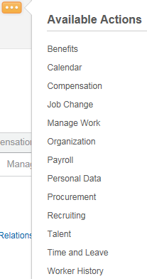

- THEN CLICK ON ENTER TIME

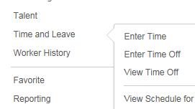

- ENTER THE DATE FOR THE WEEK OF THE HOLIDAY

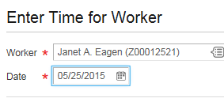

- CLICK ON ENTER TIME AND CHOOSE “ENTER TIME”. THEN CHOOSE THE DAY OF THE HOLIDAY (IN THIS CASE, MONDAY, 5/25)

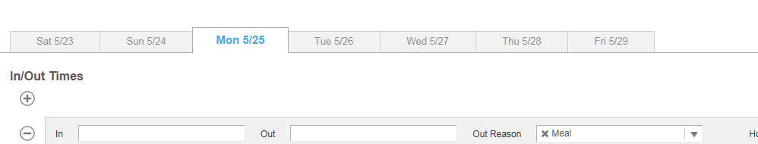

- ENTER THE NUMBER OF HOURS NEEDED TO COMPLETE A FULL DAY BEYOND THE 8 HOURS FOR THE HOLIDAY. IN THIS CASE TWO ADDITIONAL HOURS ARE NEEDED. IT IS NOT IMPORTANT WHICH HOURS ARE INPUT – JUST THAT THEY RESULT IN THE ADDITIONAL HOURS NEEDED. MAKE SURE THE “OUT REASON” IS “OUT” AND THE “TIME TYPE” IS “HOURLY TIME”

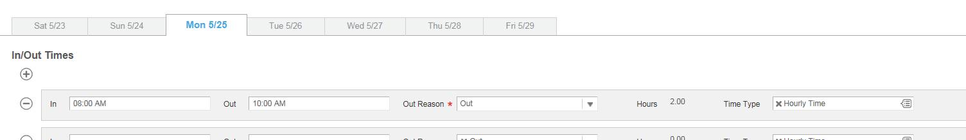

- WHEN YOU CLICK SUBMIT, THE SCREEN WILL PROVIDE A PLACE FOR A COMMENT. YOU MUST INDICATE THE REASON – IN THIS CASE AN ADJUSTMENT FOR A 10 HOUR DAY

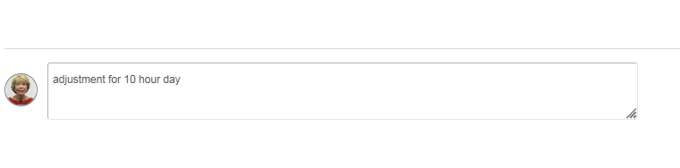

- THE TIME RECORD NOW REFLECTS 10 HOURS FOR THE DAY OF THE HOLIDAY AND A TOTAL OF 40 HOURS FOR THE WEEK

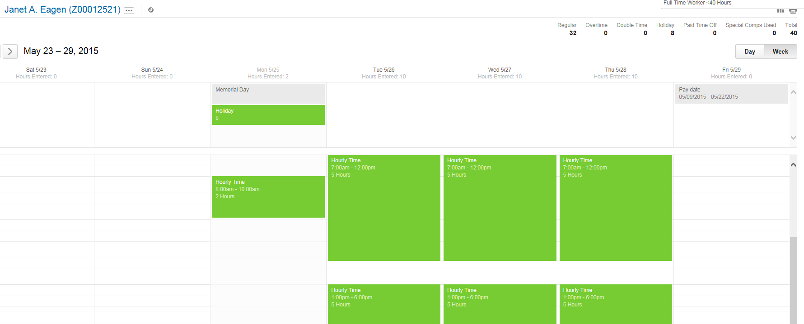

CHANGING EXTRA HOURS TO SPECIAL COMP

- EMPLOYEE COMPLETES WEEKLY TIME RECORD AND HOURS ARE APPROVED BY SUPERVISOR. TIME RECORD SHOWS TOTAL HOURS OVER 40 (NOTE THAT THE EMPLOYEE HAS APPROVED TIME OFF (SICK LEAVE) THIS WEEK)

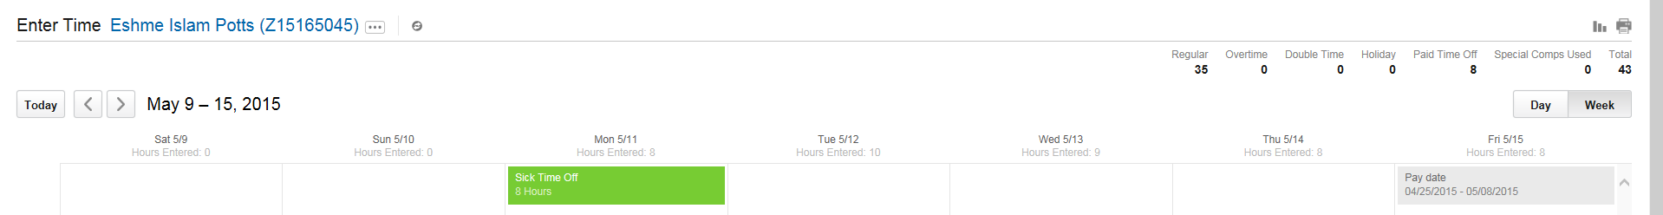

- TIMEKEEPER RUNS REPORT FOR THAT WEEK SHOWING EMPLOYEES WITH HOURS OVER 40

- TIMEKEEPER IS INFORMED BY EMPLOYEE’S SUPERVISOR THAT HOURS SHOULD BE SPECIAL COMP

TIMEKEEPER:

- TYPE EMPLOYEE’S NAME IN SEARCH BOX AND BRING UP EMPLOYEE’S SCREEN. CLICK ON THE RELATED ACTIONS SYMBOL, THEN ON “TIME AND LEAVE”, AND THEN ON “ADJUST CALCULATED TIME” (SEE EXAMPLE BELOW):

- CHOOSE THE CORRECT DATE FOR THE CORRECTION
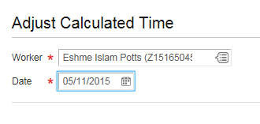

- THE SCREEN WILL SHOW THE EMPLOYEE’S TIME ENTRIES FOR THAT WEEK. THE SCREEN IS DIVIDED INTO SECTIONS: “REPORTED TIME” IS ON THE LEFT AND “CALCULATED TIME” IS ON THE RIGHT.

- FIND THE ENTRIES THAT SHOW THE ADDITIONAL HOURS WORKED. IN THIS CASE, THE EMPLOYEE WORKED A TOTAL OF 10 HOURS ON TUESDAY (5 HOURS IN THE MORNING AND 5 HOURS IN THE AFTERNOON) AND 9 HOURS ON WEDNESDAY (5 HOURS IN THE MORNING PLUS 4 HOURS IN THE AFTERNOON), THEREFORE TWO HOURS TUESDAY AND 1 HOUR WEDNESDAY NEEDS TO BE CHANGED TO SPECIAL COMP.

NOTE THAT THE ENTRIES ARE USUALLY DIVIDED INTO MORNING AND AFTERNOON, SO CHOOSE EITHER ENTRY FOR THAT DAY

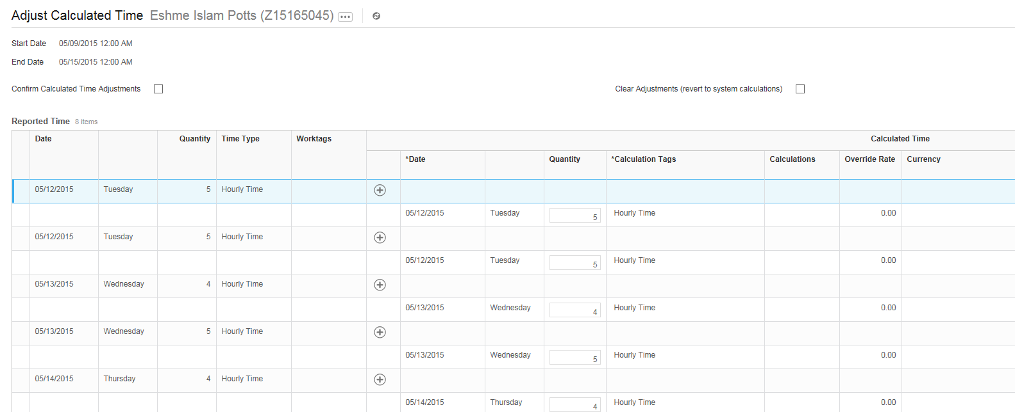

- REDUCE THE TIME UNDER “CALCULATED TIME” SO THAT EACH DAY EQUALS THE EMPLOYEE’S NORMAL WORK DAY. IN MOST CASES THIS WIELL BE A TOTAL OF 8 HOURS

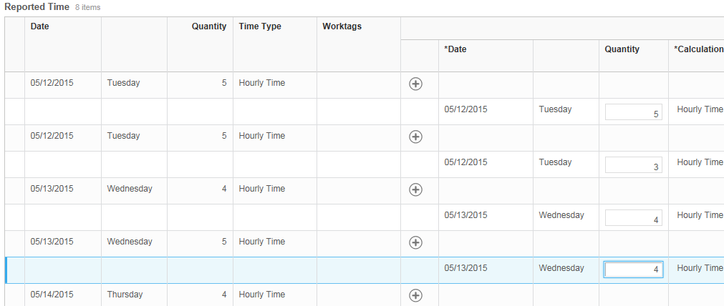

- SCROLL TO THE BOTTOM OF THE PAGE TO NOW CONVERT THE TIME THAT WAS REDUCED (IN THIS CASE A TOTAL OF 3 HOURS) TO SPECIAL COMP. YOU ARE WORKING IN THE SECTION CALLED “ADDITIONAL CALCULATED TIME”

- ADD A LINE FOR EACH AFFECTED DAY (BY CLICKING THE + SIGN) AND COMPLETE THE SPECIFIC DATE; NUMBER OF HOURS FOR THAT DAY; AND THE “CALCULATION TAG” WHICH YOU SELECT FROM THE DROPDOWN. THIS IS “ACCRUAL SPECIAL COMP”

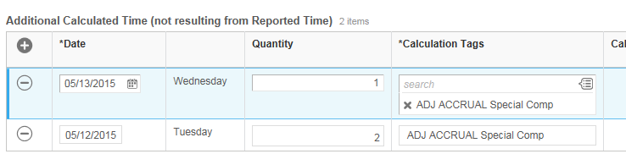

- CHECK YOUR ADJUSTMENTS VERY CAREFULLY AND MAKE SURE THAT YOUR TOTALS MATCH. IN THIS CASE REPORTED TIME FOR TUESDAY WAS 10 HOURS AND FOR WEDNESDAY WAS 9 HOURS. WE MADE THE ADJUSTMENT UNDER CALCULATED TIME TO 8 HOURS EACH DAY. SO WE NEED TO ACCOUNT FOR THREE HOURS, AND WE DID THAT UNDER ADDITIONAL CALCULATED TIME AS TWO SPECIAL COMP ENTRIES.

- SCROLL BACK UP TO THE TOP AND CHECK “CONFIRM CALCULATED TIME ADJUSTMENTS” AND THEN “SUBMIT”

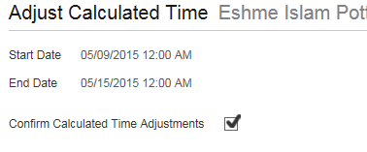

- SCROLL BACK UP TO TOP AND RETYPE THE EMPLOYEE’S NAME IN THE SEARCH BOX. CLICK ON THE RELATED ACTION SYMBOL AND THEN ON “TIME AND LEAVE”, AS YOU DID IN STEP 4. SCROLL DOWN AND CLICK ON “VIEW TIME OFF BALANCE”

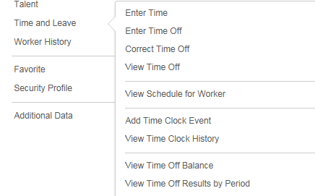

- CHOOSE CORRECT DATE AND CLICK OK

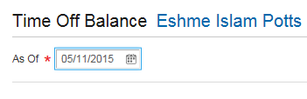

- VERIFY THAT SPECIAL COMP HAS ACCRUED IN THE PAY PERIOD. IN THIS CASE, ACCRUAL SHOULD BE 3 HOURS

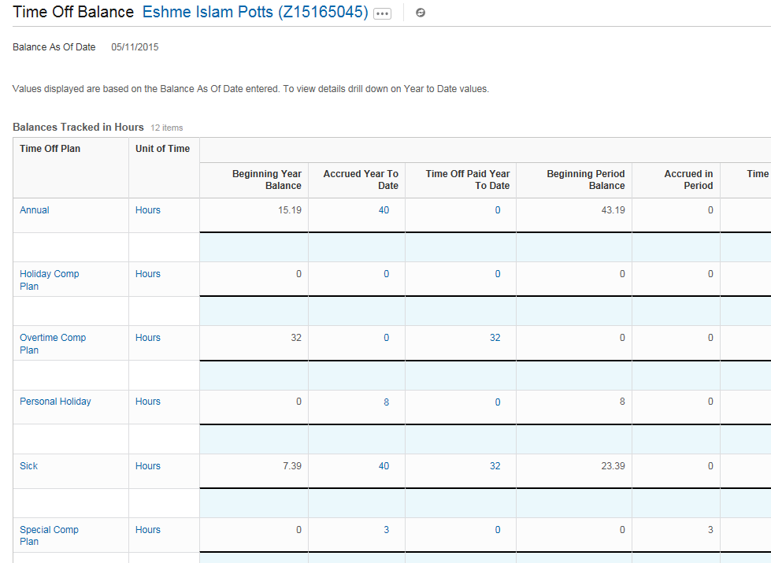

- THIS IS HOW THE TIME RECORD LOOKS AFTER COMPLETING THE PROCESS. NOTE THAT THERE IS NO LONGER ANY HOURS OVER 40 AT THE TOP, BUT RATHER SPECIAL COMP FOR EACH DAY EARNED. THE DAILY RECORD OF TIME REMAINS ACCURATE REFLECTING THE 10 HOURS WORKED ON TUESDAY AND THE 9 HOURS WORKED ON WEDNESDAY

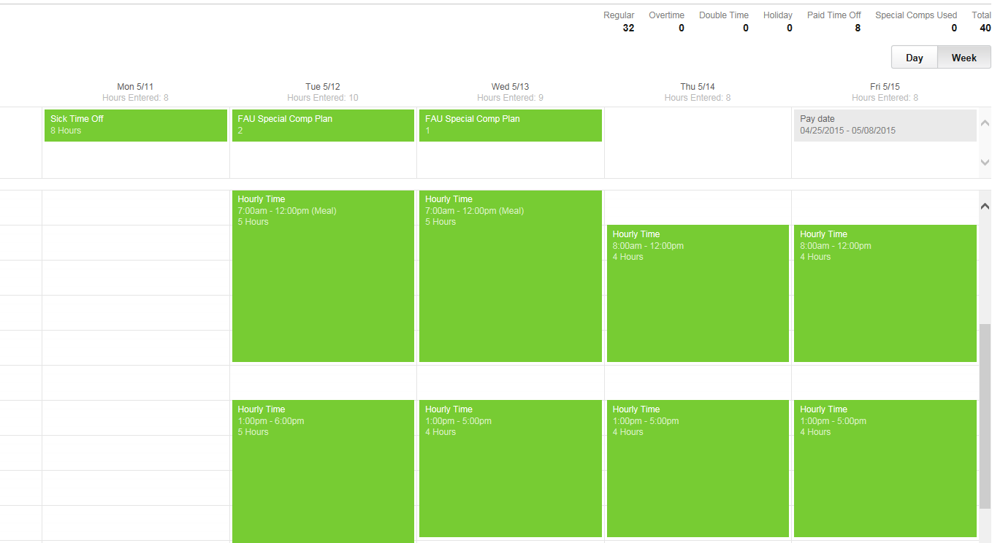

SPECIAL COMP/HOLIDAY COMP ACCRUAL: SP EMPLOYEE WORKED ON HOLIDAY

- EMPLOYEE COMPLETES WEEKLY TIME RECORD AND HOURS ARE APPROVED BY SUPERVISOR (IN THIS EXAMPLE THE EMPLOYEE WORKED ON THE HOLIDAY). TIME RECORD SHOWS TOTAL HOURS OVER 40.

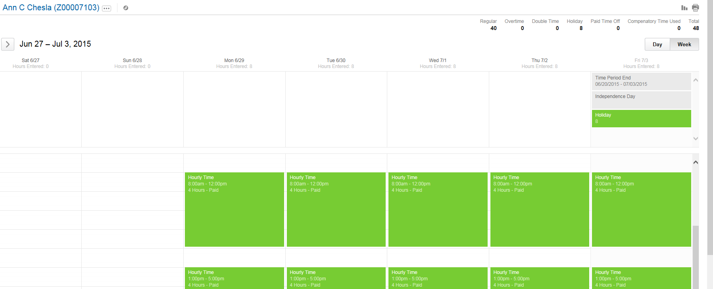

- TIMEKEEPER RUNS REPORT FOR THAT WEEK SHOWING EMPLOYEES WITH HOURS OVER 40

- TIMEKEEPER IS INFORMED BY EMPLOYEE’S SUPERVISOR THAT HOURS SHOULD BE SPECIAL COMP

TIMEKEEPER:

- TYPE EMPLOYEE’S NAME IN SEARCH BOX AND BRING UP EMPLOYEE’S SCREEN. CLICK ON THE RELATED ACTIONS SYMBOL, THEN ON TIME AND LEAVE AND THEN ON “ADJUST CALCULATED TIME”

- CHOOSE THE CORRECT DATE FOR THE CORRECTION

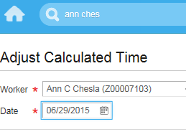

- THE SCREEN WILL SHOW THE EMPLOYEE’S TIME ENTRIES FOR THAT WEEK. THE SCREEN IS DIVIDED INTO SECTIONS: “REPORTED TIME” IS ON THE LEFT AND “CALCULATED TIME” IS ON THE RIGHT. THE REPORTED TIME REFLECTS 8 HOURS EACH DAY FOR A TOTAL OF 40 HOURS. NO CHANGES SHOULD BE MADE TO THE TOP PORTION OF THE SCREEN.

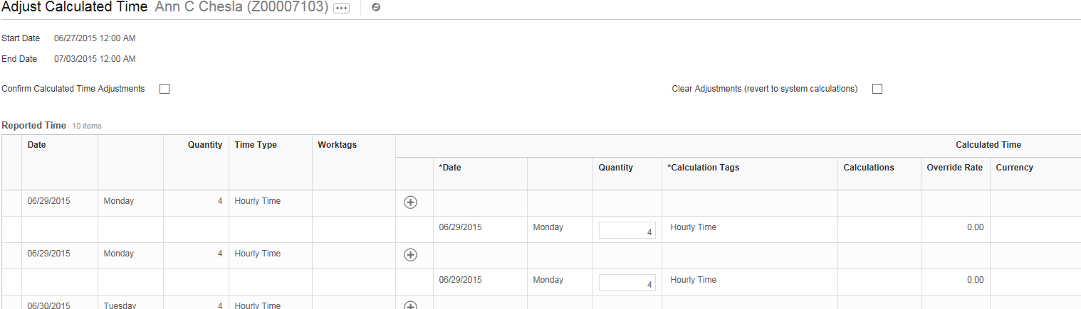

- SCROLL TO THE BOTTOM OF THE PAGE TO THE SECTION CALLED “ADDITIONAL CALCULATED TIME”. YOU WILL SEE AN ENTRY ON FRIDAY (THE DAY OF THE HOLIDAY) FOR 8 HOURS OF HOLIDAY TIME

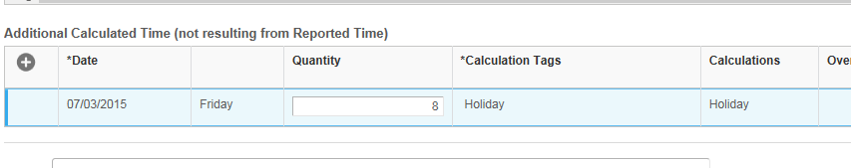

- YOU MUST CHANGE THE HOLIDAY TIME TO SPECIAL COMP. ADD A LINE BY CLICKING THE + SIGN AND COMPLETE THE SPECIFIC DATE (THE DAY OF THE HOLIDAY); NUMBER OF HOURS WORKED THAT DAY (IN THIS CASE THAT IS 8); AND THE “CALCULATION TAG” WHICH YOU SELECT FROM THE DROPDOWN. THIS IS ACCRUAL SPECIAL COMP. YOU ALSO MUST CHANGE THE NUMBER OF HOURS FOR HOLIDAY. SUBTRACT THE NUMBER OF HOURS WORKED FROM THE 8 HOLDAY HOURS. IN THIS CASE THAT BECOMES ZERO. YOU HAVE NOW CONVERTED HOLIDAY TIME TO SPECIAL COMP
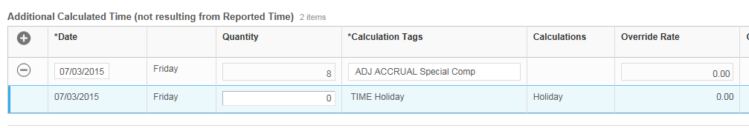

NOTE: YOU COULD DO THE EXACT SAME ADJUSTMENT, BUT CHOOSE HOLIDAY COMP INSTEAD (ALTHOUGH OUR EXAMPLE WILL PROCEED WITH SPECIAL COMP):

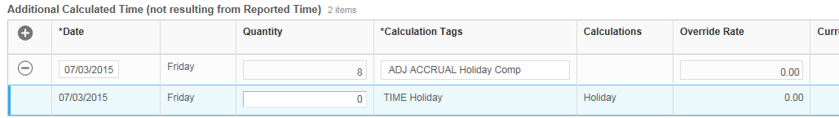

- CHECK YOUR ADJUSTMENTS VERY CAREFULLY. SCROLL BACK UP TO THE TOP AND CHECK “CONFIRM CALCULATED TIME ADJUSTMENTS” AND THEN SUBMIT

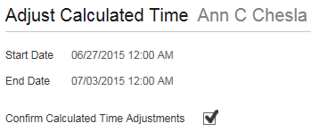

- SCROLL BACK UP TO TOP AND RETYPE THE EMPLOYEE’S NAME IN THE SEARCH BOX. CLICK ON THE RELATED ACTION SYMBOL AND THEN ON “TIME AND LEAVE”, AS YOU DID IN STEP 4. SCROLL DOWN AND CLICK ON “VIEW TIME OFF BALANCE”

- CHOOSE CORRECT DATE AND CLICK OK

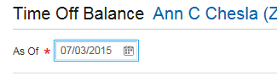

- VERIFY THAT SPECIAL COMP HAS ACCRUED IN THE PAY PERIOD. IN THIS CASE, ACCRUAL SHOULD BE 8 HOURS

- THIS IS HOW THE TIME RECORD LOOKS AFTER COMPLETING THE PROCESS. NOTE THAT THERE IS NO LONGER ANY HOURS OVER 40 AT THE TOP, BUT RATHER SPECIAL COMP FOR FRIDAY TO REPLACE THE HOLIDAY. THE DAILY RECORD OF TIME REMAINS ACCURATE

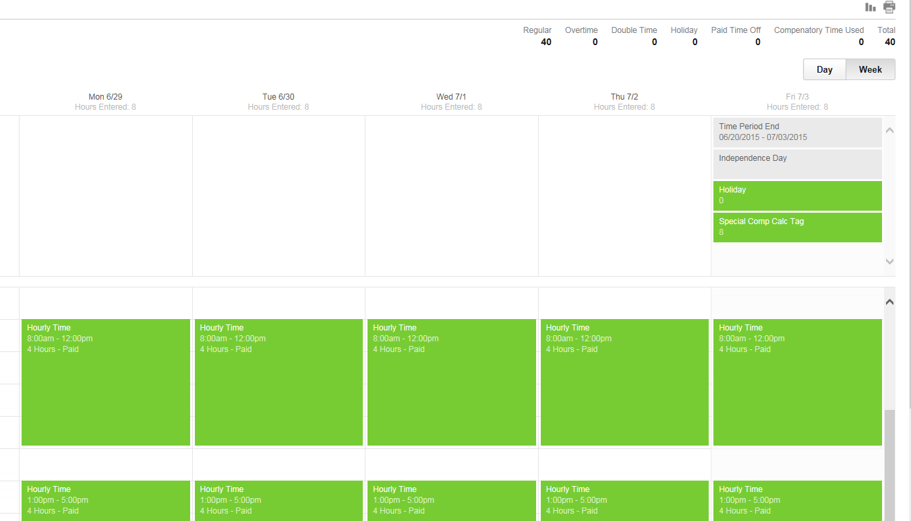

CHANGING OVERTIME TO OVERTIME COMP

- THE EMPLOYEE COMPLETES WEEKLY TIME RECORD AND HOURS ARE APPROVED BY SUPERVISOR. TIME RECORD SHOWS OVERTIME:

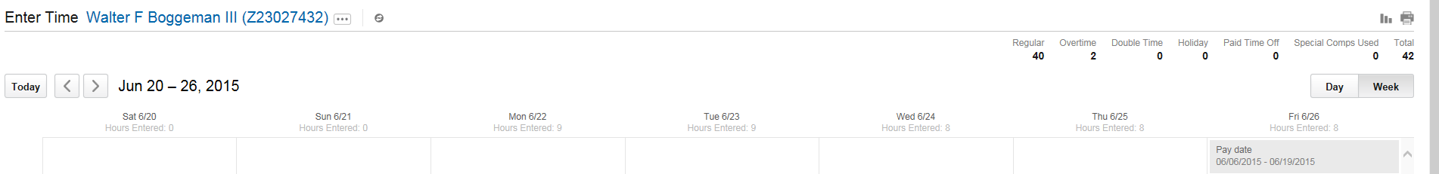

- TIMEKEEPER RUNS REPORT FOR THAT WEEK SHOWING EMPLOYEES WITH OVERTIME

- TIMEKEEPER IS INFORMED BY EMPLOYEE’S SUPERVISOR THAT HOURS SHOULD BE OVERTIME COMP; NOT OVERTIME PAY

TIMEKEEPER: (NOTE – YOU SHOULD ALWAYS REVIEW THE EMPLOYEE’S TIME RECORD BEFORE MAKING CORRECTIONS)

- TYPE EMPLOYEE’S NAME IN SEARCH BOX AND BRING UP EMPLOYEE’S SCREEN. CLICK ON THE RELATED ACTIONS SYMBOL, THEN ON TIME AND LEAVE AND THEN ON “ADJUST CALCULATED TIME” (SEE EXAMPLE BELOW):

- CHOOSE THE CORRECT DATE FOR THE CORRECTION

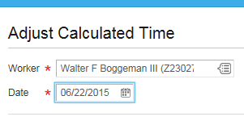
- THE SCREEN WILL SHOW THE EMPLOYEE’S TIME ENTRIES FOR THAT WEEK. THE SCREEN IS DIVIDED INTO SECTIONS: “REPORTED TIME” IS ON THE LEFT AND “CALCULATED TIME” IS ON THE RIGHT

- FIND THE ENTRIES THAT SHOW THE ADDITIONAL HOURS WORKED. IN THIS CASE, THE EMPLOYEE WORKED A TOTAL OF 9 HOURS ON BOTH MONDAY AND TUESDAY (4 HOURS IN THE MORNING AND 5 HOURS IN THE AFTERNOON). THEREFORE ONE HOUR EACH DAY NEEDS TO BE CHANGED TO OVERTIME COMP. NOTE THAT THE ENTRIES ARE USUALLY DIVIDED INTO MORNING AND AFTERNOON, SO CHOOSE EITHER ENTRY FOR THAT DAY (SEE EXAMPLE BELOW)

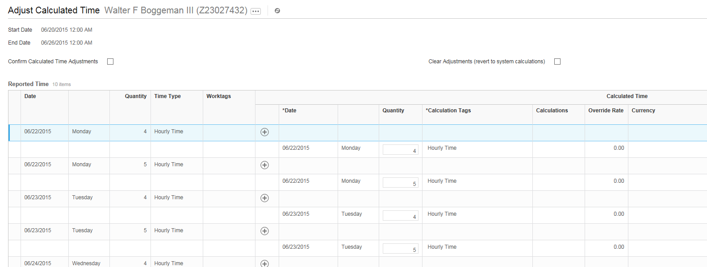

- REDUCE THE TIME UNDER “CALCULATED TIME” SO THAT EACH DAY EQUALS THE EMPLOYEE’S NORMAL WORK DAY. IN MOST CASES THIS WILL BE A TOTAL OF 8 HOURS (SEE EXAMPLES ABOVE AND BELOW).

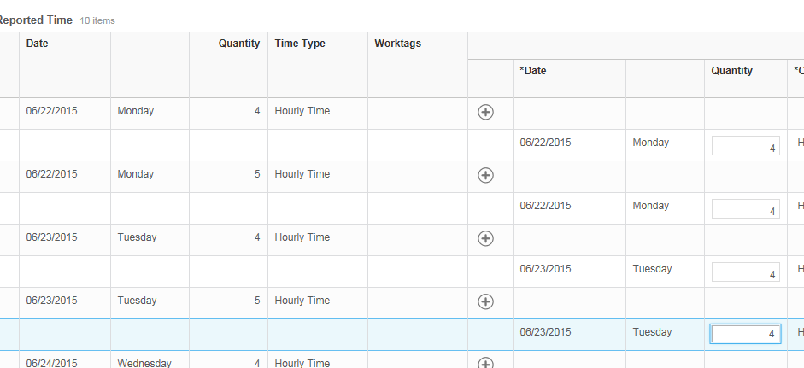

- SCROLL DOWN AND FIND THE LISTING FOR WEEKLY OVERTIME (OVERTIME IS INDICATED ON THE LAST DAY OF THE WEEK). YOU WILL SEE 2 HOURS OF WEEKLY OVERTIME ON FRIDAY

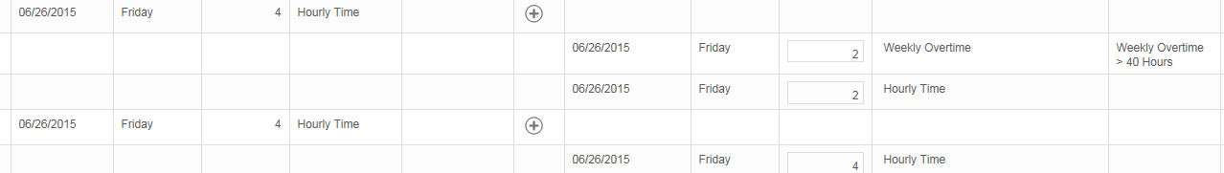

- CHANGE THE OVERTIME HOURS TO “0”, AND THEN CLICK THE + SIGN TO ADD A LINE. INSERT THE SAME NUMBER OF HOURS (IN THIS CASE 2) AND IDENTIFY AS HOURLY TIME. NOTE THAT YOU NOW HAVE 8 HOURS OF HOURLY TIME, INSTEAD OF 6 HOURS OF HOURLY TIME AND 2 HOURS OF OVERTIME.

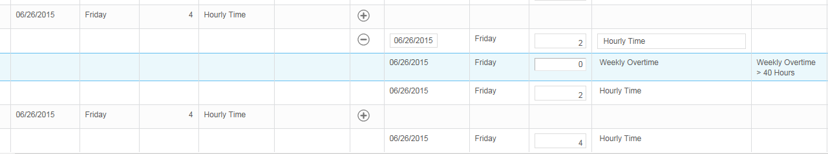

- SCROLL TO THE BOTTOM OF THE PAGE TO NOW CONVERT THE TIME THAT WAS REDUCED (IN THIS CASE A TOTAL OF 2 HOURS) TO OVERTIME COMP. YOU ARE WORKING IN THE SECTION CALLED “ADDITIONAL CALCULATED TIME”

- ADD A LINE FOR EACH AFFECTED DAY (BY CLICKING THE + SIGN) AND COMPLETE THE SPECIFIC DATE; NUMBER OF HOURS FOR THAT DAY; AND THE “CALCULATION TAG” WHICH YOU SELECT FROM THE DROPDOWN. THIS IS “ACCRUAL OVERTIME COMP”.

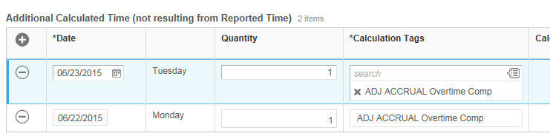

- CHECK YOUR ADJUSTMENTS VERY CAREFULLY AND MAKE SURE THAT YOUR TOTALS MATCH. IN THIS CASE REPORTED TIME FOR MONDAY AND TUESDAY WAS 9 HOURS EACH DAY. WE MADE THE ADJUSTMENT UNDER CALCULATED TIME TO 8 HOURS EACH DAY. THE OVERTIME WAS REFLECTED ON THE LAST DAY OF THE WEEK (FRIDAY) AS TWO HOURS, AND WE CHANGED THAT TO HOURLY TIME. SO WE NEED TO ACCOUNT FOR TWO HOURS, AND WE DID THAT UNDER ADDITIONAL CALCULATED TIME AS AN OVERTIME COMP ENTRY.

- SCROLL BACK UP TO THE TOP AND CHECK “CONFIRM CALCULATED TIME ADJUSTMENTS”, AND THEN SUBMIT

- SCROLL BACK UP TO TOP AND RETYPE THE EMPLOYEE’S NAME IN THE SEARCH BOX. CLICK ON THE RELATED ACTION SYMBOL AND THEN ON “TIME AND LEAVE”, AS YOU DID IN STEP 4. SCROLL DOWN AND CLICK ON “VIEW TIME OFF BALANCE”

- CHOOSE CORRECT DATE AND CLICK OK:

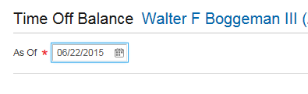

- VERIFY THAT OVERTIME COMP HAS ACCRUED IN THE PAY PERIOD. ACCRUAL SHOULD BE AT RATE OF TIME AND HALF. IN THIS CASE, ACCRUAL SHOULD BE 3 HOURS (SEE EXAMPLE BELOW)

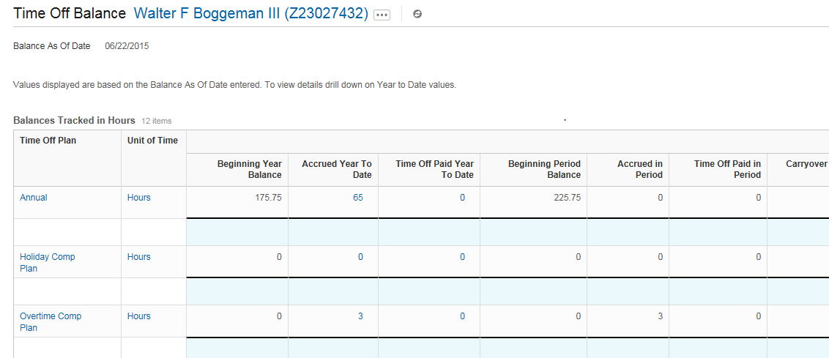

- THIS IS HOW THE TIME RECORD LOOKS AFTER COMPLETING THE PROCESS. NOTE THAT THERE IS NO LONGER OVERTIME AT THE TOP, BUT RATHER OVERTIME COMP FOR EACH DAY EARNED. THE DAILY RECORD OF TIME REMAINS ACCURATE REFLECTING THE 9 HOURS WORKED ON MONDAY AND TUESDAY

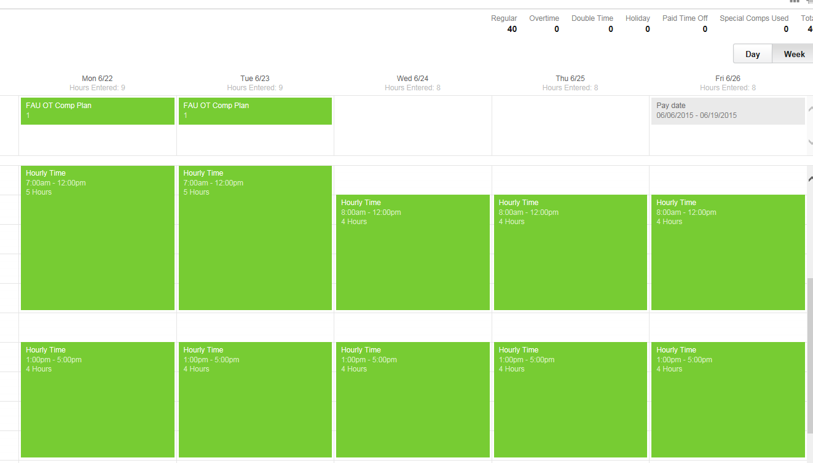

HOLIDAY COMP ACCRUAL: EXEMPT EMPLOYEE WORKED ON HOLIDAY

- AN AMP EMPLOYEE WORKS ON A HOLIDAY AND EARNS HOLIDAY COMP

- SUPERVISOR INFORMS TIMEKEEPER THAT THE EMPLOYEE EARNED HOLIDAY COMP

TIMEKEEPER: CONTACT HUMAN RESOURCES TO INPUT HOLIDAY COMP HOURS

ON CALL PAY

- TYPE EMPLOYEE’S NAME IN SEARCH BOX AND BRING UP EMPLOYEE’S SCREEN. CLICK ON THE RELATED ACTIONS SYMBOL, THEN ON TIME AND LEAVE AND THEN ON “ENTER TIME”

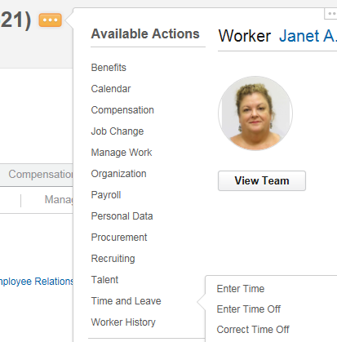

- SELECT THE WEEK FOR ON-CALL PAY AND BRING UP THE TIME RECORD. THE EMPLOYEE HAS ALREADY ENTERED TIME FOR THE WEEK AND THE SUPERVISOR HAS APPROVED

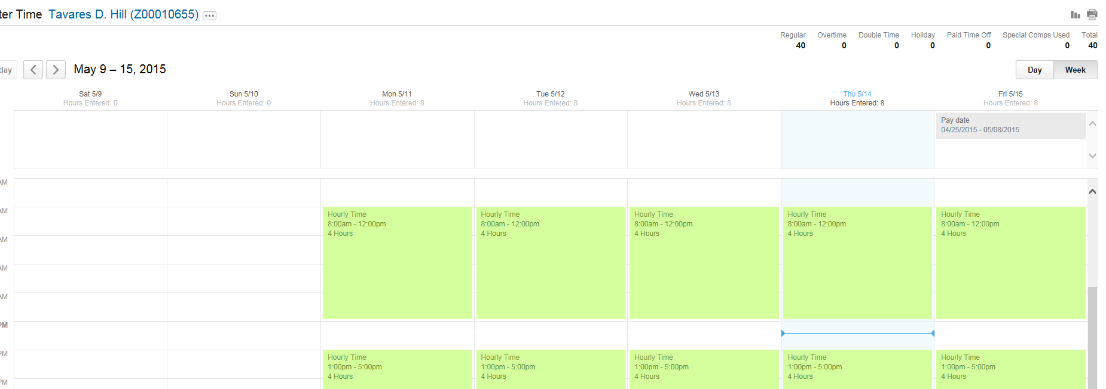

- CLICK ON ENTER TIME AND CHOOSE “ENTER TIME”. IF THE EMPLOYEE WAS ON CALL FOR ONLY ONE DAY, CHOOSE THAT DAY. IF THE EMPLOYEE WAS ON CALL FOR MULTIPLE DAYS THAT WEEK, THEN CHOOSE FRIDAY. THE HOURS ENTERED BY THE EMPLOYEE FOR THAT DAY WILL BE SHOWN ON THE SCREEN.

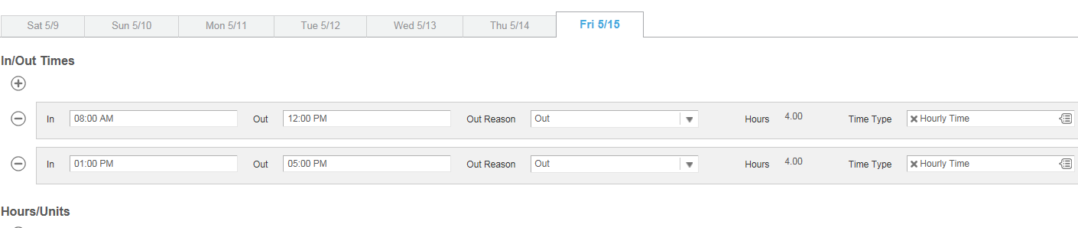

- YOU WILL ENTER ON CALL HOURS IN THE SECTION: HOURS/UNITS. YOU ENTER THE “TIME TYPE” FROM THE DROP DOWN MENU. CHOOSE TIME ENTRY CODES: ON CALL PAY

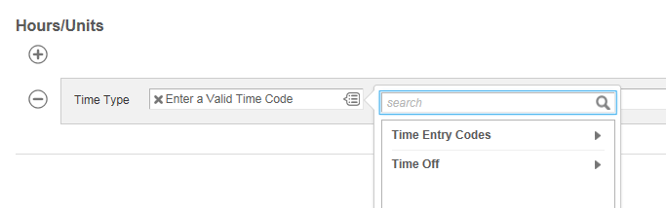

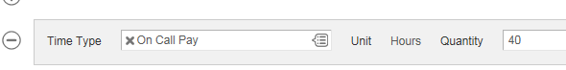

- THE ON CALL PAY HOURS ARE NOW REFLECTED ON THE TIME RECORD

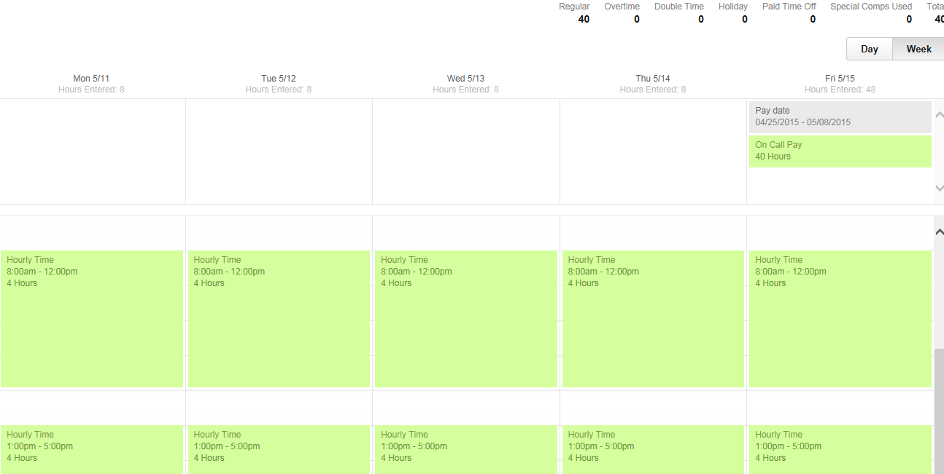

KEEP TESTING! PRACTICE SITUATIONS

ALL TESTING IS DONE IN P6. NO SUPERVISORY APPROVAL IS REQUIRED WHILE YOU ARE TESTING IN P6

https://impl.workday.com/fau6/login.flex

- ENTER TIME AND TIME OFF FOR AN SP EMPLOYEE.
- ENTER 8 HOURS OF TIME OFF
- ENTER 32 HOURS OF “HOURLY TIME”

- ENTER TIME FOR AN SP EMPLOYEE THE WEEK OF A HOLIDAY.
- ENTER 32 HOURS OF “HOURLY TIME”
- CHECK THAT TOTAL HOURS ARE 40

- ENTER TIME AND TIME OFF FOR AN SP EMPLOYEE
- ENTER 16 HOURS OF TIME OFF
- ENTER 24 HOURS OF HOURLY TIME
- DELETE THE TIME OFF

- ENTER TIME AND TIME OFF FOR AN SP EMPLOYEE
- ENTER 8 HOURS OF TIME OFF
- ENTER 32 HOURS OF HOURLY TIME
- CORRECT THE TIME OFF (CHOOSE A DIFFERENT TIME OFF OR DIFFERENT NUMBER OF HOURS)

- ENTER TIME OFF FOR AN AMP EMPLOYEE
- ENTER 16 HOURS OF TIME OFF
- DELETE 8 HOURS OF TIME OFF

- ENTER TIME FOR SP EMPLOYEE THE WEEK OF A HOLIDAY
- EMPLOYEE WORKS FOUR 10 HOUR DAYS. THE HOLIDAY FALLS ON A REGULAR WORK DAY

- ENTER TIME AND TIME OFF FOR SP EMPLOYEE
- ENTER 8 HOURS OF TIME OFF
- ENTER 35 HOURS OF WORK TIME
- TOTAL HOURS ARE OVER 40. CONVERT EXTRA HOURS TO SPECIAL COMP

- ENTER TIME FOR SP EMPLOYEE THE WEEK OF A HOLIDAY
- THE HOLIDAY FALLS ON A REGULAR WORK DAY
- ENTER 4 HOURS OF HOURLY TIME ON THE HOLIDAY
- ENTER 32 HOURS OF HOURLY TIME FOR THE OTHER WORK DAYS
- TOTAL HOURS ARE OVER 40. CONVERT EXTRA HOURS TO SPECIAL COMP AND REDUCE HOLIDAY HOURS

- ENTER TIME FOR SP EMPLOYEE
- ENTER 42 HOURS OF HOURLY TIME.
- “ENTER TIME” SCREEN SHOWS 2 HOURS OF OVERTIME
- CONVERT OVERTIME TO OVERTIME COMP

- AMP EMPLOYEE WORKED 4 HOURS ON HOLIDAY
- ENTER 4 HOURS OF HOLIDAY COMP

- ENTER TIME FOR SP EMPLOYEE
- ENTER 40 HOURS OF HOURLY TIME
- ENTER 10 HOURS OF ON CALL PAY

