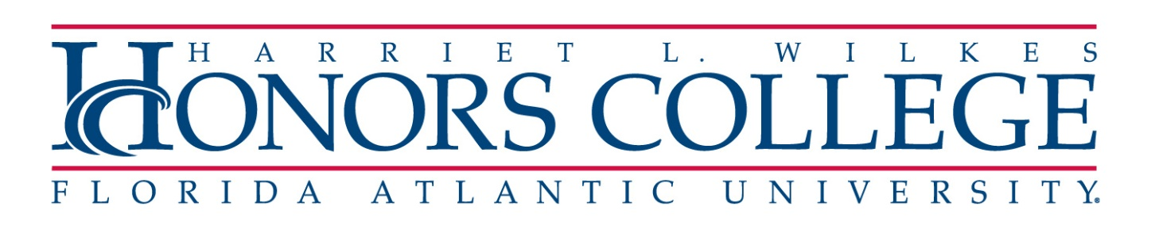
SABBATICAL APPLICATION TIMELINE
2023-2024

09/27/22 – Faculty members notified of sabbatical application process and timeline

10/05/22 – Due date for notifying Chair of intent to submit an application
Sabbatical cases opened in Interfolio

10/19/22 – Applications due to Chairs for approval/comments

10/21/21 – Applications due to Business Manager for approval

10/25/22 – Applications due to Dean for approval/comments

10/28/22 – Applications due to Provost’s Office

11/04/22 – Applications sent out to Research Committee of the UFS

11/23/22 – Recommendations of Research Committee to Provost’s Office

12/9/22 – Final approvals/denials (letters to applicants)

01/06/23 – Signed acceptances due in Provost’s Office

01/20/23 – Memo to Deans, Department Chairs / School Directors, Budget Directors, for acceptances of sabbaticals.

