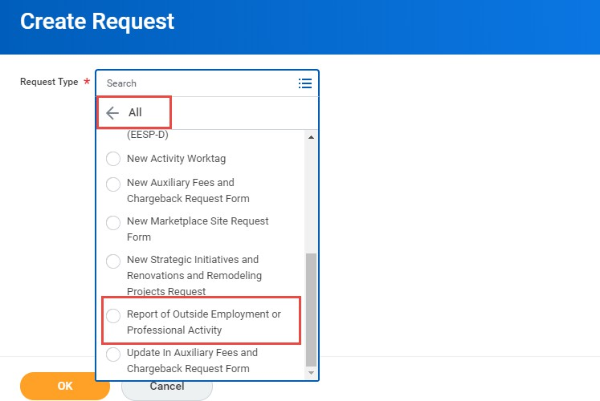
Use this process to submit reports of proposed outside employment or professional activities in accordance with University Policies and Regulations.

University Outside Employment Guidelines may be reviewed here:
http://www.fau.edu/hr/OEguidelines_final.php
http://www.fau.edu/hr/files/Outside_Activity_Form_ Explanation.pdf

- From the Workday home page, search for and 4. Continue completing the Request by answering select the CREATE REQUEST task: each required question.
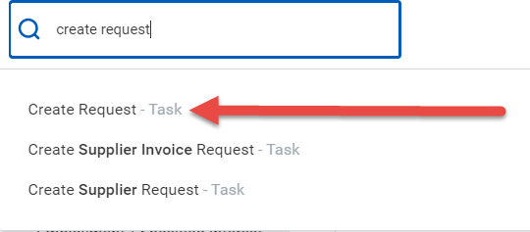
For College of Medicine faculty ONLY with no outside business/activities to report, please select or enter where appropriate: N/A, no outside employment, professional activities, or specified interest to report
5. As needed, supporting documents can be attached by dragging the document to the “Drop” box or by “selecting files” and attaching them as appropriate (Optional).
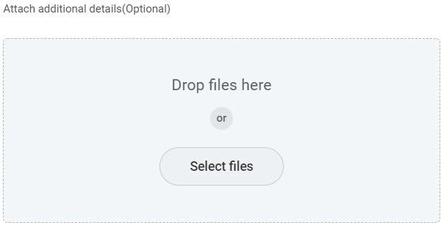
- In the field for Request Type, select “ALL”:


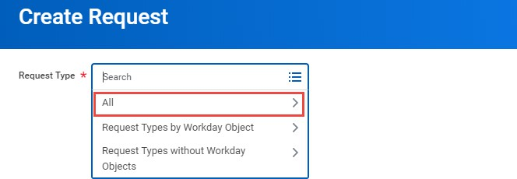
6. When complete, click Submit to route the request for approval.

- Scroll until you are able to select “Report of Outside Employment or Professional Activity” and click OK at the bottom of your screen:

***NOTES***

Reminders and FAQ’s:
  - College of Medicine Faculty must complete/submit a Report of Outside Employment, Professional Activity, even if there’s no outside employment, professional activities or specified interest to report.
  - A Report of Outside Employment, Professional Activity must be completed by all faculty and staff who engage in outside employment or professional activity on an annual basis at the start of or during the contract year.
  - A Report of Outside Employment, Professional Activity must be completed for each unique activity.

I received an error when trying to submit, what do I do?
  - Workday will highlight the question causing the error in red. Please scroll to the highlighted question to update your answer. Once all of the questions with errors have been answered, please resubmit.

How to I check on the progress of my submitted request?
To check on the progress of your request, you can:
  - Review the request via your Workday Inbox Archive

OR
  - Search and select “FAU My Requests” via the Workday Search Bar. Once selected, it will populate your submitted requests.

Once submitted, it routed to the additional managers – is something wrong?
  - For Staff & Postdocs with multiple jobs, the process will route to all managers for each position. If the additional jobs are no longer active, please contact that manager or hres@fau.edu to request the job be ended in Workday
  - For Faculty, the process will route based on the unit hierarchy in Workday. If you notice this appears incorrect, please notify the Director for Academic Personnel in the Provost’s Office.

How do I cancel my Request once it has been submitted?
  - To cancel: search your submitted request via “FAU My Request” or your Workday “Archive Inbox”, select the related actions button > Business Process > Cancel
  - Once submitted, the process cannot be corrected. If the process is still routing for approvals, you can request that it be sent back to you by contacting the individual it is with. Once sent back, you will be able to correct and resubmit your request.

How will I know my request has been approved or denied?
  - You will receive a notification in Workday once your request has been received and successfully completed by Human Resources. To access the completed request, search and select “FAU My Requests” via the Workday search bar.

