Student Travel Code of Conduct
The following policy applies to all persons traveling to meetings, conferences, retreats, athletic events or other activities using Florida Atlantic University funds, whether this travel is within the counties served by FAU or to an external destination. Individuals not signing this policy will not be approved for travel.

The Division of Student Affairs stresses the importance of individual and student organization responsibility pertaining to the use of alcohol/drugs. Neither alcoholic beverages nor non-prescription drugs can be transported or consumed during trips. The use of alcohol/drugs during University approved and student organization sponsored travel including but not limited to retreats, conventions or conferences will not be tolerated.

In addition, the sponsoring student organization or individuals may be held responsible for the actions during officially sanctioned University travel. Abuse of alcohol/drugs or other irresponsible behavior can adversely affect the status of the organization and student status for future travel plans when these lapses in judgment are foreseeable and preventable by the officers and others attending the event. The Division of Student Affairs expects such situations to be reported to the organization advisor or Dean of Students Office immediately.

I understand that when I travel using Florida Atlantic University funds, I am spending student or university funds entrusted to the Division of Student Affairs, Student Government, and Student Clubs and Organizations. I accept the responsibility to be a good steward of those funds. I also understand that I will be viewed as a representative of Florida Atlantic University, and that my behavior will reflect upon the entire university. I accept the responsibility of being a positive representative of the University.

In light of these responsibilities, I agree to abide by the following policies:
- To be familiar with and will obey, any and all of the rules established for the Trip, including the FAU Student Code of
Conduct (Regulations 4.007). I will obey all applicable laws, including those that relate to alcohol consumption.
- To attend all scheduled meetings, conference sessions, and activities related to the funded travel;
- Failure to attend the conference due to last minute cancellations may result in the student having to repay all travel
expenditures made by Florida Atlantic University on the student's behalf.
- Not to consume alcoholic beverages unless I am 21 years of age or older; and not to use illicit drugs;
  - Not to consume alcoholic beverages regardless of my age if such use is banned by the advisor or organizational leadership prior to traveling;
- Not to abuse alcoholic beverages regardless of my age;
- To operate motorized vehicles legally and responsibly; i.e., to drive within the posted speed limits; to wear a seat belt and
require passengers to do the same in accordance with the laws of the state in which I am traveling; not to operate a vehicle if I have consumed any alcohol; not to allow alcohol, illicit drugs or weapons in the vehicle; to operate only motorized vehicles for which I have a current, unrestricted license; to only use vehicles that are properly licensed and with current motor vehicle inspections; to
provide a copy of their license and automobile insurance prior to departure.
- Not to spend money or make monetary commitments on behalf of the organization or the University without following
proper procedures;
- Not to provide transportation to persons not approved for travel;
- To dress appropriately for the setting; and
- To interact professionally and responsibly with other participants at the event.

I also understand that it is the responsibility of everyone traveling to uphold these policies. If I violate them, the advisor and/or the most senior member of the organization present may take steps to protect the reputation of the University and
mitigate its liability. Those steps may include:
- Requiring that the student return to campus prior to the end of the conference at his/her own expense;
- Banning the student from further participation in the conference or meeting;
- Referring the student to the Office of Associate Vice President and Dean of Students;

Students who are referred to the Office of Dean of Students may be grounds for student code of conduct actions, including but
not limited to:
- Requiring that the student repay travel expenditures made by FAU prior to travel, including but not limiting to the cost of
travel (airline tickets and/or share of vehicle rental/fuel; prepaid accommodation expenses, conference fees, etc.);
- Banning the student from recovering out of pocket expenses related to the travel;
- Disciplining the student upon return to campus, which may include
  - Banning the student from future FAU-funded travel;
  - Removing him or her from the student organization and/or leadership in the organization; o
Referring the student to the Office of Associate Vice President and Dean of Students.

Emergencies
In case of a personal emergency the student is to contact a professional staff immediately. Any additional travel expense done without the prior approval of professional staff will be the responsibility of the student. If the need arises that the student must alter their travel plans due to emergency, the student will generally be responsible for all associated costs incurred.

RELEASE OF LIABILITY, WAIVER OF CLAIMS, EXPRESS ASSUMPTION OF RISKS, AND HOLD HARMLESS AGREEMENT

In consideration of participating in the Trip to (City), (State) for the
(name of conference, meeting, or event and hereinafter called the "Trip") and related events in designated city and state on or about (dates of Trip), or hosted by the Florida Atlantic University, I hereby agree as follows:
I, See Below , for myself and my estate, heirs, administrators, executors, and assigns, hereby release and hold harmless the State of Florida, the Florida Atlantic University Board of Trustees, and their officers, directors, employees, representatives, agents, and volunteers (collectively, the "Releasees"), from any and all liability and responsibility whatsoever, however caused, for any and all damages, claims, or causes of action that I, my estate, heirs, administrators, executors, or assigns may have for any loss, illness, personal injury, death, or property damage arising out of, connected with, or in any manner pertaining to the Trip, whether caused by the negligence of Releasees or otherwise.

I fully understand that there are potential risks and hazards associated with the Trip and its related travel, including, but not limited to, possible injury or loss of life. I further understand that while on the Trip, I will be visiting locations and interacting with persons that are not associated with or under the control or supervision of the Releasees. Despite the potential risks and hazards associated with the Trip, I wish to proceed, and freely accept and assume all risks and hazards that may arise from my participation in the Trip and that could result in loss, illness, personal injury, death, or property damage, whether caused by the negligence of Releasees or otherwise.

I further agree to comply with all applicable laws and ordinances and Florida Atlantic University ("University") regulations, rules and policies. I understand that my behavior and conduct must remain consistent with the University Student Code of Conduct. I understand that any consumption of alcoholic beverages must be done in a lawful and responsible manner and in compliance with University policy. I understand that any violations of the University Student Code of Conduct in any way relating to the Trip may subject me to disciplinary action by the University, including without limitation loss of privileges and/or dismissal from the University.
I further hereby agree to defend, indemnify and hold harmless the Releasees from any judgment, settlement, loss, liability, damage, or costs, including court costs and attorney fees for both the trial and appellate levels that Releasees may incur as a proximate result of any act or omission on my part during my participation in the Trip.
I further agree to give the University the right and permission to record my participation and appearance on videotape, audiotape, film, photography or any other medium and to use my name, likeness, voice and biographical information in connection with these recordings. The University may exhibit or distribute all or any part of these recordings for any educational or promotional purpose which the University and its employees deem appropriate. All such recordings shall be the University's property.
I will assume responsibility for all costs incurred by me on the Trip, including medical care, if needed. I understand I must be healthy and reasonably fit in order to safely participate in the Trip. In the event that I am rendered unable to communicate due to illness, accident, or emergency while participating in the Trip, I hereby give permission to a Physician selected by the Trip's personnel to hospitalize, secure proper treatment for, and to take whatever medical actions are necessary to treat me.
The undersigned states that he/she is presently and eligible participant and the information provided on the application are correct and is substantiated. Any falsification can result in immediate cancellation of all arrangements and loss of all monies paid.

I HAVE READ THIS AGREEMENT, UNDERSTAND THAT I AM GIVING UP SUBSTANTIAL RIGHTS BY SIGNING IT, AND VOLUNTARILY AGREE TO BE BOUND BY IT.
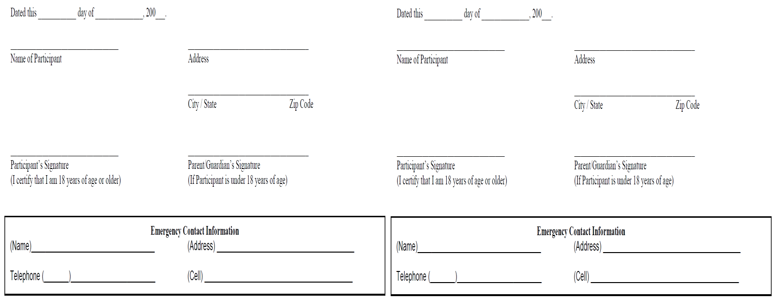

Datedthis dayof .200_ Datedthis dayof ..200 .

Name ofParticipant Address Name of Participant

ZipCod,
Address

Ci�•/Srate ZipCod,

Participam'sSignature
0 certi�·that I am l81w1of age or older)

ParenVGuardian'sSignanrre
0fPartic1pamism1der18 yem ofage)
Participam'sSignature
0 certi�·that I am 18yearsof age or older)
ParenuGuardi,n'sSignanare (IfParticipantisunder18 yeai:osfage)

EmergencyContactInformation
(Name)
!Address) _
TelephoneL ),
!Cell) _
EmergencyContactInformation
(Name),
!Address) _
TelephoneL )
!Cell) _

Datedihis dayof .200_

Name ofParticipant Address

ZipCod,
Datedthis dayof .200_

Name ofParticipant Address

City/State ZipCode

Participam'sSignature
0 certi�·that I am l81w1of age or older)
ParenVGinudian'sSi,nanrre
0fPartic1parnism,d;r18 yem ofage)

Participam'sSignamre
0 certi�·that I am181w1of age or older)

ParenVGuardian'sSignanrre
Of Participarnism1der!&yearsofage)

EmergencyContactInformation
(Name),
!Address)
TelephoneL )
!Cell) _
EmergencyContact Information
(Name),
!Address) _
TelephoneL )
!Cell) _

Datedihis dayof .200_

Name ofParticipant Address
Datedihis dayof .200 .

Name ofParticipant Address

ZipCod,
Ci�•/State ZipCode

Participam'sSignature
0 certi�·that I am 18yearsof age or older)
ParenVGinudian'sSi,nanrre
0fPartic1parnism,d;r18 years ofage)

Participam'sSig:namre
0 certi�·that I am I&1w1of age orolder)

ParentiGuardi.:m'sSignarure
(IfParticipantis under18yeaisofage)

EmergencyContactInformation
(Name),
!Address) _
TelephoneL )
!Cell) _
EmergencyContactInformation
(Name)
!Address)
TelephoneL )
!Cell) _

Datedthis dayof .200_

Name of Participant Address

ZipCod,
Datedthis dayof .200_.

Name of Participant Address

Ci�•/State ZipCod,

Participant'sSignature
0 certi�·that I am l81w1of age or older)

ParenVGinudian'sSignanrre
0fPa11ic1pamism1der18 yem ofage)
Participant'sSignature
0 certi�·that I am l81w1of age orolder)
ParentiGuanfom'sSignanrre
(IfParticipantisunder18yeai:osfage)

EmergencyContactInformation
(Name), _
!Address) _
TelephoneL )
!Cell) _
(Name)'-----------
EmergencyContactInformation
!Address) _
TelephoneL ),
!Cell) _

