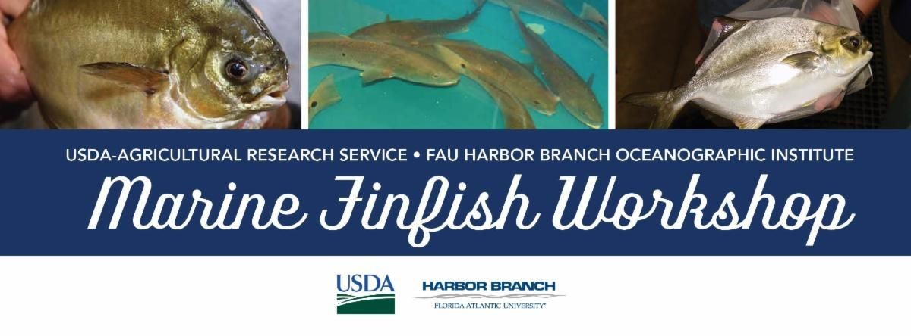

Warmwater Marine Finfish Workshop
Harbor Branch Oceanographic Institute (HBOI)- United States Department of Agriculture- Agriculture Research Service (ARS)
Date and Location: November 20th 2019, HBOI, Fort Pierce, Florida.

A Warmwater Marine Finfish Workshop was held at Florida Atlantic University’s Harbor Branch Oceanographic Institute (HBOI-FAU) on November 20th 2019. The objective of the workshop was to listen to industry partners to ensure the USDA-ARS project research priorities align with industry needs. On hand for the workshop were eight Industry members including owners and their senior level staff, two representatives from USDA-ARS, and the three Project Investigators from HBOI-FAU. USDA-ARS and HBOI-FAU personnel were freely available to address questions the Industry group had during the workshop but the scope of the workshop was determined and managed by the industry members with USDA-ARS and HBOI-FAU personnel primarily participating in a listening capacity. Below is a summary of the industry’s discussion during the meeting. The following topic areas were discussed. These topic areas included issues that were identified as barriers to commercial production. By order of priority, the producers discussed the following topics:

- Regulation
- Diet
- Disease
- New species
- Density and temperature
- Future Goals
- Partnership with the University and USDA-ARS
- Future workshops

Regulation

The principle issues regarding regulations addressed by industry partners are:

  - Discharge.
  - Citing of farms with clean seawater, including intake, discharge, and permitting.
  - Zoning for land-based systems.
  - Inconsistent and changing rules throughout Local, County, State, and Federal agencies and regulatory bodies.
  - The high number of regulatory agencies affecting different aspects of the farming enterprise. The hope here is to centralize these agencies.
  - Citing and regulation were identified as the biggest barriers to entry into the industry.
The industry members acknowledged that this project was not the vehicle for change in regulations but wanted a record of their concern.

Diet
Industry partners expressed their need for research to improve diet formulations and manufacturing capacity for Recirculating Aquaculture Systems for all phases of the fish life cycle, prioritizing the following subjects:

  - Determine the optimum frequency of feeding.
  - Expressed the need to conduct all studies under relevant conditions and partner with farms (keeping in mind that on farm trials need to be reasonable so as not to impact production cycles and output).
  - A need to address the lack of commercial availability and manufactures for feeds at the limited tonnage required by small farms and/or feeds for specific life stages that cannot be purchased in large lots.
  - Identify diets/feeds that are “specific” to warmwater marine finfish (as opposed to the salmonid based “generic” feeds available today).
  - Identify cost-effective feeds to purchase.
  - Identify the ideal nutrient requirements for lipids and proteins to achieve more economic management strategies and higher production rates.
  - Develop RAS specific diets that address cost considerations, increases in efficiency and waste capture.
  - Emphasis on minor feasible changes to make diets more optimal to species or
- production systems (i.e., coating of an existing commercial pellet).
  - Public/private partnerships to decrease the cost of manufacturing ‘white label’ diets.
- Identify an ideal diet that achieves high FCR, at a low cost and does not compromise
a. system performance (i.e. water quality, waste capture, etc.).
- Find ways to partner with feed manufacturers: manufacture + trials.
- It was identified that there is a need to validate any diet developments in a commercial setting at a commercial scale and under commercial settings. This should be done in a manner that mitigates the potential for risk of conducting research on partner farms.

It was expressed diet improvements should be addressed following these life phase priorities: 1- Grow out; 2-Finishing diets that also address off flavor; 3- Nursery (i.e., post weaning); 4- Broodstock (for the promotion of maturation); 5-First feeding to reduce size variation.

Industry partners expressed that there is no need to work on live feed replacements or first feeding diets, they felt there was already sufficient information and farm hand knowledge. Focus should be on higher return on investment for all life phases other than pre-weaning.

Also discussed were finishing diets that mitigate for off-flavor was also mentioned.

Disease

Much discussion was given to disease and fish health. Participating industry partners expressed disease related concerns and issues that need to be addressed which include:
  - Development of rapid farm level diagnostic tests. Current diagnostic tests are constrained by the expense of analyzing samples and a long process time.
  - Need for greater surveillance tools.
  - Need for same day treatment options.
  - Need for prevention options.

It was expressed that research in this area should focus on:
- Identifying more approved treatments (other than freshwater dips, copper, and killing fish).
- Prioritizing the list of the diseases known and unknown for warmwater marine fish species (the bacterial for a start).
- Focusing on these parasites first: Cryptosporidium/Amyloodinium/Neobenedenia.
- A need for greater focus on endemic versus exotic diseases.
- A need to study the susceptibility of different fish species to disease.
- Private versus public veterinary services: the ability to access rapid and affordable diagnostic protocols. Perhaps a private company could provide a more rapid response.
- Genetic selection programs for developing certified disease free strains.
- The need for developing vaccines, but more at a private level for each farm.
Emphasis was placed on the need for vaccines delivered by immersion.
- In year 1 of the current project HBOI is developing eDNA methods to detect potential disease problems before outbreaks and losses occur.
A strong emphasis was given to the importance of veterinary caregivers respecting privacy laws regarding disease reporting at the farm level, and to be cautious not to invite more regulation and testing requirements.

Certification programs were discussed in the context of the above such that increased regulation was not a result.

New Species

For this section, discussion focused on the flexibility that needs to be afforded industry to determine potential species to work on in the future. Participants were referred to https://www.fau.edu/hboi/aquaculture/status-of-marine-finfish.php to review marine finfish

currently identified by stakeholders as potential candidates for commercialization in the U.S. It was also pointed out that investment opportunities for grow out operations are limited due to the perceived risk by investors. Investors want to see stock insurance before committing finances.
The participants unanimously identified a need for a Federally backed insurance program. Cobia and Seriola were briefly mentioned by members of the group as future species.

Density and Temperature
It was suggested by industry partners that there is insufficient data on the relationship between production density and water temperature to increase production and make management decisions. It was suggested that the provision of well-developed growth curves would benefit producers in making sound management and economic decisions and thereby increase ROI. Such models should factor in physiological/behavioral/density considerations. These should be growth phase specific. The producers also stated that another important aspect to consider here is the tank dimensions and surface area ratio to optimize tank configuration and volume.

Future goals
The producers identified Future research goals for warmwater marine finfish aquaculture and that the focus should be on- the following areas:

  - Genetic selection for disease resistance. It was suggested Amyloodinium should be a priority.
  - Identification of the genome to accelerate genetic selection for disease resistance.
  - Determine the effects of microcystins and other HAB’s in source waters providing farms water on spawning, overall health, and the efficacy of their degradation/elimination prior to entering the culture system.
  - Economics: Decision making at industry investment level.

Partnership with Industry

To strengthen communication and the partnership between the marine finfish industry leaders and USDA-ARS/HBOI-FAU, it is important to:
  - Respect the intellectual property and privacy of every aquaculture producer.
  - Provide industry driven research relevant to commercial production and industry needs.
  - Consider private farm compensation strategies where possible.
  - Allocate subcontracts (private agreement) for on-farm research activities when and where appropriate.
  - Demonstrate and exhibit budget transparency.
  - Promote open and frequent formal and informal communication between all partners.
  - Allow producers, within a reasonable time frame, the ability to review publications and data from private enterprises prior to submission of said publications.

Future workshops

  - Workshops will be organized and conducted every 6 months to maintain open communication between researchers and industry partners.

  - These workshop discussions will future objectives.
  - The objective is to increase industry attendance by reaching out to industry partners with a more personalized approach.
  - Invite outside industry success experts as guest keynote speakers.
  - The project, with industry collaboration and input, will continue its current year-to- year development plan until 2024 to meet industry needs. In 2024, the Warmwater Marine Finfish Program will develop and cycle into the new ARS five-year planning used for research structure, also with industry input.

