Commercialization of Florida Pompano Production in Inland Recirculating Systems

Final Report

Contract End Date June 30, 2013

FDACS Contract No. 18490

Submitted to:
Mr. Paul Zajicek Division of Aquaculture
Department of Agriculture and Consumer Services

Submitted by:
Paul S. Wills Associate Research Professor
Aquaculture and Stock Enhancement
Harbor Branch Oceanographic Institute at Florida Atlantic University 5600 US 1 North
Fort Pierce, FL 34946 772.465.2400 Ext. 578
pwills2@hboi.fau.edu

Table of Contents
Introduction 1
Materials and Methods 2
System Design and Operation 2
Fish Production 2
Industry Workshop 3
Economic Modeling 4
Fish Quality Assessment 4
Results and Discussion 4
System Design and Operation 4
Water use 5
Biofilter Performance 6
Solar Panel Observations 7
Industry Workshop 9
Economic Modeling 10
Fish Quality Assessment 11
Final Disposition of the Harvested Fish. 11
Relevant Literature 13
Tables and Figures 15
Appendix A 34
Appendix B 37
Appendix C 41

Introduction

Several key pieces of technology are required for the successful commercialization of any aquaculture species including methods to produce juveniles to supply grow-out operations, information on nutritional requirements, design of suitable systems for grow- out, and methods for grow-out to a harvestable size. Research conducted by Harbor Branch Oceanographic Institute at Florida Atlantic University (HBOI) and the USDA- Agricultural Research Service on the culture of Florida pompano, a high value marine fish species, in near freshwater (2-8 ppt) has advanced to the stage that grow out techniques can be tested in inland commercial scale recirculating systems (Riche et al.
2009; Weirich et al. 2007; Weirich et al. 2009; HBOI and USDA, unpublished data). Methods for the successful production of juvenile Florida pompano were developed by Hoff et al. (1972, 1978a, 1978b) and have since been refined to the point that routine out- of-season production is possible (Weirich and Riley 2007; Cavalin and Weirich 2009).
Great strides in nutrition research for Florida pompano diets were coming to fruition through the USDA-ARS project at HBOI (Riche and Williams 2010, Williams 2008) including result indicating that up to 80% of fish meal in their diet can be replaced by soybean meal (Williams and Riche 2008). Marine and low-salinity recirculating aquaculture systems capable of producing in excess of ⅓ lb/gal (40 Kg/m3) of marine finfish were tested successfully at HBOI by the USDA-ARS project (Weirich et al.
2008a; Weirich et al. 2008b; Weirich et al. 2009, Pfeiffer and Wills 2009; Pfeiffer and Wills 2009; Wills et al. 2008). An especially important study showed that Florida pompano can be reared at low-salinity (5 ppt) to market size in a near-commercial scale recirculating aquaculture system (Weirich et al. 2009). The critical piece that is lacking for commercialization of Florida pompano is a demonstration that Florida pompano can be raised from juveniles to market size of 1.25 lbs (567 g) in a true commercial scale system. The goal of this project was to design and construct a commercial scale recirculating aquaculture system unit for low salinity production of Florida Pompano and demonstrate the commercial viability of pompano culture in inland systems in Florida.

The specific objectives of this project were to determine:
- time to market for Florida Pompano grown in a commercial size recirculating aquaculture system
- if use of solar heater panels will assist in heating the water for a large commercial size tank (30’ diameter, 21,100 gal, 80 m³)
- growth and survival rates of Florida Pompano raised to carrying capacity of 1/3 lbs/gal (40 Kg/m³) in near FW (8 ppt)
- the economics associated with raising Florida Pompano in a commercial scale system
- the quality of fish and yield of fillets for market

Materials and Methods
System Design and Operation
A commercial scale recirculating aquaculture system was designed based a multiplicative increase in the scale of a system design developed for low salinity culture of Florida Pompano by a long term collaborative project between USDA-ARS and
HBOI-FAU. The system design was for a capacity approximately twice that of one of the research scale low-head USDA-ARS designs in use at HBOI-FAU (~43 m³ total system volume)(Pfeiffer and Wills 2009). During a series of experiments with Red Drum this design had been operated at a total capacity of 90 Kg of fish/m³ of rearing tank volume with a feed rate of 1% body weight per day (BWD) and the biofilter had been projected to be capable of handling 8 Kg of 45% protein feed /m³ of media daily (0.5 lbs of feed per ft³ of media daily) at a salinity of 11 ppt.
Fish Production
When initially proposed the plan for this project was to source eggs from the USDA-ARS project that was ongoing with a five year plan going through to 2015. However, in the interim the USDA-ARS project was defunded by congress and the broodstock and egg production capacity was eliminated along with the rest of the project.

Therefore, a new group of broodfish, derived from the final experimental production group from the USDA-ARS experiments was developed, conditioned for spawning and several spawning attempts made using the established protocols developed for volitional spawning of Florida Pompano by the USDA-ARS project (Weirich and Riely 2007). This group of broodstock failed to produce any viable eggs. Subsequently eggs were sourced from the only viable commercial dealer available in Florida, Troutlodge, Inc. (Vero Beach, FL). Troutlodge had been contacted at the onset of the project but could not provide eggs early on since their fish were not in a spawning cycle and needed to be conditioned, just as ours were. As soon as we saw that our broodstock were not producing viable eggs, Troutlodge was contacted to initiate conditioning and subsequently eggs were purchased from them. In the mean time we continued to attempt spawing our broodfish to help ensure eggs were available. Ultimately eggs were received from Troutlodge on November 17, 2012. These eggs were hatched and grown to 74.6 g prior to stocking into the production system. Cost for the eggs and all supplies necessary for production of the 74.6 g juveniles were tracked for input into the economic analysis.
On April 22, 2013 a total of 6,607 Florida pompano (mean size 74.6 g) were stocked into the system for final grow out to a target market size of 567 g (1.25 lbs). At this mass the final biomass density in the culture tank was anticipated be at least 40 Kg/m³ assuming typical rates of growth and mortality. Cost of all supplies necessary for production of these fish were tracked for input into the economic analysis
Industry Workshop
A free industry workshop was arranged at HBOI-FAU. Invitations were mailed throughout the state using the DACS Aquaculture Division’s and Florida Aquaculture Associations mailing lists. A day long schedule of speakers and tours were arranged that covered topics including culture methods, system design, and economics of production for Florida Pompano. The final component of the workshop was a panel discussion/question and answer period that included the five speakers and DACS Division of Aquaculture Director Mr. Paul Zajicek. Mr. Zajicek distributed an opinion survey to the attendees to assess their satisfaction with the workshop and compiled the results (Appendix A). The results of this survey are reported.

Economic Modeling
Economic analysis for growing fish in the commercial scale system using data derived from this project and data compiled from other projects conducted at HBOI-FAU funded by USDA-ARS. The results of the economic analysis were reported on during the educational workshop. The full economic analysis was developed using MicroSoft ExcelTM spreadsheets and was made available online at the DACS Division of Aquaculture website (http://www.freshfromflorida.com/Divisions- Offices/Aquaculture/Agriculture-Industry/Aquaculture-Review-Council/Past-Funded- ARC-Projects/2012-2013-ARC-Funded-Projects) for people interested in Florida pompano culture in RAS.
Fish Quality Assessment
After harvest a sample of fish were provided to two fish dealers that were willing to provide data on the quality of the product. Each dealer that agreed was asked to provide dress out percentage of a skin-on fillet with the pin bones removed in comparison to wild fish they process in their businesses. They were additionally asked to provide their impression of the product quality based on appearance relative to wild fish they handle routinely in their business. They were not asked to flavor test the fish, however, both did and provided that feedback as well.

Results and Discussion
System Design and Operation
An example of a commercial scale recirculating aquaculture system that contains a total of 98 m³ (25,938 gallons) of water was designed and constructed (Figure 1). The system components include a 76.6 m³ (20,229 gallon) culture tank that is connected to the filtration systems. The filtration system consisted of (in order of water flow) a 40 µm drum screen filter (Faiver Sarl, Pentair Aquatic Ecosystems, Inc., Apopka, FL) rated for 560 gpm at 25 mg/L total suspended solids, a 12 m³ (3,170 gallon) circular biofilter filled with 7.36 m³ (260 ft³) of MB³ media (W-M-T Inc., Baton Rouge, LA), and a 3.6 m³ (940

gallon) pumping reservoir. Water was pumped back from the reservoir to the culture tank via two 1.5 hp axial flow pumps (Carry Mfg, Munger MI). A minimum of 506 gpm of the flow from these pumps returns to the tank to provide at least 1.5 turnovers per hour. The balance of the flow delivered by the main pumps flowed through either the foam fractionator (PS-300, Solar Components, Inc., Manchester NH), or the two 760 watt ultraviolet sterilizers (ALSV-8LT, Aqualogic, Inc., San Diego, CA). Wash water for the drum screen filter was provided from the filtrate exiting the drum filter and was prefiltered through two 200 µm bag filters (FV1, Pentair Aquatic Ecosystems) prior to being pressurized by the drum filter’s pressure pump. The solids laden wash water exiting the drum filter waste port was diverted through two experimental static bed filters constructed from two Wave 36 swirl separators (W. Lim, Inc. San Diego, CA) filled with
0.22 m³ (8 ft³) of MB³ media until 8/21/2014 when they were overwhelmed by the solids load. The clarified filtrate from the static bed filters re-entered the system via the biofilter and the concentrated solids collected within were purged down the drain periodically throughout the day. This system was put into operation and tested prior to stocking with Florida pompano for a period of just over a month. Components and associated prices are included in Appendix A.
Water use
Mean water use during the grow-out period (4/22/2013-2/18/2014) for the system was 7.4 % of the total system volume per day (SD=6.1)(Figure 2). Water use in the system was very low (mean 1.8% of total system volume per day SD=2.0) during the initial period of operation (4/22/2013 through 8/21/2013) due to recapture of drum screen filter backwash water by the static bed solids concentrators. During the period from 8/21/2013 through 2/18/2014 the mean water use increased to 11.1% per day (SD=4.9) since water was no longer being recaptured by the static bed filters, the majority of which was being used by the drum screen filter backwash. This was necessary since the solids load that was being captured by the static beds had increased beyond their capacity to process effectively. In order to be kept on line a static filter with two and a half to three times the capacity of the two installed would have been required. However, being a new technique that had not been tried at this scale previously, it was good to see the potential for performance during the first period of grow-out. No funds were available to retrofit a

larger capacity system during this study although that would have been interesting. At the end of the grow-out period water use increased considerably since the fish were being purged to ensure that they were not off flavor. Water use during this purge period (2/19/2014-4/7/2014) increased to 68.7 % per day (SD=21.2) this totaled an average of 17,951 gallons per day. Even with this purge rate the fish required six weeks of purging before they were considered to be on-flavor and ready for market. In the past purging of pompano during our USDA-ARS projects generally required only two to three weeks during which they were not fed. This highlights the need for effective methods for off- flavor compound control if RAS culture will be economically sustainable. During the first four weeks of the purge period the fish were still being fed a ration of 0.5% BWD, however, this was changed to 0.5% body weight per week to help speed the purging process (complete cessation of feeding was not allowed by FAU Institutional Animal Care and Use Committee protocols).
Biofilter Performance
The biofilter did not perform as expected based on the performance of similar moving bed biofilters containing MB3 media on the USDA-ARS systems. The primary differences in design, that were necessary due to availability of tanks, were that a round tank was used for the biofilter vessel, and the long-path design of the USDA-ARS systems could not be incorporated into that type of tank. As a result the capacity of the biofilter to process total ammonia nitrogen (TAN) was unexpectedly reduced with the filter as constructed only being capable of processing about 5.7 Kg of 45% protein feed per m³ of media per day. When the system was pushed to 6.5 Kg of feed per m³ of media per day, levels of ammonia consistently rose to an unacceptable level until the feed rate was dropped. Higher ammonia levels didn’t appear to cause a problem for the fish in the short term but would have likely been detrimental in the long term. A larger capacity moving bed filter constructed with a 15 foot circular tank containing at least 10.8 m³ (380 ft³) of media would be necessary to overcome the reduction in capacity. Some of the design differences that may have led to the reduced capacity of the filter included first the higher salinity of the system than was anticipated. The system was supposed to be operated at 8 ppt, however these fish did not respond well to the decrease in salinity as prior fish had. Higher salinity systems have inherently lower TAN processing capacity.

Secondly, the outflow pipe of the biofilter was initially placed in a radial position of the tank running from the center to the outside edge. Fairly soon after water flow was turned on the biofilter formed a vortex flow pattern. It was noticed after a time that a portion of the water flowing into the tank was short circuiting the media and being pulled quickly into the outflowing central vortex. The outflow pipes were subsequently shortened and moved to a position tangential to the flow on the side of the tank just prior to the inflow pipe. Thirdly, the movement of the media in this filter was substantially due to the circular water flow pattern plus the aeration. This is as opposed to just due to aeration in the USDA-ARS long-path moving bed filters. Due to this less aeration was necessary in the circular moving bed filter, as a result the dissolved oxygen in the biofilter showed a reduction rather than remaining stable as in the USDA-ARS systems. Dissolved oxygen entering the biofilter at 60-100 % saturation was reduced to as low as 40% saturation.
Therefore, oxygen may have been becoming limited in the filter. Direct injection of oxygen into the water prior to entering the biofilter helped to alleviate this problem.
Solar Panel Observations
There were no issues noted with operation of the solar panel related to clogging or other basic operations. The automatic controller sequenced the panel on days when solar heating was required during the cold months and when cooling was required during the hot months. During the period of grow out there were very few cold periods that lasted an extended period. The primary effect noticed due to the solar panel was cooling during the hot months and a general reduction in the overnight differential during the colder months (Figure 2).
Fish Production
Survival to weaning was 28.0%. On December 11, 2012 the fish were past weaning and were moved to a juvenile nursery system at HBOI-FAU (mean weight 0.1 g) and grown to an average of 5.5 g on January 11, 2013. Survival during this phase of culture was 59.3%. At 5.5 g the fish were moved to a secondary grow out facility (HBOI STARR experimental grow out systems) at HBOI-FAU for holding/grow out prior to stocking into the commercial system since it was still under construction. While in the STARR facility the fish grew from 5.5 g to an average of 74.6 g on April 22, 2013.

During this time they were fed at a rate initially of 5% body weight per day (BWD) this rate was reduced to 3% BWD prior to moving them to the commercial system. The FCR for the fish during this initial period was 2.11 (dry weight of feed offered/ wet weight of fish produced) and the fish were fed a marine grower diet from Cargill Inc. that contained 45% crude protein and 15% crude lipid. Survival was 92% to 74.6 g.
On April 22, 2103 the fish were transferred into the commercial scale system and were fed initially at 3% BWD a 45% protein 12% lipid marine grower diet from Cargill Inc. After transfer to the commercial system three attempts were made to acclimate the fish to low salinity with a target of 8 ppt salinity. On all three occasions the fish reduced their feed intake and mortalities being found began to increase (Figure 4). The parental stock of these fish is not the same as the fish that were used during the USDA-ARS studies that were routinely grown at salinities at or below 8 ppt. These fish didn’t seem to be able to withstand salinities below about 20 ppt without showing signs of excessive stress. A confounding factor may be that the numerical density of fish stocked for this demonstration was projected to produce a biomass density in the tank of 40 Kg/m³. This biomass density is above the density shown in Weirich et al. (2009) to lead to reduced production, however, was not above the 45 Kg/m³ found in a later USDA-ARS study (unpublished data). Grow out continued until February 19, 2014 when the feed ordered for the demonstration was depleted. The fish were then purged until April 8, 2014 when they were deemed no longer off-flavor via an ad hoc taste test. All of the fish were harvested and weighed on April 8, 2014 for a total of 350 days in the commercial system (total time from egg to harvest 507 days). The total weight of fish harvested from the system was 2,504.9 Kg (5,522.4 lbs). A total of 5,884 fish were harvested representing a survival from 74.6 g to final harvest of 89.1%. This survival was much higher than the
~63% anticipated based on our USDA-ARS studies conducted at 8 ppt (unpublished data). The average weight of the fish at harvest was 425 g (0.94 lbs) each. The FCR during the grow-out period in the commercial system was 4.75 and the average FCR from
5.5 g to harvest was 4.25.
There was a broad distribution in size of the fish with the smallest fish measured, in a subsample of 689 fish randomly selected during harvest, being 99.5 g (0.22 lbs; Fork Length, FL=175 mm, 6.9 inches) and the largest being 897.5 g (1.98 lbs; FL=350 mm,

13.8 inches)(Figures 5 and 6). The modal peak of the weight distribution was 430 g (0.95 lbs) the modal fork length was 270 mm (10.6 inches). The corresponding weight of a fish at this modal length would be 437 g based on the length-weight relationship calculated as; weight (g) = 7×10⁻⁶(FL mm)^{3.206} (Figure 7). The target weight for this project was 560 g (1.25 lbs). Had the survival during grow-out been consistent with that seen in the USDA-ARS experiments and the same amount of weight (as above) produced the average weight of the fish would have been about 600 g (1.3 lbs). This level of size disparity within the population of fish is of concern. Although a portion of the distribution may be due to slow growth because of reduced biofilter capacity this undoubtedly does not explain the majority of this disparity. Another contributor to the effect is in all likelihood the fact that these fish are only one generation removed from their wild ancestors (their parents were captured from the wild). There has been no basic genetic selection for production characteristics such as fast growth which would aid in uniformity. If an industry based on Pompano is to develop basic genetic selection should be a priority to improve the crop potential. Some characters that should be improved first off are growth rate, size uniformity, reduced stress response due to crowding, tolerance to low salinity, disease resistance, and improved digestion of terrestrial proteins (e.g., soy products in feed). With modern genetic selection tools that use information gained from techniques such as metabalomics the process for this type of improvement can be substantially accelerated over the generational techniques of the past.
In a commercial operation that has access to multiple large tanks (as opposed to the single tank available in this demonstration) it is possible that the fish could be graded during grow-out to correct for size disparity in culture tanks. This would require information on sizes that would be separated by different graders. Data on body width versus size by weight was collected from a subsample of 116 fish collected arbitrarily from the commercial demonstration system (Figure 8). From this a regression equation was developed and suggested grader sizes for different weights calculated (Table 1).
Industry Workshop
On June 3, 2013 from 8:30 a.m. to 3:30 p.m. an educational workshop was completed and the systems used for spawning and culture of Florida pompano were

exhibited to potential farmers. The workshop was announced broadly by the Aquaculture division of FDACS and on the HBOI-FAU Aquaculture Website to attract potential farmers from around the state of Florida to attend. The workshop attracted 47 interested parties including established and perspective farmers, potential investors, and students (Table 2). An additional 16 people registered for the workshop but did not attend. The attendance was originally targeted for 40 participants and that target was fully achieved.
A survey was distributed by FDACS during the workshop to gauge participant response to the information presented. PDF copies of the presentations given at the workshop have been made available online for people interested in Florida pompano culture in RAS. Of the 45 surveys distributed by FDACS division of aquaculture 73.3% were returned. 81.8% of the respondents indicated that they fully agreed (e.g., score of 5 on a 5 point Likert scale) with the statement “The workshop was worth the time and effort to attend” another 15.2 % scored this as a moderate agreement (4 on the 5 point Likert scale), only one (3%) scored this question as neutral (3). 90.9% indicated that they agreed with the statement “New and helpful information was presented” (scores 5 and 4 on a 5 point Likert scale), 6.1% gave a neutral score, and 3% indicated strong disagreement (1 on the 5 point Likert scale). Overall 91.4% of the 33 respondents scored each of the 6 items positively indicating satisfaction with the workshop. 97% indicated that they would attend similar workshops in the future. Other responses from the FDACS survey are summarized in Appendix B. Material from the workshop is located on the FDACS Division of Aquaculture website (http://www.freshfromflorida.com/Divisions- Offices/Aquaculture/Agriculture-Industry/Aquaculture-Review-Council/Past-Funded- ARC-Projects/2012-2013-ARC-Funded-Projects).
Economic Modeling
The economic model presented during the workshop (see below) was updated with the production data collected during the grow-out period. Each input within the model was changed to reflect the actual values collected at the final harvest (Appendix C). In addition, the number of systems was increased for the large scale scenario, presented during the workshop, from 20 to 27 to compensate for the increased period for grow-out measured. The model with these assumptions were run using two scenarios, one

with feed and equipment costs at no level of discount, and one with feed and equipment costs discounted by 20%. The breakeven costs under each scenario were calculated based on the “Operating Income” and “Net Income” output cells and graphed against sales prices (Figures 9 and 10). Based on these breakeven prices the only markets that could potentially be taken advantage of would be high end specialty markets that are willing to pay a high premium over $8.00 per pound (e.g., premium restaurants). If that is the case the system operation would need to be tuned to ensure that larger uniform fish were being produced since these markets will likely demand that level of quality. The full MSExcel™ spreadsheet with the economic model and an associated MSPowerpoint™ presentation are available on the FDACS Division of Aquaculture website (see above).
Fish Quality Assessment
The average dress-out percentage reported by the fish dealers for the farmed Pompano was 51.5% to a skin-on fillet with the pin bones removed. They reported the average dress-out percentage for a similarly butchered wild captured Pompano was 50.5%. There was a disparity between the two fish mongers in that one indicated the wild fish had a better yield by 2% while the other indicated the farmed fish had a 3.9% better yield.
Both fish mongers indicated that the fillets were very pretty (“gorgeous” according to one), and surprisingly both indicated that on ice in their display cases the farmed Pompano flesh held their color better staying a nice white rather than turning pale yellow (they did not sell the fish they held it in their cases to assess quality over time).
Both indicated that the fish were a suitable substitute for wild fish based on appearance. One indicated that a very slight amount of off-flavor was still present in the very thickest portions of the fillet and in the blood-line portions. This off-flavor wasn’t characterized as offensive just that these portions reminded the person of “freshwater fish.” The other fish monger indicated that the fish had a “lighter taste and a nice mild flavor” and others (primarily commercial fishers) that were given the fish by this individual liked it also.
Final Disposition of the Harvested Fish
Prior to harvest several fish mongers were contacted to determine whether all of the fish could be harvested and sold at one time (i.e., in bulk). The fish mongers

contacted each indicated they could only handle a couple hundred pounds at a time. Given this it would have required months to sell all of the fish and collect the final data, which would have compromised the data quality. We then began collecting information on alternative pathways that would allow a bulk harvest, ultimately food charities came to light. In these investigations a local food charity, Harvest Food and Outreach Center (HFOC) http://www.harvestfoodoutreach.org/, that had the contacts, equipment and expertise to process, package and ship the product to their subsidized food grocery chain throughout the state of Florida was identified. The stated mission of HFOC, a 501C3 registered Non-Profit Organization, is “To provide a hand up for those in need, helping them to break free from poverty by offering hunger relief, crisis care, transformative education, and employment training opportunities.” For the day of harvest HFOC arranged for a donation of 5 tons of ice for the chill killing containers and the transport containers to get the fresh fish to a fish processor, who donated time, for butchering and packaging (Figure 11-13). Fish received by HFOC from the processor were frozen and vacuumed packaged and HFOC labeled each package for discounted sale in their subsidized grocery stores (Figure 14).

Relevant Literature

Cavalin, F.G. and C.R. Weirich. 2009. Larval performance of aquacultured Florida pompano (Trachinotus carolinus) fed rotifers (Brachionus plicatilis) enriched with selected commercial diets. Aquaculture 292:67-73. 4
Hoff, F.H., C. Rowell, and T. Pulver. 1972. Artificially induced spawning of the Florida pompano under controlled conditions. Proceedings of the World Mariculture Society 3:53-64.
Hoff, F.H., T. Pulver, and J. Mountain. 1978a. Conditioning Florida pompano Trachinotus carolinus for continuous spawning. Proceedings of the World Mariculture Society 9:299-309.
Hoff, F.H., J. Mountain, T. Frakes, and K. Halscott. 1978b. Spawning, oocyte development and larval rearing of the Florida pompano Trachinotus carolinus. Proceedings of the World Mariculture Society 9:279-297.
Pfeiffer, T.J., P.S. Wills. 2009. A Low-Head Saltwater Recirculating Aquaculture System Utilized for Juvenile Red Drum Production. International Journal of Recirculating Aquaculture 10:1-24.
Pfeiffer, T.J. and P. Wills. 2009. Greenhouse gas emissions associated with direct energy inputs for a warmwater low-salinity recirculating aquaculture systems. In: Book of Abstracts, Aquaculture America 2009, Seattle, WA. p. 275.
Riche, M., C.R. Weirich, T.J. Pfeiffer, P.S. Wills, M. Davis. 2009. Trials advance low- salinity culture of cobia, pompano and other species. Global Aquaculture Advocate, Vol 12 (1).
Riche, M. and T.N. Williams. 2010. Apparent digestible protein, energy and amino acid availability of three plant proteins in Florida pompano, Trachinotus carolinus L. in seawater and low-salinity water. Aquaculture Nutrition 16: 223-230.
Weirich, C.R. and K.L. Riley. 2007. Volitional spawning of Florida pompano Trachinotus carolinus induced via administration of gonadotropin releasing hormone analogue (GnRHa). Journal of Applied Aquaculture 19(3):47-60.

Weirich, C.R., P.S. Wills, R.M. Baptiste, P.N. Woodward, F.G. Cavalin, D.D. Benetti and M.A. Riche. 2008 a. Production characteristics of juvenile cobia fed three different commercial diets in recirculating aquaculture systems. Aquaculture America 2008. Lake Buena Vista, Florida, February 9-12, 2008.
Weirich, C.R., P.S. Wills, R. Baptiste, and M. Riche. 2008 b. Production of juvenile and sub-adult cobia in recirculating aquaculture systems. 138th Annual Meeting of the American Fisheries Society. Ottawa, Canada.
Weirich, C.R., P.S. Wills, R.M. Baptiste, P.N. Woodward, and M.A. Riche. 2009.
Production characteristics and body composition of Florida pompano reared to market size at two different densities in low-salinity recirculating aquaculture systems. North American Journal of Aquaculture 71:165-173.
Weirich, C.R., P.S. Wills, R. M. Baptiste, P.N. Woodward, and M.A. Riche. 2007. Production characteristics of Florida pompano reared to market size at two different densities in low salinity RAS. Fish Farming News 14(5): 22.
Williams, T.N. 2008. An assessment of alternative feed ingredients in practical diets for Florida pompano (Trachinotus carolinus) held in low salinity recirculating systems. Masters Thesis, University of Maine, Orono, Maine, USA.
Williams, T. and M. Riche. 2008. Growth, nutrient utilization, and digestibility of soy products by Florida pompano (Trachinotus carolinus). Page 436 in Book of Abstracts: Aquaculture America 2008, Lake Buena Vista, Florida.
Wills, P.S., T. Pfieffer, and M.Davis. 2008. Use of recirculating aquaculture systems to increase production and quality of hatchery reared juvenile red drum for marine stock enhancement. 138th Annual Meeting of the American Fisheries Society. Ottawa, Canada.

Tables and Figures

Table 1. Suggested bar grader gap sizes (64th of an inch) to separate Pompano by weight.

Weight (g) | Slot Width (mm) | Grader Size
100 | 27 | 67/64
200 | 30 | 76/64
300 | 34 | 86/64
400 | 37 | 94/64
450 | 39 | 98/64
454 | 39 | 98/64
500 | 41 | 102/64
550 | 42 | 107/64
567 | 43 | 108/64
600 | 44 | 111/64

17
Table 2. List of participants who attended, spoke or assisted in logistics of the educational workshop.

Last Name First Name Institution or Company Email Address Phone #

Alo | Micah | FL Fish & Wildlife Conservation | micah.alo@myfwc.com | 941‐723‐4505
Ameen | Harry |  | harryameen@aol.com | 954‐725‐9315
Baldwin | Phillip | Walking Tree Farms | toni@walkingtreefarms.com | 772‐597‐1101
Bao | Jose A. | Bao Capital Resource | baol@me.com | 305‐333‐9338
Bao | Jose F. | Bao Capital Resource | baol@me.com | 305‐333‐9338
Bao | Juan | Bao Capital Resource | baol@me.com | 305‐333‐9338
Borders | Dennis | Private | capt.dennis@hotmail.com | 772‐475‐0418
Camp | Howard | MSH Holding, Inc. | hcamp@wgmils.com | 941‐444‐3310
Cavolo | David | Private | morgangroup@hotmail.com | 817‐217‐5857
Coburn | John | Mariculture Technologies | sales@mariculturetechnology.com | 386‐345‐3337
DeMason | Laif | Old World Exotic Fish | oldworldexfish@aol.com | 305‐248‐6640
Encomio | Vincent | Florida Oceanographic Society | vencomio@floridaocean.org | 772‐403‐3830
Esters | Frederick | Prosper & Be In Health, Inc. | pbih@pbihinc.com | 561‐753‐0725
Gutierreuz | Carlos | Wet Water Tilapia | charlie.wwt@outlook.com | 305‐458‐7040
Gutierreuz | Charlie | Wet Water Tilapia | charlie.wwt@outlook.com | 305‐458‐7040
Gutierreuz | Robert | Wet Water Tilapia | charlie.wwt@outlook.com | 305‐458‐7040
Harrison | Mark | 4H Ranch, Inc | mark@4hranches.com | 772‐828‐9561
Massar | Steve | Walking Tree Farms | toni@walkingtreefarms.com | 772‐597‐1101
Masse | Rich | Pentair Aquatic Eco‐Systems | richard.masse@pentair.com | 407‐472‐0525
McMaster | Mike | Mariculture Technologies | sales@mariculturetechnology.com | 386‐345‐3337
Mirti | Bill | Action Resources International | billmirti@bellsouth.net | 772‐528‐9591
Rivera | Araseyl | Private | nrivera828@yahoo.com | 321‐696‐5564
Rivera | Noel | Private | nrivera828@yahoo.com | 321‐696‐5564
Souza | David | Private | jsouza46@me.com | 772‐380‐3447

18
Last Name | First Name | Institution or Company | Email Address | Phone #
Torres | Alberto | Organic Tilapia | torresuniversal@yahoo.com | 786‐260‐5876
Tucker | John |  | jtuckerfish@bellsouth.net | 772‐532‐2561
Vanduyne | Will | Action Resources International | billmirti@bellsouth.net or wbdlvanduyne@aol.com | 772‐528‐9591
Vannucci | Rich | E 3, W.G. Mills, Inc. | cathyn@wgmills.com | 941‐727‐8581
Yeary | Daniel | Private | michaeltyeary@aol.com | 954‐974‐5412
Yeary | Michael | Private | michaeltyeary@aol.com | 954‐974‐5412
Zajicek | Paul | Grant coordinator | paul.zajicek@freshfromflorida.com
Zavadzkas | Gintas | Acuagenesis | gintas@acuagenesis.com | 786‐232‐7292
FAA Board Members
Boozer | David | FL Aquaculture Assn. | dboozer1@aol.com
Davis | Jane | Living Seas Animal Care | jane.davis@disney.com
Evans | Gene | Evans Farms | geneevans@mpinet.net
Evans | Geno | Evans Farms
Markham | Reggie |  | reggie_markham@yahoo.com
Martinez | Carlos | Tropical Aquaculture Laboratory | carlosvm@ufl.edu | 813‐671‐5230
McLane | Brandon | Florida Aquatic Nurseries | brandon@floridaaquatic.com
Michaels | Jim | Mote | michaels@mote.org | 941‐388‐4541, ext.  16
Rawlins | David | Rawlins Tropical Fish | rawlins@ij.net
Solano  Sturmer | Daniel  Leslie | Cedar Key Aqua Farms, Inc.  University of Florida | dans@cedarkeyclams.com  lnst@ufl.edu | 888‐252‐6735  cell 813‐546‐1186
Tanner | Marty | Aquatica Tropicals | jmtanner@gte.net
Walk‐ins
Baur | Lawrence |  | baurlo@mail.irsc.edu
Brooker | Joseph |  | jbrooke5@fau.edu

19

Last Name First Name Institution or Company Email Address Phone #

Panker Kenneth kendp123@yahoo.com
Speakers and Staff
Brennan | Nate | Mote | nbrennan@mote.org
Davis | Megan | HBOI | mdavi105@hboi.fau.edu
Main | Kevan | Mote | kmain@mote.org
Robinson | Christopher | HBOI | crobinso@hboi.fau.edu
Sunderland | Jill | HBOI | jsunder2@fau.edu
Wills | Paul | HBOI | pwills2@hboi.fau.edu
Zwemer | Amy | HBOI | azwem1@gmail.com

20
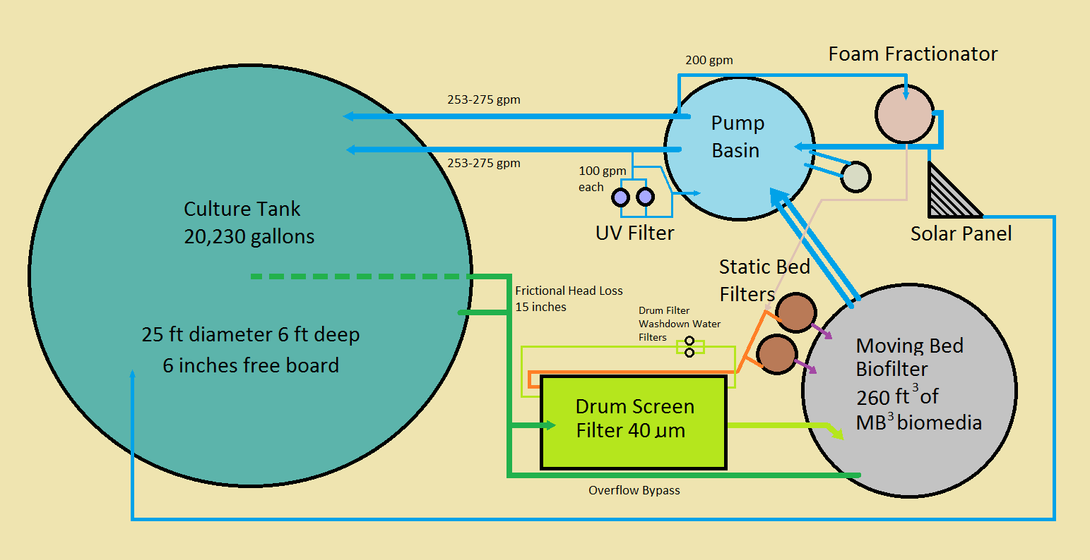

Figure 1. Schematic of the commercial scale recirculating aquaculture system tested at HBOI-FAU.

21
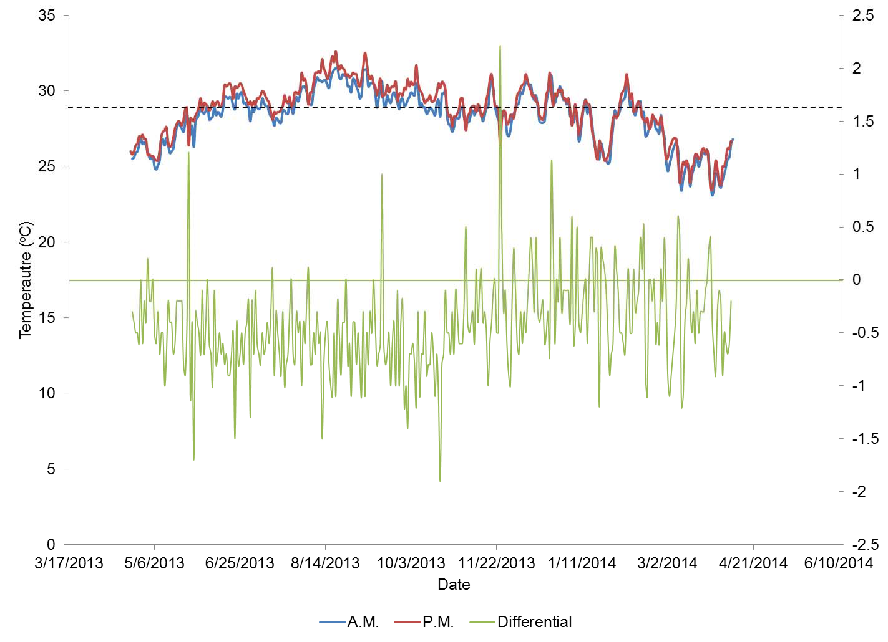
Figure 2. Temperature in the commercial demonstration system throughout the grow-out period. Black horizontal line denotes the set point for the solar panel for either radiant cooling or solar heating. Green horizontal line denotes the zero differential between morning (9 a.m.) and afternoon (4 p.m.) temperature in the system.

140
Purge Started

120

100
Percent of Total System Volume

80

60

40
22

20

0
Date

Figure 3. Water use in the commercial system throughout the grow-out period and the purge period of Florida Pompano expressed in percent of the total system volume (98,953 L) per day.

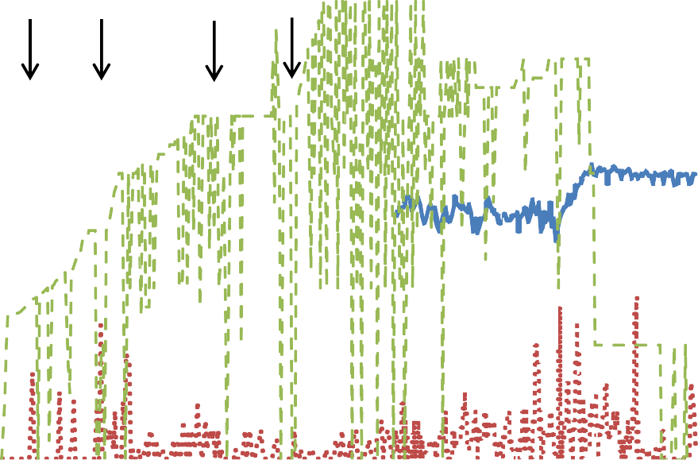
60

50

40
Vaule Indicated in Caption

30

20
23

10

0
3/17 5/6 6/25 8/14 10/3 11/22 1/11 3/2 4/21 6/10
Date

Salinity (ppt) Mortalities (n) Feed Rate (Kg)

Figure 4. Feeding and mortalities relative to attempts to reduce salinity (indicated by arrows). Notice feeding had to be suspended and mortalities increased (with one exception) during all four attempts to reduce salinity.

24

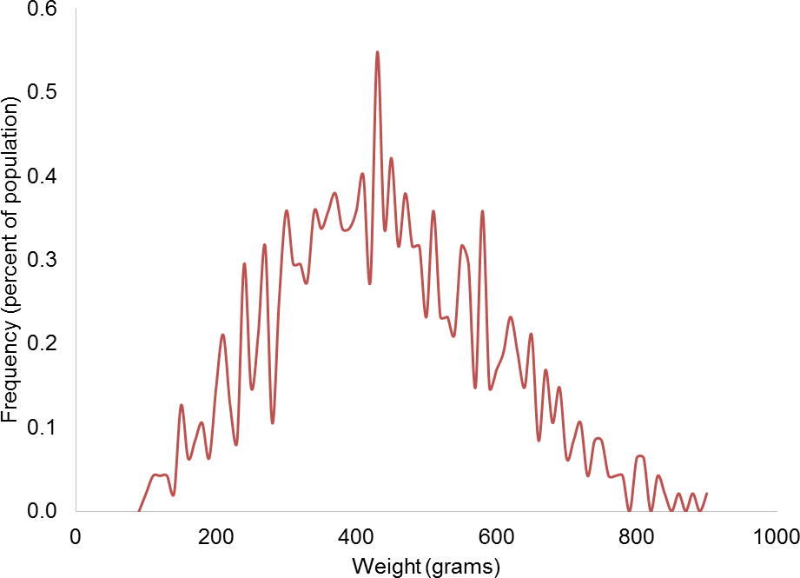

Figure 5. Frequency distribution of weights (g) from a subsample (n=689) of Pompano taken randomly during the final harvest of fish from the commercial demonstration system on April 8, 2014.

10.0
9.0
8.0
Frequency (percent of population)
7.0
6.0
5.0
4.0
3.0
25
2.0
1.0
0.0
0 50 100 150 200 250 300 350 400
Fork Length (mm)

Figure 6. Frequency distribution of fork lengths (mm) from a subsample (n=689) of Pompano taken randomly during the final harvest of fish from the commercial demonstration system on April 8, 2014.

26

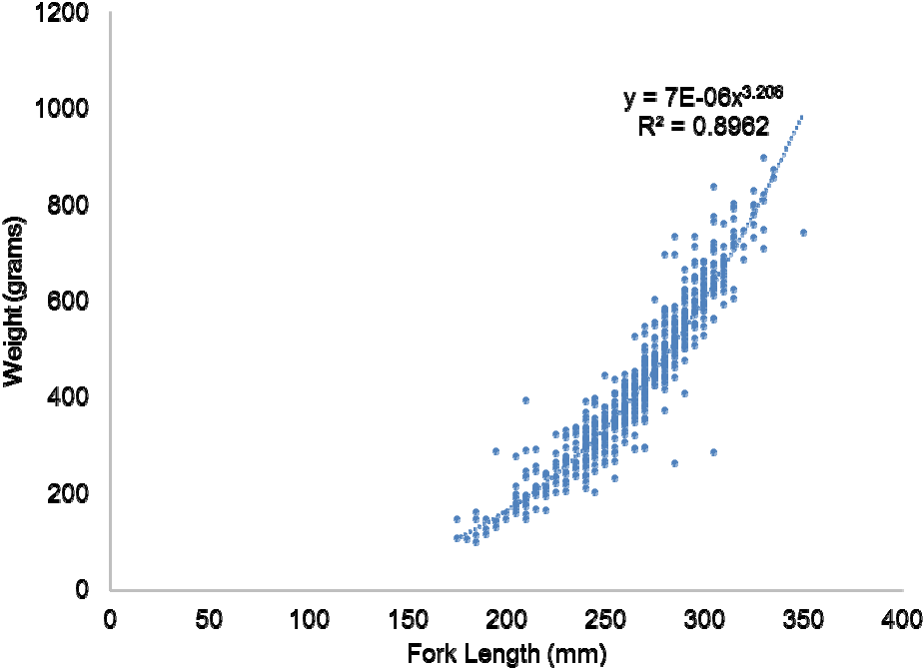

Figure 7. Length-Weight relationship of Pompano from a subsample (n=689) taken randomly during the final harvest of fish from the commercial demonstration system on April 8, 2014.

27

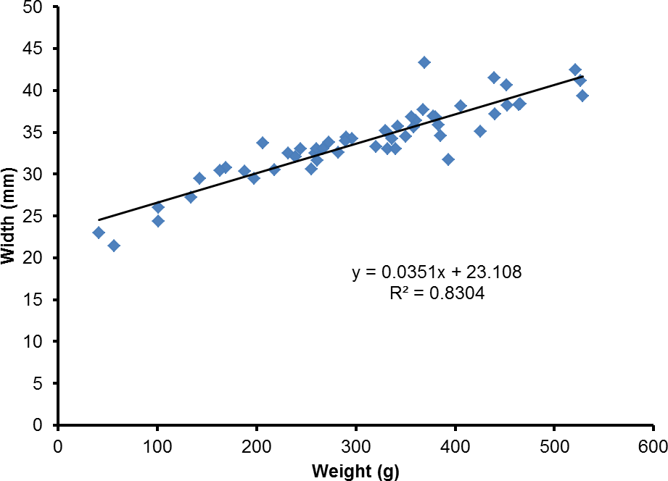

Figure 8. Relationship between weight and body width for 116 Florida Pompano sampled from the commercial demonstration system on November 13, 2013 used to calculate suggested grader sizes to separate fish by weight (Table 1).

$10,000,000
$8,000,000
$6,000,000
$4,000,000
$2,000,000
$0

$5.96 $8.15

$4.00 $4.50 $5.00 $5.50 $6.00 $6.50 $7.00 $7.50 $8.00 $8.50 $9.00
-$2,000,000
-$4,000,000
28
-$6,000,000
-$8,000,000


-$10,000,000
Sales Price (USD)

Operating Income (USD) Net Income (USD)

Figure 9. Operating income and Net income related to sales price based on the economic model for Pompano reared in a recirculating aquaculture system (available on line at FDACS Division of Aquaculture web site) without discounting equipment and feed. Breakeven values are indicated by arrows.

$10,000,000
$8,000,000
$6,000,000
$4,000,000
$2,000,000
$0

$5.45 $7.27

$4.00 $4.50 $5.00 $5.50 $6.00 $6.50 $7.00 $7.50 $8.00 $8.50 $9.00
-$2,000,000
-$4,000,000
29
-$6,000,000
-$8,000,000

-$10,000,000
Sales Price (USD)

Operating Income (USD) Net Income (USD)

Figure 10. Operating income and Net income related to sales price based on the economic model (available on line at FDACS Division of Aquaculture web site; Appendix B) for Pompano reared in a recirculating aquaculture system with equipment and feed discounted by 20%. Breakeven values are indicated by arrows.

30
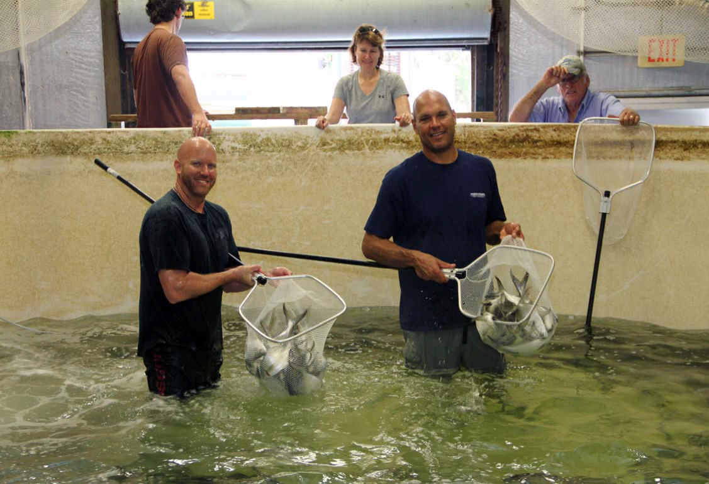
Figure 11. Harvest of Pompano from commercial demonstration system was accomplished by draining the system and hand netting.

31
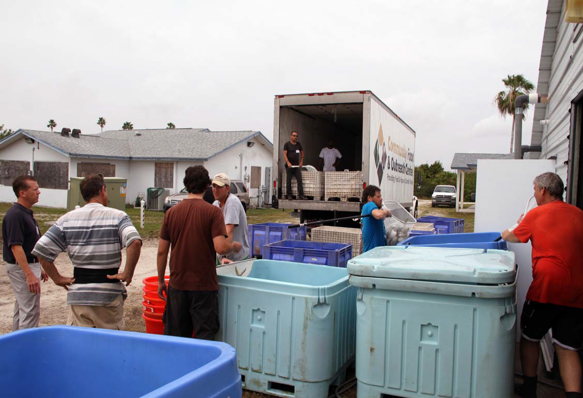
Figure 12. Harvesting and chill killing Pompano from the commercial demonstration system prior to transport to Harvest Food and Outreach Centers (HFOC). Note HFOC refrigerated truck in background and CEO Austin Hunt in blue short and grey pants on left side of picture.

32

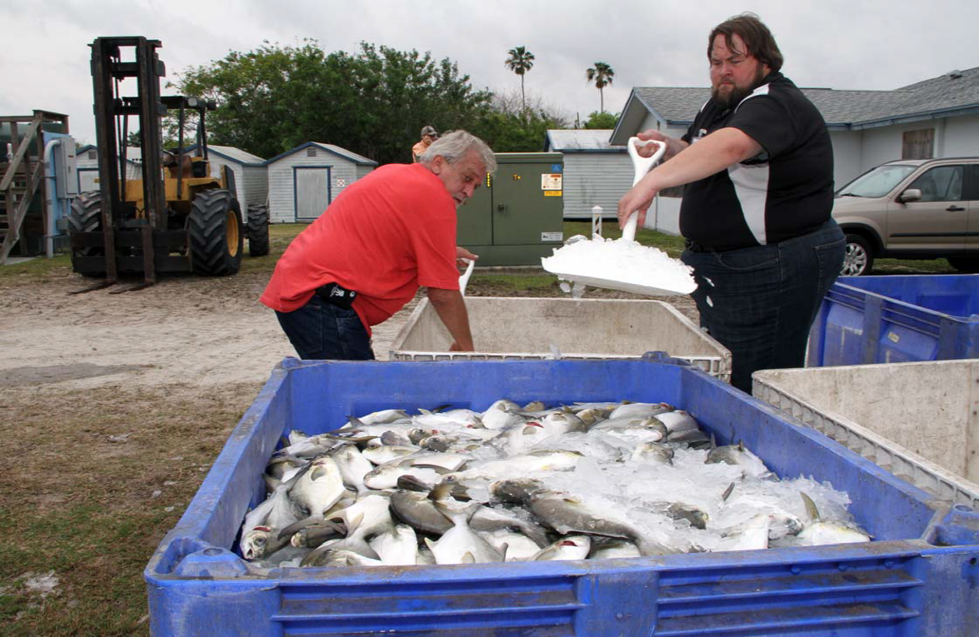
Figure 13. Harvest Food and Outreach Centers employees icing down chill killed Pompano after harvest from the commercial demonstration system prior to loading onto a refrigerated truck.

33

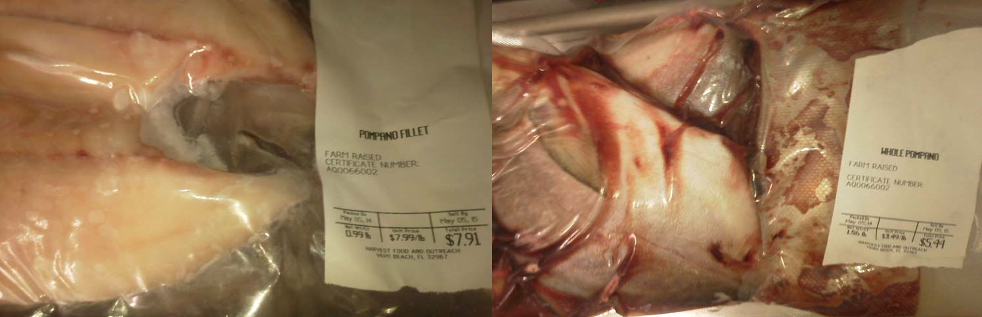

Figure 14. Frozen fillets and whole gutted Pompano reared in the commercial demonstration system packaged and ready for distribution by Harvest Food and Outreach to their subsidized grocery centers throughout Florida.

Appendix A

System capital costs for the prototype demonstration system as it was built for the project and capital costs for a similar system with a biofilter that is scaled-up based on the results.

Commercial Scale Demonstration System, System as Tested
Quantity | Description | Supplier | Cost per | Total Cost
1 | Faver 40um microscreen drum filter | AES | 22,085.45 | 22,085.45
1 | 25'x6' 20,200 gal Culture Tank | Dolphin Fiberglass | 14,500.00 | 14,500.00
2 | 1.5 hp Axial Flow Pump | Carry Mfg | 5,739.17 | 11,478.34
1 | PS250 Protein Skimmer | Solar Components Inc | 6,450.00 | 6,450.00
266 | MB3 Biomedia | W-M-T | 21.28 | 5,660.48
1 | solar array | Solar Components Inc | 4,792.00 | 4,792.00
1 | 760 Watt UV sterilizer | Aqualogic | 3,995.00 | 3,995.00
1 | 12'x3' Tank - Biofilter | Dolphin Fiberglass | 3,395.00 | 3,395.00
1 | YSI 5200 DO monitor w/ 10 m cable multi probe and software | AES | 3,450.00 | 3,450.00
1 | Plumbing materials | multiple | 3,000.00 | 3,000.00
2 | S63 regenerative blowers | AES | 1,228.00 | 2,456.00
20 | Micropore diffusers | AES | 113.00 | 2,260.00
2 | 36 inch Wave Vortex Chambers | AES | 1,061.00 | 2,122.00
1 | Electrical materials | multiple | 2,000.00 | 2,000.00
1 | 8'x3' Tank - Pumping Basin | Dolphin Fiberglass | 1,285.00 | 1,285.00
4 | oxygen solenoid valves | AES | 285.69 | 1,142.76
1 | 1/2 hp titanium pump | AES | 967.00 | 967.00
1 | Pacific Ozone Ozone Generator | AES | 948.00 | 948.00
20 | 3' bioweave Air diffusers | AES | 45.11 | 902.20
1 | Lumber materials | Local Supplier | 800.00 | 800.00
2 | 3" pressure relief valves | AES | 358.89 | 717.78
10 | oxygen flow meters 0-8 L/min | AES | 61.50 | 615.00
2 | FVI Bagfilter w/ gauge and bleedvalve | AES | 302.85 | 605.70
2 | JP1 3/4 hp pump | AES | 258.36 | 516.72
2 | 3/4" Float valves | AES | 251.03 | 502.06
400 | Concrete Blocks | Local Supplier | 1.20 | 480.00
1 | Hanna Instruments ORP controller | AES | 263.00 | 263.00
3 | Totalizing water meters | DV controls | 62.85 | 188.55
1 | 1/2" polyethylene screen full roll | AES | 160.00 | 160.00
15 | Moisture-B-Gone Dessicant | HDLtd.com | 9.02 | 135.30
1 | Pressure Gauges 0-100 psi | AES | 68.00 | 68.00
10 | 200 um filter bags | AES | 6.20 | 62.00
 |  | Total costs for Protoype System |  | 98,003.34

Commercial Scale Demonstration System, Scaled Up Biofilter
Quantity | Description | Supplier | Cost per | Total Cost
1 | Faver 40um microscreen drum filter | AES | 22,085.45 | 22,085.45
1 | 25'x6' 20,200 gal Culture Tank | Dolphin Fiberglass | 14,500.00 | 14,500.00
2 | 1.5 hp Axial Flow Pump | Carry Mfg | 5,739.17 | 11,478.34
1 | PS250 Protein Skimmer | Solar Components Inc | 6,450.00 | 6,450.00
450 | MB3 Biomedia | W-M-T | 21.28 | 9,576.00
1 | solar array | Solar Components Inc | 4,792.00 | 4,792.00
1 | 760 Watt UV sterilizer | Aqualogic | 3,995.00 | 3,995.00
1 | 15'x4' Tank - Biofilter | Dolphin Fiberglass | 5,410.00 | 5,410.00
1 | YSI 5200 DO monitor w/ 10 m cable multi probe and software | AES | 3,450.00 | 3,450.00
1 | Plumbing materials | multiple | 3,000.00 | 3,000.00
2 | S63 regenerative blowers | AES | 1,228.00 | 2,456.00
20 | Micropore diffusers | AES | 113.00 | 2,260.00
4 | 36 inch Wave Vortex Chambers | AES | 1,061.00 | 4,244.00
1 | Electrical materials | multiple | 2,000.00 | 2,000.00
1 | 8'x3' Tank - Pumping Basin | Dolphin Fiberglass | 1,285.00 | 1,285.00
4 | oxygen solenoid valves | AES | 285.69 | 1,142.76
1 | 1/2 hp titanium pump | AES | 967.00 | 967.00
1 | Pacific Ozone Ozone Generator | AES | 948.00 | 948.00
20 | 3' bioweave Air diffusers | AES | 45.11 | 902.20
1 | Lumber materials | Local Supplier | 800.00 | 800.00
2 | 3" pressure relief valves | AES | 358.89 | 717.78
10 | oxygen flow meters 0-8 L/min | AES | 61.50 | 615.00
2 | FVI Bagfilter w/ gauge and bleedvalve | AES | 302.85 | 605.70
2 | JP1 3/4 hp pump | AES | 258.36 | 516.72
2 | 3/4" Float valves | AES | 251.03 | 502.06
400 | Concrete Blocks | Local Supplier | 1.20 | 480.00
1 | Hanna Instruments ORP controller | AES | 263.00 | 263.00
3 | Totalizing water meters | DV controls | 62.85 | 188.55
1 | 1/2" polyethylene screen full roll | AES | 160.00 | 160.00
15 | Moisture-B-Gone Dessicant | HDLtd.com | 9.02 | 135.30
1 | Pressure Gauges 0-100 psi | AES | 68.00 | 68.00
10 | 200 um filter bags | AES | 6.20 | 62.00
 |  | Total projected costs per System |  | 106,055.86

Appendix B

FDACS Division of Aquaculture’s Survey of Workshop Participants

Pompano Culture in Recirculating Aquaculture Systems
Florida Atlantic University’s Harbor Branch Oceanographic Institute June 3, 2013

Participant Survey
This workshop is a component of an applied aquaculture research project recommended by the Aquaculture Review Council for funding to Adam H. Putnam, Commissioner of Agriculture. The Council and Commissioner welcome your comments to improve future workshops. Please take a few minutes to complete this survey and leave the survey at the workshop or mail it to Division of Aquaculture, 1203 Governor’s Square Blvd, Ste 501, Tallahassee, FL 32301-2961 or fax it to 850-410-0893. Thank you.
Agree Disagree
CIRCLE ONE

The workshop was worth the time and effort to attend. | 5 | 4 | 3 | 2 | 1
New and helpful information was presented. | 5 | 4 | 3 | 2 | 1
Sufficient information was presented for you to evaluate pompano production in tanks as a potential business. | 5 | 4 | 3 | 2 | 1
Presentations were informative. | 5 | 4 | 3 | 2 | 1
Meeting package was informative. | 5 | 4 | 3 | 2 | 1
You would attend similar workshops in the future. | 5 | 4 | 3 | 2 | 1
What did you like best about the workshop?

What could be improved?

Please identify topics for future workshops.

Other comments.

Survey Results

Pompano Culture in Recirculating Aquaculture Systems
Florida Atlantic University’s Harbor Branch Oceanographic Institute June 3, 2013

Participant Survey
This workshop is a component of an applied aquaculture research project recommended by the Aquaculture Review Council for funding to Adam H. Putnam, Commissioner of Agriculture. The Council and Commissioner welcome your comments to improve future workshops. Please take a few minutes to complete this survey and leave the survey at the workshop or mail it to Division of Aquaculture, 1203 Governor’s Square Blvd, Ste 501, Tallahassee, FL 32301-2961 or fax it to 850-410-0893. Thank you.
Agree Disagree
CIRCLE ONE

The workshop was worth the time and effort to attend. | 5 (27) | 4 (5) | 3 (1) | 2 | 1
New and helpful information was presented. | 5 (23) | 4 (7) | 3 (2) | 2 | 1 (1)
Sufficient information was presented for you to evaluate pompano production in tanks as a potential business. | 5 (20) | 4 (6) | 3 (4) | 2 (1) | 1 (1)
Presentations were informative. | 5 (22) | 4 (8) | 3 (3) | 2 | 1
Meeting package was informative. | 5 (28) | 4 (3) | 3 (2) | 2 | 1
You would attend similar workshops in the future. | 5 (30) | 4 (2) | 3 (1) | 2 | 1

What did you like best about the workshop?

Current status; tour of facility and meeting package; the tour; format and detail; each presenter was knowledgeable and informative; tour; demonstration project; lots of information; open discussion; diversity of opinion and data; everything (wonderful); the walk thru of the actual work area; the view and walk around active systems; HBOI campus and networking; the knowledgeable presentations; the opportunity to network with staff and other attendees; Dr. Main’s presentation; seeing the systems and how they work; very well organized. Thankful for take home materials; access to system and opportunity to take pictures; covered all aspects of culture; information on existing projects; financial;

What could be improved?

Accurate scenarios for tech transfer; final profitability; more hands-on techniques; add regulatory and a seafood buyer (?) wholefoods ? or other restaurant purchase agents, etc.; not applicable; I think it was good; more time; helping us how to get or apply for or find grants from the government; unknown; if all phases of the system had been active; 1) why aquaculture in Florida has failed on a commercial basis? 2) have aquaculture for lunch; more time to tour the entire facility; make sure none of the presenters are simply read the powerpoint slides; show live fish in all stages; if presentations could be made available in .pdf format; can’t think of anything, good job;
Please identify topics for future workshops.

Small farm production in aquaculture; marine aquaponics; more exactly like this! With various species/growout; feed production; more food fish species; tilapia growout; any aquaculture topic; other species; tilapia farming/shrimp farming; cobia, aquaponics; red drum, aquaponics; aquaponics – sustainability and profitability; more information on the business of aquaculture at a commercial level. What was presented was informative and well presented; multitrophic systems – when you get there; tilapia and shrimp; tilapia; hands-on workshops for each aspect of operation – hatchery, spawning, etc.; other aquaculture species, more specific workshops related to economics; additional species; final report from pompano study when completed;
Other comments.

Excellent workshop; terrific package egg to fiscal A+!; thanks; based on committed cash ROI is not worth the risk, have to find a way to reduce costs; great value and presentations; how to get broodstock; thank you for your time expended on all our behalfs; need to see more successful Florida commercial operations; keep up the good work; fantastic facility; serve fish for lunch;

Appendix C

Output from the Economic Model with the data input from the final harvest of the Demonstration System. The model scenario presented is using 20% discounting of feed and equipment cost.

This workbook provides modeling based on the assumptions in the associated in the Economics of Pompano Production in RAS workshop presentation and should NOT be used to make business decisions
Note: Cells highlighted in Yellow or Orange can be modified to update results
Business Evaluation
 |  | Stage 4
 |  | Case 1 | Case 2 | Case 3 | Case 4
Juvenile Cost | ea | 0.91 | 0.91 | 0.91 | 0.91
Feed Cost | lb | 0.51 | 0.51 | 0.51 | 0.51
Manager(s) | Annual | 60,000 | 60,000 | 60,000 | 60,000
Harvest Labor | Hour | 8.00 | 8.00 | 8.00 | 8.00
Farm Staff | Hour | 10.00 | 10.00 | 10.00 | 10.00

Unit

Costs

Species
Initial weight g | 75.00 | 75.00 | 75.00 | 75.00
Harvest weight g  Production Cycle Days  Stocking Density kg/m³ | 426 | 426 | 426 | 426
 | 350 | 350 | 350 | 350
 | 32.95957888 | 32.9595789 | 32.95957888 | 32.95957888

Feed Type | 3 | 3 | 3 | 3
FCR  Survival Rate % | 4.75 | 4.75 | 4.75 | 4.75
FCR  Survival Rate % | 0.90 | 0.90 | 0.90 | 0.90

Labor
Transfer / Harvest Staff Labor Hours | 40 | 40 | 40 | 40
Full Time Employees per system Count | 2 | 2 | 2 | 2

Revenue
Sales price whole per lb lb | 5.00 | 6.00 | 7.00 | 8.00

.

**
Monthly Production per System lb | 8,000 | 8,000 | 8,000 | 8,000
Annual Production lb | 96,000 | 96,000 | 96,000 | 96,000

9,522 | 9,522 | 9,522 | 9,522
8,523 | 8,523 | 8,523 | 8,523
Initial Fish Count
ea
Final Fish Count
ea
Final Fish
lbs
Change in Biomass
lbs
Feed to Purchase
lbs
Final Fish
kg
Change in Biomass
kg
Feed to Purchase
kg
Tank(s) Water Requirement
m3
System Water Requirement
m3
Cycle Water Loss
m3
Tank(s) Water Requirement
gal
System Water Requirement
gal
Cycle Water Loss
gal
8,000 | 8,000 | 8,000 | 8,000
6,426 | 6,426 | 6,426 | 6,426
30,550 | 30,550 | 30,550 | 30,550

3,628 | 3,628 | 3,628 | 3,628
2,914 | 2,914 | 2,914 | 2,914
13,858 | 13,858 | 13,858 | 13,858

111 | 111 | 111 | 111
167 | 167 | 167 | 167
877 | 877 | 877 | 877

29,324 | 29,324 | 29,324 | 29,324
44,117 | 44,117 | 44,117 | 44,117
231,679 | 231,679 | 231,679 | 231,679

68,931 | 68,931 | 68,931 | 68,931

320 | 320 | 320 | 320

Physical Plant Requirements

KW used per Production Cycle

Harvest Labor

Total Sq Ft needed Per System
20,168 | 20,168 | 20,168 | 20,168
1,242,500 | 1,242,500 | 1,242,500 | 1,242,500

Cost per System

Based on loan assumptions
$10,345 $10,345 $10,345 $10,345
below P & I

Loan Assumptions:
75% | 75% | 75% | 75%
6% | 6% | 6% | 6%
10 | 10 | 10 | 10

% Financing ‐ Equip Interest Rate
Equipment Term Years

% Financing ‐ Real Estate Real Estate Interest Rate
75% | 75% | 75% | 75%
5% | 5% | 5% | 5%
20 | 20 | 20 | 20

Real Estate Term Years

RE Assumptions:
0.7 | 0.7 | 0.7 | 0.7
7,000 | 7,000 | 7,000 | 7,000
18 | 18 | 18 | 18

Needed per System Acres

Price for land Acre

Price for existing warehouse Sqft

Total Calculated Costs

Fry | 8,624 | 8,624 | 8,624 | 8,624
Feed | 15,642 | 15,642 | 15,642 | 15,642
Oxygen | 1,380 | 1,380 | 1,380 | 1,380
Water | 24 | 24 | 24 | 24
Electric | 8,272 | 8,272 | 8,272 | 8,272
Harvest Labor | 320 | 320 | 320 | 320
Total Variable  Capital Costs | 34,262 | 34,262 | 34,262 | 34,262

Total
10,345 | 10,345 | 10,345 | 10,345
44,607 | 44,607 | 44,607 | 44,607

Cost per Fish
Eggs | 1.012 | 1.012 | 1.012 | 1.012
Feed | 1.835 | 1.835 | 1.835 | 1.835
Oxygen | 0.162 | 0.162 | 0.162 | 0.162
Water | 0.003 | 0.003 | 0.003 | 0.003
Electric | 0.971 | 0.971 | 0.971 | 0.971
Harvest Labor | 0.038 | 0.038 | 0.038 | 0.038
Total Variable  Capital Costs | 4.020 | 4.020 | 4.020 | 4.020
Total Variable  Capital Costs | 1.214 | 1.214 | 1.214 | 1.214
Total | 5.234 | 5.234 | 5.234 | 5.234

Cost per Lb
Eggs | 1.078 | 1.078 | 1.078 | 1.078
Feed | 1.955 | 1.955 | 1.955 | 1.955
Oxygen | 0.173 | 0.173 | 0.173 | 0.173
Water | 0.003 | 0.003 | 0.003 | 0.003
Electric | 1.034 | 1.034 | 1.034 | 1.034
Harvest Labor | 0.040 | 0.040 | 0.040 | 0.040
Total Variable  Capital Costs | 4.283 | 4.283 | 4.283 | 4.283
Total Variable  Capital Costs | 1.293 | 1.293 | 1.293 | 1.293
Total | 5.576 | 5.576 | 5.576 | 5.576

Everything above this point represents a single system. To model higher production, increase the number of systems. Everything below this point represents the number of systems indicated below.
#  Systems  Equipment volume discount | 27 | 27 | 27 | 27
#  Systems  Equipment volume discount | 20% | 20% | 20% | 20%

Annual Production in Lbs 2,592,000 2,592,000 2,592,000 2,592,000
Annual Revenue and Expenses

Annual Revenue  Sales  Less: Variable Costs |  |  | 12,960,000 | 15,552,000 | 18,144,000 | 20,736,000
Fry Feed Oxygen Water Electric  Harvest Labor |  |  | 2,794,176 | 2,794,176 | 2,794,176 | 2,794,176
 |  |  | 5,068,008 | 5,068,008 | 5,068,008 | 5,068,008
 |  |  | 447,120 | 447,120 | 447,120 | 447,120
 |  |  | 7,776 | 7,776 | 7,776 | 7,776
 |  |  | 2,680,128 | 2,680,128 | 2,680,128 | 2,680,128
 |  |  | 103,680 | 103,680 | 103,680 | 103,680
Operating |  | Gross Margin  Manager  Staff | 11,100,888 | 11,100,888 | 11,100,888 | 11,100,888
 |  | Gross Margin  Manager  Staff | 1,859,112 | 4,451,112 | 7,043,112 | 9,635,112
 |  | Gross Margin  Manager  Staff | 1,620,000 | 1,620,000 | 1,620,000 | 1,620,000
 |  | Gross Margin  Manager  Staff | 1,123,200 | 1,123,200 | 1,123,200 | 1,123,200
1% | System Maintenance |  | 268,380 | 268,380 | 268,380 | 268,380
Operating Expense |  |  | 3,011,580 | 3,011,580 | 3,011,580 | 3,011,580

Operating Income | (1,152,468) | 1,439,532 | 4,031,532 | 6,623,532
Interest Expense‐Equip | 1,166,495 | 1,166,495 | 1,166,495 | 1,166,495
Interest Expense‐Bldg | 367,468 | 367,468 | 367,468 | 367,468
Depreciation‐Bldg | 490,082 | 490,082 | 490,082 | 490,082
Depreciation‐Equip | 2,683,800 | 2,683,800 | 2,683,800 | 2,683,800
Non‐Operating Expense | 4,707,845 | 4,707,845 | 4,707,845 | 4,707,845
Net Income | (5,860,313) | (3,268,313) | (676,313) | 1,915,687

Equipment Costs
Tank System | 26,838,000 26,838,000 26,838,000 26,838,000

Property Costs
Own
Land Building | Acres Sq Ft | 18.90  544,536 | 18.90  544,536 | 18.90  544,536 | 18.90  544,536
Land Exp |  | 132,300 | 132,300 | 132,300 | 132,300
Bldg Exp |  | 9,801,648 | 9,801,648 | 9,801,648 | 9,801,648
 | Total | 9,933,948 | 9,933,948 | 9,933,948 | 9,933,948

Up front cash required  Equipment Real Property  Total | 6,709,500  2,483,487 | 6,709,500  2,483,487 | 6,709,500  2,483,487 | 6,709,500  2,483,487
Up front cash required  Equipment Real Property  Total | 9,192,987 | 9,192,987 | 9,192,987 | 9,192,987

Cash Flow ‐ Annual from first Harvest
Operating Income/Loss Less: | (1,152,468) | 1,439,532 | 4,031,532 | 6,623,532
Principle and Interest ‐ Equip | 2,681,611 2,681,611 2,681,611 2,681,611
Change in Cash | (3,834,079) | (1,242,079) | 1,349,921 | 3,941,921
Principle and Interest ‐ Bldg | 590,037 590,037 590,037 590,037
Change in Cash | (4,424,116) | (1,832,116) | 759,884 | 3,351,884

