Indian River Lagoon Observatory Science and Technology Advisory Committee
July 29, 2014, 1:00-4:30 p.m.
Florida Atlantic University, Harbor Branch Oceanographic Institute Summarized Meeting Notes
A primary goal of Harbor Branch’s Indian River Lagoon Observatory (IRLO) is to work collaboratively with the agencies and neighboring science organizations. The Indian River Lagoon Observatory Science and Technology Advisory Committee (IRLO-STAC) was established to provide a venue to share ideas and gather input on the IRLO monitoring network. The focus of this first meeting of IRLO-STAC was to familiarize the committee with Land/Ocean Biogeochemical Observatories (LOBO) technology and gather feedback on IRLO's proposed sites for LOBO installations by Harbor Branch in the Indian River Lagoon (IRL) and St. Lucie Estuary (SLE). The agenda for the meeting is on page 8. The list of participants is on page 9.

LOBOs are designed to reduce biofouling, minimize operational and maintenance expenses, and provide real-time and retrospective high-accuracy and high-resolution data via a dedicated interactive website. The LOBO units have the flexibility to substitute or add different sensor instruments as new scientific needs are identified. Harbor Branch was awarded funds from the 2014 State Legislative Budget through the Florida Department of Environmental Protection (DEP) for a real-time water quality monitoring network at six sites in the SLE and nearby IRL. Harbor Branch also received a grant from the Harbor Branch Oceanographic Institute Foundation (HBOIF) for three LOBO units to be placed in the IRL at locations in Indian River County and northern St. Lucie County, in addition to an IRL site near Harbor Branch where an existing LOBO will remain. Thus, over the next year, a LOBO network will be deployed at 10 sites in the IRL and SLE, with the resulting data available real-time to all users.

Summary of Presentations and Q&A

Land/Ocean Biogeochemical Observatory (LOBO) Overview

Dave Gillett, Applications Scientist, Sea-Bird Coastal
Summary: Seabird Coastal takes the best of its three sub-companies to form streamlined packages that provide instrumentation that deliver high-quality, real-time data that overcomes the traditional challenges of coastal monitoring. High-frequency monitoring provides fine-scale variations in water quality dynamics not typically seen with traditional grab sampling. This instrumentation was developed by MBARI engineers and scientists and was first deployed in 2003. The instrumentation used in the LOBOS units are robust, rugged and have been tested for oceanographic monitoring for years prior to being used to monitor estuarine systems. New instrumentation is being developed such as the SeaFET pH meter.
Q&A:
- Brian Sharpe: Who has the capability to plot the data?
  - That is dependent on each network, but HBOI provides real-time public viewing and access of the data for plotting as part of the web based portal.

- Steve Snoberger: Does anything lock out errors/outliers?
  - Yes, Harbor Branch is able to put initial range limits on public viewing; however, all of the raw data will be archived.
- Rich Paperno: Is there an internal mechanism that sends emails if there are QA/QC issues or values are out of range?
  - That mechanism is not quite there yet, but it is being worked on. Harbor Branch reviews the incoming data on a daily basis and will continue to do this when the other LOBO units are installed
- Mark Perry: Is there GPS capability that will track the instruments in sense of a security issue?
  - Yes
Building a Successful Water Quality Monitoring Observation Network

Eric Milbrandt, Marine Laboratory Director, Sanibel-Captiva Conservation Foundation (SCCF)
Summary: The SCCF was established 12 years ago. The River, Estuary and Coastal Observing Network (RECON) is an initiative of SCCF. The major goal of RECON is to tease apart human-caused versus climate-related disturbances and the responses of the organisms in that environment. The ultimate focus is processes and linkages to indicator species more than just monitoring and documentation. High-frequency monitoring yields tremendous amounts of data, therefore, a reliable, user-friendly interface is necessary to mine the data effectively. RECON has been operating their LOBOs for 6 years, currently at 8 sites, and they are very confident in the equipment, data, visualization, and precision. They lost one unit due to lighting. Groups that have used their LOBO data include cities, towns, water management districts, and the Army Corps of Engineers. Some of the criteria for site selection include: purpose/objective; partnerships; maintenance due to site conditions such as excessive fouling, sedimentation, macroalgae; protection from vandalism, debris, lighting and boat strikes; stratification; logistics and site accessibility.
Q&A:
- Vembu Subramanian: Did you do any assimilations or modeling with your data?
  - One time we did capture the nearshore dynamics of the Gulf of Mexico. We have written numerous proposals to work on modeling.
- Mark Perry: Can you clarify what is done annually vs. the 5-year life expectancy of the sensors?
  - Annual calibration is very important to keep the sensors up to standards. Properly maintained sensors may last more than 5 years.
- Robert Weaver: What is the turnaround time for factory calibration? What is the monthly cleaning?
  - Sea-Bird’s goal for factory calibration is 3 weeks, but typically is 4-6 weeks.
  - During monthly cleanings, all sensors are cleaned using a serious of cleaning solutions.

Indian River Lagoon Observatory Land/Ocean Biogeochemical Observatory (LOBO) Network Proposed Locations in the Indian River Lagoon and St. Lucie Estuary

M. Dennis Hanisak, Research Professor, FAU Harbor Branch
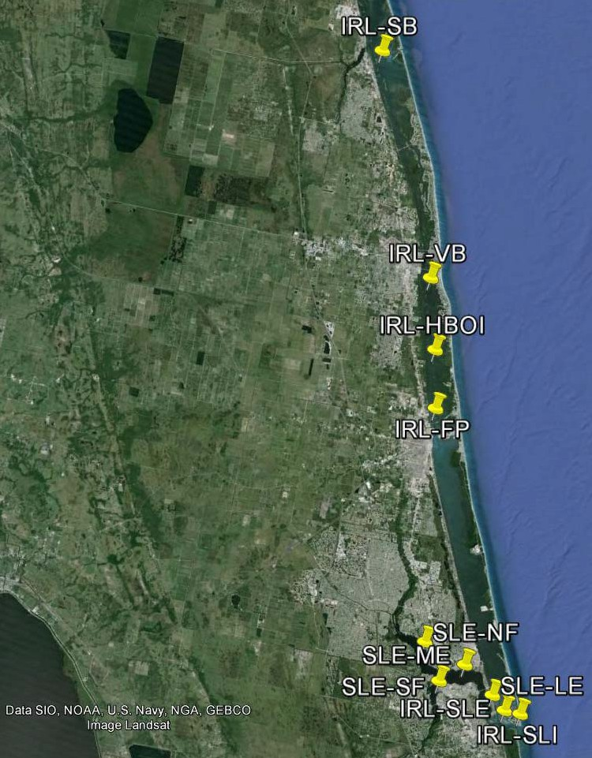
Summary: The Indian River Lagoon Observatory (IRLO) was initiated to investigate ecological relationships in the IRL and how they are impacted by natural and human-induced stressors. An important component of IRLO is the development of a network of advanced observing stations in the Lagoon. LOBOs provide real-time, high-accuracy and high-resolution water quality data through an interactive website. This enables scientists, managers, educators, students, and the public to enhance observations to follow long-term ecosystem changes and those driven by events such as freshwater discharges, algal blooms, storms, and droughts. Harbor Branch has been operating two LOBO units for 18 months in the IRL. We plan to instrument 10 sites in the IRL and SLE. A strawman of proposed sites was
presented to stimulate discussion among participants (Fig. 1). These sites are ecologically important because of the dynamic interface between freshwater inputs from river and canal discharges and oceanic water from the inlets.
Q&A:
- Steve Snoberger: What is the timeline for deployment?
  - Sensors in Indian River County and northern St. Lucie County will be deployed first as those funds are already available. Those LOBOs have been ordered and will be online by the end of the year. The sensors for the SLE and southern IRL will follow several months later, and is dependent on the timing of the finalized contract with DEP.
- Will you be putting an Aquadopp on all new LOBOs? Is it a current meter?
  - Yes, an Aquadopp will be on all new LOBOs. It is a current meter.
- Brian Sharpe: What is the capability to talk to one another to target the same body of water?
  - The sites do not communicate with one another, but anyone can plot them together through LOBOviz, which will be available on

the IRLO network website.
- Vembu Subramanian: He confirmed that he is working with Dennis Hanisak so that all IRLO LOBO data will also be available through the SECOORA (Southeast Coastal Ocean Observing Regional Association) website, broadening the impact of the IRLO network.
Figure 1. Strawman presented at the meeting for continuous LOBO monitoring in the IRL and SLE: IRL-SB (Sebastian), IRL-VB (Vero Beach), IRL-HBOI (Harbor Branch), IRL-FP (Fort Pierce), SLE-NF (North Fork), SLE-SF (South Fork), SLE-ME (Middle Estuary), SLE-ME (Lower Estuary Estuary), IRL-SLE (in the IRL near the confluence with the SLE), and IRL-SLI (IRL near St. Lucie Inlet).

Key Bullets from the Discussion Session led by Rae Ann Wessel (Natural Resource Policy Director, Sanibel-Captiva Conservation Foundation)
Site Selection Criteria
- Rae Ann Wessel: What will drive site selection? Aggregated data from sites could feed into TMDL development. Other considerations could include location near oysters, seagrasses, endangered species areas, flows of freshwater (low flow, high flow), attachment areas (e.g., pilings), possible modification of sensors for different sites, and access. There is a need to choose sites that assist with policy and management changes.
- Gretchen Ehrlinger: Connecting the hydrology to the recovery of in situ organisms will be an important tie.
- Eric Milbrandt: RECON has two sites located near recovery/restoration sites.
- Diana Hughes: It is important to look at a public education component to show that all the freshwater is not always coming from Lake Okeechobee releases, but is from basin watershed runoff. Palm City would be a good location to capture basin watershed runoff.
- Rae Ann Wessel: The legislature is responding to extraordinary conditions with extraordinary funding. The expectation that this money is going to enable solutions, which is what is required from this investment.

Current Monitoring Efforts
- Dennis Hanisak (following a discussion of this item): An easy-to-use map of current monitoring sites by all researchers and agencies in IRL is not readily available; compiling this information and making such a map would be a useful tool.
- Roosevelt Bridge
  - Diana Hughes: This site is a point of compliance for TMDLs that will be monitored annually to every 5 years. There is historical record of sampling in certain locations in SLE, meaning there could be hot spots to locate LOBOs.
  - Todd Reinhold: The Health Department has been monitoring for bacteria levels since 2000 at this location, and it will be the one site to be continued even as funding is cut.
  - Rae Ann Wessel: The South Florida Water Management District has a sampler at surface and near bottom at this site.
  - Vincent Encomio: DEP has a transect near the Florida Oceanographic Society (FOS). FOS has an oyster restoration site near Roosevelt Bridge.
- Gretchen Ehrlinger: RECOVER (REstoration COordination & VERification) has system-wide SAV/oyster/benthic infauna monitoring.
- Val Paul: SLE sites are very near the Smithsonian Marine Station’s long-term benthic monitoring sites and Roosevelt Bridge; that project is showing strong correlations between salinity and infauna diversity. Also, the Smithsonian has a YSI EXO sonde at its dock in the IRL, so there are some data from south of the Fort Pierce Inlet that are available.

- Diana Hughes & Vince Encomio: RECOVER has some sites south of Palm City Bridge/Latent Park; North Fork east of Bessie Crick would be a good location.

Logistics/Site Permanence
- Gretchen Ehrlinger: If LOBO sites are located near other monitoring efforts, costs may be cut by optimizing trips to coincide with efforts from other groups.
- Rae Ann Wessel: You need to consider the question of what you’re looking to learn at each site. You can vary by depth as well as location to help yield a broader picture. For us, being in the channel is not as useful as being in the shallows where the grasses and oysters are.
- Rae Ann Wessel: Permitting to put in structure to deploy LOBO may be more extensive in time and effort than would be ideal so look at partnering with other agencies or to use on existing structures.

Discussion Summary
The discussion focused on determining the best locations for the LOBO units based on benefiting existing monitoring hot spots; reducing redundancy of similar sampling; and management, agencies, and community needs. It was determined that the placement of the LOBO units will provide a broad look at the estuary system and will allow for continuation of monitoring to detect ecosystem change. Determination of the overall objective for the LOBO-SLE network will ultimately dictate the placement of each unit. Is the priority to monitor conditions in the lagoon in order to track changes in ecosystem management or to help answer scientific questions? In both cases, an understanding of current monitoring efforts is essential to prevent duplication of instrumentation and to optimize monitoring efforts in the St. Lucie Estuary. Although several suggestions were made to relocate LOBO units periodically (annually?) to find optimal locations, the dynamic nature of the estuary coupled with the infrastructure efforts required for each site make movement less than ideal.
To effectively manage the logistics and infrastructure of the network, it was recommended to not locate any of the LOBO units on a bridge because of increased sedimentation and increased flow due to the proximity to the deeper Intracoastal Waterway (ICW). In addition, if locating a LOBO unit on an ICW channel marker, it will be best to avoid big bends/turns in the navigation channel because of boat strike hazards. The location of the LOBO unit in the water column will be important especially if there is a lot of stratification; the consensus was the major concern is the relationships of water quality with key benthic organisms so a distance of 1 m from the bottom seems to be a good target.
Collectively, the group thought that the strawman sites in the Lower Estuary and the St. Lucie Inlet were not as important as adding a second LOBO in the South Fork, and a LOBO north of the Jensen Beach Causeway. Key points in the discussion were:
- In the South Fork, one LOBO should be located near the outflow of the C-44 canal to provide baseline monitoring, especially important to monitor total nitrogen in this area. Having a LOBO in this area will assist with management decisions. Knowing more about C44, which is an issue within the community, before any changes are made in its

management is important. A second LOBO will be located downstream (perhaps near the Palm City Bridge) to further capture the freshwater inputs from the immediately surrounding watershed.
- A LOBO in the North Fork will be important because previous studies (e.g., Brian. Lapointe) found this area to be the main source of phosphorus coming into the estuary. Locating the LOBO east of Bessie Creek should capture all of the incoming freshwater from this region of the watershed.
- A LOBO unit southeast of the Roosevelt Bridge is appealing because it is located near a frequently sampled area (DOH bacterial sampling, DEP TMDL sampling) as well as in close proximity to the RECOVER and restoration sites.
- A LOBO unit in the “crossroads” (in the IRL near the confluence of the SLE) would capture tidal fluctuations and account for any freshwater flowing out into the ocean.
- The final LOBO unit should be moved further north into the IRL to fill in the gap between Fort Pierce and St. Lucie Inlet and to track the northern flow of SLE water, including impact of Lake Okeechobee releases.
Overall the consensus for the general locations of the sites of the participants of this meeting was:
- For the four sites funded by HBOI/HBOIF (Fig. 2):
  - In the IRL, Sebastian (south of the Sebastian River and Sebastian Inlet) and Vero Beach (near the South Relief Canal) in Indian River County
  - In the IRL, near HBOI/Linkport (existing LOBO site) and Fort Pierce (north of Taylor Creek) in St. Lucie County
- For the six sites funded by the State Legislative Budget (see Fig. 3):
  - North Fork, South Fork (2 sites), and Middle Estuary near the Roosevelt Bridge in the SLE
  - In the IRL near the confluence with the SLE
  - Another IRL site north of that confluence, between the Jensen Beach Causeway and Nettles Island.
Final specific sites at these locations will be selected by Harbor Branch, in consideration of any permits/permissions required from the Coast Guard and logistical constraints. DEP concurrence is also required for the six sites funded by the State Legislative Budget.

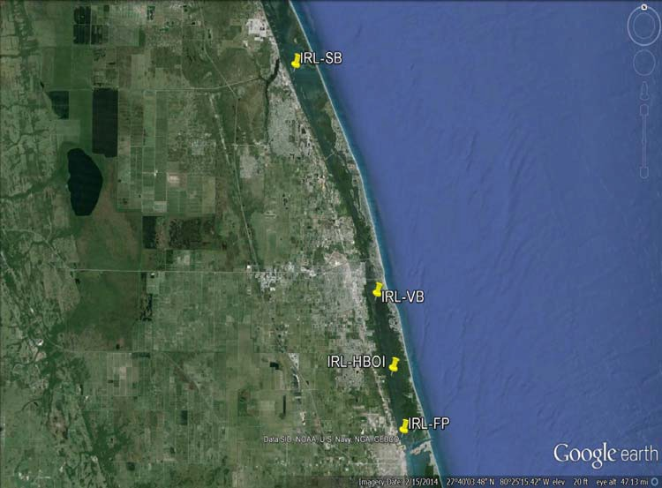
Figure 2. Recommended sites for continuous LOBO monitoring in Indian River County and northern St. Lucie County: IRL-SB (Sebastian), IRL-VB (Vero Beach), IRL-HBOI (Harbor Branch), and IRL-FP (Fort Pierce).
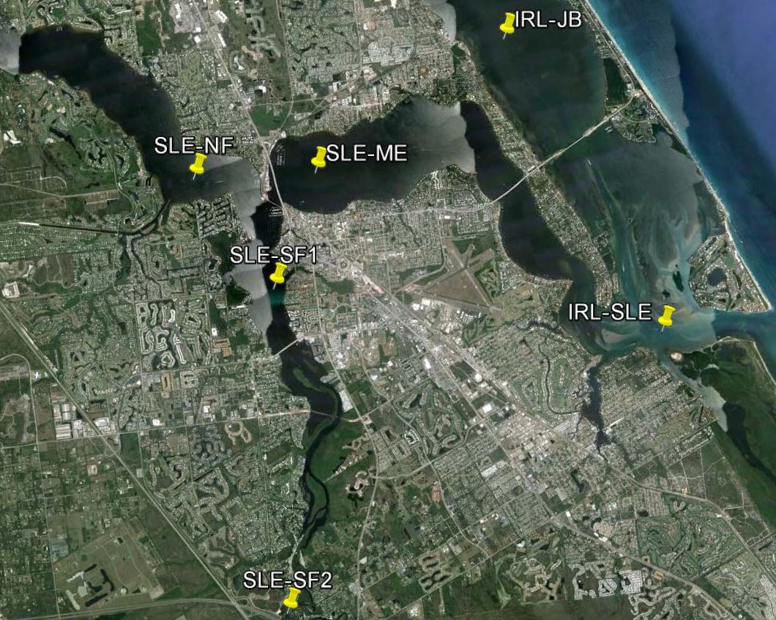
Figure 3. Recommended sites for continuous LOBO monitoring in the SLE and nearby IRL: SLE-NF (North Fork), SLE-SF1 and 2 (South Fork), SLE-ME (Middle Estuary), IRL-SLE (in the IRL near the confluence with the SLE), and IRL-JB (IRL near Jensen Beach).

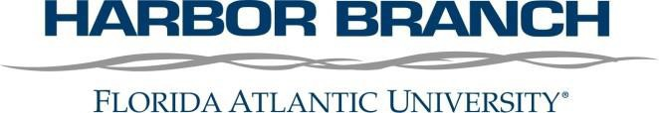

Indian River Lagoon Observatory Science and Technology Advisory Committee (IRLO-STAC)
July 29, 2014
1 – 4:30 p.m.
FAU Harbor Branch, LE 246-247

AGENDA

1 p.m. Welcome and Introductions
- Dr. Megan Davis, Interim Executive Director, FAU Harbor Branch

1:15 p.m. Land/Ocean Biogeochemical Observatory (LOBO) Overview
- Dave Gillett, Applications Scientist, Sea-Bird Coastal
1:35 p.m. Building a Successful Water Quality Monitoring Observation Network
- Eric Milbrandt, Marine Laboratory Director Sanibel-Captiva Conservation Foundation
2:10 p.m. Indian River Lagoon Observatory Land/Ocean Biogeochemical Observatory (LOBO) Network Proposed Locations in the Indian River Lagoon and St. Lucie Estuary
- Dr. Dennis Hanisak, Research Professor, FAU Harbor Branch

2:45 p.m. Break

3:00 p.m. Group Discussion
- Moderator: Rae Ann Wessel, Natural Resource Policy Director Sanibel-Captiva Conservation Foundation
4:30 p.m. Conclusion

IRLO-STAC Meeting FAU Harbor Branch July 29, 2014
Attendee List
Megan Davis, FAU Harbor Branch
Gretchen Ehlinger, US Army Corps of Engineers Vincent Encomio, Florida Oceanographic Society
Stacy Feken (by phone), Florida Department of Environmental Protection Steve Fousek, St. Lucie County
Tom Frazer, University of Florida Water Institute David Gillett, Sea Bird Coastal
Dennis Hanisak, FAU Harbor Branch Diana Hughes, Martin County
Lydia Jackson, Brevard County
Chuck Jacoby, St. Johns River Water Management District David Koerner, St. Lucie County Health Department Brian Lapointe, FAU Harbor Branch
Eric Milbrandt, Sanibel-Captiva Conservation Foundation
Rich Paperno, Florida Fish and Wildlife Conservation Commission Valerie Paul, Smithsonian Marine Station
Mark Perry, Florida Oceanographic Society
Todd Reinhold, Martin County Department of Health Mark Shafer, US Army Corps of Engineers
Brian Sharpe, Florida Department of Environmental Protection Steve Snoberger, Carter Associates, Inc
Vembu Subramanian, Southeast Coastal Ocean Observing Regional Association Cassondra Thomas, South Florida Water Management District
Robert Weaver, Florida Institute of Technology
Rae Ann Wessel, Sanibel-Captiva Conservation Foundation Edith Widder, Ocean Research and Conservation Association Zhixiao Xie, Florida Atlantic University
Jennifer Zimmerman, HACH Hydromet

