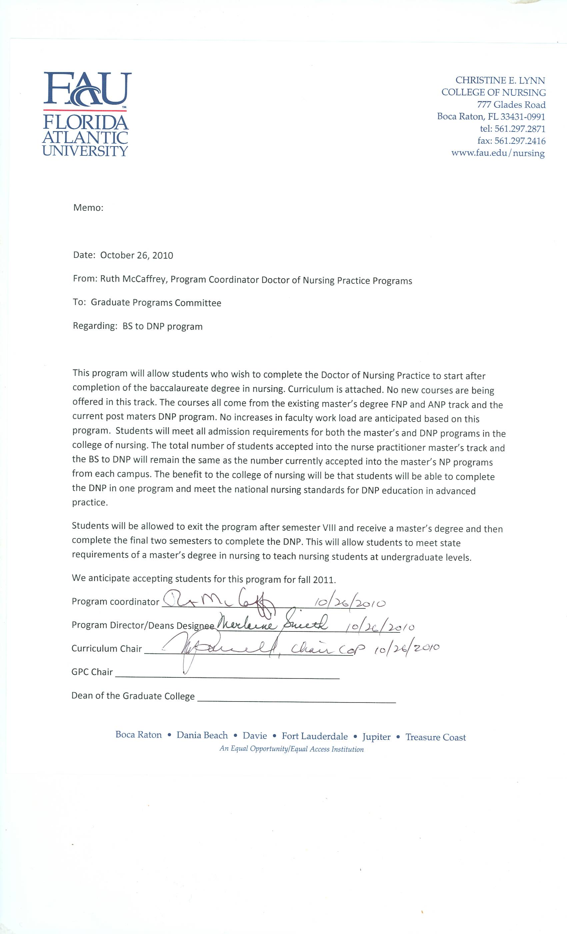

Christine E. Lynn College of Nursing
Florida Atlantic University
NEW BS to DNP TRACK CURRICULUM
Course Name | Course Number | Credits
SEMESTER I
Pathophysiology | NGR 6141 | 3
Adv Nursing Situations: Care of the family across the lifespan | NGR 6611 | 3
Epidemiology | NGR 6930 | 3
SEMESTER II
Statistics | STA 6113 | 3
Philosophical and Theoretical Foundations of Nursing | NGR 6811 | 3
Caring: An essential domain of nursing knowledge | NGR 7116 | 3
SEMESTER III
Population Based Caring in Aging Societies | NGR 7661 | 3
Healthcare Leadership | NGR 7793 | 3
Advanced Pharmacotherapeutices | NGR 6172 | 3
DNP Seminar I | NGR7941c | 1
SEMESTER IV
Advanced Nursing Situations Health Assessment | NGR 6002 | 3
Advanced Nursing Situations in Practice | NGR 6002L | 1
Public Policy in the Context of Nursing and Health | NGR 7738 | 3
DNP Seminar I I | NGR7942c | 2
SEMESTER V
Advanced Nursing Situations Foundations of Primary Care | NGR 6200 | 3
Advanced Nursing Situations Foundations of Primary Care Lab | NGR 6200L | 3
Theory guided models for Advanced Practice Nursing | NGR 7124 | 3
SEMESTER VI
Advanced Nursing Situations: Comprehensive Primary | NGR 6605 | 3
Advanced Nursing Situations: Comprehensive Primary LAB | NGR 6605L | 3
Research for Advanced Practice Nursing | NGR 7850 | 3
SEMESTER VII
Adv Nurse Situations of the Childbearing/Childrearing Family | NGR 6634 | 3
Advanced Nursing Situations of the Childbearing | NGR 6634L | 3
Evaluating Systems and Models in Advanced Practice Nursing | NGR 7826 | 3
SEMESTER VIII
Practice Management | NGR 7930 | 3
DNP Seminar III | NGR7943c | 1
SEMESTER IX
Advanced Nursing Situations DNP RESIDENCY & CAPSTONE | NGR7945 | 6
SEMESTER X
Advanced Nursing Situations DNP RESIDENCY & CAPSTONE | NGR7945 | 6
Routing for Approval: Doctoral Programs Committee 9-24-2010 Approved
Committee on Programs 10/4/2010 Approved
Faculty Assembly 10/25/2010 Approved
UGPC 11-3-2010
Steering 11-23-2010
University Faculty Senate 12-3-2010

