SmartTag Inactivation Ticket Request

Please find below an explanation of each field you find in this request.

- Brief Explanation of the Request – please provide an explanation or the reason why you need to inactivate the SmartTag.

- What Company is this tag needed for? – Please select if the SmartTag is under FAU, FAUF, or Both companies

The SmartTag will not be able to be inactivated unless all the activities listed for your fund type have been completed. Please follow the steps below:

- For Fund Types:
Carryforward and Educational & General/GTAIDS:
- To clear out the budget to $0 – Please run any Budget to Actual Reports to make sure the budget is $0, see below some reports you could run. If you still have any questions, please contact the Budget Office.
  - FAU Budget to Actual Expenses By SmartTag
  - FAU Budget to Actual Expenses By SmartTag & Fund Type
  - FAU Budget to Actual_Revenue and Expense_SmartTag Quick View
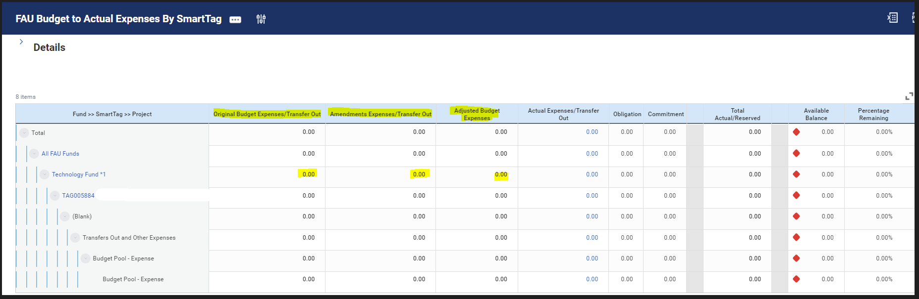
- To clear out actual expenses to $0 – Please run any of the budget to actual reports mentioned above, if you still have any questions, please contact General Accounting.

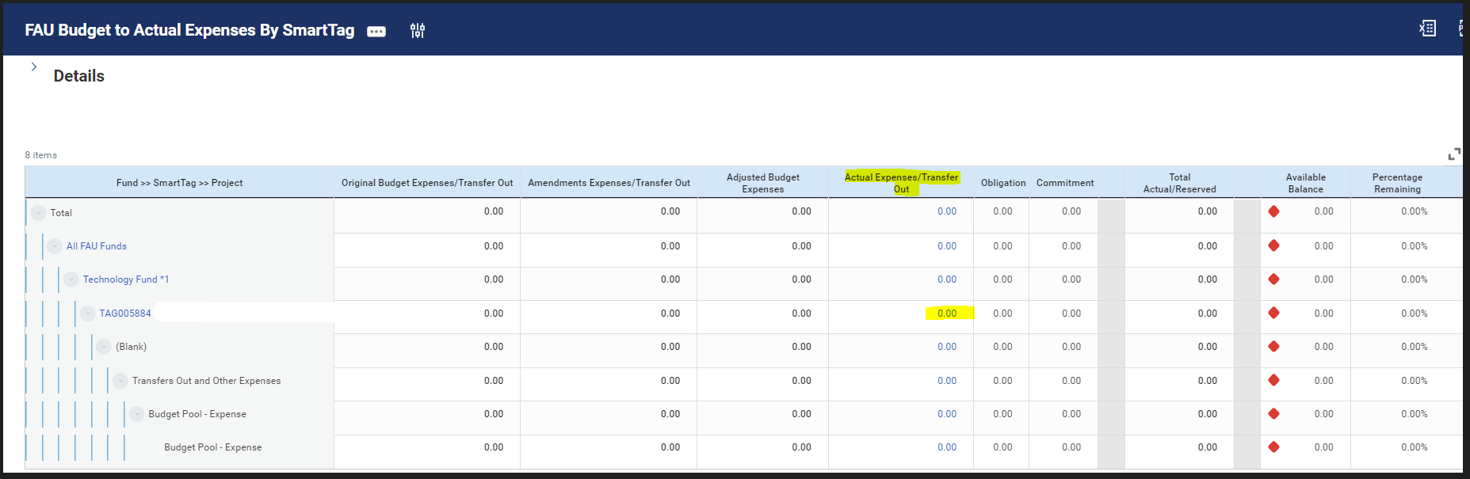

- To clear out Commitments and Obligations to $0 - Please run any of the budget to actual reports mentioned above, if you still have any questions, please contact Procurement.
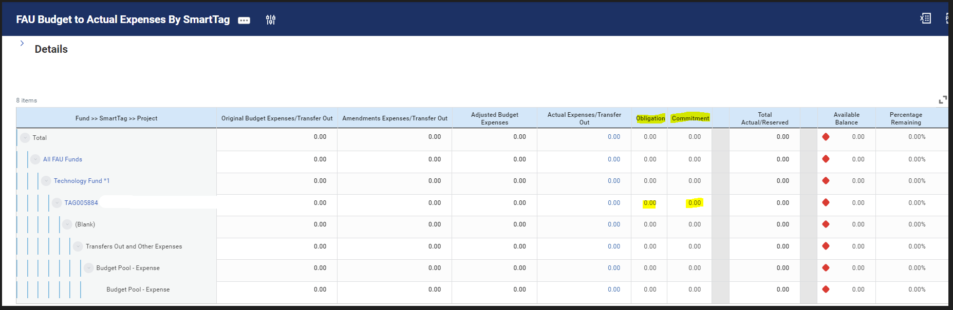

- To clear out Positions, Members, Staffing, and Unavailable to Fill data attached to the SmartTag – Please follow the instructions below, if you still have any questions, please contact Human Resources.
In Workday, search for the SmartTag you want to inactivate.


Go to the Members tab and make sure is empty, all positions have either close or move to another SmartTag.
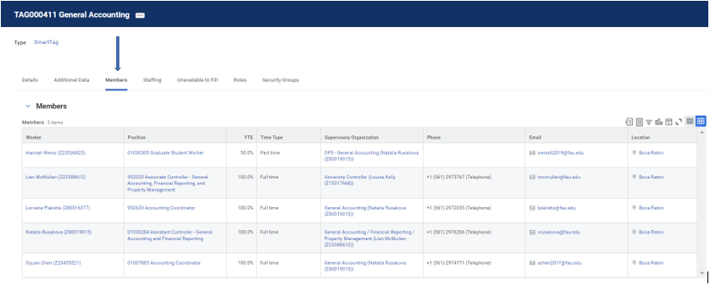

Then, go to the Staffing tab and make sure is empty, all positions have either close or move to another SmartTag.
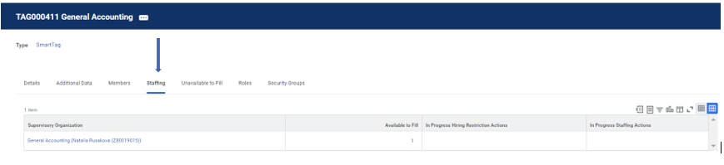
Then, go to the Unavailable to Fill tab and make sure is empty, all positions have either close or move to another SmartTag.
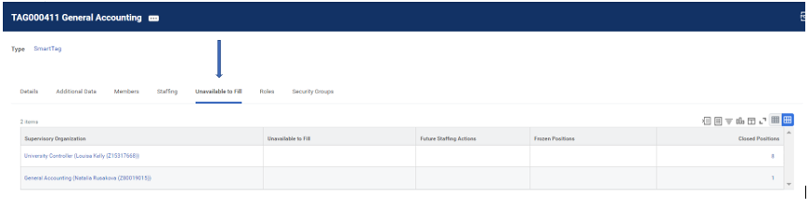
- Before inactivating the SmartTag, please verify that it is not currently assigned to a supervisory organization. You can do this by requesting the designated HR partner in your area to run this report 'FAU Position Default Organization Assignments by Supervisory Organization' to check this information.

- For all other fund types:
- To clear out the budget to $0 – Please follow the steps above
- To clear out actual expenses to $0 - Please follow the steps above
2. To clear out fund balance/net position to $0 Please run FAU FIN Available Balance by SmartTag or Fund (FORMERLY Auxiliary and Foundation Report)

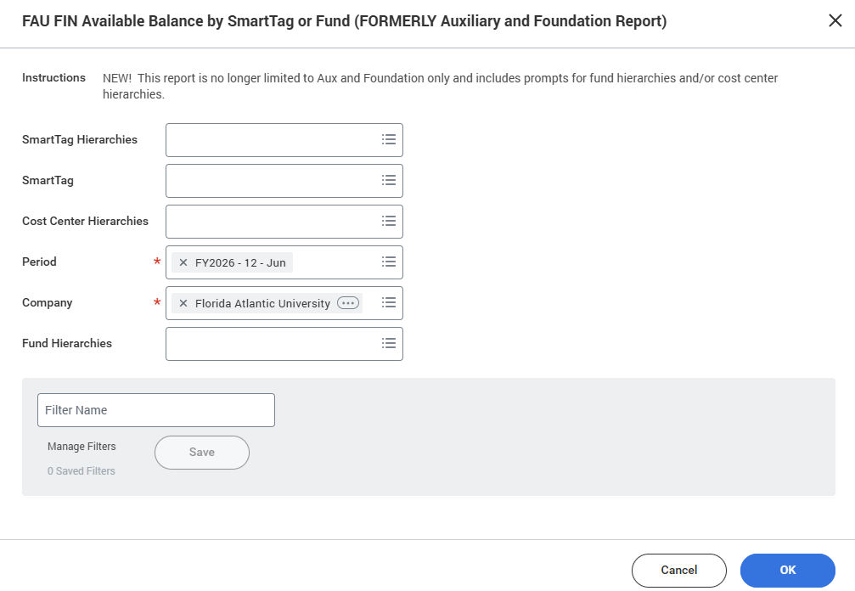
3. To clear out Commitments and Obligations to $0 – Please follow the steps above.
4. To clear out Positions, Members, Staffing, and Unavailable to Fill data attached to the SmartTag – Please follow the steps above.
5. Before inactivating the SmartTag, please verify that it is not currently assigned to a supervisory organization. You can do this by requesting the designated HR partner in your area to run this report 'FAU Position Default Organization Assignments by Supervisory Organization' to check this information.

- Fund Type: Please select the SmartTag Fund Type.

- Please enter the SmartTag with the title: Please provide this information.
- Please enter the Cost Center Manager for this SmartTag: Please provide this information.

- Are you requesting to inactivate the Cost Center?

  - If the answer is Yes, please enter the Cost Center with the title.

- Is the Smarttag linked to a detail code used in Marketplace or Banner?

  - If the answer is Yes, please provide the detail code and Name (existing)

