Budget Office Ticket Requests
- The Budget Office has created several request types in Workday to support departments’ financial needs, replacing the use of Team Dynamix. To submit a request, search the Workday search bar for any of the following:

- Budget Office SmartTag Inactivation
- Budget Amendment Questions
- Budget Office SmartTag Title Change
- Budget Office Carryforward SmartTag Request
- Budget Office New SmartTag Request Form
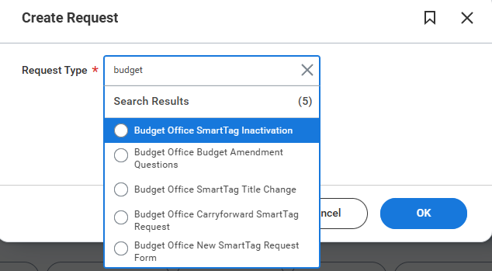

- You will be prompted to answer questions about the SmartTag, including its cost center, purpose, and fund type.
- Once submitted, the request will be submitted to the Budget Office for review and other departments accordingly. After it is completed, the initiator will receive both a Workday notification and an email indicating whether the request was approved or denied. One can always find its request in the archive inbox on Workday.
- These requests are not intended for creating a new FAUF gift or Sponsored TAGs. Please contact the Foundation and Sponsored departments for guidance.

Examples:
- Budget Office SmartTag Inactivation:
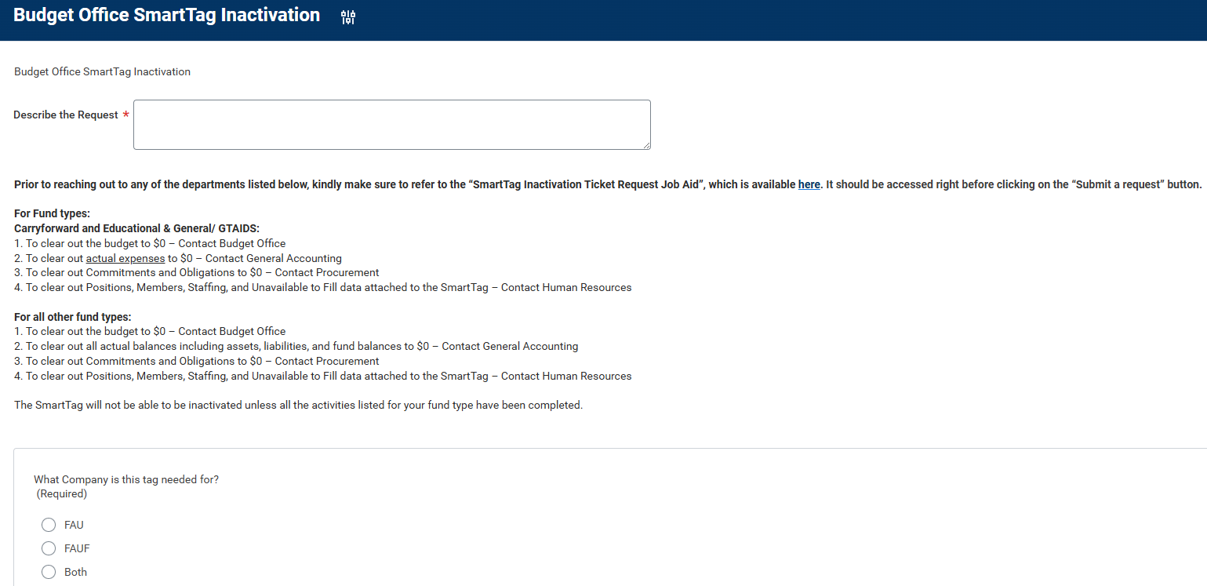

- Budget Office Budget Amendment Questions:
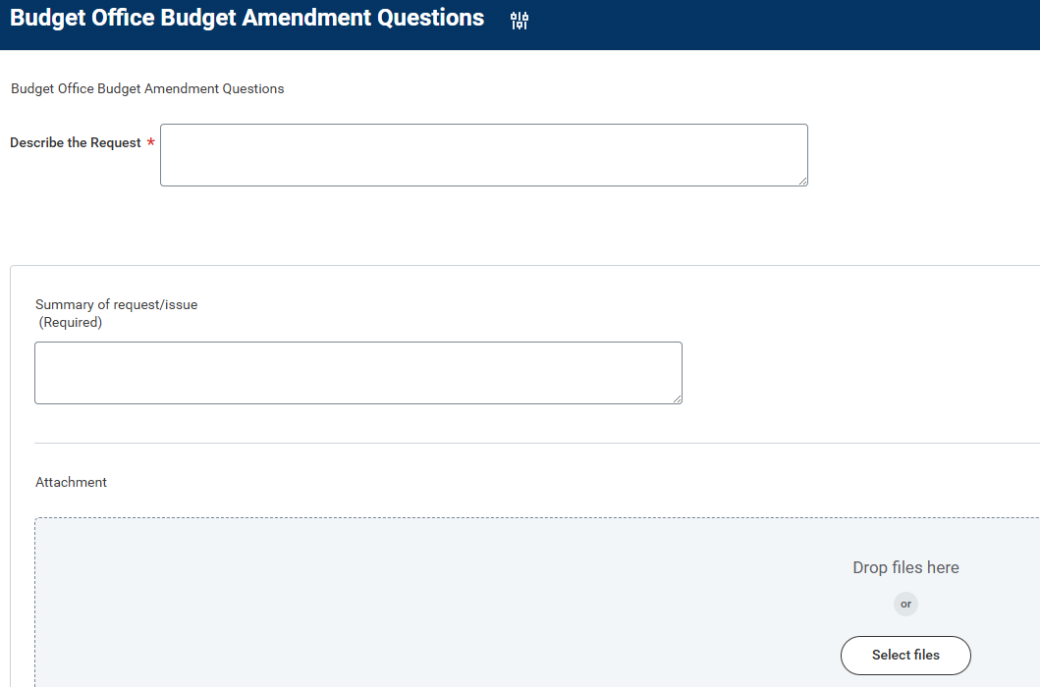

- Budget Office SmartTag Title Change
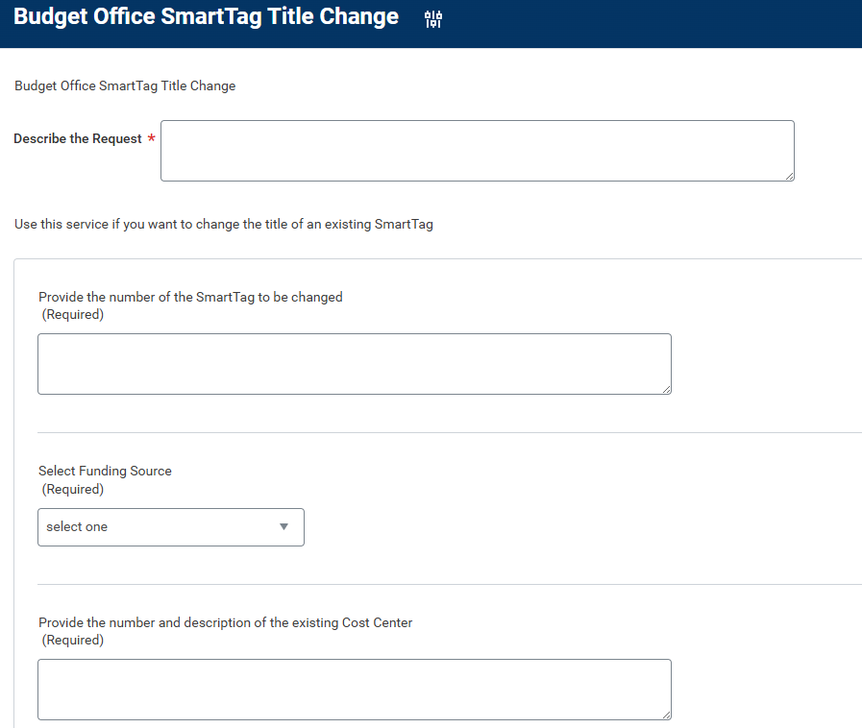
- Budget Office Carryforward SmartTag Request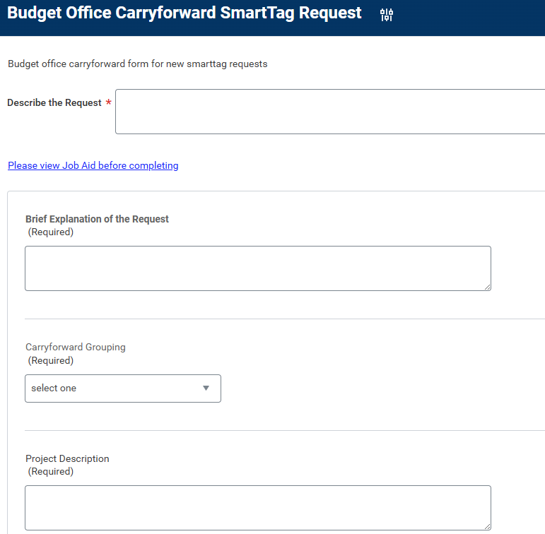

- Budget Office New SmartTag Request