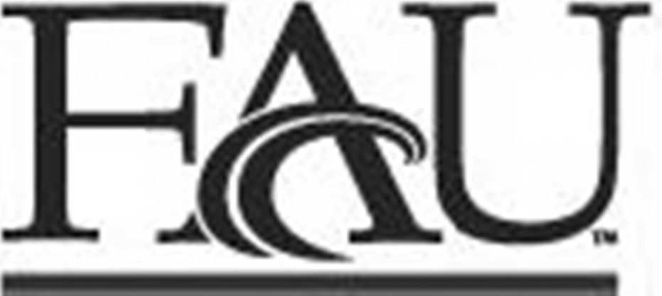
Aid Year: ________________________

Parent Killed in Line of Dutry
Office of Student Financial Aid | Florida Atlantic University
FORM: IASCFH

Submit this form online via owlfiles.fau.edu
Need Help? Visit fau.edu/finaid/contact
Z
Student Name Student Z Number FAU Email Address

Address Telephone
REQUESTING AID FOR: (Check One) □ Fall __________ □ Spring __________ □ Summer __________
On the FAFSA application under section Parent Killed in Line of Duty you responded “YES” to the following question:

Was the student’s parent or guardian killed in the line of duty while (1) serving on active duty as a member of the U.S. armed forces on or after September 11, 2001, or (2) performing official duties as a public safety officer?

A public safety officer generally includes the following:
• Law enforcement officer, firefighter, or chaplain
• Federal Emergency Management Agency (FEMA) employee
• Emergency management or civil defense agency employee
• Member of a rescue squad or ambulance crew
• Others defined in the Omnibus Crime Control and Safe Streets Act of 1968.

BASED ON YOUR RESPONSE, PLEASE SEE BELOW A DESCRIPTION OF CIRCUMSTANCES AND PROVIDE SUPPORTING DOCUMENATATION REQUESTED ALONG WITH THIS FORM.

DECRIPTION OF CIRCUMSTANCES: (Check one) | SUPPORTING DOCUMENTATION:
- □ Parent or guardian killed in the line of  duty while serving on active duty as a  member of the U.S. armed forces on or  after September 11, 2001  Iraq Afghanistan Service Grant  Student is less than 33 years old as of the January 1 prior to the award year for which the applicant is applying (e.g., for the 2024–25 award year, a student must be less than 33 years old as of January 1, 2024, to be eligible). | - Student Birth Certificate showing relationship  to parent.  - A copy of the service member’s DD Form 1300 (Report of Casualty) which documents death in the line of duty.  OR  A copy of the service member’s DD Form 214 and death certificate, documenting that the date and cause of death occurred during and as a result of active duty.  OR  A copy of a Department of Veterans Affairs Death Narrative Document.
- □ Parent or guardian was killed in  the line of duty while performing official  duties as a public safety officer.  Student is less than 33 years old as of the January 1 prior to the award year for which the applicant is applying (e.g., for the 2024–25 award year, a student must be less than 33 years old as of January 1, 2024, to be eligible). | - Student Birth Certificate showing relationship  to parent.  - Government Issued Death Certificate (funeral notice/obituary may be acceptable with  accompanying documentation which shows relationship between the deceased and the student).  - A determination letter acknowledging eligibility for certain federal benefits under the Public Safety Officers Benefit (PSOB) program administered by the Department of Justice.  OR  A written letter of attestation or determination made by a state or local government official with supervisory or other relevant oversight authority of an individual who died in the line of duty while serving as a public safety officer.  OR  Documentation of the student qualifying for a state tuition or other state benefit accorded to the children or other family members of a public safety officer.  OR  Provide official letter from department or agency  which parent served. Specifically stating parent  or guardian killed in the line of duty.
- □ Error in response to FAFSA question.  Response should have been “NO”. | - No documentation needed. You are requesting for a financial aid representative to update the question on your FAFSA to a response of “NO”.
ADDITIONAL RESOURCES FOR CHILDREN WITH PARENTS IN U.S. ARMED FORCES:
- VA Educational Student Hotline at 1-888-442-4551
- VA Education Benefits For Survivors And Dependents | Veterans Affairs
- Military and Veterans Student Success Center | Florida Atlantic University (fau.edu)

ADDITIONAL RESOURCES FOR CHILDREN WITH PARENTS IN PUBLIC SAFETY:
- Public Safety Officers Benefit Program

I have read and understand the following: (Check each box to confirm)
□ Submitting an form does not guarantee an approval.
□ I understand that additional documentation may be requested to make a determination.
□ I will be notified of the decision via my FAU student email.

I certify that I have read the policy and the conditions and certify that all information reported is complete and correct. I certify that documents submitted with this form are true, complete, and have not been altered.
Student Signature | Date

