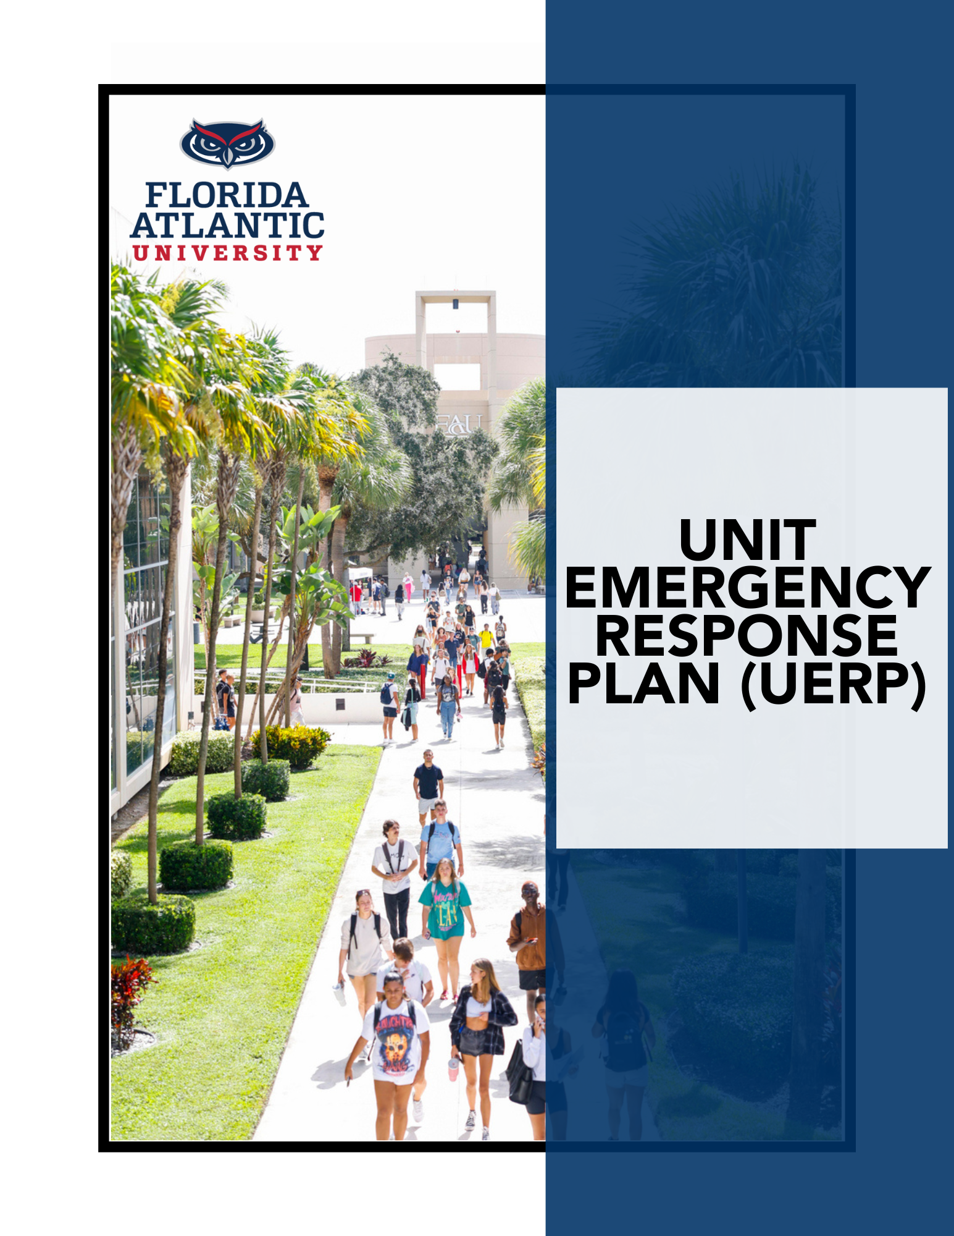
[INSERT NAME OF UNIT]
[INSERT UNIT LOCATION]
[MM/DD/YY]

APPROVAL AND PROMULGATION
It is the policy of Florida Atlantic to protect its human and physical assets and ensure continued operations during and after all emergencies, whether natural or manmade, by implementing appropriate emergency management policies, plans, and procedures designed to ensure the University's ability to respond to and recover from emergencies effectively.
The Unit Emergency Response Plan (UERP) of the [INSERT NAME OF UNIT] is written in support of the FAU Comprehensive Emergency Management Plan (CEMP) and identifies a baseline of preparedness for a full range of potential emergencies. The Plan is designed to be flexible so that either portions of it or the entire Plan can be activated as needed based on the nature of the emergency.
This Plan is intended to comply with all applicable University, local, state, and federal laws and regulations. In the absence of specific regulatory mandates for particular situations, best emergency management practices shall be followed.
All Unit personnel of [INSERT NAME OF UNIT] are expected to be familiar with the Plan and to carry out their assigned roles and responsibilities during an emergency.
The [INSERT NAME OF UNIT] is authorized to amend this Plan to maintain operational consistency, implement corrective action, enhance the document, or apply other appropriate changes.
It is authorized by [INSERT NAME OF UNIT LEADER], [INSERT UNIT LEADER POSITION], that this promulgation shall be effective upon signing and remain in force until amended or rescinded by further promulgation.
[INSERT NAME OF UNIT LEADER]
[INSERT MM/DD/YY]

Contents
APPROVAL AND PROMULGATION 2
IMPORTANT PHONE NUMBERS 5
OVERVIEW 6
1. Introduction 6
2. Planning Assumptions 6
FACILITY INFORMATION 7
1. Areas of Responsibility 7
List the Unit’s Areas of Responsibility 7
2. Panic Buttons 7
Panic Button Protocols 8
Panic Button Locations 8
3. Emergency Equipment Locations 9
PREPARING FOR EMERGENCY EVENTS 10
1. Unit Preparedness Checklist 10
2. Notification of an Emergency 11
Notification of an Emergency Procedure 11
Unit Phone Tree 13
3. Essential Personnel Program 14
Unit Essential Personnel Roster 16
4. Non-FAU Essential Personnel 17
Unit Non-FAU Essential Personnel Roster 18
5. Global Travel Safety & Security 19
EVACUATION & SHELTER-IN-PLACE PROCEDURES 20
1. Evacuation Procedures 20
Visitor Evacuation Procedures 20
2. Shelter-in-Place Procedures 22
Visitor Shelter-in-Place Procedures 22
3. Tropical Cyclone 24
Tropical Cyclone Implementation Procedures Checklist 25
4. Special Circumstances & Activities 26
DAMAGE ASSESSMENT 28
1. What Is It? 28
2. When To Report Post-Disaster-related Damage 28
3. How to Report Post-Disaster-related Damage 28
EMERGENCY COSTS AND LABOR TRACKING 29
1. What Is It? 29
2. How Is It Done 29
TRAINING, EXERCISE & PLAN MAINTENANCE 30
1. Training & Exercise 30
2. Plan Maintenance 31
APPENDIX I: EMERGENCY KIT CHECKLIST 32
APPENDIX II: EMERGENCY PROCEDURES 33
Appendix III: TROPICAL CYCLONE: WORKSPACE PREPARATION GUIDANCE 34

IMPORTANT PHONE NUMBERS
UNIT NAME | PHONE NUMBER
University Hotline | 1-888-8FAUOWL  1-888-832-8695
Florida Atlantic Police Department | Boca Raton: 561-297-3500  Jupiter: 561-799-8700  Harbor Branch: 772-216-1124  SeaTech: 954-924-7000  Davie: 954-236-1140  Fort Lauderdale: 954-201-4357
Department of Emergency Management | em@fau.edu
Office of Environmental Health & Safety | 561-297-3129
Work Control – Facilities | Boca Raton: 561-297-2240  Broward Campuses: 954-236-1534  Harbor Branch: 772-242-2246
Office of Information Technology | Help Desk: 561-297-3999
Victim Services | 561-297-4814
Counseling & Psychological Services | Boca Raton: 561-297-2277  Jupiter: 561-799-8635  Davie: 954-236-1210
Student Health Services | Boca Raton: 561-297-3512  Jupiter: 561-799-8678  Davie: 954-236-0494  After-Hours Nurse Line: 561-297-3515, Option 3
Student Accessibility Services | Boca Raton & Davie: 561-297-3880  Jupiter: 561-799-8585
Office of Civil Rights and Title IX | 561-297-3004  Florida Relay System: 800-955-8771

OVERVIEW

Introduction
Per University Policy 3.4.1, Emergency Management, [INSERT UNIT NAME] is required to have a Unit Emergency Response Plan (UERP) to ensure the readiness and resilience of Unit operations and functions. A Unit is defined as entity or group of entities that share similar essential functions, which can be a division, unit, college, office, or center. This UERP supplements Florida Atlantic’s Comprehensive Emergency Management Plan (CEMP) and is customized to meet the baseline of preparedness for a full range of potential emergencies that may disrupt normal operations. At a minimum, this UERP addresses the following:
- Preparing for emergency events;
- Evacuating and shelter-in-place procedures;
- Assessing damage to facilities; and
- Emergency costs and labor tracking

Planning Assumptions
The following assumptions are what the [INSERT UNIT NAME] believes to be true when developing this UERP:
- Unit heads shall ensure that their staff are knowledgeable regarding their Units’ emergency plans and procedures;
- All employees shall respond to an emergency event or threat according to applicable plans and procedures;
- Each employee shall immediately report a potential or actual emergency event or threat to the appropriate authorities (such as Florida Atlantic Police or 911) and to their immediate supervisor;
- All members of the University community shall provide, within the limits of their abilities, assistance to those individuals requiring it, during or after an emergency. Normally, assistance is in the form of notifying emergency responders of the location of these individuals or by providing guidance to safe areas; and
- All employees are expected to review existing emergency response protocols and procedures.

FACILITY INFORMATION

Areas of Responsibility
UERP Purview of Responsibility
Task | Yes | No
Does this UERP account for more than one (1) Unit?  If more than one Unit is included in this plan, the Unit must provide justification for this action. | ☐ | ☐
COMPLETE THE SECTION BELOW IF THE ANSWER TO THE PREVIOUS QUESTION IS YES
Please list all the Units that are accounted for or included in this plan?

Has leadership from each Unit listed approved of their inclusion in this plan? | ☐ | ☐
Please provide a clear justification for the inclusion of each Unit in this plan
[Insert justification by outline each Unit’s relevance to the plan’s objectives]

List the Unit’s Areas of Responsibility
This should include any conference rooms or event space the Unit manages. Please add additional rows to the table below as needed.
Campus | Building Name or Facility Name | Bldg. # | RM # | Type of Space
Choose an item. |  |  |  | Choose an item.
Choose an item. |  |  |  | Choose an item.
Choose an item. |  |  |  | Choose an item.
Choose an item. |  |  |  | Choose an item.
Choose an item. |  |  |  | Choose an item.
Choose an item. |  |  |  | Choose an item.
Choose an item. |  |  |  | Choose an item.
Choose an item. |  |  |  | Choose an item.

Panic Buttons
University Policy 3.3.7, Panic/Duress Alarms, establishes University guidelines for panic/duress alarm installation and usage on University sites with a law enforcement presence 24 hours a day.

The University utilizes panic/duress alarms in areas meeting a defined criteria to allow community members to contact the University Police Department via silent alarm. Those areas authorized panic/duress alarm installations must meet the defined criteria, participate in quarterly testing, annual training, and bi-annual review of conditions resulting in the installation. Activation of a panic/duress alarm requires a law enforcement response. Unarmed, non-sworn personnel will not be dispatched.
To obtain Panic Buttons from the Florida Atlantic Police Department for the Unit at a cost, please submit a Work Order within FAMIS.

Panic Button Protocols
[Insert Protocol for Unit Staff on when and how to activate the Panic Buttons]
For assistance in drafting the Panic Button protocol, please contact the Department if Emergency Management at em@fau.edu.

Panic Button Locations
Campus | Building Name | Bldg. # | RM # | Description of Location
Choose an item.
Choose an item.
Choose an item.
Choose an item.
Choose an item.

Emergency Equipment Locations
Type of Equipment | Campus | Building Name | Bldg. # | Floor # or RM# | Description of Location & Notes
 | Choose an item.
 | Choose an item.
 | Choose an item.
 | Choose an item.

Type of Equipment | Campus | Building Name | Bldg. # | Floor # | Description of Location & Notes
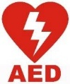 | Choose an item.
 | Choose an item.
 | Choose an item.
 | Choose an item.

Type of Equipment | Campus | Building Name | Bldg. # | Floor # | Description of Location & Notes
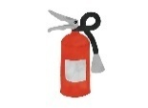 | Choose an item.
 | Choose an item.
 | Choose an item.

PREPARING FOR EMERGENCY EVENTS

Unit Preparedness Checklist
The purpose of this checklist is to ensure the Unit has taken appropriate steps to prepare for emergencies and that Unit personnel are informed of their roles and responsibilities should this Plan be activated.
Unit Preparedness Checklist
Task | Yes | No | Record Date of Completion/Notes
Have all employees (including student staff) been informed of the Unit’s Emergency Response Plan?  This should be performed on a semesterly basis, or when changes to the plan occur. | ☐ | ☐
Have all employees received training on procedures listed within the UERP (e.g., Evacuation, Shelter-in-Place, etc.)?  This should be performed on a semesterly basis, or when changes to the plan occur. | ☐ | ☐
Has the Unit leadership communicated the roles and responsibilities of employees should an emergency occur during normal hours and after-hours?  This should be updated on a semesterly basis, or when staff changes occur. | ☐ | ☐
Has the Unit included the emergency procedures listed in this plan in onboarding process for new staff members, including student staff? | ☐ | ☐
Are the Unit’s first aid and Emergency Kits being maintained?  This should be performed on a semesterly basis, or when changes to the plan occur. | ☐ | ☐
Have Evacuation Routes and Assembly Areas been communicated to employees (including student staff)?  This should be exercised on a semesterly basis, or when staff changes occur. | ☐ | ☐
Have Shelter-in-Place locations been communicated to employees (including student staff)?  This should be exercised on a semesterly basis, or when staff changes occur. | ☐ | ☐

Notification of an Emergency
It is the responsibility of primarily [INSERT POSITION TITLE] and secondarily [INSERT POSITION TITLE] to communicate and notify Unit staff of an emergency impacting the University and/or causing a disruption to Unit operations.
Notifications of an Emergency may also come from the FAU Alert System. All Unit staff, including student staff, should ensure they are able to receive notifications from the FAU Alert System at all times (e.g., phone call, text, email).

Notification of an Emergency Procedure
[Insert protocol for a tiered system (Unit Phone Tree) to notify the staff of an emergency. The protocol should address (1) Communication to staff, (2) Communication to guests and visitors, (3) Normal business hour protocol, and (4) After-hours protocol.]
For assistance in drafting the Notification of an Emergency protocol, please contact the Department if Emergency Management at em@fau.edu.

Notification Preparation Checklist
Task | Yes | No | Record Date of Completion/Notes
Have employees been advised to update their emergency contact information in Workday?  This should be updated on a semesterly basis. | ☐ | ☐
Have employees been advised to update their contact information for the FAU Alert system in Workday?  This should be updated on a semesterly basis. | ☐ | ☐
Has the Unit advised staff with university-issued phones to register for the FAU Alert system in Workday?  This is University policy and should be updated on a semesterly basis. | ☐ | ☐
Has the Unit updated the Unit’s Phone Tree (including student staff)?  This should be updated on a semesterly basis, or when staff changes occur. | ☐ | ☐
Has the Unit tested the Unit’s Phone Tree?  This should be updated and tested on a semesterly basis, or when staff changes occur. | ☐ | ☐
Has the Unit encouraged guests and visitors to download the Owl Ready app or join the FAU Alert system to receive emergency updates in the event of an emergency?  Guests can also opt into the FAU Alert system for 24 hours. Text FAUALERTGUES to 888777. | ☐ | ☐
Has the Notification protocol listed above been communicated to all employees?  This should be updated on a semesterly basis, or when staff changes occur. | ☐ | ☐

Unit Phone Tree
Please insert a Phone Tree for the Unit that uses a hierarchical, top-down communication structure. The Phone Tree should include the following for each staff member:
- Name
- Position title
- Primary phone number
- Secondary phone number

Essential Personnel Program
This program is managed by the Department of Human Resources and is governed by University Policy 3.4.1, Emergency Management, and the Essential Personnel Program Policy. In the event of severe weather conditions or emergency situations, the University may suspend operations and/or cancel classes in whole or in part. If this occurs, all Units and employees deemed essential must remain at or report to their campuses as soon as conditions reasonably permit. During an emergency, Essential Units and personnel provide services that relate directly to the health, safety, and welfare of the University, ensure continuity of critical/essential operations and functions, and maintain and protect University assets. The designation of essential depends on an employee’s duties as well as the circumstances for suspension of operations.
Only personnel who can provide appropriate documentation will be allowed on University sites/campuses, and this may also assist personnel traveling to campuses/sites. A list of personnel will be provided to FAU PD for access control purposes.
It is the Vice President of each respective Division that give the final approval to whom is determined to be essential for their Units. If Unit staff should be designated as Essential, please consult your leadership.
Please contact the Department of Human Resources for further information concerning your Unit’s Essential Personnel needs at 561-297-3057 or at http://www.fau.edu/hr/
Essential Personnel Preparation Checklist
Task | Yes | No | Record Date of Completion/Notes
Does the Unit have employees who have been designated “Essential”? | ☐ | ☐
COMPLETE THE SECTION BELOW IF THE ANSWER TO THE PREVIOUS QUESTION IS YES
Has Unit leadership communicated the roles and responsibilities of Essential Personnel should an emergency occur during normal hours or after-hours?  This should be updated on a semesterly basis, or when staff changes occur. | ☐ | ☐
Has the Unit advised Essential Personnel to prepare an Emergency Kit with the necessary supplies (e.g., keys) to access unit-owned spaces following a recall?  This should be updated on a semesterly basis, or when staff changes occur. | ☐ | ☐
Has the Unit advised Essential Personnel to have quick access to their Essential Personnel letter (e.g., on their phone, in their vehicle, etc.)?  This will be needed to access the University should the Florida Atlantic Police Department limit access to the campus. This should be performed on an annual basis. | ☐ | ☐
Does the Notification Protocol referred to in Section 2 address return to work procedures for Essential Personnel?  If not, please include this information in the Notification of an Emergency Section. | ☐ | ☐

Unit Essential Personnel Roster
Provide a list of all Unit Essential Personnel.

First Name | Last Name | Title | Email | Primary Phone Number | Secondary Phone Number
(Add Rows if Needed)

Non-FAU Essential Personnel
Non-FAU Essential Personnel are individuals who perform critical operations, functions, and tasks for the University, but are employed through an outside vendor and/or contract service providers. Examples include, but are not limited to:
- Food and Dining Services
- Ground Maintenance
During a University closure, access to the University will be limited. Therefore, all University Units that oversee and/or manage contracts for such services are responsible for ensuring that non-FAU Essential Personnel are added to the Non-FAU Essential Personnel List, which is managed by the Department of Emergency Management. The List will be provided to the Florida Atlantic Police Department for access control purposes. All non-FAU Essential Personnel will need to present the following to gain access to the University during a closure or suspension of operations:
- Designated as a non-FAU Essential Personnel by the Department of Emergency Management; and
- A current, active form of identification, such as a driver's license
To update contact information, remove individuals from the program, or add non-FAU Employees to the program, please utilize the Non-FAU Essential Personnel Form. Forms that are not fully completed will not be accepted.
Questions regarding the non-FAU Essential Personnel Program should be directed to the Department of Emergency Management at em@fau.edu.
Non-FAU Essential Personnel Preparation Checklist
Task | Yes | No | Record Date of Completion/Notes
Does the Unit have contracted services that provide essential services to the Unit or University? | ☐ | ☐
COMPLETE THE SECTION BELOW IF THE ANSWER TO THE PREVIOUS QUESTION IS YES
Does the Unit maintain an up-to-date list of primary and secondary contacts for each essential vendor? | ☐ | ☐
Have expectations been clearly communicated to vendors regarding how and when they will be contacted during an emergency? | ☐ | ☐
Have all non-FAU essential personnel updated their contact information in the FAU Alert system?  Non-FAU Essential Personnel can join the FAU Alert system by completing this form. | ☐ | ☐

Unit Non-FAU Essential Personnel Roster
Attach a list of the Unit’s Non-FAU Essential Personnel. Lists can be acquired from the Department of Emergency Management (em@fau.edu).

Global Travel Safety & Security
Board of Governors' Regulation 9.012, Foreign Influence, and Florida State Statute 1010.36, Foreign Travel for Research Institutions, require every state research institution to report and track international travel to not just countries of concern but all destinations abroad. Moreover, University Policy 3.4.2, Global Travel Safety and Security, requires all colleges and Units to be in compliance with the procedures and processes listed therein.
It is the responsibility of all colleges and Units that have staff who travel abroad to comply with all applicable travel-related and safety and security-related policies and procedures. Failure to comply with requirements set forth within University Policy 3.4.2, Global Travel Safety and Security, may result in consequences, including but not limited to delays in processing travel requests, personal fiscal responsibility, and disciplinary actions.
The Global Travel Safety & Security Committee (GTSSC) is appointed and supported by the Department of Emergency Management (DEM) and provides independent review and risk assessments for proposed international travel—particularly to destinations identified by the U.S. Department of State as Level 3 or Level 4, and to countries designated as a Foreign Country of Concern.
The GTSSC evaluates safety conditions, risk mitigation plans, and traveler preparedness to advise DEM and University leadership. Based on the destination’s risk level, GTSSC issues recommendations to the relevant Division Vice President or the Executive Leadership Team through the Executive Vice President and Chief Operating Officer.
Global Travel Safety and Security Preparation Checklist
Task | Yes | No | Record Date of Completion/Notes
Does the Unit have staff who may engage in University-related travel outside of the United States and its territories? | ☐ | ☐
Does the Unit have staff who may engage in University-related or personal travel while in possession of University assets while traveling outside of the United States and its territories? | ☐ | ☐
COMPLETE THE SECTION BELOW IF THE ANSWER TO BOTH PREVIOUS QUESTION IS YES
Is Unit Leadership aware of University policy 3.4.2, Global Travel Safety and Security? | ☐ | ☐
Does the Unit have procedures in place to ensure early reporting and proper submission of international travel registration? | ☐ | ☐
Has the Unit included the processes and procedures outlined in University Policy 3.4.2, Global Travel Safety and Security  in the onboarding process for new staff members, including student staff? | ☐ | ☐
Are the Unit staff who travel and may engage in University-related travel outside of the United States and its territories aware of the consequences of noncompliance with the University Policy, 3.4.2, Global Travel? | ☐ | ☐

EVACUATION & SHELTER-IN-PLACE PROCEDURES

Evacuation Procedures
Evacuation is a directive to move outdoors when dangerous interior conditions exist. When exiting a building for an evacuation, proceed to the Unit’s primary or secondary assembly area.
[Insert special details regarding the facilitation of an evacuation of the Unit spaces, accounting for Unit staff, and who will have specific roles and responsibilities in communicating and coordinating between affected staff and the Unit leadership team.]
For assistance in drafting the Evacuation Procedures, please contact the Department if Emergency Management at em@fau.edu.

Visitor Evacuation Procedures
Visitors present a unique challenge as they are not generally familiar with the Unit’s emergency procedures. During an emergency, visitors should be given special care to ensure that they follow the evacuation procedures listed within this plan.
[Insert special details regarding visitors, such as how the Unit will account for visitors during an evacuation.]
For assistance in drafting the Visitor Evacuation Procedures, please contact the Department if Emergency Management at em@fau.edu.

Please contact the Office of Environmental Health and Safety to designate Assembly Areas for the Unit.
List the Unit’s Assembly Areas
- Primary
- Secondary

Evacuation Preparation Checklist
Task | Yes | No | Record Date of Completion/Notes
Have primary and secondary evacuation routes been clearly identified and communicated to all Unit members, including student staff? | ☐ | ☐
Have primary and secondary Assembly Areas been clearly communicated to Unit members, including student staff? | ☐ | ☐
Has the Unit included evacuation protocols listed above in the onboarding process new staff members, including student staff? | ☐ | ☐
Have all Unit staff received training on evacuation procedures listed in this section? | ☐ | ☐
Has the Unit conducted an Evacuation Drill within the last year? | ☐ | ☐

Shelter-in-Place Procedures
Shelter-in-Place is a directive to seek immediate shelter indoors when dangerous environmental conditions exist. Similarly, these locations may also be designated by the Florida Atlantic Police Department as Safe Rooms, or locations that may be used to Hide during an emergency that necessitates the individuals to invoke the Run, Hide, Fight sequence, such as an active threat.
Each Unit at Florida Atlantic has primary and secondary Shelter-in-Place or Safe Room locations that may serve as a safe location to remain in place for an extended period of time.
Please contact the Florida Atlantic Police Department to designate Shelter-in-Place/Safe Room locations for the Unit.
List all Shelter-in-Place or Safe Room Locations
- Primary
- Secondary

[Insert special details regarding the facilitation of the movement into shelter-in-place spaces, accounting for Unit staff, and who will have specific roles and responsibilities in communicating and coordinating between affected staff and the Unit leadership team.]
For assistance in drafting the Shelter-in-Place Procedures, please contact the Department if Emergency Management at em@fau.edu.

Visitor Shelter-in-Place Procedures
Visitors present a unique challenge as they are not generally familiar with the Unit’s emergency procedures. During an emergency, visitors should be given special care to ensure that they follow the shelter-in-place procedures listed within this plan.
[Insert special details regarding visitors , such as how the Unit will account for visitors during an emergency that requires the Unit to shelter-in-place].
For assistance in drafting the Visitor Shelter-in-Place Procedures, please contact the Department if Emergency Management at em@fau.edu.

Shelter-in-Place Preparation Checklist
Task | Yes | No | Record Date of Completion/Notes
Have employees been trained on the procedures listed in the section above?  This should be performed on a semesterly basis. | ☐ | ☐
Has the Unit included shelter-in-place protocols listed above in the onboarding process new staff members, including student staff? | ☐ | ☐
Have primary and secondary shelter-in-place locations been clearly identified and communicated to all Unit members, including student staff? | ☐ | ☐
Have employees built a personal Emergency Kit?  Employees should build a kit with supplies to support their personal needs, such as medication, clothing, and food in the event they are in Shelter-in-Place locations for extended period of time. | ☐ | ☐
Do all Shelter-in-Place/Safe Room locations have an Emergency Kit? | ☐ | ☐
Can doors to Shelter-in-Place/Safe Room locations be locked from the inside? | ☐ | ☐
Is there a way to block or secure windows and doors if needed? | ☐ | ☐
Are Unit staff trained on what to do during a shelter-in-place scenario, including securing doors, turning off lights, and remaining quiet? | ☐ | ☐

Tropical Cyclone
Tropical cyclones, this includes Tropical Depressions, Tropical Storms, and Hurricanes, pose significant risks to University operations, facilities, and personnel due to their potential for high winds, heavy rainfall, flooding, and extended disruptions. It is essential that each Unit proactively prepares to mitigate these risks, ensure the safety of all staff and students, and maintain continuity of critical functions.
The Department of Emergency Management offers Hurricane Preparedness Training to Units, which is an overview and basic understanding of concepts designed around protecting, preparing, responding, and recovering from tropical cyclones. Units can request the training here.
Tropical Cyclone Preparation Checklist
Task | Yes | No | Record Date of Completion/Notes
Has the Unit identified essential functions that must continue during or after a Tropical Cyclone? | ☐ | ☐
Are critical staff roles identified and briefed on responsibilities before, during, and after the storm? | ☐ | ☐
Is there a procedure to shut down and protect electronic equipment and lab instruments?  General University guidance can be found in Appendix IV: Tropical Cyclone: Workspace Preparation Guidance. | ☐ | ☐
Do all Unit members know how they will be notified of tropical cyclone threats (e.g., FAU alert system, University announcements via emails, Florida Atlantic Advisory Page)? | ☐ | ☐
Are seasonal reminders or briefings given at the start of hurricane season?  The start of the Atlantic Hurricane Season is June 1st . | ☐ | ☐
Has the Unit identified who will return first to assess Unit damage?  This should be Essential Personnel unless otherwise directed by the Unit leadership or University directives. | ☐ | ☐

Tropical Cyclone Implementation Procedures Checklist
The intent of the Tropical Cyclone Implementation Procedures Checklist is to provide a guide for Unit’s to complete Unit-specific tasks associated with a tropical cyclone impacting one or more of Florida Atlantic’s service areas. It is designed in a time-phased implementation wherein each section includes actions the Unit will perform before tropical storm-forced winds (39mph) are expected to impact the service areas as well as post-storm once the University directs the community to return to campus.
Storm preparation will be difficult to complete once the tropical storm-force winds are within the area. Therefore, preparedness activities should be completed beforehand.
Directions: Units should complete each section with Unit-specific actions that includes the task, the individual(s) tasked with fulfilling the task, and additional information of the task. Please add additional rows to the table below as needed.
72 Hours (Three Days) Before the Onset of Tropical Storm Winds
TASK |  | TASK OWNER | DETAILS
☐
☐
48 Hours (Two Days) Before the Onset of Tropical Storm Winds
TASK |  | TASK OWNER | DETAILS
☐
☐
24 Hours (One Day) Before the Onset of Tropical Storm Winds
TASK |  | TASK OWNER | DETAILS
☐
☐
12 Hours (0.5 Days) Before the Onset of Tropical Storm Winds
TASK |  | TASK OWNER | DETAILS
☐
☐
12 Hours (0.5 Days) After University Directives to Return to Campus
TASK |  | TASK OWNER | DETAILS
☐
☐
24 Hours (One Day) After University Directives to Return to Campus
TASK |  | TASK OWNER | DETAILS
☐
☐
48 Hours (Two Days) After University Directives to Return to Campus
TASK |  | OWNER | DETAILS
☐
☐
72 (Three Days) Hours After University Directives to Return to Campus
TASK |  | TASK OWNER | DETAILS
☐
☐

Special Circumstances & Activities
The following section addresses any special circumstances or activities that the Unit performs as part of their normal, day-to-day programming and responsibilities, such as Community Engagement Events, Athletic-related Events, or Public Gatherings, Labs, Research, or other Unit-specific circumstances that require special emergency planning and consideration.
Community Engagement Events, Athletic-related Events, or Public Gatherings Preparation Checklist
Task | Yes | No | Notes/Comments
Does the Unit regularly host Community Engagement Events, Athletic-related Events, or Public Gatherings? | ☐ | ☐
COMPLETE THE SECTION BELOW IF THE ANSWER TO THE PREVIOUS QUESTION IS YES
Has the Unit Community Engagement or Event Planning staff attended Crowd Management Training with the Department of Emergency Management? | ☐ | ☐
Does the Unit create an Event Safety Plan for each hosted event?  Please contact the Department of Emergency Management on guidance for the Plan’s development. | ☐ | ☐
Does every Event Safety Plan address the following:  - Reporting Emergencies  - Severe Weather Contingency Planning  - Evacuations  - Coordination and Communication Amongst Staff | ☐ | ☐
Does the Unit hold Safety Briefings with Event Staff prior to the Event to discuss roles and responsibilities and the Event Safety Plan?  Please contact the Department of Emergency Management on guidance on how to conduct a Safety Briefing. | ☐ | ☐

Research and Laboratory Preparation Checklist
For Units requesting safety-related guidance on Research and Laboratory preparation, please contact the Office of Environmental Health & Safety at ehs@fau.edu.
Task | Yes | No | Notes/Comments
Does the Unit manage Research and/or Laboratory facilities?  If so, this should be included within the Facilities Information Section. | ☐ | ☐
COMPLETE THE SECTION BELOW IF THE ANSWER TO THE PREVIOUS QUESTION IS YES
Does the Research and/or Laboratory utilize hazardous materials? | ☐ | ☐
Has the Unit created a Research and Laboratory Safety Plan to address the following:  - Security of hazardous material in the event of an emergency  - Laboratory-specific shutdown procedures  - Adherence to the University, state, and federal standards | ☐ | ☐
Does the Research and/or Laboratory host animals as part of the research? | ☐ | ☐
Are animal care systems on generator backup? | ☐ | ☐
Has the Unit created a Research and Laboratory Safety Plan to address the following:  - Care protocols for research animals in the event of an evacuation or shelter-in-place | ☐ | ☐
Does the Notification protocol address evacuation, shelter-in-place, and recall procedures for animal care staff?  If not, please include this information in the Notification of an Emergency Section. | ☐ | ☐

Other Special Circumstances Preparation Checklist
Task | Yes | No | Notes/Comments
Does the Unit have any other Unit-specific activities that require special emergency planning and consideration? | ☐ | ☐
COMPLETE THE SECTION BELOW IF THE ANSWER TO THE PREVIOUS QUESTION IS YES

[Insert details regarding the Unit-specific special circumstances and activities that require special emergency planning and consideration, including the emergency procedures the Unit will utilize to address the special circumstances mentioned.]

DAMAGE ASSESSMENT

What Is It?
Unit-level damage assessment aids in capturing a snapshot of any damage incurred to portions of the institution post-disaster. Information gathered by the Unit supports the cost recovery efforts of the University.

When To Report Post-Disaster-related Damage
Performing a damage assessment is separate from normal day-to-day work orders submitted to Facilities Management via FAMIS. Unit-level damage assessment should be performed after the University leadership provides directives to return to campus following a disaster that disrupts University operations.
As a safety precaution, Units should not report to the University to perform damage assessment unless directed by Unit Leadership.

How to Report Post-Disaster-related Damage
When performing damage assessment, do not submit damages to FAMIS. Please follow the instructions below.
- Perform a walkthrough of Unit-owned spaces
- Record damage on the Damage Assessment Form
  - Include photos of the damage
- Email completed form to reportdamage@fau.edu
More information on damage assessment can be found at the Department of Emergency Management’s website.
Damage Assessment Preparation Checklist
Task | Yes | No | Record Date of Completion/Notes
Has Unit leadership communicated the roles and responsibilities for those who have been designated as staff who will perform Damage Assessment post-disaster?  This should be communicated on a semesterly basis, or when staff changes occur. | ☐ | ☐
Has Essential Personnel been trained on how to perform a damage assessment post-disaster? | ☐ | ☐

EMERGENCY COSTS AND LABOR TRACKING

What Is It?
In the event of a declared emergency or disaster, the Units will be instructed to track time related to response and recovery efforts to help ensure that the University can recover eligible costs through federal and state disaster assistance programs and other sources. Units must timely and comprehensively document and track all employees' time during the response and recovery phases.
It is the responsibility of the Unit’s Cost Manager, Timekeeper, or other designated employee to accurately record and submit reimbursable labor-time as well as emergency costs during a declared disaster. [INSERT PRIMARY POSITION] and [INSERT SECONDARY POSITION] have been tasked to execute said tasks on behalf of the Unit.

How Is It Done

Guidance on How To Tag Storm-Related Expenses In Workday
In collaboration with FAU’s Department of Emergency Management, the Controller’s Office has released updated guidance on how to tag storm-related expenses in Workday. The job aid outlines when to apply the Emergency Events SmartTag for reimbursable costs and when departmental tags should be used for non-qualifying expenses.
Both the job aid and a video walkthrough are embedded in the Storm and Emergency Events module within the Canvas course for Accounts Payable training.

Recording Time During a Declared Disaster.
The Individual Activity Log (IAL) records the activities/work performed by unit personnel to reimbursable labor-time during a declared disaster. Both the job aid and a video walkthrough are available on the Department of Emergency Management’s website.
Emergency Costs and Labor Tracking Preparation Checklist
Task | Yes | No | Record Date of Completion/Notes
Has the Unit’s Cost Manger, Timekeeper, or other designated employee who have been tasked with managing the Unit’s emergency costs and labor tracking been designated as Essential Personnel?  It is recommended that these individuals be designated as Essential Personnel to ensure the Unit’s continuity of operations in the event of University closure. | ☐ | ☐
Have the employees mentioned reviewed the Storm Tag or Event-Related Expenses Job Aid?  This should be reviewed on a semesterly basis, or when staff changes occur. | ☐ | ☐
Have the employees mentioned reviewed the Recording Time During a Declared Disaster (FEMA) Job Aid?  This should be reviewed on a semesterly basis, or when staff changes occur. | ☐ | ☐
Have all applicable employees been trained on how to complete the Individual Activity Log Form?  This should be reviewed on a semesterly basis, or when staff changes occur. | ☐ | ☐

TRAINING, EXERCISE & PLAN MAINTENANCE

Training & Exercise
Educating, training, testing, and exercising allow employees of the [INSERT NAME OF UNIT] to familiarize themselves with their roles and responsibilities during an emergency, ensure that systems and equipment are maintained in a constant state of readiness, and validate specific aspects of the Plan.
It is the responsibility of [INSERT POSITION TITLE OF UNIT LEADERSHIP] to ensure that [INSERT NAME OF UNIT] staff are knowledgeable regarding their Units’ emergency plans and procedures.
The following are training and exercise suggestions for the Unit – points of contacts for each Training Type is listed with name of the training.
Training Type | Description | Record Date of Completion/Notes
Response Training  Training – Seminar  In-person with the Department of Emergency Management | This awareness-level offering is designed to develop a conversation on what the risks, vulnerabilities, and disasters we may face as a community and builds upon this by discussing response actions that can be taken to protect yourself and those around you.
Unit Planning Training  Training – Seminar  Virtual with the Department of Emergency Management | This general session is designed for individuals who are leading or participating for the first time in developing a Unit Emergency Response Plan (UERP) or Unit Continuity of Operations Plan (UCOOP).
Fire Extinguisher Training  Training – Online with the Office of Environmental Health and Safety | Recognize ways to prevent workplace fires and how to select and use a fire extinguisher.
Stop the Bleed Training  Training – Seminar  In-person with the Florida Atlantic Police Department | Recognize life-threatening bleeding and how to provide basic techniques to stop the bleed.
Crowd Management Training  Training – Seminar  In-person with the Department of Emergency Management | Understand crowd dynamics, crowd management, and crowd control techniques. Reserved for employees who have Community Engagement or Event Planning roles and responsibilities.
Tabletop Exercise  Exercise – Discussion-based  In-person with the Department of Emergency Management | These are designed and tailored to specific participants and create an environment where individuals can assess their prior planning and preparedness efforts.

Plan Maintenance
The [INSERT NAME OF UNIT] facilitated the development of the Plan with participation from the [INSERT POSITION TITLE OF UNIT LEADERSHIP] and appropriate Unit staff. Revisions to this Plan will be on an "as needed" basis following actual events, exercises, or additions to governing laws or regulations, or periodic review of the Plan by the [INSERT NAME OF UNIT].
The Plan will undergo formal review by the [INSERT NAME OF UNIT] with consultation from the [INSERT POSITION TITLE OF UNIT LEADERSHIP] on an annual basis.
Plan Maintenance Checklist
Task | Yes | No | Record Date of Completion/Notes
Has this Unit elicited input from all employees (including student staff) regarding the effectiveness and usability of this Plan? | ☐ | ☐
Have post-incident critiques and recommendations from the past year been considered when revising this Plan? | ☐ | ☐
Have recommendations from previous exercises and training from the past year been considered when revising this Plan? | ☐ | ☐

APPENDIX I: EMERGENCY KIT CHECKLIST
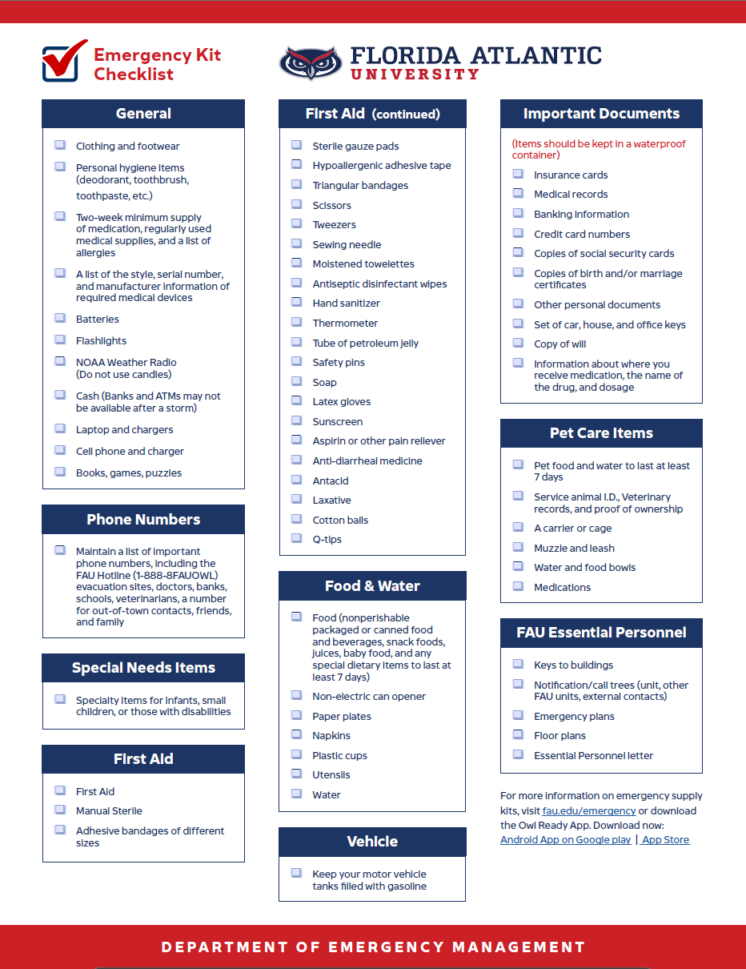

APPENDIX II: EMERGENCY PROCEDURES
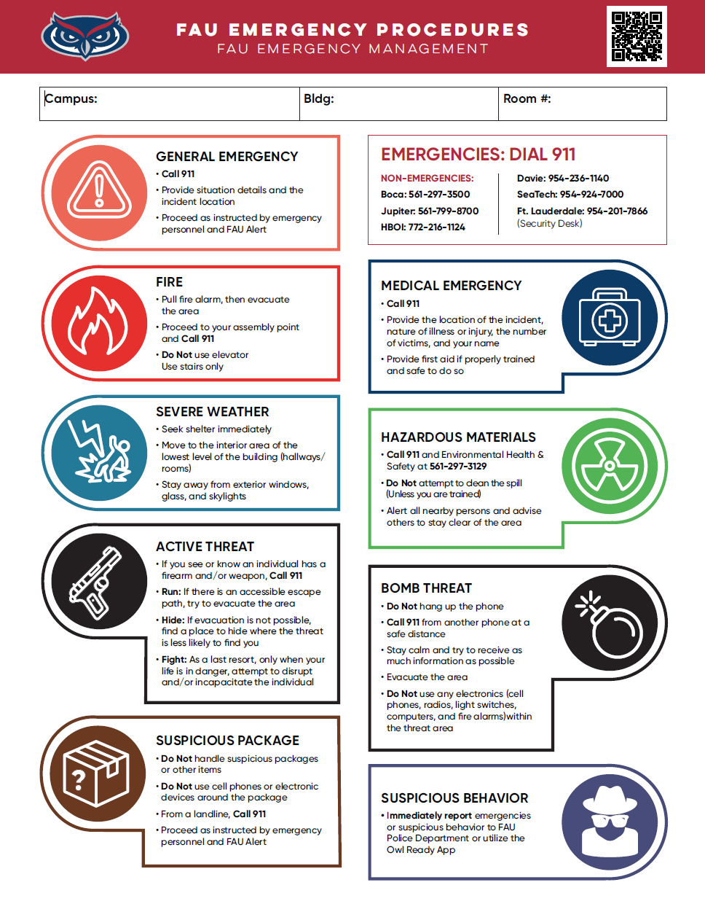

Appendix III: TROPICAL CYCLONE: WORKSPACE PREPARATION GUIDANCE
