Job Aid: Recording Labor Time During a Declared Disaster (FEMA)

**Please follow the steps below to accurately record and submit reimbursable labor-time during a declared disaster.
Step 1: Identify Which Category Your Work Falls Under
- Emergency Work - Addresses immediate threats to life, safety, or property.
  - Includes Activity Code 1 (Debris Removal) and Activity Codes 7-16 (Emergency Protective Measures).
- Permanent Work - Long-term repair or permanent restoration of damaged facilities, including hazard mitigation to reduce future risks
  - Includes Activity Codes 2-6.
- Category Z – Management Costs
  - Includes Activity Codes 17-22.
  - Covers administrative tasks associated with developing, managing, and administering FEMA Public Assistance projects.
Step 2: Complete Employee Identification Fields
- Enter Event Name (e.g., Hurricane Owlsley)
- Provide employees’ Full Name, Z-Number and Department
Example:
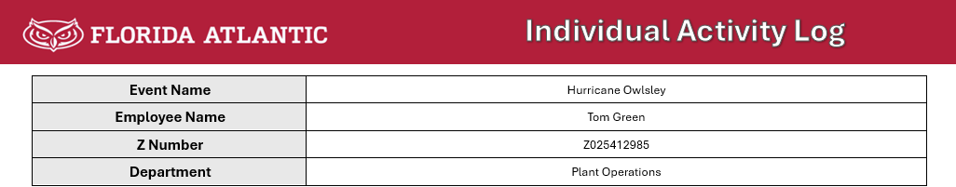

Step 3: Record the Details of the Work Performed
- Date – When the work took place
- Activity Code – Select the code that best matches the task performed (see back of activity log)
- Location - Specify the campus, building number, and room number if applicable
- Start and End Times – Record the actual time you performed the task
- Equipment Used – If applicable, work with your supervisor to reference FEMA Equipment Rate Guide to record:
  - Equipment Type and Description
  - FEMA Cost Code
  - Duration of Use
Examples:
Ted from Physical Plant is repairing a broken window related to the storm in Building 55 – Physical Science:
Thomas from FAU PD is securing the main entrance to campus so only authorized essential personnel can enter:
Step 4: Employees Submit Completed Activity Logs for Supervisor Review and Signature
Step 5: Supervisor Approval and Timekeeper Entry
- The supervisor reviews and signs the log
- The timekeeper then enters the approved activities into the employee’s time record, using a description that matches the activity code. (e.g., if the log shows Code 4, the time entry should read “Buildings & Equipment” for that day and time.)
Step 6: Submit to Risk Management – After time entry, the timekeeper scans and emails all signed activity logs to Risk Management to support the cost recovery process.

