

Emergency Operations Center (EOC) Non-Activation

Standard Operating Procedures

  - VERSION:
  - AUGUST 2026

Contents

Contents 2
Overview 4
1. Introduction 4
1.1. Purpose 4
1.2. Scope 4
1.3. Assumptions 4
Concept of Operations 5
1. General 5
1.1. Audio/Visual (A/V) Equipment 5
2. Reservations 6
3. Scheduling 6
4. Last-Minute Reservations 7
4.1. Cancellations 7
4.2. EOC Activations 7
Administration 8
1. EOC Oversight 8
2. Non-Compliance 8
Plan Development and Maintenance 9
Authority and References 10
Appendix I - EOC Layout and Room Guidelines 11
Appendix II – EOC Equipment Inventory 12

Overview

Introduction
The Emergency Operation Center (EOC) serves as the physical facility from which centralized, coordinated multi-unit support and resource procurement, as well as tactical incident management, occur. The Department of Emergency Management (DEM) is responsible for ensuring the EOC's operational readiness and for developing processes and procedures that reduce setup and activation time. This includes implementing procedures during non-activation use to streamline potential activation periods.

Purpose
This Standard Operating Procedure (SOP) establishes the use of the EOC during non-activation periods to maintain operational readiness, support the mission of Florida Atlantic University's Division of Administrative Affairs, and maximize the effective and innovative use of available resources.

Scope
This SOP supports the University’s Comprehensive Emergency Management Plan (CEMP). It outlines policies, procedures, and guidelines regarding the use of the EOC during periods of non-activation. The methods described in this SOP are utilized continuously during non-activation. The use of the EOC during activations is addressed in the CEMP's EOC Action Plan.

Assumptions
The following assumption provides the basis for this SOP and governs the use of the EOC during non-activation periods:
- The EOC may be activated at any time. If an activation occurs, all existing reservations will be immediately canceled or suspended to support emergency operations.

.

Concept of Operations

General
During non-activation periods, the EOC may be used to support the mission of the Division of Administrative Affairs by hosting meetings, trainings, and workshops.
The EOC consists of the following spaces:
- Room 110
- Room 117
- Room 118
The EOC may not be used for activities that could impact facility readiness, safety, or operational functionality, including but not limited to:
- High-liability training activities, such as defensive tactics, Rape Aggression Defense (RAD) training, cardiovascular conditioning, or similar physical activities.
- Lethal or non-lethal weapons training, certifications, demonstrations, or related activities.
- Storage, staging, cleaning, maintenance, or servicing of equipment.
- Non-University mission-related events.

Audio/Visual (A/V) Equipment
The primary purpose of the EOC audio/visual (A/V) systems and technology is to support emergency operations and EOC activation requirements. During non-activation periods, select A/V capabilities may be utilized to support approved University business functions; however, all equipment must remain configured to support emergency operations.
Individuals utilizing the EOC during non-activation periods are responsible for providing their own laptops or approved devices for presentations, displays, and other meeting functions. A/V equipment designated for emergency operations use only may not be accessed or utilized during non-activation periods. This includes, but is not limited to, the dedicated computer and television located in Room 118.
The EOC provides multiple options for visual display and connectivity based on room capabilities:
- EOC Rooms 110 and 117
  - USB-C (Recommended Option): Provides full functionality, including video, audio, camera, microphone, and device charging capabilities. This connection method is recommended for meetings, hybrid sessions, and events requiring full A/V functionality.
  - HDMI: Provides video display with limited audio capability and does not support camera, microphone, or device charging functions. This connection method is recommended for basic presentations.
  - Microsoft Cast (Wireless Display): Provides wireless video display capability for quick screen sharing. This connection method does not support audio, camera, microphone, or device charging functions.

- EOC Room 118
  - Crestron Projection System: Room 118 utilizes the Crestron control panel to support projection and display capabilities. Users should use the available connection options and verify compatibility before their scheduled reservation.
A/V equipment and technology configurations must not be modified, disconnected, or removed from the EOC. Any issues with A/V equipment functionality should be reported to DEM.

Reservations
Individuals requesting to reserve the EOC are responsible for the use of the space during the approved reservation period and for ensuring that all participants comply with established EOC rules, procedures, and usage expectations.
Food is prohibited in the EOC during non-activation periods unless DEM provides prior approval.
At the conclusion of each reservation, the responsible individual must ensure the EOC is returned to a clean, organized, and operational-ready condition.
This includes, but is not limited to:
- Ensuring the room is returned to its standard layout, with all trash and equipment brought into the room removed (see Appendix I for EOC layout).
- All non-A/V equipment (tables, chairs, glass boards, etc.) is clean
- All A/V equipment turned off
- Immediate hallways to the EOC are free and clear
The Responsible Department, through the Responsible Individual, is accountable for all outcomes associated with the use of the EOC. This includes, but is not limited to, financial impacts resulting from excessive cleaning beyond normal use, repair costs for damage, and replacement costs for furniture, equipment, technology, or other facility resources.
Individuals requesting to reserve the EOC must review the EOC Non-Activation Usage Guide prior to submitting a reservation request. The EOC Non-Activation Usage website provides access to applicable policies, procedures, usage expectations, and the EOC scheduling system.

Scheduling
Individuals requesting to reserve the EOC must complete the EOC Non-Activation Reservation Request Form, which is available through the EOC Non-Activation Reservation Dashboard. The dashboard enables users to submit reservation requests, view current and upcoming reservations in a calendar view, and access applicable policies, procedures, and guidelines related to EOC non-activation usage.

Once a reservation request is submitted, the requesting individual will receive an email notification confirming that the request has been forwarded to DEM for review.
Upon approval, the requesting individual will receive a confirmation email indicating that the reservation has been approved. Use of the EOC without prior confirmation from DEM will be considered non-compliant with established procedures and may result in applicable non-compliance actions. Refer to the Non-Compliance section of this SOP for additional information.

Last-Minute Reservations
DEM acknowledges that units may need to utilize the spaces on an impromptu or ad hoc basis. Approvals for ad hoc or “last-minute” reservations are on a case-by-case basis and are subject to DEM’s approval. Ad hoc reservations should not serve as the primary method for reserving the spaces outlined in this SOP. Individuals who use this method as their primary means of reserving spaces will be considered “non-compliant” and subject to non-compliance penalties. Please visit the Non-Compliance section of this SOP for more details.
Individuals requesting a “last-minute” reservation must communicate the request to DEM as soon as possible and must adhere to the following process:
- Verify space availability
- Visit the EOC Non-Activation Reservation Dashboard
- Complete the EOC Non-Activation Reservation Request Form
- Email em@fau.edu and copy FAUEOCReservation@room.veoci.com with the details of the request found on the EOC Non-Activation Reservation Request Form
- In the most urgent of circumstances, individuals may reach out to DEM’s Staff Duty Officer.
If approved, DEM will confirm authorization for use of the EOC through email notification. Requests for “last-minute” reservations are subject to space availability and the EOC's operational needs. If the requested space is unavailable, the reservation request will be denied.
DEM will not cancel, modify, or relocate previously approved reservations to accommodate last-minute reservation requests. Use of the EOC without prior confirmation from DEM will be considered non-compliant with established procedures and may result in applicable non-compliance actions. Refer to the Non-Compliance section of this SOP for additional information.

Cancellations
All reservation cancellations or requested changes must be submitted immediately via email to FAUEOCReservation@room.veoci.com.

EOC Activations
DEM recognizes that EOC activation may occur at any time. Upon activation, all existing non-activation reservations for the duration of the activation will be canceled, and all non-activation use of the EOC will be suspended to support emergency operations.

Administration

EOC Oversight
Administrative oversight of the EOC is assigned to DEM. DEM is responsible for ensuring the integration of facilities, equipment, personnel, and procedures necessary to maintain a functional, effective, and efficient EOC.
Individuals assigned responsibilities related to EOC operations, including support during activations and coordination of non-activation usage, are collectively referred to as EOC Admin. EOC Admin may include representatives from DEM, Administrative Affairs, and other units supporting operations within the Campus Operations building.

Non-Compliance
All associated rules, policies, and procedures governing the use of the EOC during non-activation are intended to safeguard EOC readiness for activation and operational use. Failure to adhere to the established rules, policies, and procedures may result in, but is not limited to, the following for a Responsible Person or Responsible Department:
- Revocation of approved use
- Denial of a subsequent application for reservations and future use
- Fiscal responsibility needed for clean-up, repairs, and/or replacement costs
- Memorandum to immediate supervisor, Director, and/or Executive Vice President

Plan Development and Maintenance
DEM facilitated the development of this SOP.
Revisions to this SOP will occur on an “as-needed” basis following actual events, exercises, revisions, or additions to applicable governing laws, regulations, policies, or procedures, as well as through periodic review of the SOP every three years by DEM. The review process will ensure the SOP remains current, operationally relevant, and aligned with the University’s emergency management objectives and practices.

Authority and References
Florida Atlantic University’s policy – Department of Emergency Management Policy 3 (Use of EOC During Non-Activation Periods) establishes the authority for the development and implementation of this plan.
The following laws, standards, and regulations were used to provide the requirements, other authorities, and guidance to develop this plan and its format:
- Federal
  - Public Law
    - U.S. Public Law 110-315, Higher Education Opportunity Act (HEOA) and Code of Federal Regulations (34CFR)
  - Documents
    - Federal Emergency Management Agency (FEMA) Comprehensive Preparedness Guide (CPG) 101, May 2025, Version 3.1, Developing and Maintaining Emergency Operations Plans
- University
  - University Policy 3.4.1 – Emergency Management
  - Department of Emergency Management
    - Policy #3 - Use of EOC During Non-Activation Periods

Appendix I - EOC Layout and Room Guidelines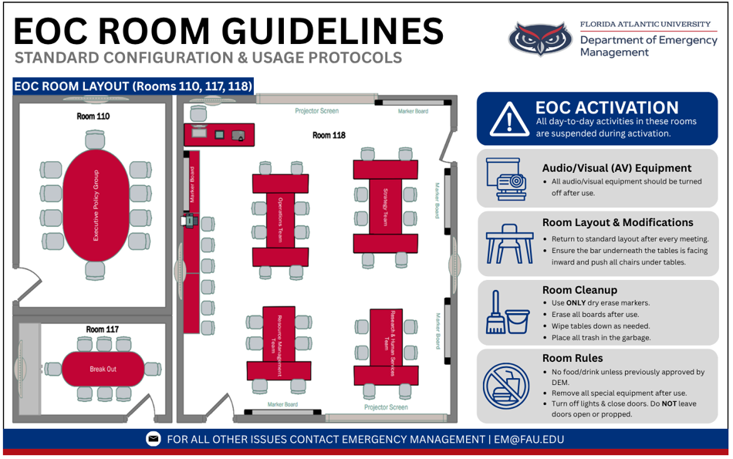

Appendix II – EOC Equipment Inventory
EOC – Room 118
Item Description | Quantity
Mounted LG TV with Remote | 1
Creston Unit | 1
Lecture Podium | 1
Desktop Monitor | 1
Mounted Sharp TV | 2
Epson Projector Screen | 2
Brothers Laser Printer | 1
Mounted Camera | 2
Mounted Glass White Board | 4
EOT Table Rolling Chair | 38
Podium Black Rolling Chair | 1
Rolling Table | 21
Wall Clock | 1

EOC – Room 117
Item Description | Quantity
Mounted Sharp TV with Remote | 1
Mounted Sennheiser TV Bar | 1
Sennheiser TV Bar Remote with Holder | 1
Tabletop Microphone | 1
Oval Conference Table | 1
Executive Black Chair | 8
Mounted Whiteboard | 2
Wall Clock | 1

EOC – Room 110
Item Description | Quantity
Mounted LG TV with Remote | 1
Mounted Sennheiser TV Bar | 1
Sennheiser TV Bar Remote with Holder | 1
Tabletop Microphone | 2
Oval Conference Table | 1
Executive Black Chair | 13
Mounted Whiteboard | 2
Tabletop Whiteboard | 1
Wall Clock | 1

