Skillsoft Instructions:

1. Access the FAU Skillsoft Training site at: https//floridaatlantic.skillport.com
2. Login with your FAU ID and Password
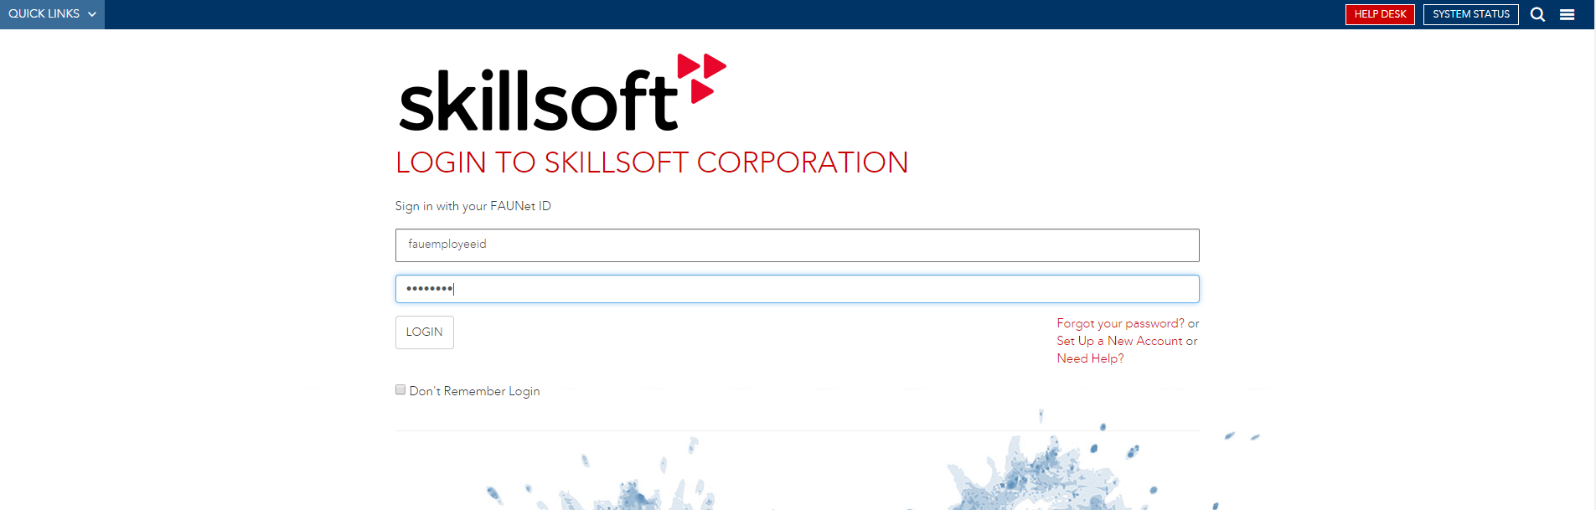
3. On the landing page, you have several choices
3.a. You can click on the search box and search the content of the entire EHS training catalog
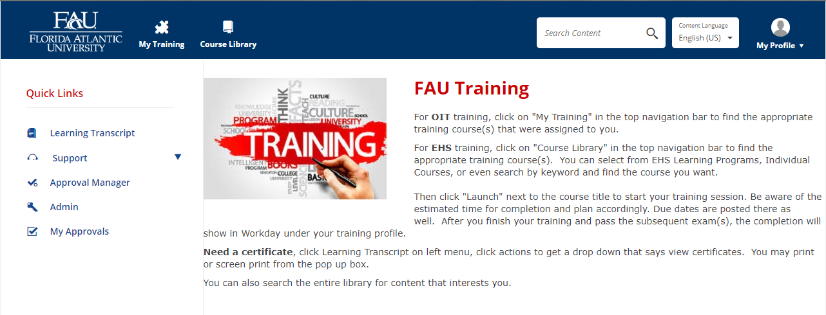
3.b. You can click on the Course Library and Find a Course …

Course Library Page in Skillsoft
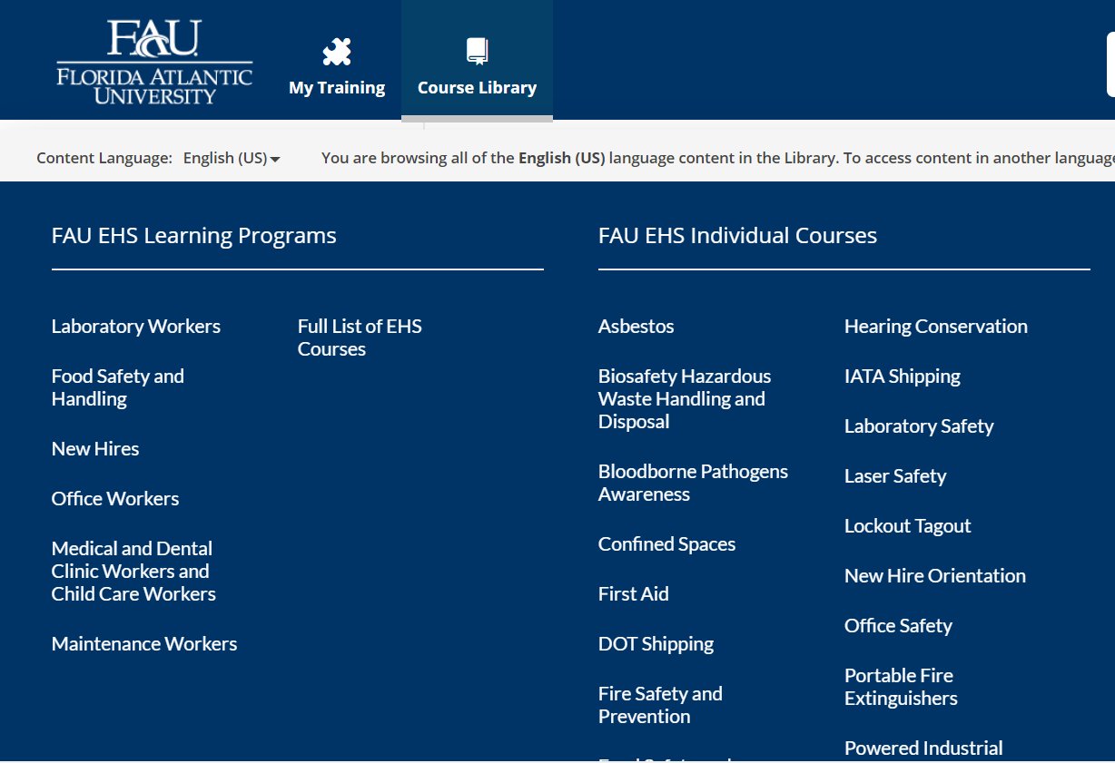
3.c. You can click on Learning Transcript to view your current, previous, and scheduled training.
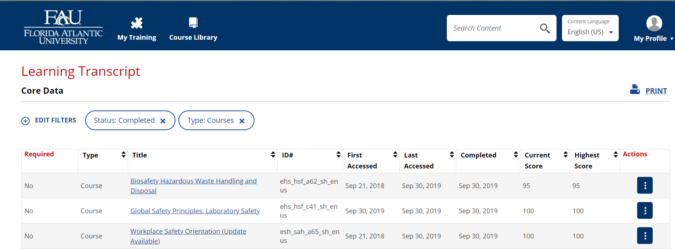

4. To print a certificate, click on Learning Transcript then click the three dots to the right of the course you want, select “View Certificate” and print.
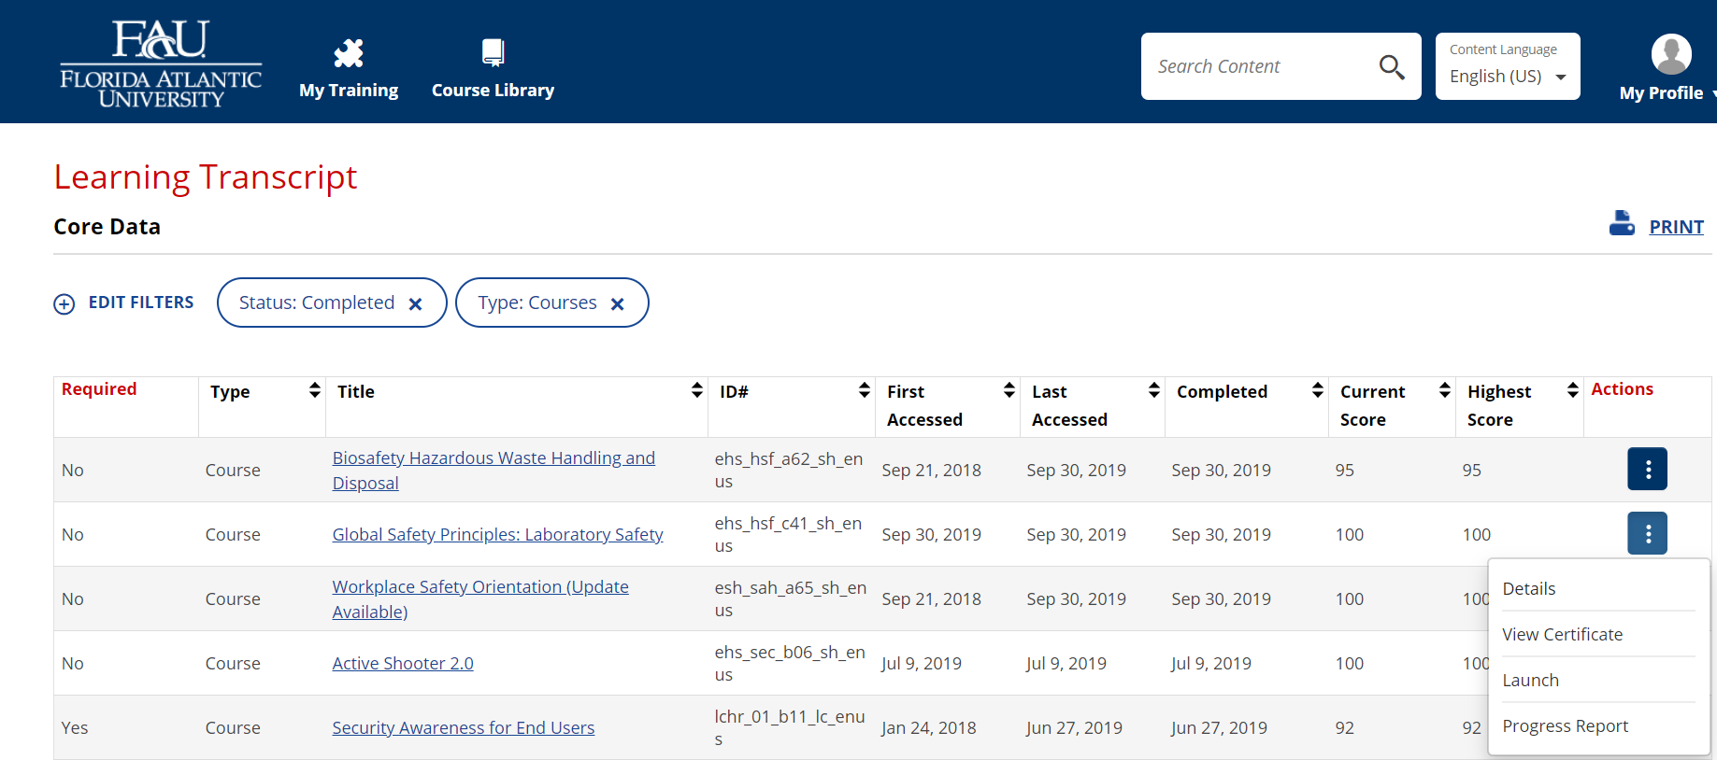

If you have any questions, please contact EHS at 561-297-3129 or ehs@fau.edu

