

2018

ANNUAL FIRE SAFETY REPORT FOR RESIDENCE HALLS

As Required by the
Higher Education Opportunity Act (HEOA)

INTRODUCTION

This public disclosure is intended to inform current and prospective students, parents, and employees about the fire safety programs and policies in place at FAU, and the institution’s state of readiness to detect and respond appropriately to fire related emergencies.
This report can be viewed on line at http://www.fau.edu/facilities/ehs/info/2017%20Fire%20Safety%20Report.pdf
Hard copies of the report are available for public viewing by calling 561-297-3129 or by visiting the Department of Environmental Health and Safety located in room 112 of the Campus Operations Building, CO-69. The EH&S Department is open from Monday to Friday, from 8 AM to 5 PM. Thank you for taking time to read the 2018 annual fire safety report. This report is also available at: http://www.fau.edu/police/clery.php.
Elements of the campus fire safety program which are administered and maintained by the Department of Environmental Health and Safety (EH&S) consist of: fire prevention policies and practices, emergency preparedness and evacuation, fire safety education and training initiatives, and descriptions of fire protection systems. Documents in the following websites are referenced in the report:
- www.fau.edu/facilities/EH&S/safety/fire-safety-program.php
- www.fau.edu/housing

The law requires each eligible institution participating in any program under this title that maintains on-campus student housing facilities shall on an annual basis, publish a fire safety report, which shall contain information with respect to the campus fire safety practices and standards of the institution including:
- Statistics concerning the following in each on-campus student housing facility during the three most recent calendar years for which data is available:
- The number of fires and cause of each fire
- The number of injuries related to a fire that result in treatment at a medical facility
- The number of deaths related to a fire and
- A description of each on-campus student housing facility fire safety system, including the fire sprinkler system:
- The number of regular mandatory supervised fire drills:
- Policies or rules on portable electrical appliances, smoking and open flames (such as candles), procedures for evacuation, and policies regarding fire safety education and training programs provided to students, faculty and staff: and
- Plans for future improvements in fire safety, if determined necessary by the institution.

FAU FIRE SAFETY PROGRAM OBJECTIVES
Florida Atlantic University (FAU) is committed to protecting the health and safety of the FAU community (i.e. faculty, staff, students, deans, directors, department heads, contractors and guests) as well as the environment. This is achieved through interdisciplinary collaboration and shared faculty governance to ensure appropriate compliance with applicable fire safety statutory requirements which is a shared responsibility amongst the FAU Community. Therefore, it is essential that members of the FAU community take an active role in this shared vision by initiating appropriate measures to ensure compliance and promote fire prevention associated with activities/operations under their direction. The primary objective of the campus fire safety program is to prevent fire and take appropriate actions before such conditions result in a fire emergency. Such measures are accomplished by:
- Conducting periodic reviews and updates of fire prevention policies.
- Conducting regularly scheduled fire drills.
- Promoting fire prevention and emergency evacuation procedures.
- Inspecting, testing and maintaining fire protection systems in accordance with National Fire Protection Association (NFPA) standards and Florida Fire Prevention Code.
- Performing plan reviews and code consultation related to capital improvement and remodeling projects and ensure buildings especially residence halls are fully protected.
- Mitigating fire hazards utilizing the information provided from regularly scheduled fire safety inspections performed by the Office of the State Fire Marshal, EH&S as well by the department of Housing and Residential Life and other fire protection consultants.
FIRE PROTECTION EQUIPMENT AND SYSTEMS
Specially designed systems are provided in all Residence Halls to assist in extinguishing fires, and to limit the spread of fire and smoke, either by automatic, semi-automatic or manual means. These include, but are not limited to, portable fire extinguishers; fire hoses, fire pumps, wet and dry stand pipe systems, automatic sprinklers, other specially engineered suppression systems, fire detection and alarm systems, fire doors and dampers. Other life safety systems like exit and emergency lights with back-up emergency power are integral parts of our residence hall fire
protection systems. Fire protection and life safety equipment are installed, inspected, tested and maintained in accordance with NFPA Codes and as required by the local AHJ. All residence halls are fully protected both with automatic sprinkler and supervised fire alarm system with sprinkler heads and smoke detectors in each student sleeping rooms.

DEFINITIONS

Cause of Fire: The circumstances, conditions or agencies that bring together a fuel, ignition source, and oxidizer (such as air or oxygen) resulting in a fire or combustion explosion.

Fire: Combustion or burning, in which substances combine chemically with oxygen from the air and typically give out bright light, heat, and smoke.

Fire drill: A practice of the emergency procedures to be used in case of fire.

Fire-related injury: Burns, smoke inhalation, or any other injury resulting from a fire.

Fire-related death: A fatality linked directly or indirectly with injuries sustained as a result of a fire.

Fire-safety system: A variety of systems and devices (fire alarm, fire sprinklers, fire extinguishers, etc.) installed in a building to detect fire and smoke, generate audible and visual alarms, and deliver water or other suppression agents to avoid or minimize harm to occupants and property.

Value of property damage: The total costs (labor, materials, taxes, etc.) necessary to bring the damaged property back to a pre-fire condition.

DESCRIPTION OF FIRE PROTECTION FEATURES AND ON-CAMPUS STUDENT HOUSING FACILITIES

Boca Raton Campus
Algonquin Hall 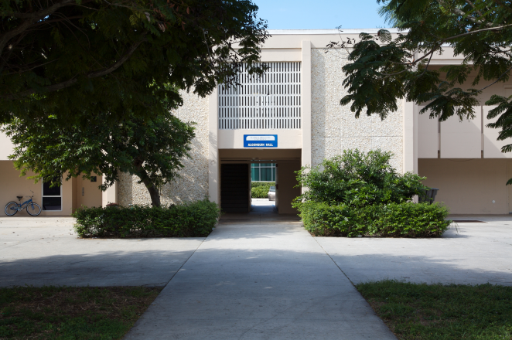
Algonquin Hall is the oldest residence hall on the FAU Boca campus. It was built in 1965 and renovated in 2007 to rejuvenate living accommodations and improve safety and security. The building is two stories high, with 43,398 sq. ft. There are 95 rooms with 95 students residing in the facility.
In Algonquin Hall a microwave-refrigerator unit is provided for every two resident. This microwave-refrigerator unit is a specially constructed unit that contains a separate refrigerator, freezer and a microwave; the wiring of the unit has been pre-approved. The building is fully sprinkled by an automatic and supervised sprinkler system with sprinkler heads installed in each sleeping room. It is also equipped with automatic fire detection and alarm systems which are monitored 24 hours by the university police department. Smoke detectors are also installed in each bedroom including the common areas. An emergency generator provides back up power to all the life safety systems installed in the building including emergency and exit lights, etc.
Business & Professional Woman’s Scholarship House (BPW)
BPW Scholarship House was established to provide campus housing for women with strong academic promise on the FAU Boca campus. It was built in 1996. The building is single story, with 4,344 sq. ft. There are 9 rooms with 17 students residing in the BPW Scholarship House. The building is fully sprinkled by automatic and supervised sprinkler systems with sprinkler heads in each room and the common areas. Automatic fire detection and alarm system with smoke detectors in all the sleeping rooms and other areas are also installed in the facility. The fire alarm system is monitored 24 hours by university police. A common kitchen facility is provided which is protected by an approved suppression system. An emergency generator provides back up power to all life safety systems including emergency and exit lights.
Glades Park Towers 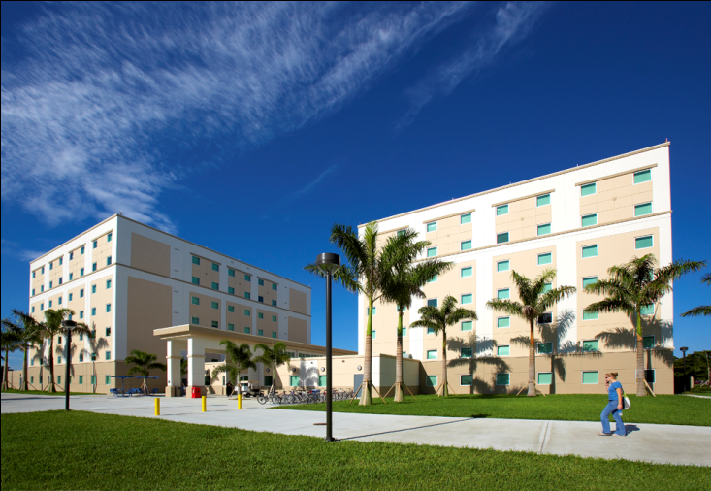
Glades Park Towers are some of the newest residence facilities at the FAU Boca campus. They were built in 2007, seven stories with two towers, one on the north and south side and a common in between them. The building covers 151,727 sq. ft. There are 169 rooms with 602 students. They are provided with an extra-long bed, desk, chair, chest of drawers and a cabinet. Rooms are not carpeted. Students can bring a small refrigerator 3.6 cubic feet or smaller with a maximum of 400 watts and/or microwave of 1.5 cubic feet capacity and with a maximum of 1100 watts.
The facility is equipped with an automatic fire detection and alarm system monitored 24 hours by university police with smoke detectors in each room and common areas. It is also fully protected by an approved and supervised automatic sprinkler system. Sprinkler heads are installed in each bed room. An indoor mass notification system was recently installed in the building. An emergency generator provides back up power to all life safety systems including emergency and exit lights.
Heritage Park Towers (HPT) 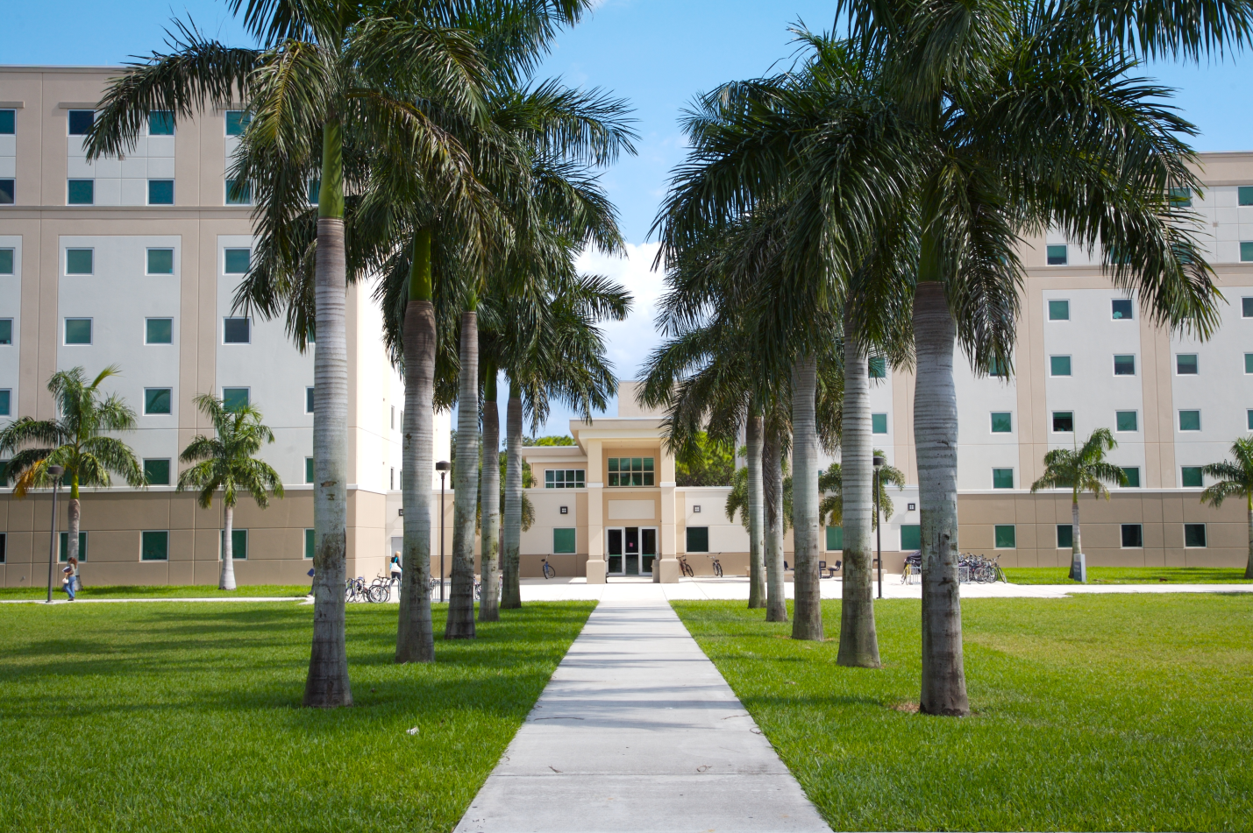
Heritage Park Towers is another residence facility on the FAU Boca campus. HPT was built in 2004. The building design has two towers and a common place that joins the two towers and covers an area of 151,727 sq. ft. There are 169 rooms with 603 students.
Students are provided with an extra-long bed, a desk and chair, cabinet as well as chest drawers. They are allowed to bring a small refrigerator not larger than 3.6 cubic feet, 400 watts; and/or microwave of 1.5 cubic feet with a maximum of 1100 watts.
The building is fully protected by a supervised automatic sprinkler system with sprinkler heads installed in all student rooms and other commons areas. Automatic fire detection and alarm systems with smoke detectors in all the rooms, monitored 24 hours by university police are also installed to protect occupants. An indoor mass notification system has also been recently installed in the building. Other life safety systems include an emergency generator which provides backup power to emergency lights, and exit signs.
Indian River Towers (IRT) 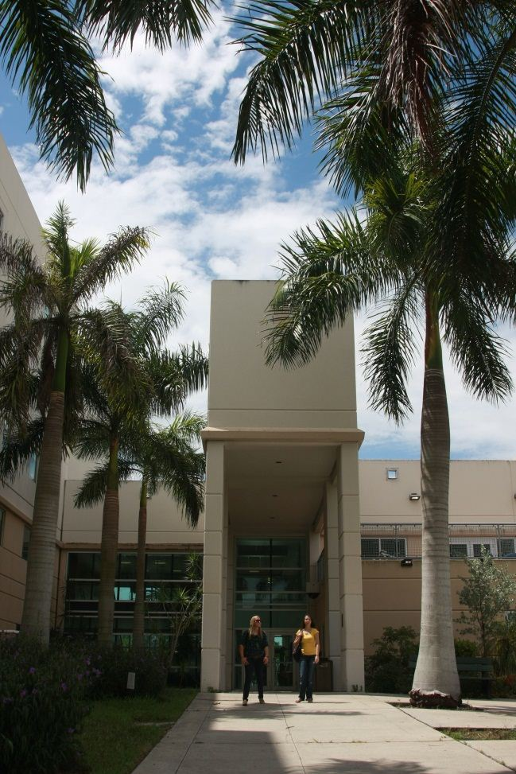
Indian River Towers was built in 2001. It is five stories tall with two towers. One on the east and one on the west side with a common area that joins the towers. It covers an area of 202,944 sq. ft. There are 472 rooms with 611 students.
Students are provided with an extra-long bed, a desk and chair as well as chest drawers. Students are allowed to bring a small refrigerator not larger than 3.6 cubic feet, 400 watts; and/or microwave of 1.5 cubic feet with a maximum of 1100 watts.
The building is fully protected by a supervised automatic sprinkler system with sprinkler heads installed in all student rooms and other commons areas. Automatic fire detection and alarm systems with smoke detectors in all the rooms, monitored 24 hours by university police are also installed to protect occupants. An emergency generator provides backup power to emergency lights, and exit signs.
University Village Apartments (UVA) 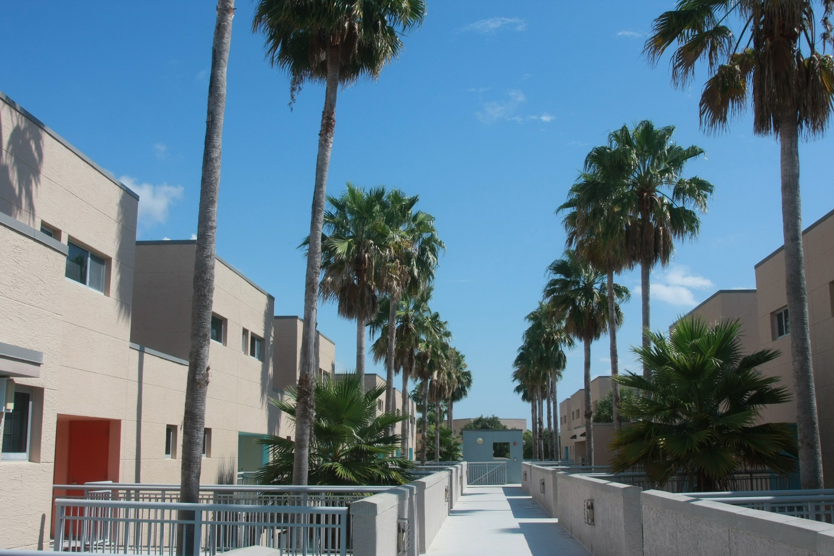
University Village Apartments are apartment style residences at FAU Boca campus. They were built in 1995.The units have studio style and four bedrooms apartments. There are a total of 14 units. The buildings cover a total of 127,297 sq. ft. This apartment community accommodates 434 rooms with 524 students.
Each student is provided with an extra-long bed, dresser, a desk and a chair and cloth cabinet. In addition a full size refrigerator, range stove and kitchen sink are also provided for each apartment. Student rooms are carpeted.
The building is fully protected by a supervised automatic sprinkler system with sprinkler heads installed in all student rooms and other commons areas. Automatic fire detection and alarm systems with smoke detectors in all the rooms, monitored 24 hours by university police are also installed to protect occupants. Other life safety systems include emergency lights, and exit signs.
Innovation Village Apartments (IVA)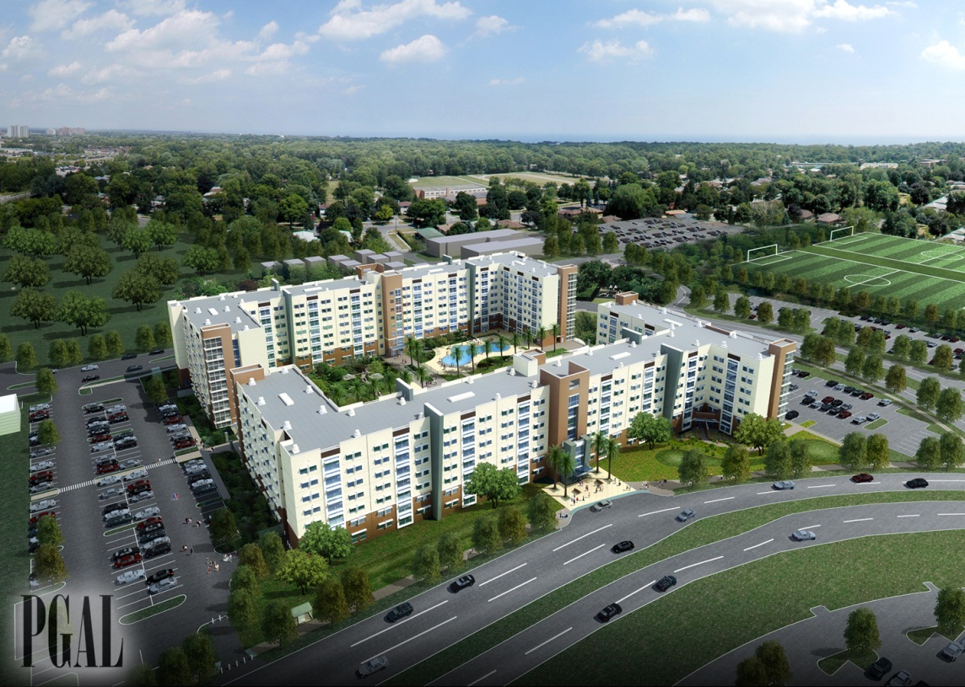
Innovation Village Apartments North and South were completed in 2011.

Innovation Village Apartments North
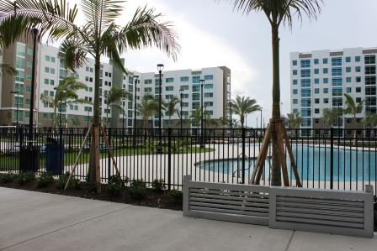
Innovation Village Apartments North is an 8-story, high-rise building with single room apartments, living rooms, study rooms and bathrooms spaces. There are a total of 611 beds in the Innovation Village Apartments North building. Each student is provided with a full size bed, dresser, desk and desk chair. In addition a full size refrigerator, stove, dishwasher, microwave and kitchen sink are also provided for each apartment. Each apartment is furnished with a sofa, chair, TV stand, coffee table and kitchen table and chairs as well as being equipped with a washer, dryer and laundry room.
The building is fully protected by a supervised automatic sprinkler system with sprinkler heads installed in all the student rooms and other commons areas and by automatic fire alarm systems with smoke detectors installed in all the rooms. The alarm system is monitored 24 hours by a Proprietary Monitoring Station. Other life safety systems include protected stairways, emergency lights, emergency generator and exit signs.

Innovation Village Apartments South 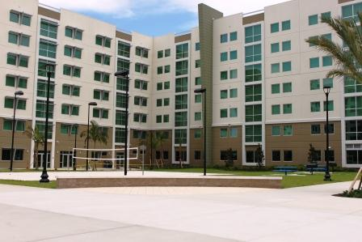
Innovation Village Apartments South is a 7-story, high-rise building. There are a total of 605 beds all singles with kitchen area within each apartment. Furnishings are the same as in the Innovation Village Apartments North. There is also a common laundry room in the building.
The building is fully protected by a supervised automatic sprinkler system with sprinkler heads installed in all student rooms and other commons areas and also by automatic fire alarm systems with smoke detectors installed in all the rooms. The alarm system is monitored 24 hours by a Proprietary Monitoring Station. Other life safety systems include emergency lights, an emergency generator and exit signs.

Parliament Hall


Parliament Hall (PAR), completed and occupied in Fall, 2013, is a suite style seven story residence hall consisting 614 beds of both double and single rooms for freshmen. It offers 24 hour front desk operation, community kitchen, classrooms, library, computer labs, fitness room, multipurpose room, laundry facilities and two story student lounges. Enhancing the student experience, PAR has an attached retail dining facility with commercial kitchens.
The building is fully protected with fire sprinkler heads and smoke detectors in each student sleeping rooms. The alarm system is monitored 24/7 by FAU police. Other life safety systems that exist in the building include emergency and exit lights backed by emergency generator power.

Jupiter Campus
MacArthur Residence Hall I 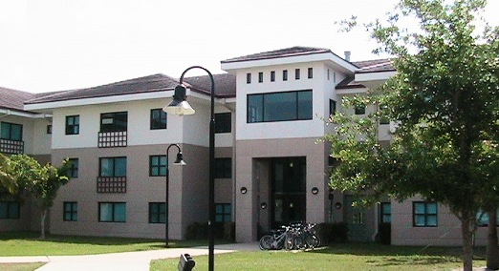
MacArthur Residence Hall I was the first residence hall that was built at the FAU Jupiter campus. The building was built in 1999 and is three stories tall with 45,682 sq. ft. There are 34 suites which can accommodate 141 students. Each occupied suite consists of four single bedrooms, a living room and a split bathroom.
Each student is provided with an extra-long bed, dresser, a desk and a chair. Each living room is furnished with a sofa, arm chair, coffee table and television stand. Student rooms are carpeted.
The building is fully protected by a supervised automatic sprinkler system with sprinkler heads installed in all student rooms and other commons areas. There is an automatic fire alarm system with smoke detectors in all the rooms, which is monitored 24 hours by Simplex Grinnell Central Monitoring Station. Other life safety systems include emergency lights, and exit signs as well as an emergency generator.
MacArthur Residence Hall II
MacArthur Residence Hall II is the second residence hall at the FAU Jupiter campus. The building was built in 2001 and is three stories tall with 45,682 sq. ft. There are 35 suites and can accommodate 146 students. Each occupied suite consists of four single bedrooms, a living room and a split bathroom.
Each student is provided with an extra-long bed, dresser, a desk and a chair. Each living room is furnished with sofa, arm chair, coffee table, and television stand. Student rooms are carpeted.
The building is fully protected by a supervised automatic sprinkler system with sprinkler heads installed in all student rooms and other commons areas. Automatic fire alarm systems with smoke detectors are installed in all rooms. The alarm system is monitored 24 hours by Simplex Grinnell Central Monitoring Station. Other life safety systems include an emergency generator, emergency lights, and exit signs.

Harbor Branch Campus
Harbor Branch Dorms and Apartments
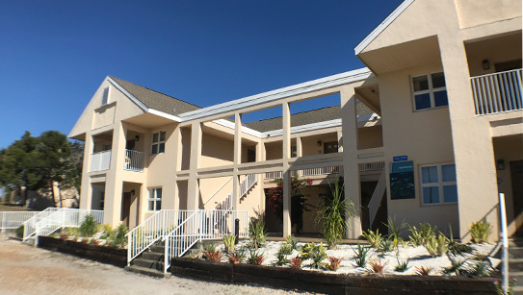

FAU Harbor Branch has limited on-site availability for housing. Space is typically used for student groups and may be used for other students, collaborators, and visitors affiliated with FAU.
Each dorm is fully furnished and include living room, dining area, bathroom, kitchen and bedrooms. Bedrooms and Bathrooms are stocked with bed sheets, blankets, pillows, pillow cases and towels. Kitchens have dishes, pots, pans, cooking utensils, microwave, stove and refrigerator.
The building is fully protected by a supervised automatic sprinkler system with sprinkler heads installed in all student rooms and other commons areas. There is an automatic fire alarm system with smoke detectors in all the rooms, which is monitored 24 hours by Simplex Grinnell Central Monitoring Station. Other life safety systems include emergency lights, and exit signs.

Fire Safety Systems in On-Campus Student Housing Facilities:
Florida Atlantic University provides the following on-campus student housing facilities at:
Boca Raton campus: Algonquin Residence Hall, Business & Professional Woman’s Scholarship House, Glades Park Towers, Heritage Park Towers, Indian River Towers, University Village Student Apartment, Innovation Village Apt. North, Innovation Village Apt. South and Parliament Hall.
MacArthur Campus in Jupiter: MacArthur Residence Hall I and MacArthur Residence Hall II.
Harbor Branch Oceanographic Institute campus: provides resident halls for visiting educators, staff, students, faculty and guests. Participants may reside in any one of the two available residential facilities for up to 5 days/4 nights.
The following tables provide a brief summary of the fire safety systems contained in each on-campus student housing facility.

FIRE SAFETY SYSTEMS IN RESIDENTIAL FACILITIES
FAU Campus | FAU STUDENT HOUSING FACILITY | FIRE ALARM MONITORING ON SITE | FIRE ALARM MONITORING OFF SITE | FULLY SPRINKLED | SMOKE DETECTOR | FIRE EXTINGUISHER DEVICE | POSTED EVACUATION PLANS & PLACARDS | NUMBER FIRE DRILLS EACH ACADEMIC YR
Boca Raton Campus | Algonquin Residence Hall | X | No | X | X | X | X | 4
Boca Raton Campus | BPW Scholarship House | X | No | X | X | X | X | 4
Boca Raton Campus | Glades Park Towers | X | No | X | X | X | X | 4
Boca Raton Campus | Heritage Park Towers | X | No | X | X | X | X | 4
Boca Raton Campus | Indian River Towers | X | No | X | X | X | X | 4
Boca Raton Campus | University Village Student Apartment | X | No | X | X | X | X | 4
Boca Raton Campus | Innovation Village Apt North | X | No | X | X | X | X | 4
Boca Raton Campus | Innovation Village Apt South | X | No | X | X | X | X | 4
Boca Raton Campus | Parliament Hall | X | No | X | X | X | X | 4
MacArthur Campus | MacArthur Residence Hall 1 | No | X | X | X | X | X | 4
MacArthur Campus | MacArthur Residence Hall 2 | No | X | X | X | X | X | 4
HBOI  Campus | Dorms | No | X | X | X | X | X | 4
HBOI  Campus | Apartments | No | X | X | X | X | X | 4

Notes:
1.MacArthur campus fire alarm panels are monitored by Simplex Grinnell.
2. HBOI campus fire alarm panels are monitored by Simplex Grinnell.

INSPECTION, TESTING, AND MAINTENANCE OF FIRE SAFETY SYSTEMS:
The Fire Safety Officer with the Department of Environmental Health and Safety administers the inspection, testing and maintenance of the campus fire suppression system program (e.g. sprinkler systems, standpipe systems, fire pumps, fire extinguishers, and special hazard fire suppression systems) in accordance with applicable National Fire Protection Association (NFPA) Standards. Licensed and/or qualified fire protection contractors inspect, test, and maintain fire suppression systems in on-campus student housing facilities at Boca Raton, Jupiter and Harbor Branch Oceanographic Institute campuses. Simplex Grinnell provides these services at the Boca Raton, MacArthur and Harbor Branch Oceanographic Institute.
The Fire Safety Officer with the Department of Environmental Health and Safety administers all aspects of the campus fire alarm program in accordance with applicable NFPA standards. Trained and qualified technicians service, install, inspect, test and maintain fire alarm systems in on-campus student housing facilities at the Boca Raton, MacArthur and Harbor Branch campuses. Simplex Grinnell provides these services at the Boca Raton, MacArthur and Harbor Branch Oceanographic Institute.
FIRE PREVENTION POLICIES AND PROCEDURES:
Several fire prevention policies and procedures have been developed and implemented. Applicable NFPA, Occupational Safety and Health Administration (OSHA), Florida Fire prevention Code, FAU Fire Safety Program, FAU safety policies and procedures as well as Housing and Residential Life Regulations and the FAU Crisis Action Guide were referenced during the development of these policies. The on-campus student housing management (Housing and Residential Life) and University Police periodically review these policies and guidelines and revise them as necessary to fit the needs of the operations therein. A summary of these policies are highlighted below:

Policy on Holiday Decorations
- All decorations and ornaments must be of fire-resistant or non-combustible material, and listed by Underwriters Laboratory (UL) and approved for use.
- The use of live or cut Christmas trees is prohibited in university buildings.
- Artificial trees made of fire retardant materials or non-combustible materials labeled with UL or Factory Mutual (FM) approval ratings are allowed. No natural trees, wreathes, boughs or other decorations constructed from the branches of natural trees may be used. Metallic trees may create electrical hazards when placed in close proximity to the electric supply; therefore the use of electric lights on metallic trees is prohibited.
- Trees and other decorations must be located so as not to obstruct exit corridors or the operation of fire protection equipment. Trees should also not be placed in any manner that could present a fall or trip hazard, impede egress, or block emergency egress from any room.
- Electrical cords should not be routed through or under doors, rugs or loose carpeting or across work surfaces. Routing of cords through these areas may cause damage to the cord and create a fire or trip hazard.
- Plugging lights into an overloaded circuit is not permitted. Multiple adaptors are prohibited. Instead, use power strips with a fuse or integral circuit breaker when extra outlets are needed.
- Decorative displays are prohibited in stairwells and should be limited in lobbies and common areas in the residence halls.
- All holiday decorations should be removed before leaving campus for the holiday and at the end of each semester.
- No candles, incense burners, potpourri pots, or scented oil warmers may be used.

Policies On Electrical Equipment and Appliances:
Prohibited fire or life safety hazards include but are not limited to the following:
- Rice cookers
- Hamburger cookers
- Frying skillets
- 110 volts extension cords
- 110 volts extension cords wrapped in duct tape
- Piggy-backed power strips or extension cords
- Duct tape wrapped around electrical plugs
- Electrical outlet with no cover plates
- Multi-plug adaptors
- Electrical floor lamps that require a bulb over 120 volts
- Any halogen lamp that requires a bulb over 120 volts
- Space heaters
- The use or storage of flammable fluid, hazardous liquids or chemicals.

Policy on Tampering:

- Tampering with or damaging fire safety equipment including automatic door closures, smoke detectors, pull stations, fire extinguishers, sprinkler heads, initiating false alarms, silencing active fire alarms, or failing to immediately evacuate during a fire alarm are violation of state fire codes, and will result in disciplinary action and are punishable under state law.

OPEN FLAME SAFETY
The use of open flame devices can substantially increase the risk of a fire resulting in serious consequences when not used appropriately. Therefore, open flame devices are strictly prohibited in on-campus student housing facilities. Examples of open flame devices include, but are not limited to: candles, incense burners, potpourri pots, scented oil warmers, tiki torches, sterno pots, Bunsen burners, fireworks, or any other portable flame-producing device. Candles can be displayed in Menorahs and other religious articles but may not be used and should remain unlit with the wicks removed. Battery operated candles listed by UL or FM serve as an acceptable substitute.
- Possession of candles, open flames, incense, hot plates and heating units with open flame or heating element are prohibited.
Open flames devices discovered during regularly scheduled fire safety inspections performed by on-campus student housing staff will be immediately confiscated and residents may be subject to disciplinary action in accordance with the Student Code of Conduct Policy.

POLICY ON ELECTRICAL SAFETY
Due to the current residential room electrical configuration, a maximum of eight (8) amps should be used per electrical outlet in a student room.

Extension cords:

Electrical cords are acceptable means of providing TEMPORARY power. However they cannot be used as a substitute for permanent electrical wiring. They can be used provided they are:

- Used temporarily and unplugged when not in use
- Used to power non-heat producing devices
- UL approved and Factory Mutual listed and three-wire grounded.
- Not connected, spliced together, or piggy-backed
- Plugged into a permanent outlet

Extension cords will not be permitted:

- When used as permanent wiring
- When used on heat producing or high voltage devices such as heaters, microwave ovens, refrigerators etc.
- If they become a tripping hazard
- When routed through openings in walls, ceilings, doorways or under flooring or carpets etc.
- When showing signs of wear, defects, bulging, exposed wire or other damage
- When plugged into a power strip or another extension cord.

COOKING SAFETY
The leading cause of kitchen fires is unattended cooking, when the food or liquid overheats and catches fire. Cooking is permitted only in approved outside areas and in residence halls that have designated cooking facilities.

While cooking, students are advised through established policies to:

- Stay near the stove or in the room at all times when cooking.

- If leaving the room it is necessary to remove the food from the heat and turn off the stove.

- Keep all loose material and objects that can catch fire, including clothing, away from the heat and the stove.

- Keep the oven, stove, toaster, and grill clean – a buildup of fat, crumbs, or grease can easily catch fire. Keep all metal or metallic items out of microwaves.

- Residents are responsible for proper use of cooking appliances.

- In the University Village Apartments, residents are permitted to use personal charcoal barbeque grills at a safe distance (at least 20 feet or more) from buildings and entrances. Personal grills are not permitted at all in the Residence Halls or on the grounds of the Residence Hall area. The use of grills is not permitted under any covered walkways landings, entrances, balconies or stairwells.

POLICY ON SMOKING SAFETY
Smoking is prohibited (including electronic cigarettes) inside any on-campus student housing facility. Furthermore, smoking is prohibited within 15 feet of, or next to, any door entrances, windows or vents in accordance with applicable university policy.
- Smoking is not permitted inside any of the residence halls, including student rooms, hallways, bathrooms, elevators, lounges dining areas and other public areas in compliance with the Florida Clean Indoor Air Act, F.S., 386.
- Since 2015, tobacco free policy is enforced at FAU. No smoking is permitted. This policy is a comprehensive enforceable policy that prohibit tobacco on college property and protect the campus community from smoke exposure.
- Careless disposal of matches and cigarettes butts is a common cause of fire. Students are continuously reminded to use caution when disposing of such items.
POLICY AND PROCEDURE ON FIRE DRILLS
Drills are an intricate part of our emergency preparedness planning and are conducted to ensure that FAU complies with the laws of the State of Florida.
Drills in the Residence Halls are conducted by Housing and Residential Life, and are coordinated by EH&S. Students living in the Residence Halls are required to participate in the scheduled fire drills.
During student orientation, or in other forums used to raise awareness, students staying on campus housing are reminded or informed about fire drills and what to do during a fire emergency. Four fire drills are scheduled in each Residence Hall during the academic year:
Fall Semester (1)
Spring Semester (1)
Summer Semester (2)
One fire drill within the first three weeks of each of the fall and spring semesters and another two drills in summer semesters is conducted. Flyers are posted in each residence hall approximately 48 hours in advance of each fire drill.
Students evacuate when the fire alarm is activated and proceed to a predetermined assembly area away from the building. Failure to do so will result in disciplinary action of a $75.00 fine. Elevators shall not be used during fire drill evacuations.
Prior arrangement shall be made to assist handicapped occupants. Resident Assistants will be assigned on each floor to ensure students are evacuating at the sound of the alarm. Once an “all cleared” signal is given to the building coordinator, the fire alarm will be silenced, reset, and occupants may be permitted to re-enter the building.
The FAU Department of Environmental Health and Safety monitors the effectiveness of the drills and documents them, while the FAU Police Department assists in crowd management and communication with Police Dispatch to ensure fire alarm activation and reset signals are monitored.
Fire drills are conducted and documented in accordance with FAU fire drill policy.
EMERGENCY EVACUATON PROCEDURES
Upon activation of a fire alarm in an on-campus student housing facility, designated staff (e.g. residence hall directors and University Police officers) initiates the fire alarm response procedure while University Police dispatch contacts the designated Fire Department. Residence hall directors meet with first responders at the fire alarm panel in the building lobby to identify the location of the activated fire alarm device. If a fire is discovered upon further investigation, designated staff activates a fire alarm pull-station to initiate a general alarm. Activation of the general alarm initiates a building evacuation. While students are evacuating, residence hall community advisors knock on student doors on each floor and assist in clearing the building while first responders initiate fire-fighting, emergency medical assistance, and crowd control procedures. Students are directed to remain at designated assembly points until the “All Clear” is given by University Police or the responding Fire Department. Please note this protocol applies to the on-campus student housing facilities at the Boca Raton, Jupiter and HBOI campuses.
What to do upon discovery of a fire:
1. Activate fire alarm system if it is not already activated. Alert other occupants in the immediate area of the fire.
2. Evacuate the building using the nearest exit or exit stairways and close door behind you as you leave. DO NOT USE ELEVATORS.
3. Call 911 from a safe location and provide name, location and nature of emergency.
4. Proceed to the common assembly area of the building.
5. Stay out until you are told to re-enter the building.
FIRE ALARM REPORTING AND EVACUATION PROTOCOLS:
If a fire alarm sounds in a building, the Resident Assistants (RA) should report to the area office immediately. The RA on duty will assume leadership for implementing the emergency protocol and the rest of the RAs will be distributed on different levels and at exit ways to assist with crowd control and expedite evacuation.
University Police dispatches the local fire department to the scene and after investigation of the incident, the alarm is silenced.
Once the alarm has been silenced and the fire department or police has given the all clear signal, the Resident Coordinator will have the RA on duty notify the rest of the RAs around the building that students are permitted to enter. No student will be permitted to enter the building until this has occurred.
The Resident Coordinator will then fill out appropriate paper work. The Resident Coordinator (RC) of the building or the assistant director and the director will get involved depending on the nature of the emergency. If the emergency is categorized to be a disaster, the emergency operation center is activated and the university community and other stakeholders are informed using the emergency alert system.
POLICY ON FIRE SAFETY INSPECTIONS
Housing and Residential Life, as well as EH&S take proactive measures to foster students’ cooperation and compliance with fire safety requirements. Residence Assistants and EH&S personnel conduct fire safety inspections of the Residence Halls, including student rooms, every semester. The State Fire Marshal inspects Residence Halls on an annual basis every summer. The State Fire Marshal inspection gives the University the ability to address and mitigate any life safety violations identified by the inspector before the start of the fall semester.
If unapproved items or practices are discovered during inspections, immediate action will be taken to remove the hazards or discontinue the practice.
POLICY ON RENTER’S INSURANCE
In an effort to provide peace of mind for students and their families, residents are encouraged to carry personal property insurance, as the University is not responsible for damage to residents’ property. Students are encouraged to review their homeowners’ policies to determine if any coverage gaps exist. If so, it is best to consult with an insurance agent regarding the purchase of rental insurance. Housing and Residential Life cannot be held responsible for damage to residents’ property.
POLICY ON FIRE SAFETY EDUCATION AND TRAINING
Florida Atlantic University’s fire safety program themes are fire prevention, emergency preparedness, and evacuation (response).
Fire prevention and fire response trainings are on-going awareness programs that focus on the elimination of fire hazards and what to do in case of a fire (i.e. EVACUATION).
Basic fire safety instruction is provided to all students living in residence halls who attend the orientation programs at the beginning of each academic year.
At least one training session is offered to all housing facility staff, faculty and RAs annually prior to the opening of the residence halls at the start of each school year. Additional trainings and workshops are also held during the year as deemed necessary, especially using venues like the Annual Fire Prevention Week. Local fire response and fire prevention personnel are invited and encouraged to participate in the training.
In addition to the training workshops, Environmental Health and Safety and the Housing staff also distribute fire safety information to students on a regular basis.

Fire Prevention

Fire prevention is one of the themes of our Fire Safety Program and training includes instructions on what should be done to reduce the potential for ignition and fuel loads. Participants are trained to recognize potentially hazardous situations such as smoking, about open flames and candles as well as cooking fires and poor housekeeping practices.
Fire Response

This training includes clear instructions on what residents should do in the event of a fire. Emphasis is made on getting out of the building at the sound of the alarm. Since small fires can be fought successfully with portable fire extinguishers, participants are also trained how to use a fire extinguisher as well as how to recognize when a fire is too large to attack.
If you MUST use a fire extinguisher:
- While holding the extinguisher by the handle, pull the pin.
- Aim the hose at the base of the fire.
- Squeeze the lever to discharge the extinguishing agent.
- Sweep the hose back and forth until the fire is extinguished.

Tips on Do’s and Don’ts of a Fire:
- In the event of a fire pull the fire alarm.
- Alert others of the danger.
- If the fire is small, you may try to put it out by using a fire extinguisher.
- Never put the fire between you and your escape route.
- When the fire department arrives allow them to control the situation.

Participants are instructed to observe the rules for safe evacuation and to practice periodically through fire drills.
Each Resident is given a copy of the Housing and Residential Life Guidebook that provides information on a variety of fire safety issues and appropriate actions to take during a fire alarm or fire emergency including:
- Not to tamper with the building fire protection features, either intentionally or accidentally.
- Not to cover smoke detectors or remove their batteries.
- Not to hang any object from a sprinkler head or subject them to physical abuse.
- Not to store objects in exit ways, including hallways, corridors and stairways, where they could obstruct egress paths.
- Know how to report fires and other emergencies.
- Items that are not allowed to be brought into their rooms.
- Hazards associated with the use of electricity and electrical cords.

2018 GOALS AND ACCOMPLISHMENTS
Florida Atlantic University continues to pursue opportunities to further develop and refine the fire safety program for on campus student housing facilities based upon changes to applicable rules/regulations and internal policies, industry best practices and available resources.
Fire Safety has always been and continues to be a high priority in the residence halls at Florida Atlantic University. All our student housing facilities are fully protected by fire sprinklers, fire alarms, and smoke detectors as well as fire extinguishers covering all occupied and unoccupied spaces. We will continue to ensure that these protection systems are properly maintained and are operational at all times .
The goals for 2018 were to target and continue to increase awareness of residents in the rooms with cooking facilities by providing training and distributing awareness materials on a regular basis so as to minimize and control cooking related fires. We conducted 100% Resident Assistants fire safety training to assist in achieving this goal and distributed cooking fire informational material for the RA’s to use with residents.

There were three (3) cooking related fires, three (3) roof maintenance related fires and one (1) unknown cause fire in 2018.

FIRE & LOG STATISTICS
Fire Statistics
FIRES for 2018
ON CAMPUS STUDENT HOUSING FACILITY | Causes | Damage | Injuries | Fatalities | Fires
Algonquin Residence Hall | N/A | $0.00 | 0 | 0 | 0
BPW Scholarship House | N/A | $0.00 | 0 | 0 | 0
Glades Park Towers | Maintnance | $1,050 | 0 | 0 | 1
Heritage Park Towers | Maintnance | $1,500 | 0 | 0 | 2
Indian River Towers | N/A | $0.00 | 0 | 0 | 0
University Village Student Apartment | N/A | $0.00 | 0 | 0 | 0
Innovation Village North | Cooking | $87,500 | 0 | 0 | 1
Innovation Village South | Several | $150.00 | 0 | 0 | 3
Parliament Hall | N/A | $0.00 | 0 | 0 | 0
MacArthur Residence Hall 1 | N/A | $0.00 | 0 | 0 | 0
MacArthur Residence Hall 2 | N/A | $0.00 | 0 | 0 | 0
HBOI Dorms | N/A | $0.00 | 0 | 0 | 0
HBOI Apartments | N/A | $0.00 | 0 | 0 | 0
Total Fires: | N/A | $90,200 | 0 | 0 | 7

Fire report for 2018

FIRES for 2017
ON CAMPUS STUDENT HOUSING FACILITY | Causes | Damage | Injuries | Fatalities | Fires
Algonquin Residence Hall | N/A | $0.00 | 0 | 0 | 0
BPW Scholarship House | N/A | $0.00 | 0 | 0 | 0
Glades Park Towers | N/A | $0.00 | 0 | 0 | 0
Heritage Park Towers | N/A | $0.00 | 0 | 0 | 0
Indian River Towers | N/A | $0.00 | 0 | 0 | 0
University Village Student Apartment | N/A | $0.00 | 0 | 0 | 0
Innovation Village North | N/A | $0.00 | 0 | 0 | 0
Innovation Village South | N/A | $0.00 | 0 | 0 | 0
Parliament Hall | N/A | $0.00 | 0 | 0 | 0
MacArthur Residence Hall 1 | N/A | $0.00 | 0 | 0 | 0
MacArthur Residence Hall 2 | N/A | $0.00 | 0 | 0 | 0
HBOI Dorms | N/A | $0.00 | 0 | 0 | 0
HBOI Apartments | N/A | $0.00 | 0 | 0 | 0
Total Fires: | N/A | $0.00 | 0 | 0 | 0

Fire report for 2017

FIRES for 2016
ON CAMPUS STUDENT HOUSING FACILITY | Causes | Damage | Injuries | Fatalities | Fires
Algonquin Residence Hall | N/A | $0.00 | 0 | 0 | 0
BPW Scholarship House | Electrical | $2,000.00 | 0 | 0 | 1
Glades Park Towers | N/A | $0.00 | 0 | 0 | 0
Heritage Park Towers | N/A | $0.00 | 0 | 0 | 0
Indian River Towers | N/A | $0.00 | 0 | 0 | 0
University Village Student Apartment | N/A | $0.00 | 0 | 0 | 1
Innovation Village North | N/A | $0.00 | 0 | 0 | 2
Innovation Village South | N/A | $0.00 | 0 | 0 | 1
Parliament Hall | N/A | $0.00 | 0 | 0 | 1
MacArthur Residence Hall 1 | N/A | $0.00 | 0 | 0 | 0
MacArthur Residence Hall 2 | N/A | $0.00 | 0 | 0 | 0
HBOI Dorms | N/A | $0.00 | 0 | 0 | 0
HBOI Apartments | N/A | $0.00 | 0 | 0 | 0
Total Fires: | N/A | $2,000.00 | 0 | 0 | 6

Fire report for 2016

2018 Fire Log
Date | Time | Campus | On-Campus Student Housing Facility | General Location | Fire related Injuries: Treatment at Medical Facility | Synopsis | Cause of Fire | Value of Property Damage Caused by the Fire
4/28/18 | 1800 | Boca Raton | Innovation Village Apartments- South | Room 426 | None | Stove top fire while cooking. | Cooking | $50.00
5/31/18 | 1503 | Boca Raton | Innovation Village Apartments- South | Room 424 | None | Grease fire while cooking. | Cooking | $100.00
6/18/18 | 1724 | Boca Raton | Innovation Village Apartments- South | Patio | None | Trash can fire. | Undetermined | N/A
12/12/18 | 1305 | Boca Raton | Heritage Park Towers- North | Roof | None | Flashing caught fire during roof maitnance | Maintnance | N/A
12/22/18 | 1521 | Boca Raton | Heritage Park Towers- South | Roof | None | Flashing caught fire during roof maitnance | Maintnance | $1,500
12/28/18 | 1758 | Boca Raton | Innovation Village Apartments- North | Room 816 | None | Grease fire while cooking | Cooking | $87,500
12/12/18 | 1521 | Boca Raton | Glades Park Tower | Roof | None | Flashing caught fire during roof maitnance | Maintnance | $1,050

Fire log for 2018

2017 Fire Log
Date | Time | Campus | On-Campus Student Housing Facility | General Location | Fire related Injuries: Treatment at Medical Facility | Synopsis | Cause of Fire | Value of Property Damage Caused by the Fire
No Fires reported in Student Residences during the year 2017.

Fire log for 2017
2016 Fire Log
Date | Time | Campus | On-Campus Student Housing Facility | General Location | Fire related Injuries: Treatment at Medical Facility | Synopsis | Cause of Fire | Value of Property Damage Caused by the Fire
1-18-2016 | 14:43 | Boca | Innovation Village Apt. North bldg. 98 | Room 220 | None | N/A | Cooking | 0.00
3-13 2016 | 11:17 | Boca | UVA 58A | Room 220C | None | N/A | Smoking | 0.00
3-29 2016 | 8:41 | Boca | Parliament hall | Room 505 | None | N/A | Candel | 200.00
7-23 2016 | 15:10 | Boca | BPW | Room 119 | None | N/A | Eletrical | 2000.00
7-25 2016 | 20:12 | Boca | IVAN | Room 312 | None | N/A | Cooking | 0.00
12-19 2016 | 14:31 | Boca | IVAS | Room 541D | None | N/A | Electrical | 400.00

Fire log for 2016

Contact Information:
To report an on-campus emergency, including all fires call … 9-1-1

Campus Fire Safety Officer …… 561-297-2460
FAU University Police ……. 561-297-3500

