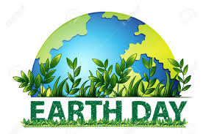

April 22, 2020

Earth Day is an annual event celebrated around the world on April 22 to help support environmental awareness.
South Florida faces several environmental issues including sourcing clean drinking water, algal blooms, and sea level rise. One environmental issue that is an ongoing issue, but with a new twist to the COVID-19 pandemic is the use and disposal of gloves and masks. Due to COVID-19, the issue of people throwing used gloves and masks on the ground has grown into a worldwide issue. For this Earth Day, please remember that almost everything thrown on the ground typically moves with stormwater into our lakes, canals, and eventually to the sea. Plastics and mask materials persist in the environment for many years, entangle and kill larger marine life, and can be ingested either as large pieces or as microplastics by animals, and potentially enter our food and water sources as microplastic particles. For this Earth Day, FAU reminds you put your gloves, masks, and all trash into a garbage can.

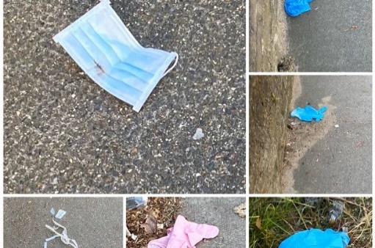
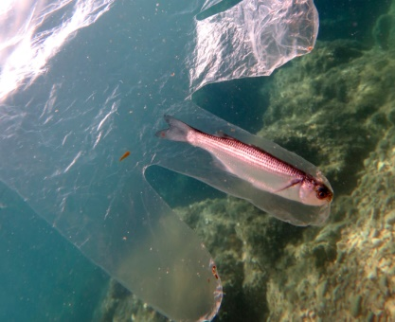
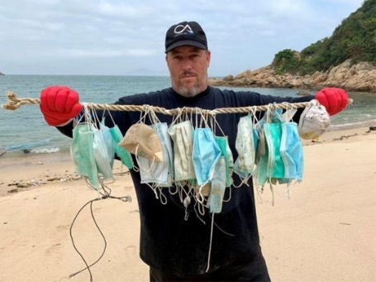

Click here for a local news stories associated with gloves and mask being discarded.

To learn about FAU’s Stormwater Management Program, or to report discharges or pollution, visit: http://www.fau.edu/divdept/envhs/SWMP/

