Methylene Chloride Exposure Control Plan

Lab:
Revision Date:
In compliance with the U-M Methylene Chloride Workplace Chemical Protection Program (WCPP), all units conducting operations involving methylene chloride, or any mixture containing methylene chloride at or above 0.1% concentration, must complete an operation-specific Exposure Control Plan.
Supervisors, or a competent representative: complete each section of this form to detail specific efforts to comply with the requirements defined in the WCPP. Send the completed form to ehs@fau.edu and maintain a copy for your records.
Lab Director/PI Name:
Operation:
Location(s) of methylene chloride operation: (click to add additional locations)
Building:
Room number(s):
Specify sub-location within room (hood, bench, workspace, etc.):
Volume of MeCl or MeCl containing mixture used in this operation:
Concentration:
Provide a detailed description of operation. Explain why elimination or substitution of methylene chloride from this operation is not feasible, not effective, or otherwise not implemented:
Describe engineering controls implemented to reduce exposures. Engineering controls protect workers by removing hazardous conditions or by placing a barrier between the worker and the hazard. Engineering controls may include ventilation devices (fume hoods, local exhaust ventilation), containment devices (glove boxes), and vapor control devices (cold trap):
Describe administrative or work practice controls implemented to reduce exposures. This may include work process training, posting of signage and demarcation of hazardous areas, ensuring adequate rest breaks, or limiting access to areas where methylene chloride exposure may be possible.
Describe personal protective equipment required for this operation. Refer to the U-M WCPP for guidance on selecting appropriate PPE:
Describe additional operation specific training required for potentially exposed persons:
List any Regulated Areas in your lab space and how they are demarcated. A Regulated Area is any area where airborne concentrations exceed, or there is a reasonable possibility they may exceed, the exposure limits. Enter “N/A or “Not Applicable” if this does not apply.
Plan Review and Updates

Supervisors, or a competent representative: Review and update the exposure control plan as necessary, and at least every 5 years, to ensure effectiveness of the exposure controls, identify any necessary updates to the exposure controls, and confirm that all persons are properly implementing the exposure controls. Updates should reflect any significant changes in the status of the approach to compliance with the exposure control requirements. Any change that may reasonably be expected to introduce additional sources of exposure to methylene chloride, or otherwise result in increased exposure to methylene chloride must be documented.

Upon instituting any changes to this form, the revised copy must be submitted to ehs@fau.edu.
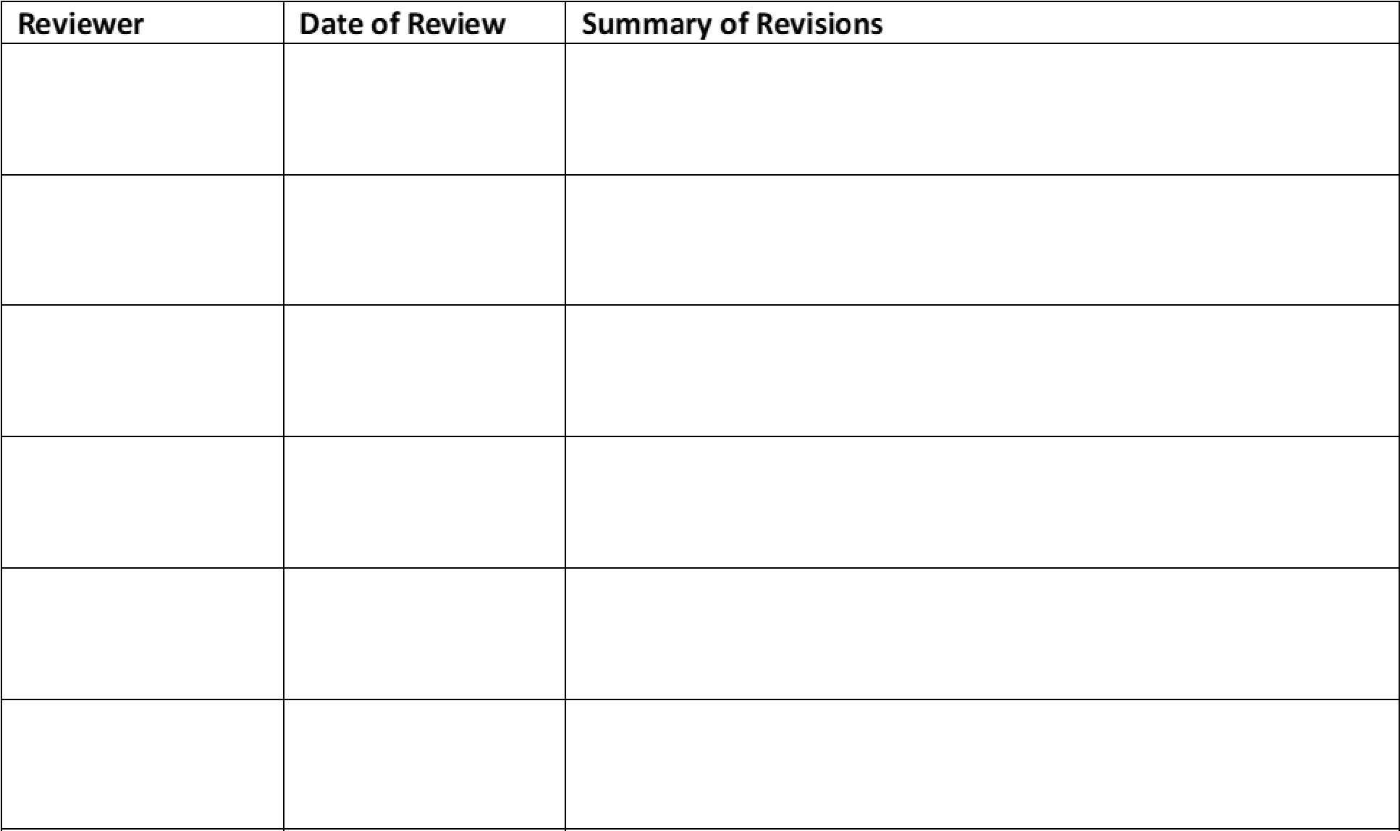

Certification
I have read and understand the above Exposure Control Plan. I have received prior approval from my Supervisor to perform this procedure. I agree to contact my Supervisor if I plan to modify this procedure.
NAME
SIGNATURE
FAUNetID #
DATE
Lab Director
Revision Date

