College of Education
Faculty Assembly Meeting
Friday, January 27, 2012
10:00 – 12:00
Boca COE 313, Jupiter EC 202 C,
Port St. Lucie MP 222, Davie LA 150

WELCOME: FA President Connie Keintz called the regular meeting of the Faculty Assembly to order at 10:09 a.m.

ATTENDANCE:
CCEI- Traci Baxley, Dilys Schoorman, Noorchaya Yahya
CE- Paul Peluso, Irene Johnson, Michael Frain
CSD- Connie Keintz, Deena Wener
Dean’s Office- Valerie Bristor, Don Torok
ELRM- Valerie Bryan, Meredith Mountford, John Hardman, Chunxue Wang
ESE- Lydia Smiley, Peggy Goldstein,
OASS - Lorraine Cross, Deborah Shepherd
T&L- Barb Ridener, Ray Amirault, Susanne Lapp, Susannah Brown, Andy Brewer, Philomena Marinaccio-Eckel, Eileen Ariza, Joan Lindgren
ES&HP – Bob Zoeller
Please advise Marinacc@fau.edu if you attended and your name does not appear above.

APPROVAL OF MINUTES: A motion to approve the November 4, 2011 minutes was made by Susannah Brown; the motion was seconded by Michael Frain. The minutes were approved by a unanimous vote.
DEAN’S TALKING POINTS
SPEAKER: Dean Valerie Bristor
SACS Accreditation: Thank you to department chairs for collecting syllabi, transcripts, CVs, etc. Please return syllabi that need revising as soon as possible. One of the toughest pieces of accreditation is faculty credentialing. Some rules and regulations are the same as in the past however some have changed. For example, if teaching a graduate level class the professor needs a terminal degree. If teaching an undergraduate class the professor needs a master’s degree or 18 credits in the field. Some things have changed in the current accreditation process. For example, we have some specialized activity courses, i.e. karate, which in the past an instructor without the required credits was able to be justified. This is no longer acceptable. Therefore we had to list some courses as noncompliant for fall. My hope is that as we go through this process we might be able to ask the SAC committee whether there are rules for justifying professor requirements for unique courses. (see end of document for Standard 3.7.1 concerning requirements for instructor of record).

Q&A Faculty Questions and Comments on faculty credentialing & Dean Bristor Answers:
QUES: “Did we have a problem with a past accreditation concerning gathering documents?”
ANS: “We were dinged on faculty accrediting from years ago. There were some issues; some of the transcripts were not okay because they were issued to students. They must be sent directly to the College of Education; not to the students or faculty. In addition, transcripts for older faculty may be requested and hard to locate. In addition, to order a transcript from a university outside the US, professors may be requested to submit to a review. The dean’s office will help to support the cost for this review.

Enrollment Caps: The University had a concern because the COE did not lift any course caps to meet student demands. Dean Bristor and Don Torok were given the opportunity to explain why the COE didn’t lift caps. We showed that we have been accommodating as many students as possible. All factors were examined from a pedagogical standpoint. Don Torok was the faculty liaison and reported that sections were added to accommodate students needing a class to graduate.
Q&A Faculty Questions and Comments & Dean Bristor Answers:
QUES: What was the rational as to why we were being asked to raise caps?
ANS: Student accommodation and FTEs. The classes we had to address were just the sections where all the seats were filled or completely closed. We had to explain that we may need to review the maximum occupancy numbers in some of our instructional labs.
COMMENT: Professors at Boca want COE rooms.

Update on response to Governor Scott: Letters were sent to all the universities asking for data to support Florida public universities. Our college provided myriad useful data because we are tied to the FDOE. Governor Scott received very large reports from the universities. At the State University Systems of Florida Dean’s Meeting, the governor’s liaison said he has received these reports but hasn’t read them as yet. If you would like a copy of the FAU report, Dr. Bristor could send it to you. In recent news, all of Florida’s university presidents were asked to testify in front of the House Education Committee. President Saunders presented alongside the presidents of FAMU and FSU. Representative Proctor, who governed this process, seemed to be genuine in his questions to get a feel for the needs of the universities.

Faculty Lines: The good news is that we have not heard any more news on additional budget cuts. The situation is unchanged from September 30th. Communication Science and Disorders and Exercise Science are currently conducting faculty searches.
Q&A Faculty Questions and Comments & Dean Bristor Answers:
QUES: What did we ask for and what did we get in terms of faculty lines?
ANS: We asked for what was prioritized in the budget and a notebook has been submitted to the provost. Upon approval, the provost sent memos approving searches for the specific lines. If we could add a new search we still would need to get approval. Conditions for approval include whether the college can afford an additional line and whether the college can pay for summer. Our summer is reserved. Part of the budget cuts was visiting lines however now we have some retirees.
COMMENT: We are not guaranteed that money for a new search if someone from our college retires.
COMMENT: In respect to the budget, I recently read that whatever was taken out of the budget last year is being replaced this year. But if we are still in deficit tuition will be raised. The folks in higher education aren’t happy because there is no guarantee that enrollment will go up. In sum, we are still bringing in fewer people with lag time for retirements and redistricting still tabled (see end of document for attachment and links).

Update on GRE scores by departmentS:
SPEAKER: Deborah Shepard
The department chairs have until today to provide decisions on the new GRE guidelines. The University Graduate Council would like to move on this by February 8, 2012. The three options for using the new GRE scores include:
1) GRE will be required as well as minimum scores on verbal /analytical/ writing skills.
2) GRE will be required as well as minimum scores on verbal and analytical.
3) GRE will be required but no minimum scores at this time.
Q&A Faculty Questions and Comments
COMMENT: Tallahassee hasn’t decided yet. Regardless of what we as a university decide, our practices will be based on state requirements for teacher education or initial certifications. We will have to do what the state says. We will have to comply with state mandates.
QUES: Does the COE have to go through this whole process again if the department wants to change their initial choice?
Dean Bristor: We will add a disclaimer in the category for notes saying that we reserve the right to change the GRE.

OLD/CONTINUING BUSINESS
SPEAKER: John Hardman
NCATE Update
This is the last semester for collecting data. The COE is getting close to crunch time. The COE has to write a report at the beginning of the fall of this year. In terms of the Diversity Committee, Dilys Schoorman provided a glossary of terms to help us define diversity. One of the most important recommendations provided by the committee is that we are not looking for every course being infused with 100% of the recommended diversity practices. However, every program has to insure that in some course work we are grounding diversity. The process of looking at which courses in each program could be taken to target continues. We are including exceptionalities in our definition of diversity. We need to document these practices not just in our own higher education curriculum, but in the K-12 curriculum as well. We need to put Diversity/ESE/Multiculturalism in our syllabi for application in K-12 schools. We need to demonstrate how we are educating our students to be aware of diversity. Patty Kirsch is doing an excellent job of assessment of the three tiers. Hopefully we will get everything by the end of the semester so we can begin writing in the fall. Committee members need to bring this information back to their departments.
NEW BUSINESS:
SPEAKER: FA President Keintz
FA Elections: We are now accepting nominations for next year’s Faculty Assembly Executive Committee: Vice President, Secretary, and Archivist. Please contact Connie Keintz or Susannah Brown to make nominations. Each department should elect their representative before the April 20th meeting.
FA Constitutional Changes: Constitution changes (see end of document) will be sent to the archivist to post on the FA web site to notify faculty and document the updated constitution and the date of changes.

SPEAKER: Dilys Schoorman
A multipronged approach is needed to gather and provide information on what is needed for research support for College of Education faculty and graduate students. Working toward quality support for research is supported by the COE GPC, the Research Committee, and the Faculty Assembly Steering Committee. This discussion needs to take place with the COE Dean and the Graduate College to determine whether/how their support for these initiatives may occur.
Faculty and Graduate students need:
1. Access to the most recent software for qualitative and quantitative data collection and analysis
2. University IEA and FAU Division of Research support for
  - uploading online data collection instruments, such as surveys
  - collecting online data
3. Methodology advisors with experience in qualitative and quantitative methods.
Such advisors could be:
  - Graduate assistantships assigned to the College and not to one department and/or
  - Through adjunct course assignments with corresponding accountability measures in place
  - Former /current graduate students
  - Supervised by full-time methodology professors.
  - Methodology advice could be structured in the IRM lab with specific times for students to work while assistants were present.
4. Internal (FAU and/or COE) APA editors for the final dissertation held accountable for consulting services.
Faculty need to gather any student or faculty comments regarding research needs to send to Dilys so that we have a better an understanding of those added problems. Steve Diaz will be contacted to request that the technology fees that our graduate students pay be used towards the purchase of Snap and Survey Monkey software to be accessible for individual student research. The proposal is due by next Friday.
Faculty COMMENT: There are people in other colleges, across the university, looking at ways to get software for qualitative research. I think this is something that should be heard across other colleges. Perhaps it should be presented to the Graduate College or the Senate.

Announcements:
Dilys Schoorman: CCEI brownbag series is now open to people outside of the department to present.
Valerie Bryan: Information will be coming out soon about visitors from South Africa February 13-15, 2012.
Lorraine Cross: The Outstanding Educators Awards will honor alumni with three or more years of teaching experience on April 20, 2012 from 5:00 p.m.-7:00 p.m. at the Alumni Center. Representatives will be asking departments for donations for the baskets.
Traci Baxley: On February 23, 2012, The Distinguished Lecture Committee will host researchers from Boston as well as local leaders in our community. The focus will be on the education and health of the people of Haiti. The following day from 9-10:30 a.m. the College of Nursing is going to have coffee sessions to discuss these same topics.
Dean Bristor: February 11, 2012, the emergency response system will be checking email addresses. You may be getting more than one email or phone call, you only need to respond to the first. This simulation is required as part of the emergency response plan.

OPEN DISCUSSION:
Meredith Mountford: The Spring 2011 courses are no longer on Bb. Every faculty member has three semesters listed.

ADJOURNMENT: Lorraine Cross moved to adjourn the meeting; the motion was seconded by Meredith Mountford. The meeting was adjourned at 11:30.
Faculty Assembly Meeting Dates for 2011-2012:
ED Room 313 (other campus locations TBA)
Friday, April 20, 2012 10:00 a.m. - noon

COLLEGE OF EDUCATION DEPARTMENTAL REPORTS
(Celebration of Success)
Communication Sciences and Disorders. Connie Keintz reported:
- Connie Keintz published the following article: Utilization of visual information and listener strategies in intelligibility impairment related to bilateral facial paresis in the International Journal of Speech-Language Pathology, November, 2011. Connie also presented a technical session in November, 2011 at the American Speech-Language-Hearing Association Annual Convention in San Diego entitled Collaborative Methods for Training Research and Evidence-Based Practice: The TRIAD Model.
- Ali Danesh published the following: DPOAEs and Contralateral Acoustic Stimulation and their Link to Sound Hypersensitivity in Children with Autism in the International Journal of Audiology in press. Ali also published A neuronal network model with STDP for tinnitus and its management by sound therapy, in the Proceedings of the IEEE-EMBS International Conference on Biomedical and Health Informatics, Hong Kong and Shenzhen, China, January, 2012.
- Dale Williams authored the textbook Communication Sciences and Disorders: An Introduction to the Professions which was published in 2011 by Taylor and Francis Group. The following FAU COE faculty contributed to authorship of chapters: Deena Wener (Neurogenic Disorders and Professional Issues: Preparation and Practice), Ali Danesh (The Auditory System), Barbara Fries (Augmentative and Alternative Communication), and Connie Keintz (Swallowing Disorders).
- Barbara Fries and Connie Keintz successfully completed the Elearning Designer/Facilitator Certification Course during the Fall, 2011 semester. Barbara Fries is currently teaching a graduate course online, and Connie Keintz is slated to do so next summer.

Counselor Education. Michael Frain had no report at this time.

Curriculum, Culture, and Educational Inquiry. Dilys Schoorman reported:
- The Department of Curriculum, Culture, and Educational Inquiry would like to invite faculty and doctoral students to present their research projects at the Spring 2012 Research Brown Bag Series, scheduled for the following Fridays:
February 17, 2012
March 16, 2012, and
April 13, 2012.
The research projects may be at any phase of study (formulation, methodology development, implementation, data interpretation, implications, etc.). The research brown bags are a "learning community" forum, where conversations take place following each presentation. The conversations promote a sense of shared knowledge construction and may, for both presenters and audience, offer new insights and perspectives about the art of research and more. Two slots, 4-45 pm and 4:45-5:30 pm, are available per Friday. There is no set rule about time limits for the presentation or conversation during each slot.
If you are interested in presenting, please email Dr. Yash Bhagwanji (ybhagwan@fau.edu) with your full name, contact information, title of the presentation, and any questions you may have. For others, please write in the dates in your calendars!
Educational Leadership and Research Methodology. Meredith Mountford reported:
- Educational Leadership has received a large grant to serve Broward County in an effort to educate their own teachers to become principals. Florida Atlantic University was recently awarded a $3.5 million Race to the Top grant for Job-Embedded Principal Preparation Programs through the Florida Department of Education. The grant will provide funding for an innovative leadership development partnership between FAU’s College of Education’s Department of Educational Leadership and Research Methodology, and Broward County Public School’s Department of Human Resource Development. Daniel Reyes-Guerra, assistant professor in the Department of Educational Leadership and Research Methodology at FAU, will serve as the principal investigator for the program and will have overall programmatic and fiscal responsibilities.

Exceptional Student Ed. Ronald Taylor reported:
- Project Review is a collaborative effort between the Department of Exceptional Student Education (DESE) at Florida Atlantic University (FAU) and the co-editors of the journal, Teacher Education and Special Education (TESE). TESE is the refereed journal of the Teacher Education Division of the Council for Exceptional Children. Project Review is a formal system to mentor doctoral students to review journal manuscript submissions, write scholarly reviews, and be involved in the acceptance decision. The project is intended to help doctoral students learn the intricacies of the scholarly review process. Doctoral students read and review a self-study training manual and then conduct reviews of manuscript submissions to the journal. The doctoral students are responsible for writing the reviews and receive extensive mentoring and feedback from faculty members. Project Review increases students’ opportunity to learn about the scholarly review process by participating in the process. Students are recognized as reviewers in upcoming issues of TESE. Professor Charles Dukes has led this effort with the help of department chair, Mike Brady.

Exercise Science & Health Promotion. Robert Zoeller had no report at this time.

Office for Academic and Student Services. Lorraine Cross reported:
- OASS is hosting two college information sessions for the FAU Admissions Open House on Saturday, January 21, 2012. These sessions are open to individuals who may be interested in applying to FAU. In addition, OASS is facilitating four Campus Day sessions for FAU Admissions on February 17th, March 16th, March 23rd and April 13th. These sessions are heavily advertised as an opportunity for admitted freshmen to meet faculty from their college of choice. Karen Kasmer will be organizing the sessions, and will be contacting departments for participation.

Teaching and Learning. Alyssa Dehass-Gonzalez reported:
- Susannah Brown successfully completed the Elearning Designer/Facilitator Certification Course during the Fall, 2011 semester.
- Congratulations to Joe Furner! His article Counting on Frank: Using bibliotherapy in mathematics teaching to prevent de-geniusing was recently published. The following link will take you to Joe’s article. http://www.pythagoras.org.za/index.php/pythagoras/article/view/133
- Professors David Kumar, Mena Marinaccio, and Ronald Persin will be presenting at the Teaching with Technology Showcase at the Davie campus on February 17, 2012.

Submitted by, Philomena Marinaccio-Eckel Secretary, Faculty Assembly
The Faculty Assembly is an advisory body. As such, it passes along the faculty concerns, recommendations, and motions to the Dean. The Assembly does not create or prohibit programs/policies. It does, however, communicate issues to which the Dean is expected to respond.

APPENDICES

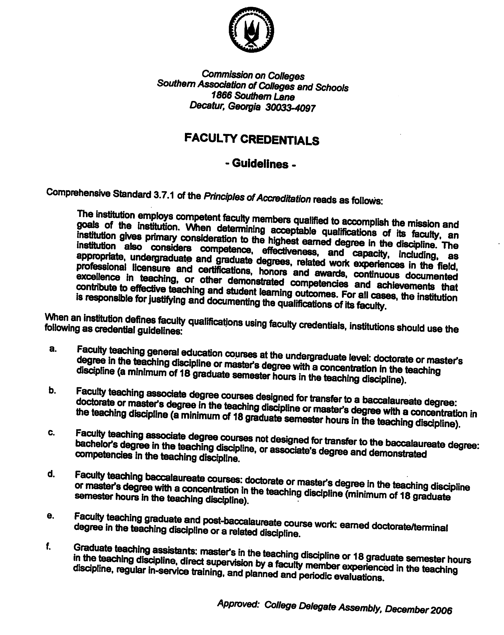

ii. Nomination and Election Changes
The Steering Committee of the Faculty Assembly will serve as the Nomination Committee.
- Nomination
  - The Steering Committee shall call for nominations for officers from eligible members of the Faculty Assembly during the first week following Spring Break during the second week of February.
  - Nominees will be contacted by the President to verify that he/she is willing to run for the office.
  - Nominations will remain open for a period of a minimum of two weeks.
  - The Steering Committee President and Vice President of the Steering Committee will assemble the ballot and prepare it for display on the Assembly’s Election web page.
- Election
  - The election will be conducted electronically no later than two weeks prior to the final Faculty Assembly Meeting of the Spring Semester.
  - All voting will be conducted electronically by secret ballot with access restricted to voting members of the Assembly.
  - Results of the voting will be tallied by the President, Vice-President, and a member of the Steering Committee. The President of the Faculty Assembly will be notified of the results via email after the election has closed. Results will be verified by one other member of the Steering Committee. The nominees will be notified of the results following this verification. Results will then be announced to the entire faculty assembly in a timely manner. immediately.
  - The new officers will be introduced at the last scheduled meeting of the Faculty Assembly.
  - Each department representative will be elected by faculty from each department prior to the end of the spring semester.

- Framework for discussion with the COE Dean and the Graduate College to determine whether/how their support for these initiatives may occur.
Faculty and Graduate students need:
1. Access to the most recent software for qualitative and quantitative data collection and analysis
2. University IEA and FAU Division of Research support for
  - uploading online data collection instruments, such as surveys
  - collecting online data
3. Methodology advisors with experience in qualitative and quantitative methods.
Such advisors could be:
  - Graduate assistantships assigned to the College and not to one department and/or
  - Through adjunct course assignments with corresponding accountability measures in place
  - Former /current graduate students
  - Supervised by full-time methodology professors.
  - Methodology advice could be structured in the IRM lab with specific times for students to work while assistants were present.

4. Internal (FAU and/or COE) APA editors for the final dissertation held accountable for consulting services.

- HOUSE HIGHER ED PLAN CALLS FOR CUTS, 8 % TUITION BOOST
House Higher Ed Appropriations Committee meeting (see below) where Chairman O'Toole offered her 2012-13 budget proposal and proposed conforming language. At the top of the list of noteworthy changes included in O'Toole's proposal are:
(1) an overall 6% cut to higher education funding,
(2) an 8% tuition increase, and
(3) a proposal to create a statewide virtual vehicle for post-secondary education.
Here is the link to the Chair’s budget proposal.
http://www.myfloridahouse.gov/Sections/Documents/loaddoc.aspx?PublicationType=Committees&CommitteeId=2600&Session=2012&DocumentType=Meeting Packets&FileName=hes-chairs proposal1-24-12 ONLINE.pdf
Below is an executive summary for the SUS and the Board Office prepared by the BOG. Whereas the executive summary for the SUS rolls various budget issues into one line, the following narrative breaks out some of the issues between the special units and E&G.
Universities:
The bottom line shows that the SUS is receiving a 2.2% increase. However, this needs some explanation.
First, special units (UF IFAS and Medical Schools) are held harmless from any budget reductions and they receive the following adjustments:
· 8% Graduate/Professional & Out-of-State Fee Increase - $7 M
· FIU/UCF Medical Schools - $1.9 M (matches Board request)
· UF-IFAS Ruskin Aquaculture Lab - $123,207
· UF-IFAS Animal Ag Industry Science & Technology - $2.2 M
· UF-IFAS Horticulture Research, Science & Education - $1.45 M
· UF-IFAS Caladium Industry Research - $417,000
· Moffitt Cancer Center - $2.9 M (matches Board request)
· Institute of Human & Machine Cognition - $3 M (matches Board request)
Second, E&G (main campuses) receive a total reduction in state funds of $153 M. This includes a base budget reduction of $138 M, a reduction of $30 M due to changes in retirement, and some other specific line item adjustments listed below. The base budget reduction would be partially offset by an 8% undergraduate tuition increase. In addition, an assumption is made that all universities would receive approval for a 7% tuition differential increase and that all universities would implement an 8% increase for graduate/professional and out-of-state student tuition. These increases, if fully implemented, would offset the budget reduction.
In addition there are the following E&G adjustments:
· 8% UG base tuition increase - $54.1 M
· 7% Tuition Differential increase - $68 M
· 8% Graduate/Professional & Out-of-State Fee Increase - $32 M
· Florida Retirement Changes – ($30 M)
· Decrease in state funds due to student excess hours – ($10 M)
· FSU High Magnetic Field Lab - $3 M (Board requested $3.3 M)
· Florida Institute of Oceanography - $1.2 M (matches Board request)
· PO&M - $8.4 M (matches Board request)
· UCF Lou Frey Institute – $400,000
· FIU Simulation Teaching & Research Center - $500,000
· FCLA funding is transferred to the Florida College System – ($9.9 M)
- This issue transfers FCLA funds, which are currently in UF’s base budget, to the Florida College System. These funds would be merged with the College System Library and Distance Learning Consortium to form the Florida Virtual Campus. Additionally, $2.5 M is added for the UWF Degree Completion Pilot project and $2.5 M is provided to the Western Governors University Student Access Pilot project.
Board General Office
· 4 positions ($128,000 in Salaries & Benefits), plus $25,000 in operating expenses are eliminated.

