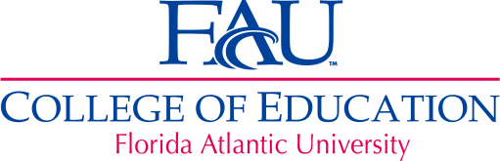

FAUS & COE RESEARCH COMMITTEE
Monday, September 26, 2011
3:15 – 4:30 p.m.

Melby Center, Room 241, 2nd Floor
Department of Educational Leadership
College of Education

AGENDA
Phone conferencing is available for those unable to attend please notify
Julie Hector at jhector@fau.edu.

- Welcome Steve Rios
- Assistant Dean Update Glenn Thomas
- School Reports School Representatives
- Review of August 29 Minutes Trish Konopelko
- Research and Development Guidelines Terri Watson / Committee
and Procedures for FAUS

- 3D logo Julie Hector / Committee
- Major Dissemination Event (Mixer, Symposium) Steve Rios / Committee
- FAUS-COE Research Summary Report Julie Hector
- Visit to Palm Pointe Trish Konopelko
- Next meeting Trish Konopelko
- Adjourn Trish Konopelko

To contact Palm Pointe: (772) 345- 3240

