FAU & COE Laboratory Schools
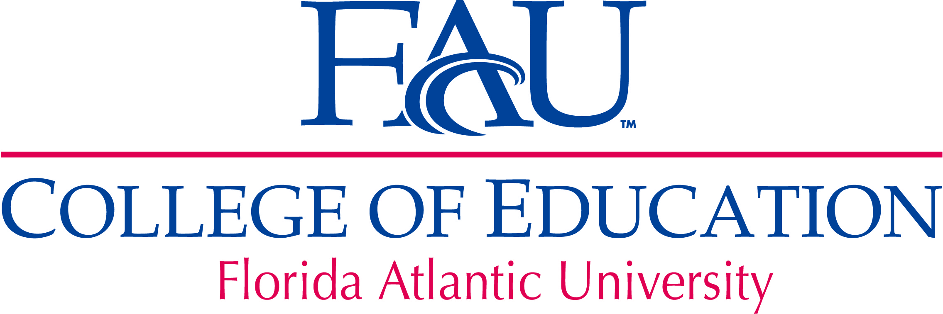

Summer 2011

FAU Laboratory Schools Research Featured at Three-Campus Virtual Forum

Research developed at the FAU/ College of Education Lab Schools will be featured at the first-ever FAU Lab Schools Virtual Research Forum, Thursday, June 2, from 5 to 8 p.m. Teachers conducting action research, an innovative study by a nationally-known special education professor, and a research team just back from presenting their work at the International Reading Association conference will comprise the three main presentations at this innovative first-ever event organized by the FAU / COE Lab Schools Research Committee.The researchers will be joined by other faculty, teachers, and students at FAU’s Boca Raton,
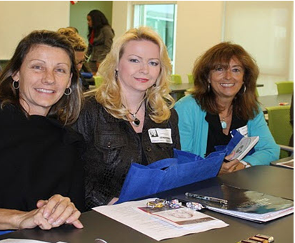 | MacArthur and Port St. Lucie campuses. Presenters will use the university’s recently acquired video conferencing equipment for the cutting-edge event.  Welcoming comments will be delivered by COE Dean Dr. Valerie J. Bristor and the keynote will be presented by FAU’s recently-appointed Vice President for Research Dr. Barry T. Rosson.  Researchers and teachers from A.D. Henderson University School, Palm Pointe Educational Research School at Tradition, and Karen Slattery Educational Research Center for Child Development will discuss their research at the forum. COE Assistant Dean Glenn Thomas will discuss the potential to conduct research at the Everglades Youth Conversation Camp/ Pine Jog Environmental Education Center , a one-of-a kind laboratory school venue. Discussion after each presentation will be facilitated by members of the Lab Schools Research Committee.
Just back from the International Reading Association Conference, virtual research forum presenters, Regina Sands, Teacher, A.D. Henderson School, Lydia Bartram, Director, Karen Slattery Educational Research Center, and Janet Towell, Ed.D., Professor, Department of Teaching and Learning
“Since our schools are so spread out, and we have stakeholders in three counties interested in our research, we must use the latest technology to span the miles and deliver our message,” said COE Assistant Dean Glenn Thomas, who oversees the lab schools.
“It is exciting that university faculty and laboratory schools teachers will have the chance to disseminate their findings in such an innovative, high-profile manner,” said Dr. Steve J. Rios, co-chair of the Lab Schools Research Committee. Editor’s Note: See next page for the full schedule of events for the virtual research forum.

FAU Schools / College of Education Virtual Research Forum Schedule
Title of Research | Presenter(s) | From
Welcome | Valerie J. Bristor, Ph.D.,  Dean, College of Education, FAU | Boca Raton  Campus  CM 130
Keynote Address  “Research to Practice” | Barry T. Rosson, Ph.D.  Vice President for Research  Dean of the Graduate College | Boca Raton  Campus  CM 130
Examining 8th Graders’ Engagement and Motivation with Kindle  e-readers  Facilitated by:  Trisha Konopelko | Elsie Garber, Teacher,  Palm Pointe Educational Research School | Treasure Coast  Campus  (Port St. Lucie)  JU 319
Combining Guiding Questions with Hands-On Science Experiments  Facilitated by:  Trisha Konopelko | Michelle Powers, Teacher,  Palm Pointe Educational Research School | Treasure Coast  Campus  (Port St. Lucie)  JU 319
Safety from Unintentional Injury for Students with Autism  Spectrum Disorders  Facilitated by:  John Hardman, Ph.D. | Jack Scott, Ph.D., Professor, Department of Exceptional Student Education & Executive Director, FAU Center for Autism and Related Disabilities | John D. MacArthur Campus  (Jupiter)  SR 275
Reading Buddies:  A Collaborative Project  Facilitated by:  Nancy Brown, Ed.D. | Janet Towell, Ed.D., Professor, Department of Teaching and Learning  Regina Sands, Teacher,  A.D. Henderson School  Lydia Bartram, Director,  Karen Slattery Educational  Research Center for Child Development | Boca Raton  Campus  CM 130
Open Dialogue – Research to Curriculum and Practice | Facilitated by:  Steve J. Rios, Ed.D., Assistant Visiting Professor, Dept. of Educational Leadership and Research Methodology and Terri Watson, Ph.D. | Boca Raton  Campus  CM 130
Closing Comments | Glenn Thomas, Assistant Dean,  FAU College of Education | Boca Raton  Campus  CM 130

Lab School Research Shines at Student-Alumni Conference

Florida Atlantic University’s College of Education (COE) Lab Schools Research Committee made an impact at the 10th Annual COE Student Achievement Council (SAC) Research Symposium. Research developed at COE Lab Schools in Boca Raton and Palm Pointe was shared with an engaged audience of more than 75 students, faculty, and department chairs. COE Dean Valerie J. Bristor and FAU President Mary Jane Saunders also attended the symposium, the first official event held last fall at FAU High School.
During her keynote address, FAU President M.J. Saunders commended the Student Achievement Council and the COE for hosting the event. “I know from my own experience as a researcher that there is no better way to form lasting and productive mentorship relationships than through the shared research experience,” said President Saunders, a former scientist and university administrator. “The journey to discovery is very exciting, and deep bonds are formed between people who take that journey together.”
“The symposium afforded all of us who attended the opportunity to gain valuable knowledge in our efforts to strive for reaching the highest levels of excellence in the classroom and reach the needs of all types of learners,” said Lab School Research Committee Co-Chair Cindy Harrison, a teacher at Palm Pointe Educational Research School at Tradition, in Port St. Lucie.

 | 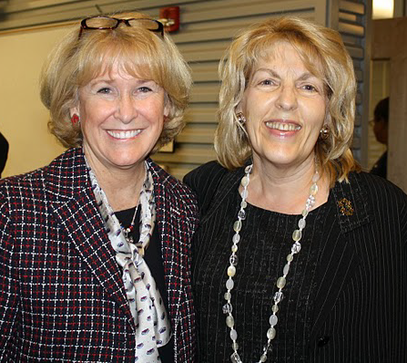
FAU Alumna Emily Bokhart, center, and Research Committee members Dr. John Hardman and Cindy Harrison, co-chair. | FAU President Mary Jane Saunders, left, and Lab School Research Committee Member Dr. Nancy Brown.
Harrison and her colleague Emily Bokhart, who also teaches at Palm Pointe, travelled more than two hours so Bokhart could present her research titled, Making the Pieces Fit: Teaching Reading, Technology, and Data Analysis. “It was an honor to be a participant at this event. Sharing the research is one of the most important steps in the process to further the learning that is done,” said Bokhart, who graduated from the FAU’s College of Education with a Master’s degree in Reading.
The conference also included a panel presentation with two members of the FAUS COE Lab Schools Research Committee. Dr. John Hardman and Dr. Terri Watson both participated on an alumni panel titled After the Tassel is Moved. Dr. Hardman is the former research director at A.D. Henderson School, the role currently filled by Dr. Watson, who also serves as dean of students for A.D. Henderson and FAU High School.
Dr. Hardman spoke about leadership for sustainability and Dr. Watson discussed how different methods of measuring graduation rates affect ethnic minority groups. Two other College of Education Alumni, Dr. Donna Goldstein, and Dr. Steve Urdegar, also presented at the conference.

Dr. Jim McLaughlin: Promoting Action Research at Laboratory Schools

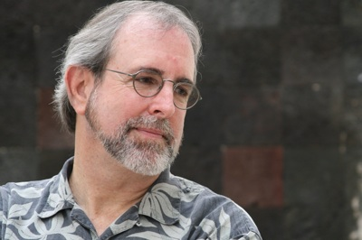 | Dr. Jim McLaughlin, a professor and Chair of the COE Department of Curriculum, Culture, and Educational Inquiry, is actively involved in the FAU University Schools’ school-wide action research teams and throughout his career has worked with teachers doing action research. The FAUS-COE Committee chose him asthe contributing voice of this interview because of his expertise and because he is such a strong advocate of action research.

RR: How did you first become involved in teacher action research?

JM: In 1992, while I was at the University of Georgia, a local middle school assistant principal asked me to do research with teachers. During that time, I created a course called Action Research. When I came to FAU in 2004, Dr. Gail Burnaford, who had done action research and had written a book on the subject agreed that we should develop a course on action research. It was approved in 2008.Three years ago I began an action research project with a group of teachers at A.D. Henderson University School. We have presented on the work and we are now completing a manuscript that we will send out for possible publication.

RR: What are some of the more challenging aspects of teacher action research?
JM: Maintaining momentum, getting sufficient support and incentives to continue, and that sort of elusive concept of creating a community of inquirers is really difficult because you have to have enough leadership from teachers, you have to have enough direction from teachers, enough energy from teachers that you can continue to work together in a positive way.

RR: What do you believe is the purpose of lab schools?
JM: The purpose of a university school is to create a very strong connection with university faculty and with perhaps foundations or research groups so that researchers can come into the school and do research with teachers, and with the permission of course of the faculty, but also so there can be serious collaboration.
Which leads to the other part of this, the outgrowth then, should be that there is this community of inquiry which is developed over a period of years. It’s hard to do. There are lots of reasons why it’s not supported over time, but that should be what university schools do. Then there’s something that we haven’t even talked about, and that is, if you are a university school, and you’re being supported in some way by the university, and yet you’re a public school; you should be working in the community in some way and you should be publicizing the kind of work that you’re doing in a way that many, perhaps all regular public schools can’t or won’t do.

RR: How do you envision the FAU lab schools functioning, ideally?
JM: I think there probably should be two research teams in the school. One would be a school-wide action research team that would have very much the kind of cycle that I described earlier, that kind of annual cycle. They would get parents involved. Had I stayed working at that school [in Georgia] for longer, I would have gotten students involved also in one of the committees. The other team would be more like a research committee that looks at the kind of research that is being done in the school by other people, university people. They would then try to figure out how teachers might work with those professors in doing that research, or what they hope to gain from it and all that, I think that might be useful.

The Following Pages Detail the Many Research Projects Underway at FAU’s Lab Schools  Title | Principal Investigator  Co-principal investigator(s) | College /Dept. | Grades or Age | # subjects | Dates | Description | IRB Approved / Sponsoring Lab School
Development of Inhibition as a Function of the Presence of an Intentional Agent | David F. Bjorklund, Ph.D.  Ashley King | Science  Psychology | Pre-K to 2nd | 200 | Jan, '09 - Jan '10 | Developmental differences in inhibition as a result of the suggested presence of an imaginary entity. | Yes / ADHUS/Karen Slattery Educational Research School for Child Development
How Children Think About Social Agreements | David F. Bjorklund, Ph.D.  Kayla Causey | Science  Psychology | 4 yr olds | 40 | Sept., ’09 – Jan., ‘10 | How children think about scenarios that involve social contracts (rules) with other people. | Yes/ Karen Slattery Educational Research School for Child Development
The Effects of Predatory Status on Children's Developing Understanding of the Mind | David F. Bjorklund, Ph.D.  Chris Cormier | Science  Psychology | 3 yrs to adult | 160 | March, ’10 – March, ‘11 | To test the prediction that reports of the continuity of mental state functions beyond death will be higher when participants are considering the minds of predators (e.g., a lion) than prey (e.g., a sheep). | Yes/ Karen Slattery Educational Research School for Child Development
Gestures and Development of Tool Use | Marissa Greif, Ph.D.  Robert Freund & Jessica Sierra | Science  Psychology | 3-4 yr olds | 10 | May, ’09 – Jan. ‘10 | How individuals learn about the functional relationships between simple tools and other objects through the use of gesture. | Yes/ Karen Slattery Educational Research School for Child Development
Do Different types of Toys Affect Children’s Play? | Marissa Greif, Ph.D.  Robert Freund & Patricia Perez | Science  Psychology | 2 to 5 yr olds | 60 | Feb., ’09 – Dec., ‘10 | How different types of toys affect children’s play (i.e., fantasy and cooperative dimensions of children’s play) and how they affect children’s cognitive development. | Yes/ Karen Slattery Educational Research School for Child Development
Title | Principal Investigator  Co-principal investigator(s) | College /Dept. | Grades / Age | # subjects | Dates | Description | IRB Approved / Sponsoring Lab School
Learning about Objects | Marissa Greif, Ph.D.  Patricia Perez | Science  Psychology | 2 to 6 yrs old | 160 | June, ’10 – June, ‘11 | To investigate children’s intuitions about categories of objects. | Yes / ADHUS/Karen Slattery Educational Research School for Child Development
The Role and Impact of Culture in Early Childhood Education Curriculum | Dilys Schoorman, Ph.D.  SumblaPervaiz& Sandra Charity- Martinez | Education Curriculum, Culture and Educational Inquiry | 4 yr olds | 15 | Feb., ’09 – Feb., ’10 and Feb., ’10-Feb.,’11 | How students’ home culture is included in the curriculum and the impact of such inclusion on young children. | Yes / Karen Slattery Educational Research School for Child Development
”Reading Buddies”: A Collaborative Project (FAU, A.D. Henderson, Slattery) | Janet Towell, Ed.D.  Regina Sands and Lydia Bartram | Education | 4 yr olds and 6th graders | 56 | Nov., ’09 – Dec, ‘14 | How a cross-age reading model affects reading attitude and reading achievement at the preschool and sixth grade level. | Yes / ADHUS/Karen Slattery Educational Research School for Child Development
Noun and Verb Learning in Preschool Children and Adults | Alan Kersten, Ph.D.  Simone Chin and Natalie Yanneta | Education | 3-30 yrs old | 200 | June, ’10 – June, ‘11 | To examine the learning strategies underlying children's acquisition of nouns and verbs and to test the theory related to what children attend to when learning certain types of verbs. | Yes / Karen Slattery Educational Research School for Child Development
Using Video Self-Modeling to Enhance the Social Skills of Middle School Students with Asperger’s Disorder | Dr. Jack Scott  Kathryn Steele | Education | Grades  6 to 8 | 6 | Current | To explore the use of video self- modeling on social skills with middle school students who have Autism Spectrum Disorders (ASD) and Asperger’s Disorder. | Yes / Palm Pointe

Title | Principal Investigator  Co-principal investigator(s) | College /Dept. | Grades / Age | # subjects | Dates | Description | IRB Approved / Sponsoring Lab School
Using Gaggle.net in Middle School Reading | Dr. Maria Vasquez  Cindy Harrison | Education | Middle School Intensive Reading Classes | 15 | Current | To examine how educational discussion boards and blogs impact students’ reading, their ability to respond critically to classroom assignments and to develop language and critical thinking skills. | St. Lucie County  School District / Palm Pointe
Reading Rally | Dr. James McLaughlin  Kathleen Melrose,  Trish Dibari & Research Team | Education | Grades  2 to 8 | 170 | Current | To investigate the impact on student achievement by integrating three Rally Reading programs into the core curriculum. | Planned for September 2011 / Palm Pointe
Word Sorts with Support | Heather Davis  Michelle Gagne & Ingrid Rodriguez and research team | Education | Grade 2 | 5 students per class | Current | To explore the impact of using word sorts with online support (with Spelling City.com) | St. Lucie County  School District / Palm Pointe

Title | Principal Investigator  Co-principal investigator(s) | College /Dept. | Grades / Age | # subjects | Dates | Description | IRB Approved / Sponsoring Lab School
E-Readers (Kindle) in Middle School | Elsie Garber  Cindy Harrison | Education | Grade 8 | 14 | Current | To examine the level of student engagement and motivation when eighth grade students are presented the opportunity to read books via Kindle e-Readers. | Palm Pointe/  St. Lucie County  School District
Efficiency of Learning Centers | Summer Kuba  Amanda Shaffer | Education | Grade 6 | 15 | Current | To examine the effect that cooperative learning groups, using a variety of text and visual structures, have on students’ mastery of skills such as the use of context clues to determine word meanings and identification of text features. | Palm Pointe/  St. Lucie County  School District
Motivational Mozart | Kristin Morlock | Education | First grade | 5 | Current | To examine the impact of classical music on students’ writing. | Palm Pointe/  St. Lucie County  School District

