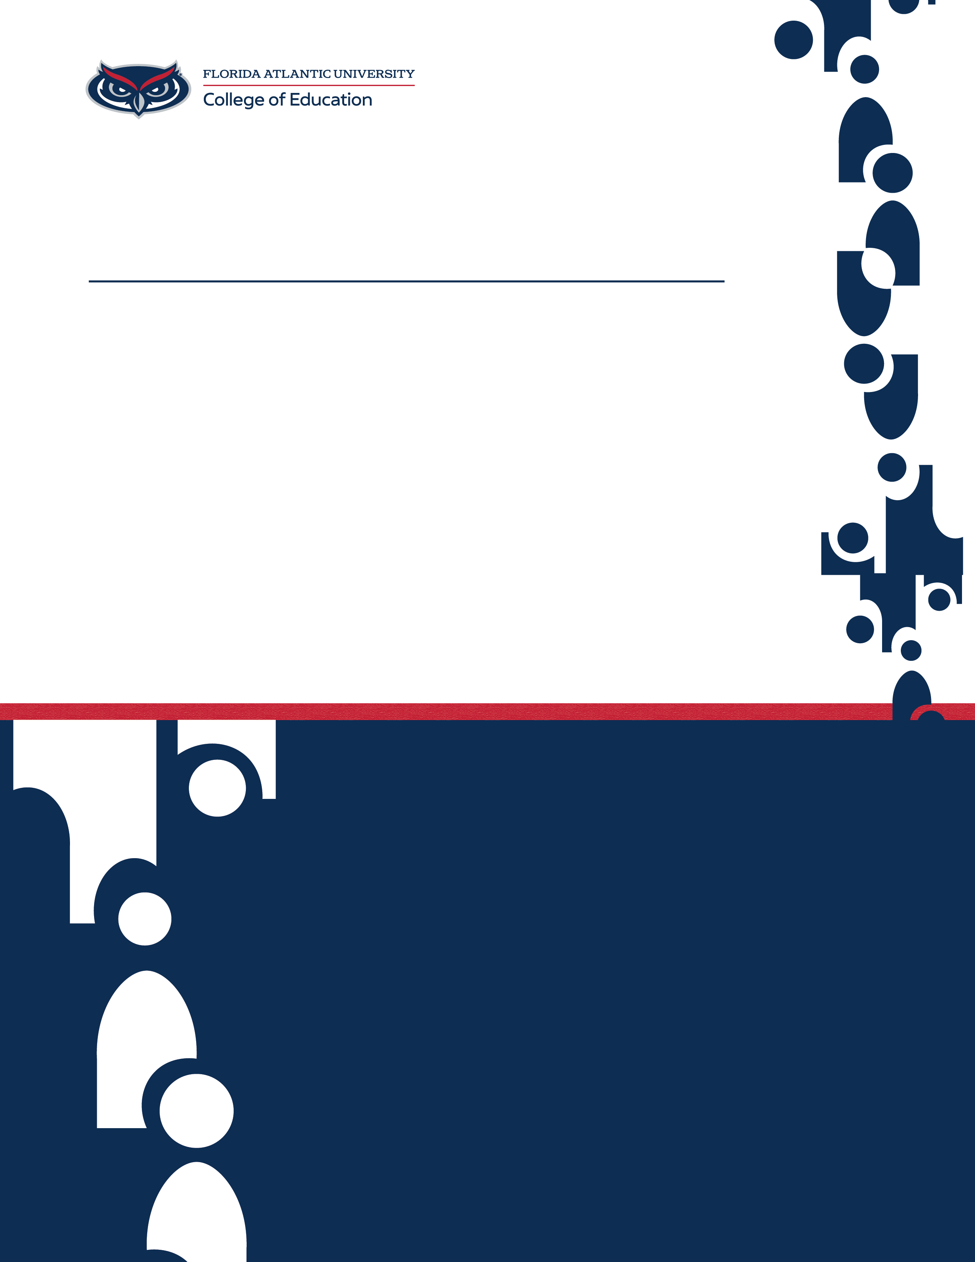
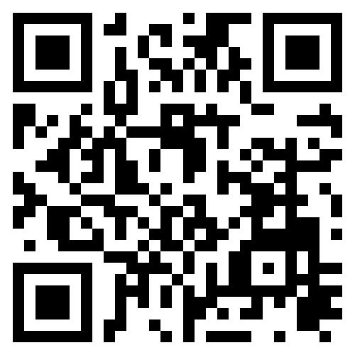
Select “Enable Editing”. Title font size should be 18-25. Keep the distance from the logo and title similar to how it is now!
Additional information may be put here. Consider limit.
To add a QR code of your own, left click and then right click on the QR code above. Select "Change Picture". Select the source of your image file. This will allow you to pick your image. Adjust the placement of the new QR code if necessary, but please keep it in the same relative space.

If there is additional content that you do not require, you
can select the content by left clicking, and then right click for the option to "Cut”. You may also use the shortcut Ctrl + X on your keyboard. If you delete a text box, ensure you right click on the edge or corner of the text box so that the whole thing is selected. If you select the middle of the text box, these options will not be available to you.

If you would like to keep the FAU Red in the Title box, click
on "Font color". Go to "More colors". Go to the “Custom” tab and #CC0000 under Hex. Then click "OK".

For general text, keep the font size to 10-12. You may
format the text however you like, but please be considerate the text box size and refrain from adjustments. It was set to this size for flexibility and legibility. The approved fonts are Arial, Century Gothic, Helvetica, and Avenir. Any variants of these fonts are approved.

