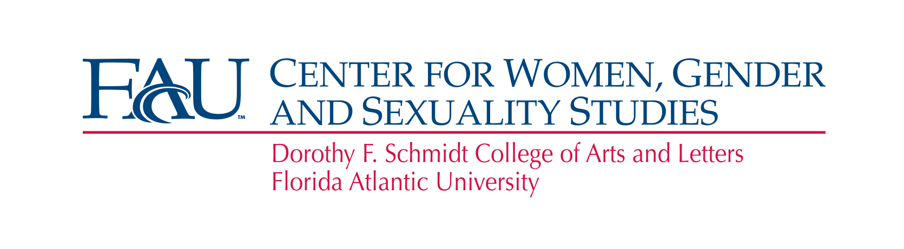
Student Leadership Building Bridges Luncheon
Post-event Survey

Name of Student Organization: _______________________________________

Contact Person and Email:

Name/Position: ____________________________________________

Email: ____________________________________________

Survey Questions:

- How would you evaluate today’s Leadership Luncheon (excellent, good, needs improvement)? Please provide a brief comment below to explain your evaluation.

- Do you plan on organizing a raising awareness campaign on-campus about sex trafficking?

- In what month do you think the campaign will roughly take place?

- Would you like to collaborate on this campaign with other student organization? Do you have specific ones in mind?

- What support would you like the WGSS Center to provide in order to ensure the success of your campaign?

