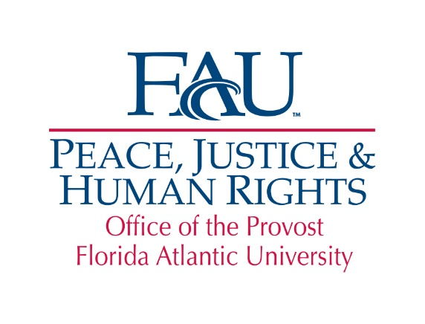

The Peace, Justice and Human Rights (PJHR)
Latin American and Caribbean International Students Scholarship

The Peace, Justice and Human Rights (PJHR) Latin American and Caribbean International Students Scholarship is offered by the Peace, Justice and Human Rights Initiative to currently enrolled international students actively engaged in issues related to peace, social justice and human rights who plan to apply their academic knowledge to improving human rights, peace and social justice in their home country. The Scholarship will assist with the educational costs incurred by international students from Latin America and the Caribbean by offering a $500 stipend for each semester of academic year 2018-2019 based on satisfactory academic progress. Students receiving this Scholarship can be reclassified as in-state for tuition purposes for each semester of the award based on satisfactory academic progress.

Eligibility: Applicants must be either a full-time undergraduate or graduate international student holding either a F1 or J1 visa; Latin American or Caribbean¹ citizen with a minimum 3.0 GPA undergraduate or 3.5 GPA graduate. Students must maintain the minimum GPA for each semester of the award.

Requirements: Students are required to complete the application, including a 1,000-word essay detailing how they plan to apply their academic knowledge to improving human rights, peace and social justice in their home country; submit an unofficial copy of their transcript and their resume. Students awarded the Scholarship are expected to contribute to the programming of the Center for Global Engagement (e.g., International Education Week, Festival of Nations or the International Friends Program).

Application Process: The completed application and supporting documentation must be submitted via email to pjhr@fau.edu by March 30, 2018 in order to be considered. Applicants will be notified of the decision of the PJHR International Scholarship Committee by April 27, 2018.

Name: _____________________________________________________________ Z#:___________________________
Last First M.I.

Address: _____________________________________________________________________________________________
Street Address City State Zip

Telephone: ( ) _________________________ Email: _______________________________________________

Country of citizenship: _______________________________ Grade Point Average: __________________

Major: _____________________________________________________________________________________________
Undergraduate: freshman sophomore junior senior

Graduate: Masters Ph.D. Anticipated Graduation Month/Year:____________

_________________________________________________________________________________________________________
¹Eligible Latin American and Caribbean countries and territories are: Anguilla; Antigua and Barbuda; Argentina; Aruba; Bahamas; Barbados; Belize; Bermuda; Bolivia; Brazil; British Virgin Islands; Caribbean Netherlands; Cayman Islands; Chile; Colombia; Costa Rica; Cuba; Curacao; Dominica; Dominican Republic; Ecuador; El Salvador; Falkland Islands; French Guiana; Grenada; Guadeloupe; Guatemala; Guyana; Haiti; Honduras; Jamaica; Martinique; Mexico; Montserrat; Nicaragua; Panama; Paraguay; Peru; Puerto Rico; St. Barthelemy; St. Kitts and Nevis; St. Lucia; St. Maarten/St. Martin; St. Vincent and the Grenadines; Suriname; Trinidad and Tobago; Turks and Caicos Islands; Uruguay; U.S. Virgin Islands and Venezuela.

In 1,000 words or less, briefly explain how you plan to apply your academic degree to improve

peace, social justice and human rights within your home country:

I authorize the release of this application and any relevant supporting information to persons involved in the selection of scholarship recipients. If awarded a scholarship, I give permission to FAU to use my name, photo and general biographical information for publicity and marketing purposes.

Applicant’s Signature Date

