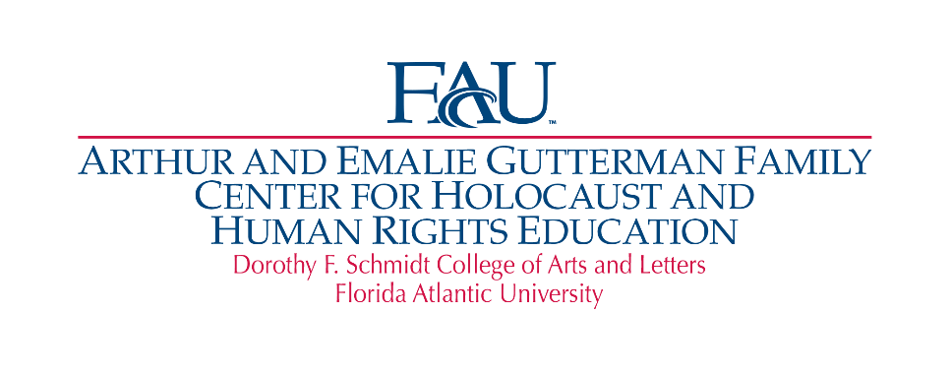
Summer Institute for Educators in Grades 5-12
Resistance During the Holocaust
Tuesday, June 21st - Thursday, June 23, 2022
8:30 AM – 3:00 PM IN PERSON - FAU Boca Raton Campus

Application (please type)

Name : Cell Phone:
School Email Address:
Alternate Email Address:
School District: School Name:
Principal’s Name: Grade Level (s):
Subject(s) Taught:

- Previous Holocaust Professional Development participation
1.
2.
3.
4.

- What topics related to the Holocaust have you incorporated into your classroom
instruction?

- What are your expectations from the Summer Institute for Educators?

- How do you plan to implement your new knowledge into classroom instruction?

Capacity is limited.
-Email completed applications to Linda Medvin lmedvin@fau.edu and cc to Ellen Sax esax@fau.edu
before April 1st, 2022.
-Participants will be notified on or before April 15th, 2022.
-Once accepted, participants will receive registration information and be required to pay the registration fee of $50.
-The registration fee is refundable at the completion of the Summer Institute.
-Accomodations are available nearby. Please call for more information. Ellen Sax 561-297-0849

