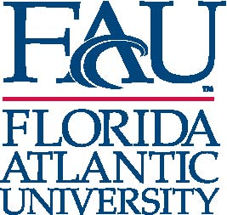
Continuing Education
777 Glades Road, CU 232
Boca Raton, FL 33431-0991
e-mail: rrivaux@fau.edu

Date:

Name of Parent(s)
Address Line 1
Address Line 2

Re: Student Name

Dear (Parent name):

Your child has expressed an interest in attending Florida Atlantic University as a Non Degree Student during the Fall/Spring semester.

Florida Atlantic University defines anyone under the age of 18 as a minor. As the parent of a minor we would like to make you aware of situations that your child may encounter.

- The possible controversial content of courses or ensuing discussions in the classroom
- The maturity level of the minor students that enables him or her to learn the course content and perform as equals to the adults in the classroom
- There is also the possibility that someone may inappropriately make sexual advances to your child (many students do not look as young as they are).

Please return this letter with your signature acknowledging that you give your child permission to attend Florida Atlantic University and that you are also aware that your child may be exposed to language that is not commonly used at home.

Best regards,

Gary W. Perry, Ph.D.
Interim University Provost and Chief Academic Officer

Wendy M. Kutchner, Ed.D.
Assistant Vice President/Enrollment Management
University Registrar

I acknowledge that my child may encounter some of the circumstances described above while attending Florida Atlantic University.

____________________________________________________________________________________________________________
Signature of Parent Printed Name Date

