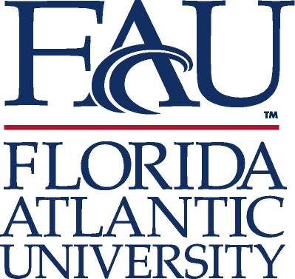

APPLICATION FOR JACK MILLER FORUM (JMF) UNDERGRADUATE RESEARCH FORUM AND FUNDING

Due February 14, 2014

The JMF will fund two undergraduate research grants, and one graduate research grant. Each award is $250 dollars. The purpose of the research is to promote the study and exploration of American founding principles, relating to the American founding, American political thought, American political development, liberty, and freedom.

Z #.________________________

LAST NAME_______________________FIRST NAME_____________________MI_______
HOME ADDRESS_______________________________________COUNTRY_____________
CITY __________________STATE_________ ZIP CODE______________
EMAIL ADDRESS____________________________________
DAYTIME PHONE_____________________ EVENING PHONE_______________________
Research Purpose:

JMF will host a symposium in April. The symposium will provide a forum for undergraduate and graduate students to present their research. Winners will workshop with a distinguished speaker and present their research on a panel.

__________________________________________________________________________________

Membership in professional and honor societies; honors and awards:
___________________________________________________________________________________
Be sure to include:

____ Unofficial Transcript
____ Resume
____ Writing Sample

I certify that the information given in this application is complete and accurate.

Signature______________________________ Date_______________________

Return to the Political Science Department: SO 392, 561-297-3210.

