Colby Katz: Photography, Narrative and Role Playing

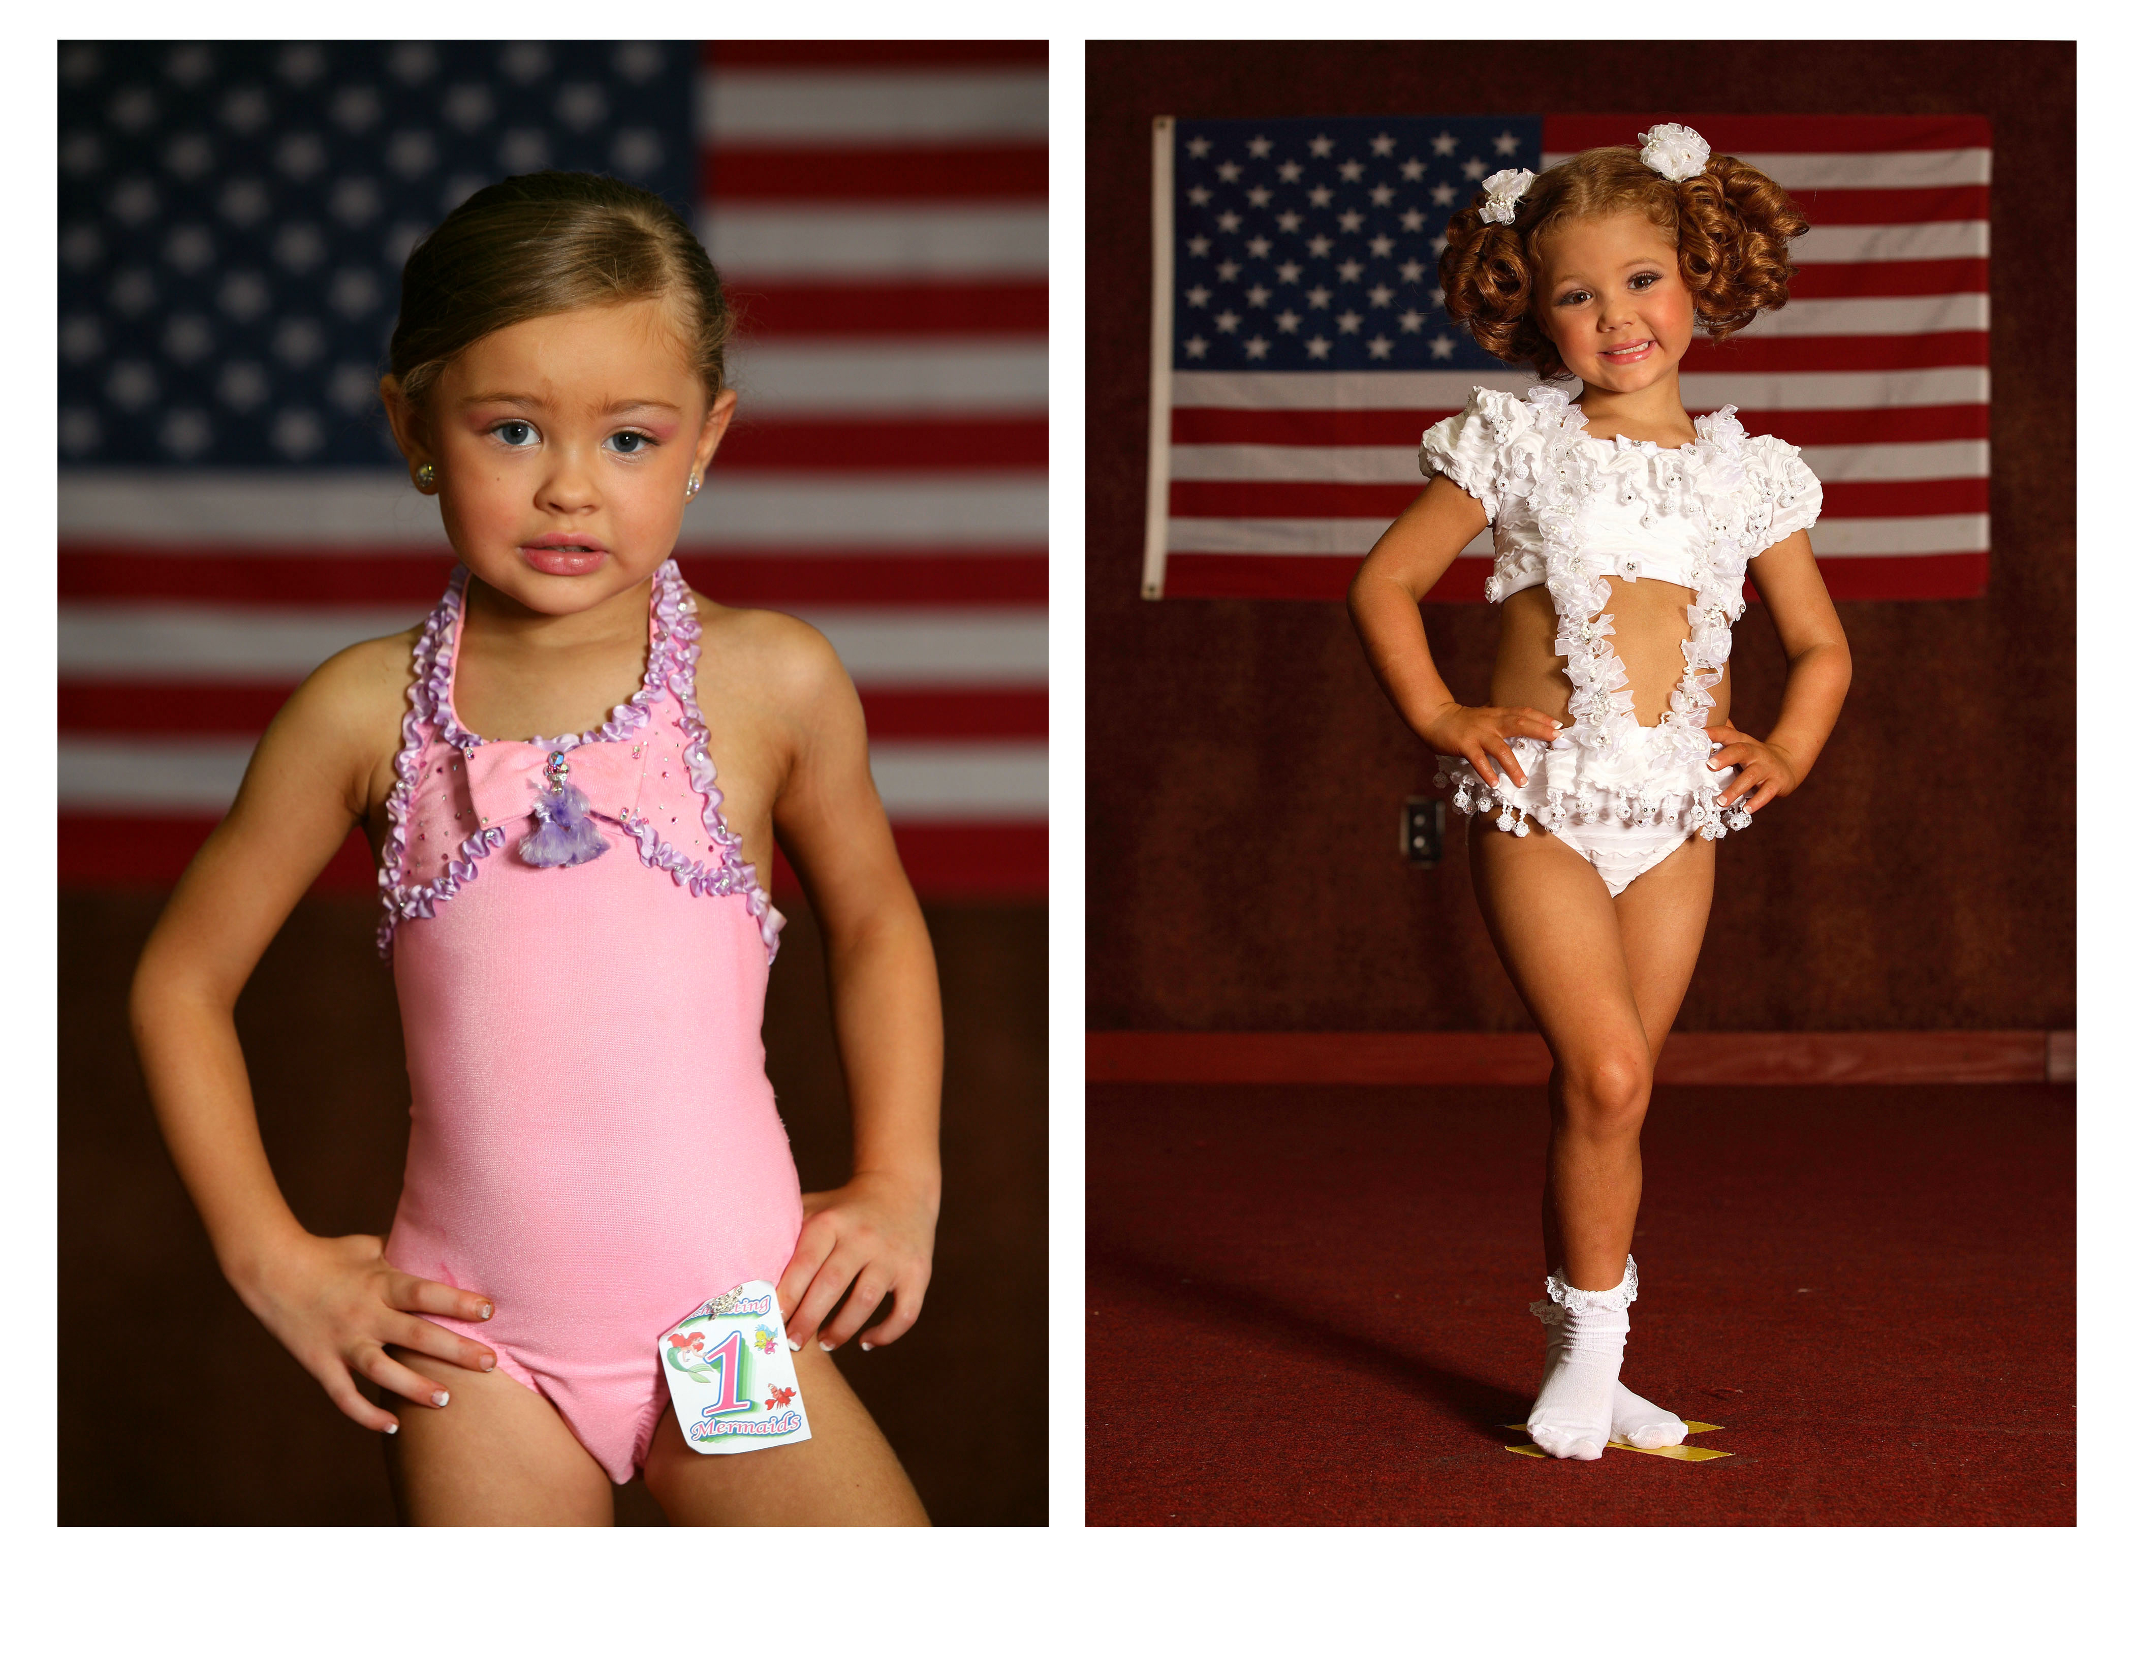
Colby Katz

Fort Lauderdale-based artist Colby Katz was born in Washington D.C. and received her bachelor’s degree in photography from New York University. Katz is well known for her series of photographs in the world of beauty pageants. Her photographic style has been described as honest, awkward, empathetic and humanizing towards the subjects she documents.

A beauty pageant contestant herself as a young girl, her goal is to give a voice to those actually involved in this controversial ritual, complete with roles to perform.
Colby Katz. Taylor and Tiffany, 2006.

Beauty Pageants

A beauty pageant is a competition based mainly, though not entirely, on the physical beauty of its contestants, often incorporating personality, talent demonstration, and question responses as judged criteria. Beauty pageants have been around since the late 1800’s, but the modern beauty pageant's origin is traceable to the Miss America Pageant, which was first held in Atlantic City in 1921. Pageants have always been fairly controversial events, especially children’s pageants, which often encourage little girls to dress and act like little women.

Critical Thinking

- Who is being judged in the competition? Is it only the contestants?
- Who judges you in your life? Who do you judge?
- What roles do these pageant contestants play while on stage (different from off-stage)?
- What roles do you assume in your everyday life? How many roles do you play (daughter, sister, student, etc)? Which are the most active? Which are the most passive?
- Think about assigning a rating scale for immeasurable qualities, such as beauty, talent, and personality. Is this fair? Who creates standards, why and how?
(Hint: think about what constitutes/creates a Miss America winner and what she looks/acts like)

What does it mean to be Narrative?

If a picture is worth 1,000 words then it would seem photography is by its very nature a storytelling medium. Narrative photography is essentially telling a story through pictures, without words; a secession of photographs culminating in a photo-essay. Katz’ Beauty Pageants permits us an insider's view backstage or behind-the-scenes of pageants, inside hotel rooms, elevators and hallways where teeny-tot contestants are being fussed and fawned over, preened and perfected, hair-sprayed and spray-tanned by a swarm of proud, ambitious mothers.

Critical Thinking

- How do Katz’s photographs demonstrate perspective and imply narrative?
- How many points of view does Katz capture as a photographer?
- Do you think that she focuses on pageants for a reason? What might that be?
- What questions might Colby Katz be asking of the viewer?
- What are some other popular activities in our culture that are glamorized but could otherwise be considered negative? (Other Katz’ subjects include conventions, hunting, carnival sideshows)

Pre- or Post-Visit Activity 1: The Fiction of Photography?

Without a doubt, the invention and widespread use and accessibility of photography altered art and life as we knew it. In the beginning stages of photography people trusted the objectivity of photography. People soon realized that the perspective of the artist came into play. Of course, with the recent invention, accessibility, and ease of digital Photoshop and image manipulation, the world has experienced another seismic change. No longer are photographs even upheld as evidence in the courtroom—because manipulation can be so easy. Can visual documentation and recording of people, places, and things be recorded accurately and honestly? Philosophically, this notion can be linked to the question What is truth? Both photographers in the 2009 South Florida Cultural Consortium address the increasing blurring between real and fake, true and false—either through computer manipulation or first-hand documentation. Discuss the perspective of the artist and point of view of the subject in the photograph. Can they ever be the same?

Assignment:

1. Choose a famous (or not-so-famous) photograph from the Internet or a magazine. Suggestions:

- Colby Katz Photography (colbykatz.com)
- LIFE Magazine Historic Photo Archive hosted by Google (http://images.google.com/hosted/life)
- Getty Images Archive (http://www.gettyimages.com/)
- LIFE Magazine (http://www.life.com/ --check out “Real or Fake?” section)

2. Tell the untold story behind the image, either from first-person perspective or as an outsider. If there are not people in the image, or if the image is of an incident (real or fake), create a narrative based on historical information/research you can find.

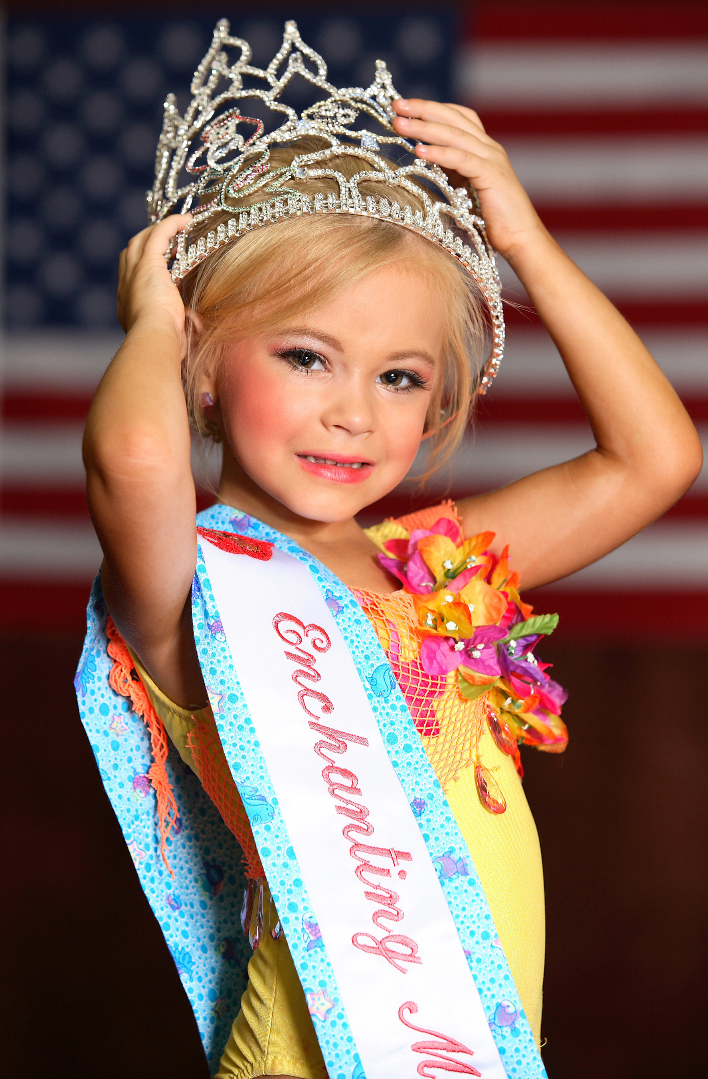
Pre- or Post-Visit Activity 2: Self Reflection and Perspective
Discussion Questions/Writing Activity

Look closely at Colby Katz’s website and view the full series of Beauty Pageant photographs. Form groups and discuss the nature of expectation versus reality. Write a collective response or paragraph. Afterwards, have a class discussion and share your views.

Critical Thinking

- What things are you interested in? Are your interests the same as those of your parents?
- What did you want to be (occupation) now and when you were a child? What do your parents want you to be? What did they want to be as kids? What are they now?
- How many points of view does Katz capture as a photographer? Discuss the difference between the points of view as the parents, the children, and the photographer: what does each person see?
Colby Katz. Amanda, 2006.
- Write a response from each perspective.

Sunshine State Standards: VA.A.1.34, VA.B.1.34, VA.C.1.34, VA.D.1.34, VA.E.1.34, LA.678.3.1.1, LA.678.3.1.2, LA.6.3.3.4, LA.678.3.5.3, LA.9101112.3.1.1, LA.9101112.3.1.2, LA.9101112.3.1.3, LA.9101112.3.2.1, LA.9101112.3.2.2, LA.9101112.3.3.1, LA.9101112.3.3.2, LA.9101112.3.3.3, LA.9101112.3.3.4, LA. 9101112.3.5.3

