JANE DOE
777 Glades Road • BOCA RATON, FL • 33431
CELL 561.297.2661 • E-MAIL faujse2016@gmail.com



- Untitled (from UN:RESOLVED series), 2015
silkscreen, gesso and graphite
22 x 30 inches

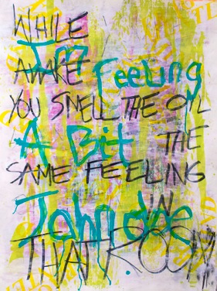

- Untitled (from UN:RESOLVED series), 2015
silkscreen, gesso and graphite
22 x 30 inches



- Marty, 2014
silkscreen
22 x 30 inches

