  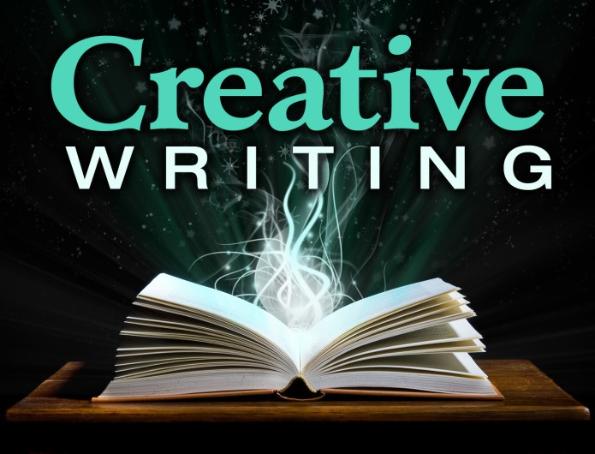
    - June 24 – June 28
  SCiFi Collab Lab
  Intensive Creative Writing Summer Camp for Teens
  SciFi Collab Lab is a one-week, intensive creative writing experience for students in grades 9 – 12 (ages 14-18). Campers will explore the key aspects of writing science fiction and fantasy stories through a combination of exercises, craft talks, and directed readings. Elements such as plot, character, voice, and setting will all be considered. Working together to come up with new worlds and new characters to inhabit them, campers will write short stories that will be published in a magazine they can take home at the end of the session.
  Registration Deadline: June 17th
  Tuition: $290 Includes deposit and a copy of a published magazine with the camper’s work
  FAU – Boca Raton campus
  9am – 4pm
  6/24 – 6/28
  A great opportunity for young writers!
  FAU English Department
  CU 306, 777 Glades Road
  Boca Raton, FL 33431
  (561-297-2974)
  mfa@fau.edu
  fau.edu/english/mfa

